Exploratory Data Analysis (EDA)¶

## Highlights¶

* Violin plots were omitted since no real insights were seen.
* Outlier detection and cleaning
  + After narrowing the scope to only Social channels, most extreme outliers were dropped instantaneously.
  + Z score method - omitted (got rid of all rows).
  + IQR method - omitted (got rid of all rows early on in the weeks).
  + Reasonable maximum was used to remove remaining outliers.
* Primary learning objectives
  + Optimal number of creatives per funnel + publisher.
    - Publisher 3 and 4 seem to be the most influential for all but CTR KPIs. One thing to experiment with is increasing the number of creatives at a specific funnel and publisher in an attempt to increase a certain KPI. For instance, if trying to increase sales CVR, increasing the number of creatives in the LF using publisher 1, 12 and 5 could prove useful.
  + Impact of number of creatives in market on performance.
    - On average, the number of creatives in market is highly positively correlated with KPIs.
* Low observance categorical values were grouped into "Other" category.

In [ ]:

**import** pandas **as** pd  
**import** numpy **as** np  
**import** matplotlib.pyplot **as** plt  
**import** seaborn **as** sns  
**import** warnings  
  
*# Set graph style*  
sns**.**set()  
  
pd**.**options**.**display**.**max_columns **=** **None**  
warnings**.**filterwarnings('ignore')  
  
**%matplotlib** inline

In [ ]:

data **=** pd**.**read_csv('C:/Users/saulc/OneDrive - University of Calgary/Classes/Econ 599 - OneDrive/KPI Project Data 0120_1221.csv')  
labeled_data **=** pd**.**read_csv('C:/Users/saulc/OneDrive - University of Calgary/Classes/Econ 599 - OneDrive/labeled_data.csv')

In [ ]:

*# Focus only on Social channel*  
social_data **=** data[data**.**channel **==** 'Social']**.**drop(columns**=**['channel', 'size'])  
labeled_social_data **=** labeled_data[labeled_data**.**channel **==** 1]**.**drop(columns**=**['channel', 'size'])  
print(f'Number of creative observations dropped: {len(data) **-** len(social_data)}')

Number of creative observations dropped: 10819

In [ ]:

print(social_data**.**shape)  
social_data**.**head()

(2452, 628)

Out[ ]:

|  | **Creative ID** | **funnel** | **publisher** | **lob** | **product** | **theme** | **kpi_audience** | **creative_versions** | **price** | **price_placement** | **discount** | **offer_placement** | **offer_group** | **asset_type** | **video_type** | **length** | **2019-12-30-Spend** | **2020-1-6-Spend** | **2020-1-13-Spend** | **2020-1-20-Spend** | **2020-1-27-Spend** | **2020-2-3-Spend** | **2020-2-10-Spend** | **2020-2-17-Spend** | **2020-2-24-Spend** | **2020-3-2-Spend** | **2020-3-9-Spend** | **2020-3-16-Spend** | **2020-4-13-Spend** | **2020-4-20-Spend** | **2020-4-27-Spend** | **2020-5-4-Spend** | **2020-5-11-Spend** | **2020-5-18-Spend** | **2020-5-25-Spend** | **2020-6-1-Spend** | **2020-6-8-Spend** | **2020-6-15-Spend** | **2020-6-22-Spend** | **2020-6-29-Spend** | **2020-7-6-Spend** | **2020-7-13-Spend** | **2020-7-20-Spend** | **2020-7-27-Spend** | **2020-8-3-Spend** | **2020-8-10-Spend** | **2020-8-17-Spend** | **2020-8-24-Spend** | **2020-8-31-Spend** | **2020-9-7-Spend** | **2020-9-14-Spend** | **2020-9-21-Spend** | **2020-9-28-Spend** | **2020-10-5-Spend** | **2020-10-12-Spend** | **2020-10-19-Spend** | **2020-10-26-Spend** | **2020-11-2-Spend** | **2020-11-9-Spend** | **2020-11-16-Spend** | **2020-11-23-Spend** | **2020-11-30-Spend** | **2020-12-7-Spend** | **2020-12-14-Spend** | **2020-12-21-Spend** | **2020-12-28-Spend** | **2021-1-4-Spend** | **2021-1-11-Spend** | **2021-1-18-Spend** | **2021-1-25-Spend** | **2021-2-1-Spend** | **2021-2-8-Spend** | **2021-2-15-Spend** | **2021-2-22-Spend** | **2021-3-1-Spend** | **2021-3-8-Spend** | **2021-3-15-Spend** | **2021-3-22-Spend** | **2021-3-29-Spend** | **2021-4-5-Spend** | **2021-4-12-Spend** | **2021-4-19-Spend** | **2021-4-26-Spend** | **2021-5-3-Spend** | **2021-5-10-Spend** | **2021-5-17-Spend** | **2021-5-24-Spend** | **2021-5-31-Spend** | **2021-6-7-Spend** | **2021-6-14-Spend** | **2021-6-21-Spend** | **2021-6-28-Spend** | **2021-7-5-Spend** | **2021-7-12-Spend** | **2021-7-19-Spend** | **2021-7-26-Spend** | **2021-8-2-Spend** | **2021-8-9-Spend** | **2021-8-16-Spend** | **2021-8-23-Spend** | **2021-8-30-Spend** | **2021-9-6-Spend** | **2021-9-13-Spend** | **2021-9-20-Spend** | **2021-9-27-Spend** | **2021-10-4-Spend** | **2021-10-11-Spend** | **2021-10-18-Spend** | **2021-10-25-Spend** | **2021-11-1-Spend** | **2021-11-8-Spend** | **2021-11-15-Spend** | **2021-11-22-Spend** | **2021-11-29-Spend** | **2021-12-6-Spend** | **2021-12-13-Spend** | **2021-12-20-Spend** | **2021-12-27-Spend** | **2019-12-30-Impressions** | **2020-1-6-Impressions** | **2020-1-13-Impressions** | **2020-1-20-Impressions** | **2020-1-27-Impressions** | **2020-2-3-Impressions** | **2020-2-10-Impressions** | **2020-2-17-Impressions** | **2020-2-24-Impressions** | **2020-3-2-Impressions** | **2020-3-9-Impressions** | **2020-3-16-Impressions** | **2020-4-13-Impressions** | **2020-4-20-Impressions** | **2020-4-27-Impressions** | **2020-5-4-Impressions** | **2020-5-11-Impressions** | **2020-5-18-Impressions** | **2020-5-25-Impressions** | **2020-6-1-Impressions** | **2020-6-8-Impressions** | **2020-6-15-Impressions** | **2020-6-22-Impressions** | **2020-6-29-Impressions** | **2020-7-6-Impressions** | **2020-7-13-Impressions** | **2020-7-20-Impressions** | **2020-7-27-Impressions** | **2020-8-3-Impressions** | **2020-8-10-Impressions** | **2020-8-17-Impressions** | **2020-8-24-Impressions** | **2020-8-31-Impressions** | **2020-9-7-Impressions** | **2020-9-14-Impressions** | **2020-9-21-Impressions** | **2020-9-28-Impressions** | **2020-10-5-Impressions** | **2020-10-12-Impressions** | **2020-10-19-Impressions** | **2020-10-26-Impressions** | **2020-11-2-Impressions** | **2020-11-9-Impressions** | **2020-11-16-Impressions** | **2020-11-23-Impressions** | **2020-11-30-Impressions** | **2020-12-7-Impressions** | **2020-12-14-Impressions** | **2020-12-21-Impressions** | **2020-12-28-Impressions** | **2021-1-4-Impressions** | **2021-1-11-Impressions** | **2021-1-18-Impressions** | **2021-1-25-Impressions** | **2021-2-1-Impressions** | **2021-2-8-Impressions** | **2021-2-15-Impressions** | **2021-2-22-Impressions** | **2021-3-1-Impressions** | **2021-3-8-Impressions** | **2021-3-15-Impressions** | **2021-3-22-Impressions** | **2021-3-29-Impressions** | **2021-4-5-Impressions** | **2021-4-12-Impressions** | **2021-4-19-Impressions** | **2021-4-26-Impressions** | **2021-5-3-Impressions** | **2021-5-10-Impressions** | **2021-5-17-Impressions** | **2021-5-24-Impressions** | **2021-5-31-Impressions** | **2021-6-7-Impressions** | **2021-6-14-Impressions** | **2021-6-21-Impressions** | **2021-6-28-Impressions** | **2021-7-5-Impressions** | **2021-7-12-Impressions** | **2021-7-19-Impressions** | **2021-7-26-Impressions** | **2021-8-2-Impressions** | **2021-8-9-Impressions** | **2021-8-16-Impressions** | **2021-8-23-Impressions** | **2021-8-30-Impressions** | **2021-9-6-Impressions** | **2021-9-13-Impressions** | **2021-9-20-Impressions** | **2021-9-27-Impressions** | **2021-10-4-Impressions** | **2021-10-11-Impressions** | **2021-10-18-Impressions** | **2021-10-25-Impressions** | **2021-11-1-Impressions** | **2021-11-8-Impressions** | **2021-11-15-Impressions** | **2021-11-22-Impressions** | **2021-11-29-Impressions** | **2021-12-6-Impressions** | **2021-12-13-Impressions** | **2021-12-20-Impressions** | **2021-12-27-Impressions** | **2019-12-30-CTR** | **2020-1-6-CTR** | **2020-1-13-CTR** | **2020-1-20-CTR** | **2020-1-27-CTR** | **2020-2-3-CTR** | **2020-2-10-CTR** | **2020-2-17-CTR** | **2020-2-24-CTR** | **2020-3-2-CTR** | **2020-3-9-CTR** | **2020-3-16-CTR** | **2020-4-13-CTR** | **2020-4-20-CTR** | **2020-4-27-CTR** | **2020-5-4-CTR** | **2020-5-11-CTR** | **2020-5-18-CTR** | **2020-5-25-CTR** | **2020-6-1-CTR** | **2020-6-8-CTR** | **2020-6-15-CTR** | **2020-6-22-CTR** | **2020-6-29-CTR** | **2020-7-6-CTR** | **2020-7-13-CTR** | **2020-7-20-CTR** | **2020-7-27-CTR** | **2020-8-3-CTR** | **2020-8-10-CTR** | **2020-8-17-CTR** | **2020-8-24-CTR** | **2020-8-31-CTR** | **2020-9-7-CTR** | **2020-9-14-CTR** | **2020-9-21-CTR** | **2020-9-28-CTR** | **2020-10-5-CTR** | **2020-10-12-CTR** | **2020-10-19-CTR** | **2020-10-26-CTR** | **2020-11-2-CTR** | **2020-11-9-CTR** | **2020-11-16-CTR** | **2020-11-23-CTR** | **2020-11-30-CTR** | **2020-12-7-CTR** | **2020-12-14-CTR** | **2020-12-21-CTR** | **2020-12-28-CTR** | **2021-1-4-CTR** | **2021-1-11-CTR** | **2021-1-18-CTR** | **2021-1-25-CTR** | **2021-2-1-CTR** | **2021-2-8-CTR** | **2021-2-15-CTR** | **2021-2-22-CTR** | **2021-3-1-CTR** | **2021-3-8-CTR** | **2021-3-15-CTR** | **2021-3-22-CTR** | **2021-3-29-CTR** | **2021-4-5-CTR** | **2021-4-12-CTR** | **2021-4-19-CTR** | **2021-4-26-CTR** | **2021-5-3-CTR** | **2021-5-10-CTR** | **2021-5-17-CTR** | **2021-5-24-CTR** | **2021-5-31-CTR** | **2021-6-7-CTR** | **2021-6-14-CTR** | **2021-6-21-CTR** | **2021-6-28-CTR** | **2021-7-5-CTR** | **2021-7-12-CTR** | **2021-7-19-CTR** | **2021-7-26-CTR** | **2021-8-2-CTR** | **2021-8-9-CTR** | **2021-8-16-CTR** | **2021-8-23-CTR** | **2021-8-30-CTR** | **2021-9-6-CTR** | **2021-9-13-CTR** | **2021-9-20-CTR** | **2021-9-27-CTR** | **2021-10-4-CTR** | **2021-10-11-CTR** | **2021-10-18-CTR** | **2021-10-25-CTR** | **2021-11-1-CTR** | **2021-11-8-CTR** | **2021-11-15-CTR** | **2021-11-22-CTR** | **2021-11-29-CTR** | **2021-12-6-CTR** | **2021-12-13-CTR** | **2021-12-20-CTR** | **2021-12-27-CTR** | **2019-12-30-CVR (SV)** | **2020-1-6-CVR (SV)** | **2020-1-13-CVR (SV)** | **2020-1-20-CVR (SV)** | **2020-1-27-CVR (SV)** | **2020-2-3-CVR (SV)** | **2020-2-10-CVR (SV)** | **2020-2-17-CVR (SV)** | **2020-2-24-CVR (SV)** | **2020-3-2-CVR (SV)** | **2020-3-9-CVR (SV)** | **2020-3-16-CVR (SV)** | **2020-4-13-CVR (SV)** | **2020-4-20-CVR (SV)** | **2020-4-27-CVR (SV)** | **2020-5-4-CVR (SV)** | **2020-5-11-CVR (SV)** | **2020-5-18-CVR (SV)** | **2020-5-25-CVR (SV)** | **2020-6-1-CVR (SV)** | **2020-6-8-CVR (SV)** | **2020-6-15-CVR (SV)** | **2020-6-22-CVR (SV)** | **2020-6-29-CVR (SV)** | **2020-7-6-CVR (SV)** | **2020-7-13-CVR (SV)** | **2020-7-20-CVR (SV)** | **2020-7-27-CVR (SV)** | **2020-8-3-CVR (SV)** | **2020-8-10-CVR (SV)** | **2020-8-17-CVR (SV)** | **2020-8-24-CVR (SV)** | **2020-8-31-CVR (SV)** | **2020-9-7-CVR (SV)** | **2020-9-14-CVR (SV)** | **2020-9-21-CVR (SV)** | **2020-9-28-CVR (SV)** | **2020-10-5-CVR (SV)** | **2020-10-12-CVR (SV)** | **2020-10-19-CVR (SV)** | **2020-10-26-CVR (SV)** | **2020-11-2-CVR (SV)** | **2020-11-9-CVR (SV)** | **2020-11-16-CVR (SV)** | **2020-11-23-CVR (SV)** | **2020-11-30-CVR (SV)** | **2020-12-7-CVR (SV)** | **2020-12-14-CVR (SV)** | **2020-12-21-CVR (SV)** | **2020-12-28-CVR (SV)** | **2021-1-4-CVR (SV)** | **2021-1-11-CVR (SV)** | **2021-1-18-CVR (SV)** | **2021-1-25-CVR (SV)** | **2021-2-1-CVR (SV)** | **2021-2-8-CVR (SV)** | **2021-2-15-CVR (SV)** | **2021-2-22-CVR (SV)** | **2021-3-1-CVR (SV)** | **2021-3-8-CVR (SV)** | **2021-3-15-CVR (SV)** | **2021-3-22-CVR (SV)** | **2021-3-29-CVR (SV)** | **2021-4-5-CVR (SV)** | **2021-4-12-CVR (SV)** | **2021-4-19-CVR (SV)** | **2021-4-26-CVR (SV)** | **2021-5-3-CVR (SV)** | **2021-5-10-CVR (SV)** | **2021-5-17-CVR (SV)** | **2021-5-24-CVR (SV)** | **2021-5-31-CVR (SV)** | **2021-6-7-CVR (SV)** | **2021-6-14-CVR (SV)** | **2021-6-21-CVR (SV)** | **2021-6-28-CVR (SV)** | **2021-7-5-CVR (SV)** | **2021-7-12-CVR (SV)** | **2021-7-19-CVR (SV)** | **2021-7-26-CVR (SV)** | **2021-8-2-CVR (SV)** | **2021-8-9-CVR (SV)** | **2021-8-16-CVR (SV)** | **2021-8-23-CVR (SV)** | **2021-8-30-CVR (SV)** | **2021-9-6-CVR (SV)** | **2021-9-13-CVR (SV)** | **2021-9-20-CVR (SV)** | **2021-9-27-CVR (SV)** | **2021-10-4-CVR (SV)** | **2021-10-11-CVR (SV)** | **2021-10-18-CVR (SV)** | **2021-10-25-CVR (SV)** | **2021-11-1-CVR (SV)** | **2021-11-8-CVR (SV)** | **2021-11-15-CVR (SV)** | **2021-11-22-CVR (SV)** | **2021-11-29-CVR (SV)** | **2021-12-6-CVR (SV)** | **2021-12-13-CVR (SV)** | **2021-12-20-CVR (SV)** | **2021-12-27-CVR (SV)** | **2019-12-30-CVR (BF)** | **2020-1-6-CVR (BF)** | **2020-1-13-CVR (BF)** | **2020-1-20-CVR (BF)** | **2020-1-27-CVR (BF)** | **2020-2-3-CVR (BF)** | **2020-2-10-CVR (BF)** | **2020-2-17-CVR (BF)** | **2020-2-24-CVR (BF)** | **2020-3-2-CVR (BF)** | **2020-3-9-CVR (BF)** | **2020-3-16-CVR (BF)** | **2020-4-13-CVR (BF)** | **2020-4-20-CVR (BF)** | **2020-4-27-CVR (BF)** | **2020-5-4-CVR (BF)** | **2020-5-11-CVR (BF)** | **2020-5-18-CVR (BF)** | **2020-5-25-CVR (BF)** | **2020-6-1-CVR (BF)** | **2020-6-8-CVR (BF)** | **2020-6-15-CVR (BF)** | **2020-6-22-CVR (BF)** | **2020-6-29-CVR (BF)** | **2020-7-6-CVR (BF)** | **2020-7-13-CVR (BF)** | **2020-7-20-CVR (BF)** | **2020-7-27-CVR (BF)** | **2020-8-3-CVR (BF)** | **2020-8-10-CVR (BF)** | **2020-8-17-CVR (BF)** | **2020-8-24-CVR (BF)** | **2020-8-31-CVR (BF)** | **2020-9-7-CVR (BF)** | **2020-9-14-CVR (BF)** | **2020-9-21-CVR (BF)** | **2020-9-28-CVR (BF)** | **2020-10-5-CVR (BF)** | **2020-10-12-CVR (BF)** | **2020-10-19-CVR (BF)** | **2020-10-26-CVR (BF)** | **2020-11-2-CVR (BF)** | **2020-11-9-CVR (BF)** | **2020-11-16-CVR (BF)** | **2020-11-23-CVR (BF)** | **2020-11-30-CVR (BF)** | **2020-12-7-CVR (BF)** | **2020-12-14-CVR (BF)** | **2020-12-21-CVR (BF)** | **2020-12-28-CVR (BF)** | **2021-1-4-CVR (BF)** | **2021-1-11-CVR (BF)** | **2021-1-18-CVR (BF)** | **2021-1-25-CVR (BF)** | **2021-2-1-CVR (BF)** | **2021-2-8-CVR (BF)** | **2021-2-15-CVR (BF)** | **2021-2-22-CVR (BF)** | **2021-3-1-CVR (BF)** | **2021-3-8-CVR (BF)** | **2021-3-15-CVR (BF)** | **2021-3-22-CVR (BF)** | **2021-3-29-CVR (BF)** | **2021-4-5-CVR (BF)** | **2021-4-12-CVR (BF)** | **2021-4-19-CVR (BF)** | **2021-4-26-CVR (BF)** | **2021-5-3-CVR (BF)** | **2021-5-10-CVR (BF)** | **2021-5-17-CVR (BF)** | **2021-5-24-CVR (BF)** | **2021-5-31-CVR (BF)** | **2021-6-7-CVR (BF)** | **2021-6-14-CVR (BF)** | **2021-6-21-CVR (BF)** | **2021-6-28-CVR (BF)** | **2021-7-5-CVR (BF)** | **2021-7-12-CVR (BF)** | **2021-7-19-CVR (BF)** | **2021-7-26-CVR (BF)** | **2021-8-2-CVR (BF)** | **2021-8-9-CVR (BF)** | **2021-8-16-CVR (BF)** | **2021-8-23-CVR (BF)** | **2021-8-30-CVR (BF)** | **2021-9-6-CVR (BF)** | **2021-9-13-CVR (BF)** | **2021-9-20-CVR (BF)** | **2021-9-27-CVR (BF)** | **2021-10-4-CVR (BF)** | **2021-10-11-CVR (BF)** | **2021-10-18-CVR (BF)** | **2021-10-25-CVR (BF)** | **2021-11-1-CVR (BF)** | **2021-11-8-CVR (BF)** | **2021-11-15-CVR (BF)** | **2021-11-22-CVR (BF)** | **2021-11-29-CVR (BF)** | **2021-12-6-CVR (BF)** | **2021-12-13-CVR (BF)** | **2021-12-20-CVR (BF)** | **2021-12-27-CVR (BF)** | **2019-12-30-Internet CVR (S)** | **2020-1-6-Internet CVR (S)** | **2020-1-13-Internet CVR (S)** | **2020-1-20-Internet CVR (S)** | **2020-1-27-Internet CVR (S)** | **2020-2-3-Internet CVR (S)** | **2020-2-10-Internet CVR (S)** | **2020-2-17-Internet CVR (S)** | **2020-2-24-Internet CVR (S)** | **2020-3-2-Internet CVR (S)** | **2020-3-9-Internet CVR (S)** | **2020-3-16-Internet CVR (S)** | **2020-4-13-Internet CVR (S)** | **2020-4-20-Internet CVR (S)** | **2020-4-27-Internet CVR (S)** | **2020-5-4-Internet CVR (S)** | **2020-5-11-Internet CVR (S)** | **2020-5-18-Internet CVR (S)** | **2020-5-25-Internet CVR (S)** | **2020-6-1-Internet CVR (S)** | **2020-6-8-Internet CVR (S)** | **2020-6-15-Internet CVR (S)** | **2020-6-22-Internet CVR (S)** | **2020-6-29-Internet CVR (S)** | **2020-7-6-Internet CVR (S)** | **2020-7-13-Internet CVR (S)** | **2020-7-20-Internet CVR (S)** | **2020-7-27-Internet CVR (S)** | **2020-8-3-Internet CVR (S)** | **2020-8-10-Internet CVR (S)** | **2020-8-17-Internet CVR (S)** | **2020-8-24-Internet CVR (S)** | **2020-8-31-Internet CVR (S)** | **2020-9-7-Internet CVR (S)** | **2020-9-14-Internet CVR (S)** | **2020-9-21-Internet CVR (S)** | **2020-9-28-Internet CVR (S)** | **2020-10-5-Internet CVR (S)** | **2020-10-12-Internet CVR (S)** | **2020-10-19-Internet CVR (S)** | **2020-10-26-Internet CVR (S)** | **2020-11-2-Internet CVR (S)** | **2020-11-9-Internet CVR (S)** | **2020-11-16-Internet CVR (S)** | **2020-11-23-Internet CVR (S)** | **2020-11-30-Internet CVR (S)** | **2020-12-7-Internet CVR (S)** | **2020-12-14-Internet CVR (S)** | **2020-12-21-Internet CVR (S)** | **2020-12-28-Internet CVR (S)** | **2021-1-4-Internet CVR (S)** | **2021-1-11-Internet CVR (S)** | **2021-1-18-Internet CVR (S)** | **2021-1-25-Internet CVR (S)** | **2021-2-1-Internet CVR (S)** | **2021-2-8-Internet CVR (S)** | **2021-2-15-Internet CVR (S)** | **2021-2-22-Internet CVR (S)** | **2021-3-1-Internet CVR (S)** | **2021-3-8-Internet CVR (S)** | **2021-3-15-Internet CVR (S)** | **2021-3-22-Internet CVR (S)** | **2021-3-29-Internet CVR (S)** | **2021-4-5-Internet CVR (S)** | **2021-4-12-Internet CVR (S)** | **2021-4-19-Internet CVR (S)** | **2021-4-26-Internet CVR (S)** | **2021-5-3-Internet CVR (S)** | **2021-5-10-Internet CVR (S)** | **2021-5-17-Internet CVR (S)** | **2021-5-24-Internet CVR (S)** | **2021-5-31-Internet CVR (S)** | **2021-6-7-Internet CVR (S)** | **2021-6-14-Internet CVR (S)** | **2021-6-21-Internet CVR (S)** | **2021-6-28-Internet CVR (S)** | **2021-7-5-Internet CVR (S)** | **2021-7-12-Internet CVR (S)** | **2021-7-19-Internet CVR (S)** | **2021-7-26-Internet CVR (S)** | **2021-8-2-Internet CVR (S)** | **2021-8-9-Internet CVR (S)** | **2021-8-16-Internet CVR (S)** | **2021-8-23-Internet CVR (S)** | **2021-8-30-Internet CVR (S)** | **2021-9-6-Internet CVR (S)** | **2021-9-13-Internet CVR (S)** | **2021-9-20-Internet CVR (S)** | **2021-9-27-Internet CVR (S)** | **2021-10-4-Internet CVR (S)** | **2021-10-11-Internet CVR (S)** | **2021-10-18-Internet CVR (S)** | **2021-10-25-Internet CVR (S)** | **2021-11-1-Internet CVR (S)** | **2021-11-8-Internet CVR (S)** | **2021-11-15-Internet CVR (S)** | **2021-11-22-Internet CVR (S)** | **2021-11-29-Internet CVR (S)** | **2021-12-6-Internet CVR (S)** | **2021-12-13-Internet CVR (S)** | **2021-12-20-Internet CVR (S)** | **2021-12-27-Internet CVR (S)** |
| --- | --- | --- | --- | --- | --- | --- | --- | --- | --- | --- | --- | --- | --- | --- | --- | --- | --- | --- | --- | --- | --- | --- | --- | --- | --- | --- | --- | --- | --- | --- | --- | --- | --- | --- | --- | --- | --- | --- | --- | --- | --- | --- | --- | --- | --- | --- | --- | --- | --- | --- | --- | --- | --- | --- | --- | --- | --- | --- | --- | --- | --- | --- | --- | --- | --- | --- | --- | --- | --- | --- | --- | --- | --- | --- | --- | --- | --- | --- | --- | --- | --- | --- | --- | --- | --- | --- | --- | --- | --- | --- | --- | --- | --- | --- | --- | --- | --- | --- | --- | --- | --- | --- | --- | --- | --- | --- | --- | --- | --- | --- | --- | --- | --- | --- | --- | --- | --- | --- | --- | --- | --- | --- | --- | --- | --- | --- | --- | --- | --- | --- | --- | --- | --- | --- | --- | --- | --- | --- | --- | --- | --- | --- | --- | --- | --- | --- | --- | --- | --- | --- | --- | --- | --- | --- | --- | --- | --- | --- | --- | --- | --- | --- | --- | --- | --- | --- | --- | --- | --- | --- | --- | --- | --- | --- | --- | --- | --- | --- | --- | --- | --- | --- | --- | --- | --- | --- | --- | --- | --- | --- | --- | --- | --- | --- | --- | --- | --- | --- | --- | --- | --- | --- | --- | --- | --- | --- | --- | --- | --- | --- | --- | --- | --- | --- | --- | --- | --- | --- | --- | --- | --- | --- | --- | --- | --- | --- | --- | --- | --- | --- | --- | --- | --- | --- | --- | --- | --- | --- | --- | --- | --- | --- | --- | --- | --- | --- | --- | --- | --- | --- | --- | --- | --- | --- | --- | --- | --- | --- | --- | --- | --- | --- | --- | --- | --- | --- | --- | --- | --- | --- | --- | --- | --- | --- | --- | --- | --- | --- | --- | --- | --- | --- | --- | --- | --- | --- | --- | --- | --- | --- | --- | --- | --- | --- | --- | --- | --- | --- | --- | --- | --- | --- | --- | --- | --- | --- | --- | --- | --- | --- | --- | --- | --- | --- | --- | --- | --- | --- | --- | --- | --- | --- | --- | --- | --- | --- | --- | --- | --- | --- | --- | --- | --- | --- | --- | --- | --- | --- | --- | --- | --- | --- | --- | --- | --- | --- | --- | --- | --- | --- | --- | --- | --- | --- | --- | --- | --- | --- | --- | --- | --- | --- | --- | --- | --- | --- | --- | --- | --- | --- | --- | --- | --- | --- | --- | --- | --- | --- | --- | --- | --- | --- | --- | --- | --- | --- | --- | --- | --- | --- | --- | --- | --- | --- | --- | --- | --- | --- | --- | --- | --- | --- | --- | --- | --- | --- | --- | --- | --- | --- | --- | --- | --- | --- | --- | --- | --- | --- | --- | --- | --- | --- | --- | --- | --- | --- | --- | --- | --- | --- | --- | --- | --- | --- | --- | --- | --- | --- | --- | --- | --- | --- | --- | --- | --- | --- | --- | --- | --- | --- | --- | --- | --- | --- | --- | --- | --- | --- | --- | --- | --- | --- | --- | --- | --- | --- | --- | --- | --- | --- | --- | --- | --- | --- | --- | --- | --- | --- | --- | --- | --- | --- | --- | --- | --- | --- | --- | --- | --- | --- | --- | --- | --- | --- | --- | --- | --- | --- | --- | --- | --- | --- | --- | --- | --- | --- | --- | --- | --- | --- | --- | --- | --- | --- | --- | --- | --- | --- | --- | --- | --- | --- | --- | --- | --- | --- | --- | --- | --- | --- | --- | --- | --- | --- | --- | --- | --- | --- | --- | --- | --- | --- | --- | --- | --- | --- | --- | --- | --- | --- | --- | --- | --- | --- | --- | --- | --- | --- | --- | --- | --- | --- | --- | --- | --- | --- | --- | --- | --- | --- | --- | --- | --- | --- | --- | --- | --- | --- | --- | --- | --- | --- | --- | --- | --- | --- | --- | --- | --- | --- | --- | --- | --- | --- | --- | --- | --- | --- | --- | --- | --- | --- | --- | --- | --- | --- | --- | --- | --- | --- | --- | --- | --- | --- | --- | --- | --- | --- | --- | --- | --- | --- | --- | --- | --- | --- | --- | --- |
| **0** | Creative 1 | MF | Publisher 1 | LOB 1 | Product 1 | Theme 1 | Audience 1 | Creative 1 | No Price | NaN | 0.0 | NaN | No offer | Vid | Stock | :15 | NaN | NaN | NaN | NaN | NaN | NaN | NaN | NaN | NaN | NaN | NaN | NaN | NaN | NaN | NaN | NaN | NaN | NaN | NaN | NaN | NaN | NaN | NaN | NaN | NaN | NaN | NaN | NaN | NaN | NaN | NaN | NaN | NaN | NaN | NaN | NaN | NaN | NaN | NaN | NaN | NaN | NaN | NaN | NaN | NaN | NaN | NaN | NaN | NaN | NaN | NaN | NaN | NaN | NaN | NaN | NaN | NaN | NaN | NaN | NaN | NaN | NaN | $2 | $3 | $4 | $4 | $22 | $853 | $1,692 | $1,394 | $150 | $3 | $4 | $7 | $6 | NaN | NaN | NaN | NaN | NaN | NaN | NaN | NaN | NaN | NaN | NaN | NaN | NaN | NaN | NaN | NaN | NaN | NaN | NaN | NaN | NaN | NaN | NaN | NaN | NaN | NaN | NaN | NaN | NaN | NaN | NaN | NaN | NaN | NaN | NaN | NaN | NaN | NaN | NaN | NaN | NaN | NaN | NaN | NaN | NaN | NaN | NaN | NaN | NaN | NaN | NaN | NaN | NaN | NaN | NaN | NaN | NaN | NaN | NaN | NaN | NaN | NaN | NaN | NaN | NaN | NaN | NaN | NaN | NaN | NaN | NaN | NaN | NaN | NaN | NaN | NaN | NaN | NaN | NaN | NaN | NaN | NaN | NaN | NaN | NaN | NaN | NaN | NaN | NaN | 205 | 317 | 417 | 403 | 797 | 41,890 | 83,865 | 68,932 | 7,236 | 111 | 117 | 229 | 210 | NaN | NaN | NaN | NaN | NaN | NaN | NaN | NaN | NaN | NaN | NaN | NaN | NaN | NaN | NaN | NaN | NaN | NaN | NaN | NaN | NaN | NaN | NaN | NaN | NaN | NaN | NaN | NaN | NaN | NaN | NaN | NaN | NaN | NaN | NaN | NaN | NaN | NaN | NaN | NaN | NaN | NaN | NaN | NaN | NaN | NaN | NaN | NaN | NaN | NaN | NaN | NaN | NaN | NaN | NaN | NaN | NaN | NaN | NaN | NaN | NaN | NaN | NaN | NaN | NaN | NaN | NaN | NaN | NaN | NaN | NaN | NaN | NaN | NaN | NaN | NaN | NaN | NaN | NaN | NaN | NaN | NaN | NaN | NaN | NaN | NaN | NaN | NaN | NaN | 0.98% | 1.58% | 0.00% | 0.00% | 0.13% | 0.43% | 0.48% | 0.43% | 0.41% | 0.90% | 1.71% | 0.00% | 0.00% | NaN | NaN | NaN | NaN | NaN | NaN | NaN | NaN | NaN | NaN | NaN | NaN | NaN | NaN | NaN | NaN | NaN | NaN | NaN | NaN | NaN | NaN | NaN | NaN | NaN | NaN | NaN | NaN | NaN | NaN | NaN | NaN | NaN | NaN | NaN | NaN | NaN | NaN | NaN | NaN | NaN | NaN | NaN | NaN | NaN | NaN | NaN | NaN | NaN | NaN | NaN | NaN | NaN | NaN | NaN | NaN | NaN | NaN | NaN | NaN | NaN | NaN | NaN | NaN | NaN | NaN | NaN | NaN | NaN | NaN | NaN | NaN | NaN | NaN | NaN | NaN | NaN | NaN | NaN | NaN | NaN | NaN | NaN | NaN | NaN | NaN | NaN | NaN | NaN | 0.00% | 0.00% | 0.00% | 0.00% | 0.00% | 0.00% | 0.00% | 0.00% | 0.00% | 0.00% | 0.00% | 0.00% | 0.00% | NaN | NaN | NaN | NaN | NaN | NaN | NaN | NaN | NaN | NaN | NaN | NaN | NaN | NaN | NaN | NaN | NaN | NaN | NaN | NaN | NaN | NaN | NaN | NaN | NaN | NaN | NaN | NaN | NaN | NaN | NaN | NaN | NaN | NaN | NaN | NaN | NaN | NaN | NaN | NaN | NaN | NaN | NaN | NaN | NaN | NaN | NaN | NaN | NaN | NaN | NaN | NaN | NaN | NaN | NaN | NaN | NaN | NaN | NaN | NaN | NaN | NaN | NaN | NaN | NaN | NaN | NaN | NaN | NaN | NaN | NaN | NaN | NaN | NaN | NaN | NaN | NaN | NaN | NaN | NaN | NaN | NaN | NaN | NaN | NaN | NaN | NaN | NaN | NaN | 0.00% | 0.00% | 0.00% | 0.00% | 0.00% | 0.00% | 0.00% | 0.00% | 0.00% | 0.00% | 0.00% | 0.00% | 0.00% | NaN | NaN | NaN | NaN | NaN | NaN | NaN | NaN | NaN | NaN | NaN | NaN | NaN | NaN | NaN | NaN | NaN | NaN | NaN | NaN | NaN | NaN | NaN | NaN | NaN | NaN | NaN | NaN | NaN | NaN | NaN | NaN | NaN | NaN | NaN | NaN | NaN | NaN | NaN | NaN | NaN | NaN | NaN | NaN | NaN | NaN | NaN | NaN | NaN | NaN | NaN | NaN | NaN | NaN | NaN | NaN | NaN | NaN | NaN | NaN | NaN | NaN | NaN | NaN | NaN | NaN | NaN | NaN | NaN | NaN | NaN | NaN | NaN | NaN | NaN | NaN | NaN | NaN | NaN | NaN | NaN | NaN | NaN | NaN | NaN | NaN | NaN | NaN | NaN | 0.00% | 0.00% | 0.00% | 0.00% | 0.00% | 0.00% | 0.00% | 0.00% | 0.00% | 0.00% | 0.00% | 0.00% | 0.00% | NaN | NaN | NaN | NaN | NaN | NaN | NaN | NaN | NaN | NaN | NaN | NaN | NaN | NaN | NaN | NaN | NaN | NaN | NaN | NaN | NaN | NaN | NaN | NaN | NaN | NaN | NaN |
| **8** | Creative 9 | MF | Publisher 3 | LOB 1 | Product 1 | Theme 1 | Audience 2 | Creative 1 | No Price | NaN | 0.0 | NaN | No offer | Vid | Stock | :15 | NaN | NaN | NaN | NaN | NaN | NaN | NaN | NaN | NaN | NaN | NaN | NaN | NaN | NaN | NaN | NaN | NaN | NaN | NaN | NaN | NaN | NaN | NaN | NaN | NaN | NaN | NaN | NaN | NaN | NaN | NaN | NaN | NaN | NaN | NaN | NaN | NaN | NaN | NaN | NaN | NaN | NaN | NaN | NaN | NaN | NaN | NaN | NaN | NaN | NaN | NaN | NaN | NaN | NaN | NaN | NaN | NaN | NaN | NaN | NaN | NaN | NaN | $1,724 | $3,344 | $3,110 | $3,327 | $3,340 | $3,529 | $3,526 | $3,518 | $1,162 | NaN | NaN | NaN | NaN | NaN | NaN | NaN | NaN | NaN | NaN | NaN | NaN | NaN | NaN | NaN | NaN | NaN | NaN | NaN | NaN | NaN | NaN | NaN | NaN | NaN | NaN | NaN | NaN | NaN | NaN | NaN | NaN | NaN | NaN | NaN | NaN | NaN | NaN | NaN | NaN | NaN | NaN | NaN | NaN | NaN | NaN | NaN | NaN | NaN | NaN | NaN | NaN | NaN | NaN | NaN | NaN | NaN | NaN | NaN | NaN | NaN | NaN | NaN | NaN | NaN | NaN | NaN | NaN | NaN | NaN | NaN | NaN | NaN | NaN | NaN | NaN | NaN | NaN | NaN | NaN | NaN | NaN | NaN | NaN | NaN | NaN | NaN | NaN | NaN | NaN | NaN | NaN | NaN | 63,550 | 125,249 | 107,590 | 117,234 | 119,314 | 127,372 | 133,784 | 131,902 | 33,827 | NaN | NaN | NaN | NaN | NaN | NaN | NaN | NaN | NaN | NaN | NaN | NaN | NaN | NaN | NaN | NaN | NaN | NaN | NaN | NaN | NaN | NaN | NaN | NaN | NaN | NaN | NaN | NaN | NaN | NaN | NaN | NaN | NaN | NaN | NaN | NaN | NaN | NaN | NaN | NaN | NaN | NaN | NaN | NaN | NaN | NaN | NaN | NaN | NaN | NaN | NaN | NaN | NaN | NaN | NaN | NaN | NaN | NaN | NaN | NaN | NaN | NaN | NaN | NaN | NaN | NaN | NaN | NaN | NaN | NaN | NaN | NaN | NaN | NaN | NaN | NaN | NaN | NaN | NaN | NaN | NaN | NaN | NaN | NaN | NaN | NaN | NaN | NaN | NaN | NaN | NaN | NaN | NaN | 0.49% | 0.35% | 0.26% | 0.27% | 0.27% | 0.26% | 0.23% | 0.24% | 0.23% | NaN | NaN | NaN | NaN | NaN | NaN | NaN | NaN | NaN | NaN | NaN | NaN | NaN | NaN | NaN | NaN | NaN | NaN | NaN | NaN | NaN | NaN | NaN | NaN | NaN | NaN | NaN | NaN | NaN | NaN | NaN | NaN | NaN | NaN | NaN | NaN | NaN | NaN | NaN | NaN | NaN | NaN | NaN | NaN | NaN | NaN | NaN | NaN | NaN | NaN | NaN | NaN | NaN | NaN | NaN | NaN | NaN | NaN | NaN | NaN | NaN | NaN | NaN | NaN | NaN | NaN | NaN | NaN | NaN | NaN | NaN | NaN | NaN | NaN | NaN | NaN | NaN | NaN | NaN | NaN | NaN | NaN | NaN | NaN | NaN | NaN | NaN | NaN | NaN | NaN | NaN | NaN | NaN | 0.27% | 0.15% | 0.11% | 0.12% | 0.11% | 0.09% | 0.08% | 0.10% | 0.09% | NaN | NaN | NaN | NaN | NaN | NaN | NaN | NaN | NaN | NaN | NaN | NaN | NaN | NaN | NaN | NaN | NaN | NaN | NaN | NaN | NaN | NaN | NaN | NaN | NaN | NaN | NaN | NaN | NaN | NaN | NaN | NaN | NaN | NaN | NaN | NaN | NaN | NaN | NaN | NaN | NaN | NaN | NaN | NaN | NaN | NaN | NaN | NaN | NaN | NaN | NaN | NaN | NaN | NaN | NaN | NaN | NaN | NaN | NaN | NaN | NaN | NaN | NaN | NaN | NaN | NaN | NaN | NaN | NaN | NaN | NaN | NaN | NaN | NaN | NaN | NaN | NaN | NaN | NaN | NaN | NaN | NaN | NaN | NaN | NaN | NaN | NaN | NaN | NaN | NaN | NaN | NaN | NaN | 37.77% | 35.93% | 34.39% | 17.91% | 25.14% | 21.20% | 16.44% | 25.02% | 11.82% | NaN | NaN | NaN | NaN | NaN | NaN | NaN | NaN | NaN | NaN | NaN | NaN | NaN | NaN | NaN | NaN | NaN | NaN | NaN | NaN | NaN | NaN | NaN | NaN | NaN | NaN | NaN | NaN | NaN | NaN | NaN | NaN | NaN | NaN | NaN | NaN | NaN | NaN | NaN | NaN | NaN | NaN | NaN | NaN | NaN | NaN | NaN | NaN | NaN | NaN | NaN | NaN | NaN | NaN | NaN | NaN | NaN | NaN | NaN | NaN | NaN | NaN | NaN | NaN | NaN | NaN | NaN | NaN | NaN | NaN | NaN | NaN | NaN | NaN | NaN | NaN | NaN | NaN | NaN | NaN | NaN | NaN | NaN | NaN | NaN | NaN | NaN | NaN | NaN | NaN | NaN | NaN | NaN | 0.00% | 0.00% | 1.49% | 0.17% | 0.17% | 0.16% | 0.15% | 0.15% | 0.00% | NaN | NaN | NaN | NaN | NaN | NaN | NaN | NaN | NaN | NaN | NaN | NaN | NaN | NaN | NaN | NaN | NaN | NaN | NaN | NaN | NaN | NaN | NaN | NaN | NaN | NaN | NaN | NaN | NaN | NaN | NaN |
| **9** | Creative 10 | MF | Publisher 4 | LOB 1 | Product 1 | Theme 1 | Audience 2 | Creative 1 | No Price | NaN | 0.0 | NaN | No offer | Vid | Stock | :15 | NaN | NaN | NaN | NaN | NaN | NaN | NaN | NaN | NaN | NaN | NaN | NaN | NaN | NaN | NaN | NaN | NaN | NaN | NaN | NaN | NaN | NaN | NaN | NaN | NaN | NaN | NaN | NaN | NaN | NaN | NaN | NaN | NaN | NaN | NaN | NaN | NaN | NaN | NaN | NaN | NaN | NaN | NaN | NaN | NaN | NaN | NaN | NaN | NaN | NaN | NaN | NaN | NaN | NaN | NaN | NaN | NaN | NaN | NaN | NaN | NaN | NaN | $282 | $529 | $479 | $458 | $442 | $632 | $542 | $574 | $87 | NaN | NaN | NaN | NaN | NaN | NaN | NaN | NaN | NaN | NaN | NaN | NaN | NaN | NaN | NaN | NaN | NaN | NaN | NaN | NaN | NaN | NaN | NaN | NaN | NaN | NaN | NaN | NaN | NaN | NaN | NaN | NaN | NaN | NaN | NaN | NaN | NaN | NaN | NaN | NaN | NaN | NaN | NaN | NaN | NaN | NaN | NaN | NaN | NaN | NaN | NaN | NaN | NaN | NaN | NaN | NaN | NaN | NaN | NaN | NaN | NaN | NaN | NaN | NaN | NaN | NaN | NaN | NaN | NaN | NaN | NaN | NaN | NaN | NaN | NaN | NaN | NaN | NaN | NaN | NaN | NaN | NaN | NaN | NaN | NaN | NaN | NaN | NaN | NaN | NaN | NaN | NaN | NaN | 27,381 | 46,901 | 43,107 | 39,422 | 41,999 | 49,238 | 44,079 | 47,429 | 7,547 | NaN | NaN | NaN | NaN | NaN | NaN | NaN | NaN | NaN | NaN | NaN | NaN | NaN | NaN | NaN | NaN | NaN | NaN | NaN | NaN | NaN | NaN | NaN | NaN | NaN | NaN | NaN | NaN | NaN | NaN | NaN | NaN | NaN | NaN | NaN | NaN | NaN | NaN | NaN | NaN | NaN | NaN | NaN | NaN | NaN | NaN | NaN | NaN | NaN | NaN | NaN | NaN | NaN | NaN | NaN | NaN | NaN | NaN | NaN | NaN | NaN | NaN | NaN | NaN | NaN | NaN | NaN | NaN | NaN | NaN | NaN | NaN | NaN | NaN | NaN | NaN | NaN | NaN | NaN | NaN | NaN | NaN | NaN | NaN | NaN | NaN | NaN | NaN | NaN | NaN | NaN | NaN | NaN | 0.66% | 0.57% | 0.61% | 0.58% | 0.51% | 0.58% | 0.53% | 0.54% | 0.49% | NaN | NaN | NaN | NaN | NaN | NaN | NaN | NaN | NaN | NaN | NaN | NaN | NaN | NaN | NaN | NaN | NaN | NaN | NaN | NaN | NaN | NaN | NaN | NaN | NaN | NaN | NaN | NaN | NaN | NaN | NaN | NaN | NaN | NaN | NaN | NaN | NaN | NaN | NaN | NaN | NaN | NaN | NaN | NaN | NaN | NaN | NaN | NaN | NaN | NaN | NaN | NaN | NaN | NaN | NaN | NaN | NaN | NaN | NaN | NaN | NaN | NaN | NaN | NaN | NaN | NaN | NaN | NaN | NaN | NaN | NaN | NaN | NaN | NaN | NaN | NaN | NaN | NaN | NaN | NaN | NaN | NaN | NaN | NaN | NaN | NaN | NaN | NaN | NaN | NaN | NaN | NaN | NaN | 0.07% | 0.10% | 0.08% | 0.09% | 0.07% | 0.04% | 0.05% | 0.04% | 0.09% | NaN | NaN | NaN | NaN | NaN | NaN | NaN | NaN | NaN | NaN | NaN | NaN | NaN | NaN | NaN | NaN | NaN | NaN | NaN | NaN | NaN | NaN | NaN | NaN | NaN | NaN | NaN | NaN | NaN | NaN | NaN | NaN | NaN | NaN | NaN | NaN | NaN | NaN | NaN | NaN | NaN | NaN | NaN | NaN | NaN | NaN | NaN | NaN | NaN | NaN | NaN | NaN | NaN | NaN | NaN | NaN | NaN | NaN | NaN | NaN | NaN | NaN | NaN | NaN | NaN | NaN | NaN | NaN | NaN | NaN | NaN | NaN | NaN | NaN | NaN | NaN | NaN | NaN | NaN | NaN | NaN | NaN | NaN | NaN | NaN | NaN | NaN | NaN | NaN | NaN | NaN | NaN | NaN | 73.04% | 68.23% | 11.60% | 12.68% | 4.76% | 4.06% | 15.88% | 27.41% | 26.50% | NaN | NaN | NaN | NaN | NaN | NaN | NaN | NaN | NaN | NaN | NaN | NaN | NaN | NaN | NaN | NaN | NaN | NaN | NaN | NaN | NaN | NaN | NaN | NaN | NaN | NaN | NaN | NaN | NaN | NaN | NaN | NaN | NaN | NaN | NaN | NaN | NaN | NaN | NaN | NaN | NaN | NaN | NaN | NaN | NaN | NaN | NaN | NaN | NaN | NaN | NaN | NaN | NaN | NaN | NaN | NaN | NaN | NaN | NaN | NaN | NaN | NaN | NaN | NaN | NaN | NaN | NaN | NaN | NaN | NaN | NaN | NaN | NaN | NaN | NaN | NaN | NaN | NaN | NaN | NaN | NaN | NaN | NaN | NaN | NaN | NaN | NaN | NaN | NaN | NaN | NaN | NaN | NaN | 0.00% | 0.00% | 0.93% | 1.01% | 0.00% | 0.00% | 0.00% | 0.00% | 0.00% | NaN | NaN | NaN | NaN | NaN | NaN | NaN | NaN | NaN | NaN | NaN | NaN | NaN | NaN | NaN | NaN | NaN | NaN | NaN | NaN | NaN | NaN | NaN | NaN | NaN | NaN | NaN | NaN | NaN | NaN | NaN |
| **10** | Creative 11 | MF | Publisher 5 | LOB 1 | Product 1 | Theme 1 | Audience 2 | Creative 1 | No Price | NaN | 0.0 | NaN | No offer | Vid | Stock | :15 | NaN | NaN | NaN | NaN | NaN | NaN | NaN | NaN | NaN | NaN | NaN | NaN | NaN | NaN | NaN | NaN | NaN | NaN | NaN | NaN | NaN | NaN | NaN | NaN | NaN | NaN | NaN | NaN | NaN | NaN | NaN | NaN | NaN | NaN | NaN | NaN | NaN | NaN | NaN | NaN | NaN | NaN | NaN | NaN | NaN | NaN | NaN | NaN | NaN | NaN | NaN | NaN | NaN | NaN | NaN | NaN | NaN | NaN | NaN | NaN | NaN | NaN | $50 | $88 | $102 | $110 | $124 | $131 | $114 | $106 | $25 | NaN | NaN | NaN | NaN | NaN | NaN | NaN | NaN | NaN | NaN | NaN | NaN | NaN | NaN | NaN | NaN | NaN | NaN | NaN | NaN | NaN | NaN | NaN | NaN | NaN | NaN | NaN | NaN | NaN | NaN | NaN | NaN | NaN | NaN | NaN | NaN | NaN | NaN | NaN | NaN | NaN | NaN | NaN | NaN | NaN | NaN | NaN | NaN | NaN | NaN | NaN | NaN | NaN | NaN | NaN | NaN | NaN | NaN | NaN | NaN | NaN | NaN | NaN | NaN | NaN | NaN | NaN | NaN | NaN | NaN | NaN | NaN | NaN | NaN | NaN | NaN | NaN | NaN | NaN | NaN | NaN | NaN | NaN | NaN | NaN | NaN | NaN | NaN | NaN | NaN | NaN | NaN | NaN | 2,676 | 5,540 | 5,971 | 6,365 | 7,127 | 8,255 | 8,097 | 8,131 | 1,928 | NaN | NaN | NaN | NaN | NaN | NaN | NaN | NaN | NaN | NaN | NaN | NaN | NaN | NaN | NaN | NaN | NaN | NaN | NaN | NaN | NaN | NaN | NaN | NaN | NaN | NaN | NaN | NaN | NaN | NaN | NaN | NaN | NaN | NaN | NaN | NaN | NaN | NaN | NaN | NaN | NaN | NaN | NaN | NaN | NaN | NaN | NaN | NaN | NaN | NaN | NaN | NaN | NaN | NaN | NaN | NaN | NaN | NaN | NaN | NaN | NaN | NaN | NaN | NaN | NaN | NaN | NaN | NaN | NaN | NaN | NaN | NaN | NaN | NaN | NaN | NaN | NaN | NaN | NaN | NaN | NaN | NaN | NaN | NaN | NaN | NaN | NaN | NaN | NaN | NaN | NaN | NaN | NaN | 0.37% | 0.36% | 0.37% | 0.22% | 0.24% | 0.23% | 0.19% | 0.20% | 0.16% | NaN | NaN | NaN | NaN | NaN | NaN | NaN | NaN | NaN | NaN | NaN | NaN | NaN | NaN | NaN | NaN | NaN | NaN | NaN | NaN | NaN | NaN | NaN | NaN | NaN | NaN | NaN | NaN | NaN | NaN | NaN | NaN | NaN | NaN | NaN | NaN | NaN | NaN | NaN | NaN | NaN | NaN | NaN | NaN | NaN | NaN | NaN | NaN | NaN | NaN | NaN | NaN | NaN | NaN | NaN | NaN | NaN | NaN | NaN | NaN | NaN | NaN | NaN | NaN | NaN | NaN | NaN | NaN | NaN | NaN | NaN | NaN | NaN | NaN | NaN | NaN | NaN | NaN | NaN | NaN | NaN | NaN | NaN | NaN | NaN | NaN | NaN | NaN | NaN | NaN | NaN | NaN | NaN | 0.22% | 0.09% | 0.15% | 0.06% | 0.04% | 0.02% | 0.05% | 0.18% | 0.10% | NaN | NaN | NaN | NaN | NaN | NaN | NaN | NaN | NaN | NaN | NaN | NaN | NaN | NaN | NaN | NaN | NaN | NaN | NaN | NaN | NaN | NaN | NaN | NaN | NaN | NaN | NaN | NaN | NaN | NaN | NaN | NaN | NaN | NaN | NaN | NaN | NaN | NaN | NaN | NaN | NaN | NaN | NaN | NaN | NaN | NaN | NaN | NaN | NaN | NaN | NaN | NaN | NaN | NaN | NaN | NaN | NaN | NaN | NaN | NaN | NaN | NaN | NaN | NaN | NaN | NaN | NaN | NaN | NaN | NaN | NaN | NaN | NaN | NaN | NaN | NaN | NaN | NaN | NaN | NaN | NaN | NaN | NaN | NaN | NaN | NaN | NaN | NaN | NaN | NaN | NaN | NaN | NaN | 37.37% | 0.00% | 0.00% | 0.00% | 0.00% | 12.11% | 37.05% | 24.60% | 0.00% | NaN | NaN | NaN | NaN | NaN | NaN | NaN | NaN | NaN | NaN | NaN | NaN | NaN | NaN | NaN | NaN | NaN | NaN | NaN | NaN | NaN | NaN | NaN | NaN | NaN | NaN | NaN | NaN | NaN | NaN | NaN | NaN | NaN | NaN | NaN | NaN | NaN | NaN | NaN | NaN | NaN | NaN | NaN | NaN | NaN | NaN | NaN | NaN | NaN | NaN | NaN | NaN | NaN | NaN | NaN | NaN | NaN | NaN | NaN | NaN | NaN | NaN | NaN | NaN | NaN | NaN | NaN | NaN | NaN | NaN | NaN | NaN | NaN | NaN | NaN | NaN | NaN | NaN | NaN | NaN | NaN | NaN | NaN | NaN | NaN | NaN | NaN | NaN | NaN | NaN | NaN | NaN | NaN | 0.00% | 0.00% | 0.00% | 0.00% | 0.00% | 0.00% | 0.00% | 0.00% | 0.00% | NaN | NaN | NaN | NaN | NaN | NaN | NaN | NaN | NaN | NaN | NaN | NaN | NaN | NaN | NaN | NaN | NaN | NaN | NaN | NaN | NaN | NaN | NaN | NaN | NaN | NaN | NaN | NaN | NaN | NaN | NaN |
| **11** | Creative 12 | LF | Publisher 5 | LOB 1 | Product 2 | Theme 1 | Audience 2 | Creative 2 | Price 1 | NaN | 0.0 | NaN | No offer | Vid | Stock | :15 | NaN | NaN | NaN | NaN | NaN | NaN | NaN | NaN | NaN | NaN | NaN | NaN | NaN | NaN | NaN | NaN | NaN | NaN | NaN | NaN | NaN | NaN | NaN | NaN | NaN | NaN | NaN | NaN | NaN | NaN | NaN | NaN | NaN | NaN | NaN | NaN | NaN | NaN | NaN | NaN | NaN | NaN | NaN | NaN | NaN | NaN | NaN | NaN | NaN | NaN | NaN | NaN | NaN | NaN | NaN | NaN | NaN | NaN | NaN | NaN | NaN | NaN | NaN | $1 | NaN | NaN | NaN | NaN | NaN | NaN | NaN | NaN | NaN | NaN | NaN | NaN | NaN | NaN | NaN | NaN | NaN | NaN | NaN | NaN | NaN | NaN | NaN | NaN | NaN | NaN | NaN | NaN | NaN | NaN | NaN | NaN | NaN | NaN | NaN | NaN | NaN | NaN | NaN | NaN | NaN | NaN | NaN | NaN | NaN | NaN | NaN | NaN | NaN | NaN | NaN | NaN | NaN | NaN | NaN | NaN | NaN | NaN | NaN | NaN | NaN | NaN | NaN | NaN | NaN | NaN | NaN | NaN | NaN | NaN | NaN | NaN | NaN | NaN | NaN | NaN | NaN | NaN | NaN | NaN | NaN | NaN | NaN | NaN | NaN | NaN | NaN | NaN | NaN | NaN | NaN | NaN | NaN | NaN | NaN | NaN | NaN | NaN | NaN | NaN | NaN | 119 | NaN | NaN | NaN | NaN | NaN | NaN | NaN | NaN | NaN | NaN | NaN | NaN | NaN | NaN | NaN | NaN | NaN | NaN | NaN | NaN | NaN | NaN | NaN | NaN | NaN | NaN | NaN | NaN | NaN | NaN | NaN | NaN | NaN | NaN | NaN | NaN | NaN | NaN | NaN | NaN | NaN | NaN | NaN | NaN | NaN | NaN | NaN | NaN | NaN | NaN | NaN | NaN | NaN | NaN | NaN | NaN | NaN | NaN | NaN | NaN | NaN | NaN | NaN | NaN | NaN | NaN | NaN | NaN | NaN | NaN | NaN | NaN | NaN | NaN | NaN | NaN | NaN | NaN | NaN | NaN | NaN | NaN | NaN | NaN | NaN | NaN | NaN | NaN | NaN | NaN | NaN | NaN | NaN | NaN | NaN | NaN | NaN | NaN | NaN | NaN | NaN | 0.00% | NaN | NaN | NaN | NaN | NaN | NaN | NaN | NaN | NaN | NaN | NaN | NaN | NaN | NaN | NaN | NaN | NaN | NaN | NaN | NaN | NaN | NaN | NaN | NaN | NaN | NaN | NaN | NaN | NaN | NaN | NaN | NaN | NaN | NaN | NaN | NaN | NaN | NaN | NaN | NaN | NaN | NaN | NaN | NaN | NaN | NaN | NaN | NaN | NaN | NaN | NaN | NaN | NaN | NaN | NaN | NaN | NaN | NaN | NaN | NaN | NaN | NaN | NaN | NaN | NaN | NaN | NaN | NaN | NaN | NaN | NaN | NaN | NaN | NaN | NaN | NaN | NaN | NaN | NaN | NaN | NaN | NaN | NaN | NaN | NaN | NaN | NaN | NaN | NaN | NaN | NaN | NaN | NaN | NaN | NaN | NaN | NaN | NaN | NaN | NaN | NaN | 0.00% | NaN | NaN | NaN | NaN | NaN | NaN | NaN | NaN | NaN | NaN | NaN | NaN | NaN | NaN | NaN | NaN | NaN | NaN | NaN | NaN | NaN | NaN | NaN | NaN | NaN | NaN | NaN | NaN | NaN | NaN | NaN | NaN | NaN | NaN | NaN | NaN | NaN | NaN | NaN | NaN | NaN | NaN | NaN | NaN | NaN | NaN | NaN | NaN | NaN | NaN | NaN | NaN | NaN | NaN | NaN | NaN | NaN | NaN | NaN | NaN | NaN | NaN | NaN | NaN | NaN | NaN | NaN | NaN | NaN | NaN | NaN | NaN | NaN | NaN | NaN | NaN | NaN | NaN | NaN | NaN | NaN | NaN | NaN | NaN | NaN | NaN | NaN | NaN | NaN | NaN | NaN | NaN | NaN | NaN | NaN | NaN | NaN | NaN | NaN | NaN | NaN | 0.00% | NaN | NaN | NaN | NaN | NaN | NaN | NaN | NaN | NaN | NaN | NaN | NaN | NaN | NaN | NaN | NaN | NaN | NaN | NaN | NaN | NaN | NaN | NaN | NaN | NaN | NaN | NaN | NaN | NaN | NaN | NaN | NaN | NaN | NaN | NaN | NaN | NaN | NaN | NaN | NaN | NaN | NaN | NaN | NaN | NaN | NaN | NaN | NaN | NaN | NaN | NaN | NaN | NaN | NaN | NaN | NaN | NaN | NaN | NaN | NaN | NaN | NaN | NaN | NaN | NaN | NaN | NaN | NaN | NaN | NaN | NaN | NaN | NaN | NaN | NaN | NaN | NaN | NaN | NaN | NaN | NaN | NaN | NaN | NaN | NaN | NaN | NaN | NaN | NaN | NaN | NaN | NaN | NaN | NaN | NaN | NaN | NaN | NaN | NaN | NaN | NaN | 0.00% | NaN | NaN | NaN | NaN | NaN | NaN | NaN | NaN | NaN | NaN | NaN | NaN | NaN | NaN | NaN | NaN | NaN | NaN | NaN | NaN | NaN | NaN | NaN | NaN | NaN | NaN | NaN | NaN | NaN | NaN | NaN | NaN | NaN | NaN | NaN | NaN | NaN | NaN |

In [ ]:

labeled_social_data**.**head()

Out[ ]:

|  | **Creative ID** | **funnel** | **publisher** | **lob** | **product** | **theme** | **kpi_audience** | **creative_versions** | **price** | **price_placement** | **discount** | **offer_placement** | **offer_group** | **asset_type** | **video_type** | **length** | **Mean_Spend** | **total_spend** | **total_Impressions** | **Mean_CTR** | **Mean_CVRS** | **Mean_CVRBF** | **Mean_CVRSV** | **Peak_CTR** | **Peak_CVRS** | **Peak_CVRBF** | **Peak_CVRSV** | **Med_CTR** | **Med_CVRS** | **Med_CVRBF** | **Med_CVRSV** | **CTR_W0** | **CTR_W1** | **CTR_W2** | **CTR_W3** | **CTR_W4** | **CTR_W5** | **CTR_W6** | **CTR_W7** | **CTR_W8** | **CTR_W9** | **CTR_W10** | **CTR_W11** | **CTR_W12** | **CTR_W13** | **CTR_W14** | **CTR_W15** | **CTR_W16** | **CTR_W17** | **CTR_W18** | **CTR_W19** | **CTR_W20** | **CTR_W21** | **CTR_W22** | **CTR_W23** | **CTR_W24** | **CTR_W25** | **CTR_W26** | **CTR_W27** | **CTR_W28** | **CTR_W29** | **CTR_W30** | **CTR_W31** | **CTR_W32** | **CTR_W33** | **CTR_W34** | **CTR_W35** | **CTR_W36** | **CTR_W37** | **CTR_W38** | **CTR_W39** | **CTR_W40** | **CTR_W41** | **CTR_W42** | **CTR_W43** | **CTR_W44** | **CTR_W45** | **CTR_W46** | **CTR_W47** | **CVR(BF)_W0** | **CVR(BF)_W1** | **CVR(BF)_W2** | **CVR(BF)_W3** | **CVR(BF)_W4** | **CVR(BF)_W5** | **CVR(BF)_W6** | **CVR(BF)_W7** | **CVR(BF)_W8** | **CVR(BF)_W9** | **CVR(BF)_W10** | **CVR(BF)_W11** | **CVR(BF)_W12** | **CVR(BF)_W13** | **CVR(BF)_W14** | **CVR(BF)_W15** | **CVR(BF)_W16** | **CVR(BF)_W17** | **CVR(BF)_W18** | **CVR(BF)_W19** | **CVR(BF)_W20** | **CVR(BF)_W21** | **CVR(BF)_W22** | **CVR(BF)_W23** | **CVR(BF)_W24** | **CVR(BF)_W25** | **CVR(BF)_W26** | **CVR(BF)_W27** | **CVR(BF)_W28** | **CVR(BF)_W29** | **CVR(BF)_W30** | **CVR(BF)_W31** | **CVR(BF)_W32** | **CVR(BF)_W33** | **CVR(BF)_W34** | **CVR(BF)_W35** | **CVR(BF)_W36** | **CVR(BF)_W37** | **CVR(BF)_W38** | **CVR(BF)_W39** | **CVR(BF)_W40** | **CVR(BF)_W41** | **CVR(BF)_W42** | **CVR(BF)_W43** | **CVR(BF)_W44** | **CVR(BF)_W45** | **CVR(BF)_W46** | **CVR(BF)_W47** | **CVR(SV)_W0** | **CVR(SV)_W1** | **CVR(SV)_W2** | **CVR(SV)_W3** | **CVR(SV)_W4** | **CVR(SV)_W5** | **CVR(SV)_W6** | **CVR(SV)_W7** | **CVR(SV)_W8** | **CVR(SV)_W9** | **CVR(SV)_W10** | **CVR(SV)_W11** | **CVR(SV)_W12** | **CVR(SV)_W13** | **CVR(SV)_W14** | **CVR(SV)_W15** | **CVR(SV)_W16** | **CVR(SV)_W17** | **CVR(SV)_W18** | **CVR(SV)_W19** | **CVR(SV)_W20** | **CVR(SV)_W21** | **CVR(SV)_W22** | **CVR(SV)_W23** | **CVR(SV)_W24** | **CVR(SV)_W25** | **CVR(SV)_W26** | **CVR(SV)_W27** | **CVR(SV)_W28** | **CVR(SV)_W29** | **CVR(SV)_W30** | **CVR(SV)_W31** | **CVR(SV)_W32** | **CVR(SV)_W33** | **CVR(SV)_W34** | **CVR(SV)_W35** | **CVR(SV)_W36** | **CVR(SV)_W37** | **CVR(SV)_W38** | **CVR(SV)_W39** | **CVR(SV)_W40** | **CVR(SV)_W41** | **CVR(SV)_W42** | **CVR(SV)_W43** | **CVR(SV)_W44** | **CVR(SV)_W45** | **CVR(SV)_W46** | **CVR(SV)_W47** | **Internet_CVR(S)_W0** | **Internet_CVR(S)_W1** | **Internet_CVR(S)_W2** | **Internet_CVR(S)_W3** | **Internet_CVR(S)_W4** | **Internet_CVR(S)_W5** | **Internet_CVR(S)_W6** | **Internet_CVR(S)_W7** | **Internet_CVR(S)_W8** | **Internet_CVR(S)_W9** | **Internet_CVR(S)_W10** | **Internet_CVR(S)_W11** | **Internet_CVR(S)_W12** | **Internet_CVR(S)_W13** | **Internet_CVR(S)_W14** | **Internet_CVR(S)_W15** | **Internet_CVR(S)_W16** | **Internet_CVR(S)_W17** | **Internet_CVR(S)_W18** | **Internet_CVR(S)_W19** | **Internet_CVR(S)_W20** | **Internet_CVR(S)_W21** | **Internet_CVR(S)_W22** | **Internet_CVR(S)_W23** | **Internet_CVR(S)_W24** | **Internet_CVR(S)_W25** | **Internet_CVR(S)_W26** | **Internet_CVR(S)_W27** | **Internet_CVR(S)_W28** | **Internet_CVR(S)_W29** | **Internet_CVR(S)_W30** | **Internet_CVR(S)_W31** | **Internet_CVR(S)_W32** | **Internet_CVR(S)_W33** | **Internet_CVR(S)_W34** | **Internet_CVR(S)_W35** | **Internet_CVR(S)_W36** | **Internet_CVR(S)_W37** | **Internet_CVR(S)_W38** | **Internet_CVR(S)_W39** | **Internet_CVR(S)_W40** | **Internet_CVR(S)_W41** | **Internet_CVR(S)_W42** | **Internet_CVR(S)_W43** | **Internet_CVR(S)_W44** | **Internet_CVR(S)_W45** | **Internet_CVR(S)_W46** | **Internet_CVR(S)_W47** | **Impressions_W0** | **Impressions_W1** | **Impressions_W2** | **Impressions_W3** | **Impressions_W4** | **Impressions_W5** | **Impressions_W6** | **Impressions_W7** | **Impressions_W8** | **Impressions_W9** | **Impressions_W10** | **Impressions_W11** | **Impressions_W12** | **Impressions_W13** | **Impressions_W14** | **Impressions_W15** | **Impressions_W16** | **Impressions_W17** | **Impressions_W18** | **Impressions_W19** | **Impressions_W20** | **Impressions_W21** | **Impressions_W22** | **Impressions_W23** | **Impressions_W24** | **Impressions_W25** | **Impressions_W26** | **Impressions_W27** | **Impressions_W28** | **Impressions_W29** | **Impressions_W30** | **Impressions_W31** | **Impressions_W32** | **Impressions_W33** | **Impressions_W34** | **Impressions_W35** | **Impressions_W36** | **Impressions_W37** | **Impressions_W38** | **Impressions_W39** | **Impressions_W40** | **Impressions_W41** | **Impressions_W42** | **Impressions_W43** | **Impressions_W44** | **Impressions_W45** | **Impressions_W46** | **Impressions_W47** | **Spend_W0** | **Spend_W1** | **Spend_W2** | **Spend_W3** | **Spend_W4** | **Spend_W5** | **Spend_W6** | **Spend_W7** | **Spend_W8** | **Spend_W9** | **Spend_W10** | **Spend_W11** | **Spend_W12** | **Spend_W13** | **Spend_W14** | **Spend_W15** | **Spend_W16** | **Spend_W17** | **Spend_W18** | **Spend_W19** | **Spend_W20** | **Spend_W21** | **Spend_W22** | **Spend_W23** | **Spend_W24** | **Spend_W25** | **Spend_W26** | **Spend_W27** | **Spend_W28** | **Spend_W29** | **Spend_W30** | **Spend_W31** | **Spend_W32** | **Spend_W33** | **Spend_W34** | **Spend_W35** | **Spend_W36** | **Spend_W37** | **Spend_W38** | **Spend_W39** | **Spend_W40** | **Spend_W41** | **Spend_W42** | **Spend_W43** | **Spend_W44** | **Spend_W45** | **Spend_W46** | **Spend_W47** |
| --- | --- | --- | --- | --- | --- | --- | --- | --- | --- | --- | --- | --- | --- | --- | --- | --- | --- | --- | --- | --- | --- | --- | --- | --- | --- | --- | --- | --- | --- | --- | --- | --- | --- | --- | --- | --- | --- | --- | --- | --- | --- | --- | --- | --- | --- | --- | --- | --- | --- | --- | --- | --- | --- | --- | --- | --- | --- | --- | --- | --- | --- | --- | --- | --- | --- | --- | --- | --- | --- | --- | --- | --- | --- | --- | --- | --- | --- | --- | --- | --- | --- | --- | --- | --- | --- | --- | --- | --- | --- | --- | --- | --- | --- | --- | --- | --- | --- | --- | --- | --- | --- | --- | --- | --- | --- | --- | --- | --- | --- | --- | --- | --- | --- | --- | --- | --- | --- | --- | --- | --- | --- | --- | --- | --- | --- | --- | --- | --- | --- | --- | --- | --- | --- | --- | --- | --- | --- | --- | --- | --- | --- | --- | --- | --- | --- | --- | --- | --- | --- | --- | --- | --- | --- | --- | --- | --- | --- | --- | --- | --- | --- | --- | --- | --- | --- | --- | --- | --- | --- | --- | --- | --- | --- | --- | --- | --- | --- | --- | --- | --- | --- | --- | --- | --- | --- | --- | --- | --- | --- | --- | --- | --- | --- | --- | --- | --- | --- | --- | --- | --- | --- | --- | --- | --- | --- | --- | --- | --- | --- | --- | --- | --- | --- | --- | --- | --- | --- | --- | --- | --- | --- | --- | --- | --- | --- | --- | --- | --- | --- | --- | --- | --- | --- | --- | --- | --- | --- | --- | --- | --- | --- | --- | --- | --- | --- | --- | --- | --- | --- | --- | --- | --- | --- | --- | --- | --- | --- | --- | --- | --- | --- | --- | --- | --- | --- | --- | --- | --- | --- | --- | --- | --- | --- | --- | --- | --- | --- | --- | --- | --- | --- | --- | --- | --- | --- | --- | --- | --- | --- | --- | --- | --- | --- | --- | --- | --- | --- | --- | --- | --- | --- | --- | --- | --- | --- | --- | --- | --- | --- | --- | --- | --- | --- | --- | --- | --- | --- | --- | --- |
| **0** | Creative 1 | 1 | 0 | 0 | 1 | 0 | 0 | 0 | 0 | 5 | 0.0 | 7 | 0 | 8 | 4 | 4 | 318.769231 | 4144.0 | 204729.0 | 0.542308 | 0.000000 | 0.000000 | 0.000000 | 1.71 | 0.00 | 0.00 | 0.00 | 1.71 | 0.00 | 0.00 | 0.00 | 0.98 | 1.58 | 0.00 | 0.00 | 0.13 | 0.43 | 0.48 | 0.43 | 0.41 | 0.9 | 1.71 | 0.0 | 0.0 | 0.0 | 0.0 | 0.0 | 0.0 | 0.0 | 0.0 | 0.0 | 0.0 | 0.0 | 0.0 | 0.0 | 0.0 | 0.0 | 0.0 | 0.0 | 0.0 | 0.0 | 0.0 | 0.0 | 0.0 | 0.0 | 0.0 | 0.0 | 0.0 | 0.0 | 0.0 | 0.0 | 0.0 | 0.0 | 0.0 | 0.0 | 0.0 | 0.0 | 0.0 | 0.0 | 0.00 | 0.00 | 0.00 | 0.00 | 0.00 | 0.00 | 0.00 | 0.00 | 0.00 | 0.0 | 0.0 | 0.0 | 0.0 | 0.0 | 0.0 | 0.0 | 0.0 | 0.0 | 0.0 | 0.0 | 0.0 | 0.0 | 0.0 | 0.0 | 0.0 | 0.0 | 0.0 | 0.0 | 0.0 | 0.0 | 0.0 | 0.0 | 0.0 | 0.0 | 0.0 | 0.0 | 0.0 | 0.0 | 0.0 | 0.0 | 0.0 | 0.0 | 0.0 | 0.0 | 0.0 | 0.0 | 0.0 | 0.0 | 0.00 | 0.00 | 0.00 | 0.00 | 0.00 | 0.00 | 0.00 | 0.00 | 0.00 | 0.0 | 0.0 | 0.0 | 0.0 | 0.0 | 0.0 | 0.0 | 0.0 | 0.0 | 0.0 | 0.0 | 0.0 | 0.0 | 0.0 | 0.0 | 0.0 | 0.0 | 0.0 | 0.0 | 0.0 | 0.0 | 0.0 | 0.0 | 0.0 | 0.0 | 0.0 | 0.0 | 0.0 | 0.0 | 0.0 | 0.0 | 0.0 | 0.0 | 0.0 | 0.0 | 0.0 | 0.0 | 0.0 | 0.0 | 0.0 | 0.0 | 0.00 | 0.00 | 0.00 | 0.00 | 0.00 | 0.00 | 0.0 | 0.0 | 0.0 | 0.0 | 0.0 | 0.0 | 0.0 | 0.0 | 0.0 | 0.0 | 0.0 | 0.0 | 0.0 | 0.0 | 0.0 | 0.0 | 0.0 | 0.0 | 0.0 | 0.0 | 0.0 | 0.0 | 0.0 | 0.0 | 0.0 | 0.0 | 0.0 | 0.0 | 0.0 | 0.0 | 0.0 | 0.0 | 0.0 | 0.0 | 0.0 | 0.0 | 0.0 | 0.0 | 0.0 | 0.0 | 205.0 | 317.0 | 417.0 | 403.0 | 797.0 | 41890.0 | 83865.0 | 68932.0 | 7236.0 | 111.0 | 117.0 | 229.0 | 210.0 | 0.0 | 0.0 | 0.0 | 0.0 | 0.0 | 0.0 | 0.0 | 0.0 | 0.0 | 0.0 | 0.0 | 0.0 | 0.0 | 0.0 | 0.0 | 0.0 | 0.0 | 0.0 | 0.0 | 0.0 | 0.0 | 0.0 | 0.0 | 0.0 | 0.0 | 0.0 | 0.0 | 0.0 | 0.0 | 0.0 | 0.0 | 0.0 | 0.0 | 0.0 | 0.0 | 2.0 | 3.0 | 4.0 | 4.0 | 22.0 | 853.0 | 1692.0 | 1394.0 | 150.0 | 3.0 | 4.0 | 7.0 | 6.0 | 0.0 | 0.0 | 0.0 | 0.0 | 0.0 | 0.0 | 0.0 | 0.0 | 0.0 | 0.0 | 0.0 | 0.0 | 0.0 | 0.0 | 0.0 | 0.0 | 0.0 | 0.0 | 0.0 | 0.0 | 0.0 | 0.0 | 0.0 | 0.0 | 0.0 | 0.0 | 0.0 | 0.0 | 0.0 | 0.0 | 0.0 | 0.0 | 0.0 | 0.0 | 0.0 |
| **8** | Creative 9 | 1 | 11 | 0 | 1 | 0 | 8 | 0 | 0 | 5 | 0.0 | 7 | 0 | 8 | 4 | 4 | 2953.333333 | 26580.0 | 959822.0 | 0.288889 | 0.254444 | 25.068889 | 0.124444 | 0.49 | 1.49 | 37.77 | 0.27 | 0.49 | 1.49 | 37.77 | 0.27 | 0.49 | 0.35 | 0.26 | 0.27 | 0.27 | 0.26 | 0.23 | 0.24 | 0.23 | 0.0 | 0.00 | 0.0 | 0.0 | 0.0 | 0.0 | 0.0 | 0.0 | 0.0 | 0.0 | 0.0 | 0.0 | 0.0 | 0.0 | 0.0 | 0.0 | 0.0 | 0.0 | 0.0 | 0.0 | 0.0 | 0.0 | 0.0 | 0.0 | 0.0 | 0.0 | 0.0 | 0.0 | 0.0 | 0.0 | 0.0 | 0.0 | 0.0 | 0.0 | 0.0 | 0.0 | 0.0 | 0.0 | 0.0 | 37.77 | 35.93 | 34.39 | 17.91 | 25.14 | 21.20 | 16.44 | 25.02 | 11.82 | 0.0 | 0.0 | 0.0 | 0.0 | 0.0 | 0.0 | 0.0 | 0.0 | 0.0 | 0.0 | 0.0 | 0.0 | 0.0 | 0.0 | 0.0 | 0.0 | 0.0 | 0.0 | 0.0 | 0.0 | 0.0 | 0.0 | 0.0 | 0.0 | 0.0 | 0.0 | 0.0 | 0.0 | 0.0 | 0.0 | 0.0 | 0.0 | 0.0 | 0.0 | 0.0 | 0.0 | 0.0 | 0.0 | 0.0 | 0.27 | 0.15 | 0.11 | 0.12 | 0.11 | 0.09 | 0.08 | 0.10 | 0.09 | 0.0 | 0.0 | 0.0 | 0.0 | 0.0 | 0.0 | 0.0 | 0.0 | 0.0 | 0.0 | 0.0 | 0.0 | 0.0 | 0.0 | 0.0 | 0.0 | 0.0 | 0.0 | 0.0 | 0.0 | 0.0 | 0.0 | 0.0 | 0.0 | 0.0 | 0.0 | 0.0 | 0.0 | 0.0 | 0.0 | 0.0 | 0.0 | 0.0 | 0.0 | 0.0 | 0.0 | 0.0 | 0.0 | 0.0 | 0.0 | 0.0 | 1.49 | 0.17 | 0.17 | 0.16 | 0.15 | 0.15 | 0.0 | 0.0 | 0.0 | 0.0 | 0.0 | 0.0 | 0.0 | 0.0 | 0.0 | 0.0 | 0.0 | 0.0 | 0.0 | 0.0 | 0.0 | 0.0 | 0.0 | 0.0 | 0.0 | 0.0 | 0.0 | 0.0 | 0.0 | 0.0 | 0.0 | 0.0 | 0.0 | 0.0 | 0.0 | 0.0 | 0.0 | 0.0 | 0.0 | 0.0 | 0.0 | 0.0 | 0.0 | 0.0 | 0.0 | 0.0 | 63550.0 | 125249.0 | 107590.0 | 117234.0 | 119314.0 | 127372.0 | 133784.0 | 131902.0 | 33827.0 | 0.0 | 0.0 | 0.0 | 0.0 | 0.0 | 0.0 | 0.0 | 0.0 | 0.0 | 0.0 | 0.0 | 0.0 | 0.0 | 0.0 | 0.0 | 0.0 | 0.0 | 0.0 | 0.0 | 0.0 | 0.0 | 0.0 | 0.0 | 0.0 | 0.0 | 0.0 | 0.0 | 0.0 | 0.0 | 0.0 | 0.0 | 0.0 | 0.0 | 0.0 | 0.0 | 0.0 | 0.0 | 0.0 | 0.0 | 1724.0 | 3344.0 | 3110.0 | 3327.0 | 3340.0 | 3529.0 | 3526.0 | 3518.0 | 1162.0 | 0.0 | 0.0 | 0.0 | 0.0 | 0.0 | 0.0 | 0.0 | 0.0 | 0.0 | 0.0 | 0.0 | 0.0 | 0.0 | 0.0 | 0.0 | 0.0 | 0.0 | 0.0 | 0.0 | 0.0 | 0.0 | 0.0 | 0.0 | 0.0 | 0.0 | 0.0 | 0.0 | 0.0 | 0.0 | 0.0 | 0.0 | 0.0 | 0.0 | 0.0 | 0.0 | 0.0 | 0.0 | 0.0 | 0.0 |
| **9** | Creative 10 | 1 | 12 | 0 | 1 | 0 | 8 | 0 | 0 | 5 | 0.0 | 7 | 0 | 8 | 4 | 4 | 447.222222 | 4025.0 | 347103.0 | 0.563333 | 0.215556 | 27.128889 | 0.070000 | 0.66 | 1.01 | 73.04 | 0.10 | 0.66 | 1.01 | 73.04 | 0.10 | 0.66 | 0.57 | 0.61 | 0.58 | 0.51 | 0.58 | 0.53 | 0.54 | 0.49 | 0.0 | 0.00 | 0.0 | 0.0 | 0.0 | 0.0 | 0.0 | 0.0 | 0.0 | 0.0 | 0.0 | 0.0 | 0.0 | 0.0 | 0.0 | 0.0 | 0.0 | 0.0 | 0.0 | 0.0 | 0.0 | 0.0 | 0.0 | 0.0 | 0.0 | 0.0 | 0.0 | 0.0 | 0.0 | 0.0 | 0.0 | 0.0 | 0.0 | 0.0 | 0.0 | 0.0 | 0.0 | 0.0 | 0.0 | 73.04 | 68.23 | 11.60 | 12.68 | 4.76 | 4.06 | 15.88 | 27.41 | 26.50 | 0.0 | 0.0 | 0.0 | 0.0 | 0.0 | 0.0 | 0.0 | 0.0 | 0.0 | 0.0 | 0.0 | 0.0 | 0.0 | 0.0 | 0.0 | 0.0 | 0.0 | 0.0 | 0.0 | 0.0 | 0.0 | 0.0 | 0.0 | 0.0 | 0.0 | 0.0 | 0.0 | 0.0 | 0.0 | 0.0 | 0.0 | 0.0 | 0.0 | 0.0 | 0.0 | 0.0 | 0.0 | 0.0 | 0.0 | 0.07 | 0.10 | 0.08 | 0.09 | 0.07 | 0.04 | 0.05 | 0.04 | 0.09 | 0.0 | 0.0 | 0.0 | 0.0 | 0.0 | 0.0 | 0.0 | 0.0 | 0.0 | 0.0 | 0.0 | 0.0 | 0.0 | 0.0 | 0.0 | 0.0 | 0.0 | 0.0 | 0.0 | 0.0 | 0.0 | 0.0 | 0.0 | 0.0 | 0.0 | 0.0 | 0.0 | 0.0 | 0.0 | 0.0 | 0.0 | 0.0 | 0.0 | 0.0 | 0.0 | 0.0 | 0.0 | 0.0 | 0.0 | 0.0 | 0.0 | 0.93 | 1.01 | 0.00 | 0.00 | 0.00 | 0.00 | 0.0 | 0.0 | 0.0 | 0.0 | 0.0 | 0.0 | 0.0 | 0.0 | 0.0 | 0.0 | 0.0 | 0.0 | 0.0 | 0.0 | 0.0 | 0.0 | 0.0 | 0.0 | 0.0 | 0.0 | 0.0 | 0.0 | 0.0 | 0.0 | 0.0 | 0.0 | 0.0 | 0.0 | 0.0 | 0.0 | 0.0 | 0.0 | 0.0 | 0.0 | 0.0 | 0.0 | 0.0 | 0.0 | 0.0 | 0.0 | 27381.0 | 46901.0 | 43107.0 | 39422.0 | 41999.0 | 49238.0 | 44079.0 | 47429.0 | 7547.0 | 0.0 | 0.0 | 0.0 | 0.0 | 0.0 | 0.0 | 0.0 | 0.0 | 0.0 | 0.0 | 0.0 | 0.0 | 0.0 | 0.0 | 0.0 | 0.0 | 0.0 | 0.0 | 0.0 | 0.0 | 0.0 | 0.0 | 0.0 | 0.0 | 0.0 | 0.0 | 0.0 | 0.0 | 0.0 | 0.0 | 0.0 | 0.0 | 0.0 | 0.0 | 0.0 | 0.0 | 0.0 | 0.0 | 0.0 | 282.0 | 529.0 | 479.0 | 458.0 | 442.0 | 632.0 | 542.0 | 574.0 | 87.0 | 0.0 | 0.0 | 0.0 | 0.0 | 0.0 | 0.0 | 0.0 | 0.0 | 0.0 | 0.0 | 0.0 | 0.0 | 0.0 | 0.0 | 0.0 | 0.0 | 0.0 | 0.0 | 0.0 | 0.0 | 0.0 | 0.0 | 0.0 | 0.0 | 0.0 | 0.0 | 0.0 | 0.0 | 0.0 | 0.0 | 0.0 | 0.0 | 0.0 | 0.0 | 0.0 | 0.0 | 0.0 | 0.0 | 0.0 |
| **10** | Creative 11 | 1 | 13 | 0 | 1 | 0 | 8 | 0 | 0 | 5 | 0.0 | 7 | 0 | 8 | 4 | 4 | 94.444444 | 850.0 | 54090.0 | 0.260000 | 0.000000 | 12.347778 | 0.101111 | 0.37 | 0.00 | 37.37 | 0.22 | 0.37 | 0.00 | 37.37 | 0.22 | 0.37 | 0.36 | 0.37 | 0.22 | 0.24 | 0.23 | 0.19 | 0.20 | 0.16 | 0.0 | 0.00 | 0.0 | 0.0 | 0.0 | 0.0 | 0.0 | 0.0 | 0.0 | 0.0 | 0.0 | 0.0 | 0.0 | 0.0 | 0.0 | 0.0 | 0.0 | 0.0 | 0.0 | 0.0 | 0.0 | 0.0 | 0.0 | 0.0 | 0.0 | 0.0 | 0.0 | 0.0 | 0.0 | 0.0 | 0.0 | 0.0 | 0.0 | 0.0 | 0.0 | 0.0 | 0.0 | 0.0 | 0.0 | 37.37 | 0.00 | 0.00 | 0.00 | 0.00 | 12.11 | 37.05 | 24.60 | 0.00 | 0.0 | 0.0 | 0.0 | 0.0 | 0.0 | 0.0 | 0.0 | 0.0 | 0.0 | 0.0 | 0.0 | 0.0 | 0.0 | 0.0 | 0.0 | 0.0 | 0.0 | 0.0 | 0.0 | 0.0 | 0.0 | 0.0 | 0.0 | 0.0 | 0.0 | 0.0 | 0.0 | 0.0 | 0.0 | 0.0 | 0.0 | 0.0 | 0.0 | 0.0 | 0.0 | 0.0 | 0.0 | 0.0 | 0.0 | 0.22 | 0.09 | 0.15 | 0.06 | 0.04 | 0.02 | 0.05 | 0.18 | 0.10 | 0.0 | 0.0 | 0.0 | 0.0 | 0.0 | 0.0 | 0.0 | 0.0 | 0.0 | 0.0 | 0.0 | 0.0 | 0.0 | 0.0 | 0.0 | 0.0 | 0.0 | 0.0 | 0.0 | 0.0 | 0.0 | 0.0 | 0.0 | 0.0 | 0.0 | 0.0 | 0.0 | 0.0 | 0.0 | 0.0 | 0.0 | 0.0 | 0.0 | 0.0 | 0.0 | 0.0 | 0.0 | 0.0 | 0.0 | 0.0 | 0.0 | 0.00 | 0.00 | 0.00 | 0.00 | 0.00 | 0.00 | 0.0 | 0.0 | 0.0 | 0.0 | 0.0 | 0.0 | 0.0 | 0.0 | 0.0 | 0.0 | 0.0 | 0.0 | 0.0 | 0.0 | 0.0 | 0.0 | 0.0 | 0.0 | 0.0 | 0.0 | 0.0 | 0.0 | 0.0 | 0.0 | 0.0 | 0.0 | 0.0 | 0.0 | 0.0 | 0.0 | 0.0 | 0.0 | 0.0 | 0.0 | 0.0 | 0.0 | 0.0 | 0.0 | 0.0 | 0.0 | 2676.0 | 5540.0 | 5971.0 | 6365.0 | 7127.0 | 8255.0 | 8097.0 | 8131.0 | 1928.0 | 0.0 | 0.0 | 0.0 | 0.0 | 0.0 | 0.0 | 0.0 | 0.0 | 0.0 | 0.0 | 0.0 | 0.0 | 0.0 | 0.0 | 0.0 | 0.0 | 0.0 | 0.0 | 0.0 | 0.0 | 0.0 | 0.0 | 0.0 | 0.0 | 0.0 | 0.0 | 0.0 | 0.0 | 0.0 | 0.0 | 0.0 | 0.0 | 0.0 | 0.0 | 0.0 | 0.0 | 0.0 | 0.0 | 0.0 | 50.0 | 88.0 | 102.0 | 110.0 | 124.0 | 131.0 | 114.0 | 106.0 | 25.0 | 0.0 | 0.0 | 0.0 | 0.0 | 0.0 | 0.0 | 0.0 | 0.0 | 0.0 | 0.0 | 0.0 | 0.0 | 0.0 | 0.0 | 0.0 | 0.0 | 0.0 | 0.0 | 0.0 | 0.0 | 0.0 | 0.0 | 0.0 | 0.0 | 0.0 | 0.0 | 0.0 | 0.0 | 0.0 | 0.0 | 0.0 | 0.0 | 0.0 | 0.0 | 0.0 | 0.0 | 0.0 | 0.0 | 0.0 |
| **11** | Creative 12 | 0 | 13 | 0 | 2 | 0 | 8 | 6 | 1 | 5 | 0.0 | 7 | 0 | 8 | 4 | 4 | 1.000000 | 1.0 | 119.0 | 0.000000 | 0.000000 | 0.000000 | 0.000000 | 0.00 | 0.00 | 0.00 | 0.00 | 0.00 | 0.00 | 0.00 | 0.00 | 0.00 | 0.00 | 0.00 | 0.00 | 0.00 | 0.00 | 0.00 | 0.00 | 0.00 | 0.0 | 0.00 | 0.0 | 0.0 | 0.0 | 0.0 | 0.0 | 0.0 | 0.0 | 0.0 | 0.0 | 0.0 | 0.0 | 0.0 | 0.0 | 0.0 | 0.0 | 0.0 | 0.0 | 0.0 | 0.0 | 0.0 | 0.0 | 0.0 | 0.0 | 0.0 | 0.0 | 0.0 | 0.0 | 0.0 | 0.0 | 0.0 | 0.0 | 0.0 | 0.0 | 0.0 | 0.0 | 0.0 | 0.0 | 0.00 | 0.00 | 0.00 | 0.00 | 0.00 | 0.00 | 0.00 | 0.00 | 0.00 | 0.0 | 0.0 | 0.0 | 0.0 | 0.0 | 0.0 | 0.0 | 0.0 | 0.0 | 0.0 | 0.0 | 0.0 | 0.0 | 0.0 | 0.0 | 0.0 | 0.0 | 0.0 | 0.0 | 0.0 | 0.0 | 0.0 | 0.0 | 0.0 | 0.0 | 0.0 | 0.0 | 0.0 | 0.0 | 0.0 | 0.0 | 0.0 | 0.0 | 0.0 | 0.0 | 0.0 | 0.0 | 0.0 | 0.0 | 0.00 | 0.00 | 0.00 | 0.00 | 0.00 | 0.00 | 0.00 | 0.00 | 0.00 | 0.0 | 0.0 | 0.0 | 0.0 | 0.0 | 0.0 | 0.0 | 0.0 | 0.0 | 0.0 | 0.0 | 0.0 | 0.0 | 0.0 | 0.0 | 0.0 | 0.0 | 0.0 | 0.0 | 0.0 | 0.0 | 0.0 | 0.0 | 0.0 | 0.0 | 0.0 | 0.0 | 0.0 | 0.0 | 0.0 | 0.0 | 0.0 | 0.0 | 0.0 | 0.0 | 0.0 | 0.0 | 0.0 | 0.0 | 0.0 | 0.0 | 0.00 | 0.00 | 0.00 | 0.00 | 0.00 | 0.00 | 0.0 | 0.0 | 0.0 | 0.0 | 0.0 | 0.0 | 0.0 | 0.0 | 0.0 | 0.0 | 0.0 | 0.0 | 0.0 | 0.0 | 0.0 | 0.0 | 0.0 | 0.0 | 0.0 | 0.0 | 0.0 | 0.0 | 0.0 | 0.0 | 0.0 | 0.0 | 0.0 | 0.0 | 0.0 | 0.0 | 0.0 | 0.0 | 0.0 | 0.0 | 0.0 | 0.0 | 0.0 | 0.0 | 0.0 | 0.0 | 119.0 | 0.0 | 0.0 | 0.0 | 0.0 | 0.0 | 0.0 | 0.0 | 0.0 | 0.0 | 0.0 | 0.0 | 0.0 | 0.0 | 0.0 | 0.0 | 0.0 | 0.0 | 0.0 | 0.0 | 0.0 | 0.0 | 0.0 | 0.0 | 0.0 | 0.0 | 0.0 | 0.0 | 0.0 | 0.0 | 0.0 | 0.0 | 0.0 | 0.0 | 0.0 | 0.0 | 0.0 | 0.0 | 0.0 | 0.0 | 0.0 | 0.0 | 0.0 | 0.0 | 0.0 | 0.0 | 0.0 | 0.0 | 1.0 | 0.0 | 0.0 | 0.0 | 0.0 | 0.0 | 0.0 | 0.0 | 0.0 | 0.0 | 0.0 | 0.0 | 0.0 | 0.0 | 0.0 | 0.0 | 0.0 | 0.0 | 0.0 | 0.0 | 0.0 | 0.0 | 0.0 | 0.0 | 0.0 | 0.0 | 0.0 | 0.0 | 0.0 | 0.0 | 0.0 | 0.0 | 0.0 | 0.0 | 0.0 | 0.0 | 0.0 | 0.0 | 0.0 | 0.0 | 0.0 | 0.0 | 0.0 | 0.0 | 0.0 | 0.0 | 0.0 | 0.0 |

In [ ]:

*# Explore variables and time variables seperately*  
social_data **=** social_data**.**iloc[:, :16]  
week_data **=** labeled_social_data**.**iloc[:, 31:]

Outlier Detection and Cleaning¶

In [ ]:

week_data**.**head()

Out[ ]:

|  | **CTR_W0** | **CTR_W1** | **CTR_W2** | **CTR_W3** | **CTR_W4** | **CTR_W5** | **CTR_W6** | **CTR_W7** | **CTR_W8** | **CTR_W9** | **CTR_W10** | **CTR_W11** | **CTR_W12** | **CTR_W13** | **CTR_W14** | **CTR_W15** | **CTR_W16** | **CTR_W17** | **CTR_W18** | **CTR_W19** | **CTR_W20** | **CTR_W21** | **CTR_W22** | **CTR_W23** | **CTR_W24** | **CTR_W25** | **CTR_W26** | **CTR_W27** | **CTR_W28** | **CTR_W29** | **CTR_W30** | **CTR_W31** | **CTR_W32** | **CTR_W33** | **CTR_W34** | **CTR_W35** | **CTR_W36** | **CTR_W37** | **CTR_W38** | **CTR_W39** | **CTR_W40** | **CTR_W41** | **CTR_W42** | **CTR_W43** | **CTR_W44** | **CTR_W45** | **CTR_W46** | **CTR_W47** | **CVR(BF)_W0** | **CVR(BF)_W1** | **CVR(BF)_W2** | **CVR(BF)_W3** | **CVR(BF)_W4** | **CVR(BF)_W5** | **CVR(BF)_W6** | **CVR(BF)_W7** | **CVR(BF)_W8** | **CVR(BF)_W9** | **CVR(BF)_W10** | **CVR(BF)_W11** | **CVR(BF)_W12** | **CVR(BF)_W13** | **CVR(BF)_W14** | **CVR(BF)_W15** | **CVR(BF)_W16** | **CVR(BF)_W17** | **CVR(BF)_W18** | **CVR(BF)_W19** | **CVR(BF)_W20** | **CVR(BF)_W21** | **CVR(BF)_W22** | **CVR(BF)_W23** | **CVR(BF)_W24** | **CVR(BF)_W25** | **CVR(BF)_W26** | **CVR(BF)_W27** | **CVR(BF)_W28** | **CVR(BF)_W29** | **CVR(BF)_W30** | **CVR(BF)_W31** | **CVR(BF)_W32** | **CVR(BF)_W33** | **CVR(BF)_W34** | **CVR(BF)_W35** | **CVR(BF)_W36** | **CVR(BF)_W37** | **CVR(BF)_W38** | **CVR(BF)_W39** | **CVR(BF)_W40** | **CVR(BF)_W41** | **CVR(BF)_W42** | **CVR(BF)_W43** | **CVR(BF)_W44** | **CVR(BF)_W45** | **CVR(BF)_W46** | **CVR(BF)_W47** | **CVR(SV)_W0** | **CVR(SV)_W1** | **CVR(SV)_W2** | **CVR(SV)_W3** | **CVR(SV)_W4** | **CVR(SV)_W5** | **CVR(SV)_W6** | **CVR(SV)_W7** | **CVR(SV)_W8** | **CVR(SV)_W9** | **CVR(SV)_W10** | **CVR(SV)_W11** | **CVR(SV)_W12** | **CVR(SV)_W13** | **CVR(SV)_W14** | **CVR(SV)_W15** | **CVR(SV)_W16** | **CVR(SV)_W17** | **CVR(SV)_W18** | **CVR(SV)_W19** | **CVR(SV)_W20** | **CVR(SV)_W21** | **CVR(SV)_W22** | **CVR(SV)_W23** | **CVR(SV)_W24** | **CVR(SV)_W25** | **CVR(SV)_W26** | **CVR(SV)_W27** | **CVR(SV)_W28** | **CVR(SV)_W29** | **CVR(SV)_W30** | **CVR(SV)_W31** | **CVR(SV)_W32** | **CVR(SV)_W33** | **CVR(SV)_W34** | **CVR(SV)_W35** | **CVR(SV)_W36** | **CVR(SV)_W37** | **CVR(SV)_W38** | **CVR(SV)_W39** | **CVR(SV)_W40** | **CVR(SV)_W41** | **CVR(SV)_W42** | **CVR(SV)_W43** | **CVR(SV)_W44** | **CVR(SV)_W45** | **CVR(SV)_W46** | **CVR(SV)_W47** | **Internet_CVR(S)_W0** | **Internet_CVR(S)_W1** | **Internet_CVR(S)_W2** | **Internet_CVR(S)_W3** | **Internet_CVR(S)_W4** | **Internet_CVR(S)_W5** | **Internet_CVR(S)_W6** | **Internet_CVR(S)_W7** | **Internet_CVR(S)_W8** | **Internet_CVR(S)_W9** | **Internet_CVR(S)_W10** | **Internet_CVR(S)_W11** | **Internet_CVR(S)_W12** | **Internet_CVR(S)_W13** | **Internet_CVR(S)_W14** | **Internet_CVR(S)_W15** | **Internet_CVR(S)_W16** | **Internet_CVR(S)_W17** | **Internet_CVR(S)_W18** | **Internet_CVR(S)_W19** | **Internet_CVR(S)_W20** | **Internet_CVR(S)_W21** | **Internet_CVR(S)_W22** | **Internet_CVR(S)_W23** | **Internet_CVR(S)_W24** | **Internet_CVR(S)_W25** | **Internet_CVR(S)_W26** | **Internet_CVR(S)_W27** | **Internet_CVR(S)_W28** | **Internet_CVR(S)_W29** | **Internet_CVR(S)_W30** | **Internet_CVR(S)_W31** | **Internet_CVR(S)_W32** | **Internet_CVR(S)_W33** | **Internet_CVR(S)_W34** | **Internet_CVR(S)_W35** | **Internet_CVR(S)_W36** | **Internet_CVR(S)_W37** | **Internet_CVR(S)_W38** | **Internet_CVR(S)_W39** | **Internet_CVR(S)_W40** | **Internet_CVR(S)_W41** | **Internet_CVR(S)_W42** | **Internet_CVR(S)_W43** | **Internet_CVR(S)_W44** | **Internet_CVR(S)_W45** | **Internet_CVR(S)_W46** | **Internet_CVR(S)_W47** | **Impressions_W0** | **Impressions_W1** | **Impressions_W2** | **Impressions_W3** | **Impressions_W4** | **Impressions_W5** | **Impressions_W6** | **Impressions_W7** | **Impressions_W8** | **Impressions_W9** | **Impressions_W10** | **Impressions_W11** | **Impressions_W12** | **Impressions_W13** | **Impressions_W14** | **Impressions_W15** | **Impressions_W16** | **Impressions_W17** | **Impressions_W18** | **Impressions_W19** | **Impressions_W20** | **Impressions_W21** | **Impressions_W22** | **Impressions_W23** | **Impressions_W24** | **Impressions_W25** | **Impressions_W26** | **Impressions_W27** | **Impressions_W28** | **Impressions_W29** | **Impressions_W30** | **Impressions_W31** | **Impressions_W32** | **Impressions_W33** | **Impressions_W34** | **Impressions_W35** | **Impressions_W36** | **Impressions_W37** | **Impressions_W38** | **Impressions_W39** | **Impressions_W40** | **Impressions_W41** | **Impressions_W42** | **Impressions_W43** | **Impressions_W44** | **Impressions_W45** | **Impressions_W46** | **Impressions_W47** | **Spend_W0** | **Spend_W1** | **Spend_W2** | **Spend_W3** | **Spend_W4** | **Spend_W5** | **Spend_W6** | **Spend_W7** | **Spend_W8** | **Spend_W9** | **Spend_W10** | **Spend_W11** | **Spend_W12** | **Spend_W13** | **Spend_W14** | **Spend_W15** | **Spend_W16** | **Spend_W17** | **Spend_W18** | **Spend_W19** | **Spend_W20** | **Spend_W21** | **Spend_W22** | **Spend_W23** | **Spend_W24** | **Spend_W25** | **Spend_W26** | **Spend_W27** | **Spend_W28** | **Spend_W29** | **Spend_W30** | **Spend_W31** | **Spend_W32** | **Spend_W33** | **Spend_W34** | **Spend_W35** | **Spend_W36** | **Spend_W37** | **Spend_W38** | **Spend_W39** | **Spend_W40** | **Spend_W41** | **Spend_W42** | **Spend_W43** | **Spend_W44** | **Spend_W45** | **Spend_W46** | **Spend_W47** |
| --- | --- | --- | --- | --- | --- | --- | --- | --- | --- | --- | --- | --- | --- | --- | --- | --- | --- | --- | --- | --- | --- | --- | --- | --- | --- | --- | --- | --- | --- | --- | --- | --- | --- | --- | --- | --- | --- | --- | --- | --- | --- | --- | --- | --- | --- | --- | --- | --- | --- | --- | --- | --- | --- | --- | --- | --- | --- | --- | --- | --- | --- | --- | --- | --- | --- | --- | --- | --- | --- | --- | --- | --- | --- | --- | --- | --- | --- | --- | --- | --- | --- | --- | --- | --- | --- | --- | --- | --- | --- | --- | --- | --- | --- | --- | --- | --- | --- | --- | --- | --- | --- | --- | --- | --- | --- | --- | --- | --- | --- | --- | --- | --- | --- | --- | --- | --- | --- | --- | --- | --- | --- | --- | --- | --- | --- | --- | --- | --- | --- | --- | --- | --- | --- | --- | --- | --- | --- | --- | --- | --- | --- | --- | --- | --- | --- | --- | --- | --- | --- | --- | --- | --- | --- | --- | --- | --- | --- | --- | --- | --- | --- | --- | --- | --- | --- | --- | --- | --- | --- | --- | --- | --- | --- | --- | --- | --- | --- | --- | --- | --- | --- | --- | --- | --- | --- | --- | --- | --- | --- | --- | --- | --- | --- | --- | --- | --- | --- | --- | --- | --- | --- | --- | --- | --- | --- | --- | --- | --- | --- | --- | --- | --- | --- | --- | --- | --- | --- | --- | --- | --- | --- | --- | --- | --- | --- | --- | --- | --- | --- | --- | --- | --- | --- | --- | --- | --- | --- | --- | --- | --- | --- | --- | --- | --- | --- | --- | --- | --- | --- | --- | --- | --- | --- | --- | --- | --- | --- | --- | --- | --- | --- | --- | --- | --- | --- | --- | --- | --- | --- | --- | --- | --- | --- | --- | --- | --- | --- | --- | --- | --- | --- | --- | --- | --- | --- | --- | --- | --- |
| **0** | 0.98 | 1.58 | 0.00 | 0.00 | 0.13 | 0.43 | 0.48 | 0.43 | 0.41 | 0.9 | 1.71 | 0.0 | 0.0 | 0.0 | 0.0 | 0.0 | 0.0 | 0.0 | 0.0 | 0.0 | 0.0 | 0.0 | 0.0 | 0.0 | 0.0 | 0.0 | 0.0 | 0.0 | 0.0 | 0.0 | 0.0 | 0.0 | 0.0 | 0.0 | 0.0 | 0.0 | 0.0 | 0.0 | 0.0 | 0.0 | 0.0 | 0.0 | 0.0 | 0.0 | 0.0 | 0.0 | 0.0 | 0.0 | 0.00 | 0.00 | 0.00 | 0.00 | 0.00 | 0.00 | 0.00 | 0.00 | 0.00 | 0.0 | 0.0 | 0.0 | 0.0 | 0.0 | 0.0 | 0.0 | 0.0 | 0.0 | 0.0 | 0.0 | 0.0 | 0.0 | 0.0 | 0.0 | 0.0 | 0.0 | 0.0 | 0.0 | 0.0 | 0.0 | 0.0 | 0.0 | 0.0 | 0.0 | 0.0 | 0.0 | 0.0 | 0.0 | 0.0 | 0.0 | 0.0 | 0.0 | 0.0 | 0.0 | 0.0 | 0.0 | 0.0 | 0.0 | 0.00 | 0.00 | 0.00 | 0.00 | 0.00 | 0.00 | 0.00 | 0.00 | 0.00 | 0.0 | 0.0 | 0.0 | 0.0 | 0.0 | 0.0 | 0.0 | 0.0 | 0.0 | 0.0 | 0.0 | 0.0 | 0.0 | 0.0 | 0.0 | 0.0 | 0.0 | 0.0 | 0.0 | 0.0 | 0.0 | 0.0 | 0.0 | 0.0 | 0.0 | 0.0 | 0.0 | 0.0 | 0.0 | 0.0 | 0.0 | 0.0 | 0.0 | 0.0 | 0.0 | 0.0 | 0.0 | 0.0 | 0.0 | 0.0 | 0.0 | 0.00 | 0.00 | 0.00 | 0.00 | 0.00 | 0.00 | 0.0 | 0.0 | 0.0 | 0.0 | 0.0 | 0.0 | 0.0 | 0.0 | 0.0 | 0.0 | 0.0 | 0.0 | 0.0 | 0.0 | 0.0 | 0.0 | 0.0 | 0.0 | 0.0 | 0.0 | 0.0 | 0.0 | 0.0 | 0.0 | 0.0 | 0.0 | 0.0 | 0.0 | 0.0 | 0.0 | 0.0 | 0.0 | 0.0 | 0.0 | 0.0 | 0.0 | 0.0 | 0.0 | 0.0 | 0.0 | 205.0 | 317.0 | 417.0 | 403.0 | 797.0 | 41890.0 | 83865.0 | 68932.0 | 7236.0 | 111.0 | 117.0 | 229.0 | 210.0 | 0.0 | 0.0 | 0.0 | 0.0 | 0.0 | 0.0 | 0.0 | 0.0 | 0.0 | 0.0 | 0.0 | 0.0 | 0.0 | 0.0 | 0.0 | 0.0 | 0.0 | 0.0 | 0.0 | 0.0 | 0.0 | 0.0 | 0.0 | 0.0 | 0.0 | 0.0 | 0.0 | 0.0 | 0.0 | 0.0 | 0.0 | 0.0 | 0.0 | 0.0 | 0.0 | 2.0 | 3.0 | 4.0 | 4.0 | 22.0 | 853.0 | 1692.0 | 1394.0 | 150.0 | 3.0 | 4.0 | 7.0 | 6.0 | 0.0 | 0.0 | 0.0 | 0.0 | 0.0 | 0.0 | 0.0 | 0.0 | 0.0 | 0.0 | 0.0 | 0.0 | 0.0 | 0.0 | 0.0 | 0.0 | 0.0 | 0.0 | 0.0 | 0.0 | 0.0 | 0.0 | 0.0 | 0.0 | 0.0 | 0.0 | 0.0 | 0.0 | 0.0 | 0.0 | 0.0 | 0.0 | 0.0 | 0.0 | 0.0 |
| **8** | 0.49 | 0.35 | 0.26 | 0.27 | 0.27 | 0.26 | 0.23 | 0.24 | 0.23 | 0.0 | 0.00 | 0.0 | 0.0 | 0.0 | 0.0 | 0.0 | 0.0 | 0.0 | 0.0 | 0.0 | 0.0 | 0.0 | 0.0 | 0.0 | 0.0 | 0.0 | 0.0 | 0.0 | 0.0 | 0.0 | 0.0 | 0.0 | 0.0 | 0.0 | 0.0 | 0.0 | 0.0 | 0.0 | 0.0 | 0.0 | 0.0 | 0.0 | 0.0 | 0.0 | 0.0 | 0.0 | 0.0 | 0.0 | 37.77 | 35.93 | 34.39 | 17.91 | 25.14 | 21.20 | 16.44 | 25.02 | 11.82 | 0.0 | 0.0 | 0.0 | 0.0 | 0.0 | 0.0 | 0.0 | 0.0 | 0.0 | 0.0 | 0.0 | 0.0 | 0.0 | 0.0 | 0.0 | 0.0 | 0.0 | 0.0 | 0.0 | 0.0 | 0.0 | 0.0 | 0.0 | 0.0 | 0.0 | 0.0 | 0.0 | 0.0 | 0.0 | 0.0 | 0.0 | 0.0 | 0.0 | 0.0 | 0.0 | 0.0 | 0.0 | 0.0 | 0.0 | 0.27 | 0.15 | 0.11 | 0.12 | 0.11 | 0.09 | 0.08 | 0.10 | 0.09 | 0.0 | 0.0 | 0.0 | 0.0 | 0.0 | 0.0 | 0.0 | 0.0 | 0.0 | 0.0 | 0.0 | 0.0 | 0.0 | 0.0 | 0.0 | 0.0 | 0.0 | 0.0 | 0.0 | 0.0 | 0.0 | 0.0 | 0.0 | 0.0 | 0.0 | 0.0 | 0.0 | 0.0 | 0.0 | 0.0 | 0.0 | 0.0 | 0.0 | 0.0 | 0.0 | 0.0 | 0.0 | 0.0 | 0.0 | 0.0 | 0.0 | 1.49 | 0.17 | 0.17 | 0.16 | 0.15 | 0.15 | 0.0 | 0.0 | 0.0 | 0.0 | 0.0 | 0.0 | 0.0 | 0.0 | 0.0 | 0.0 | 0.0 | 0.0 | 0.0 | 0.0 | 0.0 | 0.0 | 0.0 | 0.0 | 0.0 | 0.0 | 0.0 | 0.0 | 0.0 | 0.0 | 0.0 | 0.0 | 0.0 | 0.0 | 0.0 | 0.0 | 0.0 | 0.0 | 0.0 | 0.0 | 0.0 | 0.0 | 0.0 | 0.0 | 0.0 | 0.0 | 63550.0 | 125249.0 | 107590.0 | 117234.0 | 119314.0 | 127372.0 | 133784.0 | 131902.0 | 33827.0 | 0.0 | 0.0 | 0.0 | 0.0 | 0.0 | 0.0 | 0.0 | 0.0 | 0.0 | 0.0 | 0.0 | 0.0 | 0.0 | 0.0 | 0.0 | 0.0 | 0.0 | 0.0 | 0.0 | 0.0 | 0.0 | 0.0 | 0.0 | 0.0 | 0.0 | 0.0 | 0.0 | 0.0 | 0.0 | 0.0 | 0.0 | 0.0 | 0.0 | 0.0 | 0.0 | 0.0 | 0.0 | 0.0 | 0.0 | 1724.0 | 3344.0 | 3110.0 | 3327.0 | 3340.0 | 3529.0 | 3526.0 | 3518.0 | 1162.0 | 0.0 | 0.0 | 0.0 | 0.0 | 0.0 | 0.0 | 0.0 | 0.0 | 0.0 | 0.0 | 0.0 | 0.0 | 0.0 | 0.0 | 0.0 | 0.0 | 0.0 | 0.0 | 0.0 | 0.0 | 0.0 | 0.0 | 0.0 | 0.0 | 0.0 | 0.0 | 0.0 | 0.0 | 0.0 | 0.0 | 0.0 | 0.0 | 0.0 | 0.0 | 0.0 | 0.0 | 0.0 | 0.0 | 0.0 |
| **9** | 0.66 | 0.57 | 0.61 | 0.58 | 0.51 | 0.58 | 0.53 | 0.54 | 0.49 | 0.0 | 0.00 | 0.0 | 0.0 | 0.0 | 0.0 | 0.0 | 0.0 | 0.0 | 0.0 | 0.0 | 0.0 | 0.0 | 0.0 | 0.0 | 0.0 | 0.0 | 0.0 | 0.0 | 0.0 | 0.0 | 0.0 | 0.0 | 0.0 | 0.0 | 0.0 | 0.0 | 0.0 | 0.0 | 0.0 | 0.0 | 0.0 | 0.0 | 0.0 | 0.0 | 0.0 | 0.0 | 0.0 | 0.0 | 73.04 | 68.23 | 11.60 | 12.68 | 4.76 | 4.06 | 15.88 | 27.41 | 26.50 | 0.0 | 0.0 | 0.0 | 0.0 | 0.0 | 0.0 | 0.0 | 0.0 | 0.0 | 0.0 | 0.0 | 0.0 | 0.0 | 0.0 | 0.0 | 0.0 | 0.0 | 0.0 | 0.0 | 0.0 | 0.0 | 0.0 | 0.0 | 0.0 | 0.0 | 0.0 | 0.0 | 0.0 | 0.0 | 0.0 | 0.0 | 0.0 | 0.0 | 0.0 | 0.0 | 0.0 | 0.0 | 0.0 | 0.0 | 0.07 | 0.10 | 0.08 | 0.09 | 0.07 | 0.04 | 0.05 | 0.04 | 0.09 | 0.0 | 0.0 | 0.0 | 0.0 | 0.0 | 0.0 | 0.0 | 0.0 | 0.0 | 0.0 | 0.0 | 0.0 | 0.0 | 0.0 | 0.0 | 0.0 | 0.0 | 0.0 | 0.0 | 0.0 | 0.0 | 0.0 | 0.0 | 0.0 | 0.0 | 0.0 | 0.0 | 0.0 | 0.0 | 0.0 | 0.0 | 0.0 | 0.0 | 0.0 | 0.0 | 0.0 | 0.0 | 0.0 | 0.0 | 0.0 | 0.0 | 0.93 | 1.01 | 0.00 | 0.00 | 0.00 | 0.00 | 0.0 | 0.0 | 0.0 | 0.0 | 0.0 | 0.0 | 0.0 | 0.0 | 0.0 | 0.0 | 0.0 | 0.0 | 0.0 | 0.0 | 0.0 | 0.0 | 0.0 | 0.0 | 0.0 | 0.0 | 0.0 | 0.0 | 0.0 | 0.0 | 0.0 | 0.0 | 0.0 | 0.0 | 0.0 | 0.0 | 0.0 | 0.0 | 0.0 | 0.0 | 0.0 | 0.0 | 0.0 | 0.0 | 0.0 | 0.0 | 27381.0 | 46901.0 | 43107.0 | 39422.0 | 41999.0 | 49238.0 | 44079.0 | 47429.0 | 7547.0 | 0.0 | 0.0 | 0.0 | 0.0 | 0.0 | 0.0 | 0.0 | 0.0 | 0.0 | 0.0 | 0.0 | 0.0 | 0.0 | 0.0 | 0.0 | 0.0 | 0.0 | 0.0 | 0.0 | 0.0 | 0.0 | 0.0 | 0.0 | 0.0 | 0.0 | 0.0 | 0.0 | 0.0 | 0.0 | 0.0 | 0.0 | 0.0 | 0.0 | 0.0 | 0.0 | 0.0 | 0.0 | 0.0 | 0.0 | 282.0 | 529.0 | 479.0 | 458.0 | 442.0 | 632.0 | 542.0 | 574.0 | 87.0 | 0.0 | 0.0 | 0.0 | 0.0 | 0.0 | 0.0 | 0.0 | 0.0 | 0.0 | 0.0 | 0.0 | 0.0 | 0.0 | 0.0 | 0.0 | 0.0 | 0.0 | 0.0 | 0.0 | 0.0 | 0.0 | 0.0 | 0.0 | 0.0 | 0.0 | 0.0 | 0.0 | 0.0 | 0.0 | 0.0 | 0.0 | 0.0 | 0.0 | 0.0 | 0.0 | 0.0 | 0.0 | 0.0 | 0.0 |
| **10** | 0.37 | 0.36 | 0.37 | 0.22 | 0.24 | 0.23 | 0.19 | 0.20 | 0.16 | 0.0 | 0.00 | 0.0 | 0.0 | 0.0 | 0.0 | 0.0 | 0.0 | 0.0 | 0.0 | 0.0 | 0.0 | 0.0 | 0.0 | 0.0 | 0.0 | 0.0 | 0.0 | 0.0 | 0.0 | 0.0 | 0.0 | 0.0 | 0.0 | 0.0 | 0.0 | 0.0 | 0.0 | 0.0 | 0.0 | 0.0 | 0.0 | 0.0 | 0.0 | 0.0 | 0.0 | 0.0 | 0.0 | 0.0 | 37.37 | 0.00 | 0.00 | 0.00 | 0.00 | 12.11 | 37.05 | 24.60 | 0.00 | 0.0 | 0.0 | 0.0 | 0.0 | 0.0 | 0.0 | 0.0 | 0.0 | 0.0 | 0.0 | 0.0 | 0.0 | 0.0 | 0.0 | 0.0 | 0.0 | 0.0 | 0.0 | 0.0 | 0.0 | 0.0 | 0.0 | 0.0 | 0.0 | 0.0 | 0.0 | 0.0 | 0.0 | 0.0 | 0.0 | 0.0 | 0.0 | 0.0 | 0.0 | 0.0 | 0.0 | 0.0 | 0.0 | 0.0 | 0.22 | 0.09 | 0.15 | 0.06 | 0.04 | 0.02 | 0.05 | 0.18 | 0.10 | 0.0 | 0.0 | 0.0 | 0.0 | 0.0 | 0.0 | 0.0 | 0.0 | 0.0 | 0.0 | 0.0 | 0.0 | 0.0 | 0.0 | 0.0 | 0.0 | 0.0 | 0.0 | 0.0 | 0.0 | 0.0 | 0.0 | 0.0 | 0.0 | 0.0 | 0.0 | 0.0 | 0.0 | 0.0 | 0.0 | 0.0 | 0.0 | 0.0 | 0.0 | 0.0 | 0.0 | 0.0 | 0.0 | 0.0 | 0.0 | 0.0 | 0.00 | 0.00 | 0.00 | 0.00 | 0.00 | 0.00 | 0.0 | 0.0 | 0.0 | 0.0 | 0.0 | 0.0 | 0.0 | 0.0 | 0.0 | 0.0 | 0.0 | 0.0 | 0.0 | 0.0 | 0.0 | 0.0 | 0.0 | 0.0 | 0.0 | 0.0 | 0.0 | 0.0 | 0.0 | 0.0 | 0.0 | 0.0 | 0.0 | 0.0 | 0.0 | 0.0 | 0.0 | 0.0 | 0.0 | 0.0 | 0.0 | 0.0 | 0.0 | 0.0 | 0.0 | 0.0 | 2676.0 | 5540.0 | 5971.0 | 6365.0 | 7127.0 | 8255.0 | 8097.0 | 8131.0 | 1928.0 | 0.0 | 0.0 | 0.0 | 0.0 | 0.0 | 0.0 | 0.0 | 0.0 | 0.0 | 0.0 | 0.0 | 0.0 | 0.0 | 0.0 | 0.0 | 0.0 | 0.0 | 0.0 | 0.0 | 0.0 | 0.0 | 0.0 | 0.0 | 0.0 | 0.0 | 0.0 | 0.0 | 0.0 | 0.0 | 0.0 | 0.0 | 0.0 | 0.0 | 0.0 | 0.0 | 0.0 | 0.0 | 0.0 | 0.0 | 50.0 | 88.0 | 102.0 | 110.0 | 124.0 | 131.0 | 114.0 | 106.0 | 25.0 | 0.0 | 0.0 | 0.0 | 0.0 | 0.0 | 0.0 | 0.0 | 0.0 | 0.0 | 0.0 | 0.0 | 0.0 | 0.0 | 0.0 | 0.0 | 0.0 | 0.0 | 0.0 | 0.0 | 0.0 | 0.0 | 0.0 | 0.0 | 0.0 | 0.0 | 0.0 | 0.0 | 0.0 | 0.0 | 0.0 | 0.0 | 0.0 | 0.0 | 0.0 | 0.0 | 0.0 | 0.0 | 0.0 | 0.0 |
| **11** | 0.00 | 0.00 | 0.00 | 0.00 | 0.00 | 0.00 | 0.00 | 0.00 | 0.00 | 0.0 | 0.00 | 0.0 | 0.0 | 0.0 | 0.0 | 0.0 | 0.0 | 0.0 | 0.0 | 0.0 | 0.0 | 0.0 | 0.0 | 0.0 | 0.0 | 0.0 | 0.0 | 0.0 | 0.0 | 0.0 | 0.0 | 0.0 | 0.0 | 0.0 | 0.0 | 0.0 | 0.0 | 0.0 | 0.0 | 0.0 | 0.0 | 0.0 | 0.0 | 0.0 | 0.0 | 0.0 | 0.0 | 0.0 | 0.00 | 0.00 | 0.00 | 0.00 | 0.00 | 0.00 | 0.00 | 0.00 | 0.00 | 0.0 | 0.0 | 0.0 | 0.0 | 0.0 | 0.0 | 0.0 | 0.0 | 0.0 | 0.0 | 0.0 | 0.0 | 0.0 | 0.0 | 0.0 | 0.0 | 0.0 | 0.0 | 0.0 | 0.0 | 0.0 | 0.0 | 0.0 | 0.0 | 0.0 | 0.0 | 0.0 | 0.0 | 0.0 | 0.0 | 0.0 | 0.0 | 0.0 | 0.0 | 0.0 | 0.0 | 0.0 | 0.0 | 0.0 | 0.00 | 0.00 | 0.00 | 0.00 | 0.00 | 0.00 | 0.00 | 0.00 | 0.00 | 0.0 | 0.0 | 0.0 | 0.0 | 0.0 | 0.0 | 0.0 | 0.0 | 0.0 | 0.0 | 0.0 | 0.0 | 0.0 | 0.0 | 0.0 | 0.0 | 0.0 | 0.0 | 0.0 | 0.0 | 0.0 | 0.0 | 0.0 | 0.0 | 0.0 | 0.0 | 0.0 | 0.0 | 0.0 | 0.0 | 0.0 | 0.0 | 0.0 | 0.0 | 0.0 | 0.0 | 0.0 | 0.0 | 0.0 | 0.0 | 0.0 | 0.00 | 0.00 | 0.00 | 0.00 | 0.00 | 0.00 | 0.0 | 0.0 | 0.0 | 0.0 | 0.0 | 0.0 | 0.0 | 0.0 | 0.0 | 0.0 | 0.0 | 0.0 | 0.0 | 0.0 | 0.0 | 0.0 | 0.0 | 0.0 | 0.0 | 0.0 | 0.0 | 0.0 | 0.0 | 0.0 | 0.0 | 0.0 | 0.0 | 0.0 | 0.0 | 0.0 | 0.0 | 0.0 | 0.0 | 0.0 | 0.0 | 0.0 | 0.0 | 0.0 | 0.0 | 0.0 | 119.0 | 0.0 | 0.0 | 0.0 | 0.0 | 0.0 | 0.0 | 0.0 | 0.0 | 0.0 | 0.0 | 0.0 | 0.0 | 0.0 | 0.0 | 0.0 | 0.0 | 0.0 | 0.0 | 0.0 | 0.0 | 0.0 | 0.0 | 0.0 | 0.0 | 0.0 | 0.0 | 0.0 | 0.0 | 0.0 | 0.0 | 0.0 | 0.0 | 0.0 | 0.0 | 0.0 | 0.0 | 0.0 | 0.0 | 0.0 | 0.0 | 0.0 | 0.0 | 0.0 | 0.0 | 0.0 | 0.0 | 0.0 | 1.0 | 0.0 | 0.0 | 0.0 | 0.0 | 0.0 | 0.0 | 0.0 | 0.0 | 0.0 | 0.0 | 0.0 | 0.0 | 0.0 | 0.0 | 0.0 | 0.0 | 0.0 | 0.0 | 0.0 | 0.0 | 0.0 | 0.0 | 0.0 | 0.0 | 0.0 | 0.0 | 0.0 | 0.0 | 0.0 | 0.0 | 0.0 | 0.0 | 0.0 | 0.0 | 0.0 | 0.0 | 0.0 | 0.0 | 0.0 | 0.0 | 0.0 | 0.0 | 0.0 | 0.0 | 0.0 | 0.0 | 0.0 |

In [ ]:

week_data**.**info()

<class 'pandas.core.frame.DataFrame'>  
Int64Index: 2452 entries, 0 to 13216  
Columns: 288 entries, CTR_W0 to Spend_W47  
dtypes: float64(288)  
memory usage: 5.4 MB

In [ ]:

week_data**.**describe()

Out[ ]:

|  | **CTR_W0** | **CTR_W1** | **CTR_W2** | **CTR_W3** | **CTR_W4** | **CTR_W5** | **CTR_W6** | **CTR_W7** | **CTR_W8** | **CTR_W9** | **CTR_W10** | **CTR_W11** | **CTR_W12** | **CTR_W13** | **CTR_W14** | **CTR_W15** | **CTR_W16** | **CTR_W17** | **CTR_W18** | **CTR_W19** | **CTR_W20** | **CTR_W21** | **CTR_W22** | **CTR_W23** | **CTR_W24** | **CTR_W25** | **CTR_W26** | **CTR_W27** | **CTR_W28** | **CTR_W29** | **CTR_W30** | **CTR_W31** | **CTR_W32** | **CTR_W33** | **CTR_W34** | **CTR_W35** | **CTR_W36** | **CTR_W37** | **CTR_W38** | **CTR_W39** | **CTR_W40** | **CTR_W41** | **CTR_W42** | **CTR_W43** | **CTR_W44** | **CTR_W45** | **CTR_W46** | **CTR_W47** | **CVR(BF)_W0** | **CVR(BF)_W1** | **CVR(BF)_W2** | **CVR(BF)_W3** | **CVR(BF)_W4** | **CVR(BF)_W5** | **CVR(BF)_W6** | **CVR(BF)_W7** | **CVR(BF)_W8** | **CVR(BF)_W9** | **CVR(BF)_W10** | **CVR(BF)_W11** | **CVR(BF)_W12** | **CVR(BF)_W13** | **CVR(BF)_W14** | **CVR(BF)_W15** | **CVR(BF)_W16** | **CVR(BF)_W17** | **CVR(BF)_W18** | **CVR(BF)_W19** | **CVR(BF)_W20** | **CVR(BF)_W21** | **CVR(BF)_W22** | **CVR(BF)_W23** | **CVR(BF)_W24** | **CVR(BF)_W25** | **CVR(BF)_W26** | **CVR(BF)_W27** | **CVR(BF)_W28** | **CVR(BF)_W29** | **CVR(BF)_W30** | **CVR(BF)_W31** | **CVR(BF)_W32** | **CVR(BF)_W33** | **CVR(BF)_W34** | **CVR(BF)_W35** | **CVR(BF)_W36** | **CVR(BF)_W37** | **CVR(BF)_W38** | **CVR(BF)_W39** | **CVR(BF)_W40** | **CVR(BF)_W41** | **CVR(BF)_W42** | **CVR(BF)_W43** | **CVR(BF)_W44** | **CVR(BF)_W45** | **CVR(BF)_W46** | **CVR(BF)_W47** | **CVR(SV)_W0** | **CVR(SV)_W1** | **CVR(SV)_W2** | **CVR(SV)_W3** | **CVR(SV)_W4** | **CVR(SV)_W5** | **CVR(SV)_W6** | **CVR(SV)_W7** | **CVR(SV)_W8** | **CVR(SV)_W9** | **CVR(SV)_W10** | **CVR(SV)_W11** | **CVR(SV)_W12** | **CVR(SV)_W13** | **CVR(SV)_W14** | **CVR(SV)_W15** | **CVR(SV)_W16** | **CVR(SV)_W17** | **CVR(SV)_W18** | **CVR(SV)_W19** | **CVR(SV)_W20** | **CVR(SV)_W21** | **CVR(SV)_W22** | **CVR(SV)_W23** | **CVR(SV)_W24** | **CVR(SV)_W25** | **CVR(SV)_W26** | **CVR(SV)_W27** | **CVR(SV)_W28** | **CVR(SV)_W29** | **CVR(SV)_W30** | **CVR(SV)_W31** | **CVR(SV)_W32** | **CVR(SV)_W33** | **CVR(SV)_W34** | **CVR(SV)_W35** | **CVR(SV)_W36** | **CVR(SV)_W37** | **CVR(SV)_W38** | **CVR(SV)_W39** | **CVR(SV)_W40** | **CVR(SV)_W41** | **CVR(SV)_W42** | **CVR(SV)_W43** | **CVR(SV)_W44** | **CVR(SV)_W45** | **CVR(SV)_W46** | **CVR(SV)_W47** | **Internet_CVR(S)_W0** | **Internet_CVR(S)_W1** | **Internet_CVR(S)_W2** | **Internet_CVR(S)_W3** | **Internet_CVR(S)_W4** | **Internet_CVR(S)_W5** | **Internet_CVR(S)_W6** | **Internet_CVR(S)_W7** | **Internet_CVR(S)_W8** | **Internet_CVR(S)_W9** | **Internet_CVR(S)_W10** | **Internet_CVR(S)_W11** | **Internet_CVR(S)_W12** | **Internet_CVR(S)_W13** | **Internet_CVR(S)_W14** | **Internet_CVR(S)_W15** | **Internet_CVR(S)_W16** | **Internet_CVR(S)_W17** | **Internet_CVR(S)_W18** | **Internet_CVR(S)_W19** | **Internet_CVR(S)_W20** | **Internet_CVR(S)_W21** | **Internet_CVR(S)_W22** | **Internet_CVR(S)_W23** | **Internet_CVR(S)_W24** | **Internet_CVR(S)_W25** | **Internet_CVR(S)_W26** | **Internet_CVR(S)_W27** | **Internet_CVR(S)_W28** | **Internet_CVR(S)_W29** | **Internet_CVR(S)_W30** | **Internet_CVR(S)_W31** | **Internet_CVR(S)_W32** | **Internet_CVR(S)_W33** | **Internet_CVR(S)_W34** | **Internet_CVR(S)_W35** | **Internet_CVR(S)_W36** | **Internet_CVR(S)_W37** | **Internet_CVR(S)_W38** | **Internet_CVR(S)_W39** | **Internet_CVR(S)_W40** | **Internet_CVR(S)_W41** | **Internet_CVR(S)_W42** | **Internet_CVR(S)_W43** | **Internet_CVR(S)_W44** | **Internet_CVR(S)_W45** | **Internet_CVR(S)_W46** | **Internet_CVR(S)_W47** | **Impressions_W0** | **Impressions_W1** | **Impressions_W2** | **Impressions_W3** | **Impressions_W4** | **Impressions_W5** | **Impressions_W6** | **Impressions_W7** | **Impressions_W8** | **Impressions_W9** | **Impressions_W10** | **Impressions_W11** | **Impressions_W12** | **Impressions_W13** | **Impressions_W14** | **Impressions_W15** | **Impressions_W16** | **Impressions_W17** | **Impressions_W18** | **Impressions_W19** | **Impressions_W20** | **Impressions_W21** | **Impressions_W22** | **Impressions_W23** | **Impressions_W24** | **Impressions_W25** | **Impressions_W26** | **Impressions_W27** | **Impressions_W28** | **Impressions_W29** | **Impressions_W30** | **Impressions_W31** | **Impressions_W32** | **Impressions_W33** | **Impressions_W34** | **Impressions_W35** | **Impressions_W36** | **Impressions_W37** | **Impressions_W38** | **Impressions_W39** | **Impressions_W40** | **Impressions_W41** | **Impressions_W42** | **Impressions_W43** | **Impressions_W44** | **Impressions_W45** | **Impressions_W46** | **Impressions_W47** | **Spend_W0** | **Spend_W1** | **Spend_W2** | **Spend_W3** | **Spend_W4** | **Spend_W5** | **Spend_W6** | **Spend_W7** | **Spend_W8** | **Spend_W9** | **Spend_W10** | **Spend_W11** | **Spend_W12** | **Spend_W13** | **Spend_W14** | **Spend_W15** | **Spend_W16** | **Spend_W17** | **Spend_W18** | **Spend_W19** | **Spend_W20** | **Spend_W21** | **Spend_W22** | **Spend_W23** | **Spend_W24** | **Spend_W25** | **Spend_W26** | **Spend_W27** | **Spend_W28** | **Spend_W29** | **Spend_W30** | **Spend_W31** | **Spend_W32** | **Spend_W33** | **Spend_W34** | **Spend_W35** | **Spend_W36** | **Spend_W37** | **Spend_W38** | **Spend_W39** | **Spend_W40** | **Spend_W41** | **Spend_W42** | **Spend_W43** | **Spend_W44** | **Spend_W45** | **Spend_W46** | **Spend_W47** |
| --- | --- | --- | --- | --- | --- | --- | --- | --- | --- | --- | --- | --- | --- | --- | --- | --- | --- | --- | --- | --- | --- | --- | --- | --- | --- | --- | --- | --- | --- | --- | --- | --- | --- | --- | --- | --- | --- | --- | --- | --- | --- | --- | --- | --- | --- | --- | --- | --- | --- | --- | --- | --- | --- | --- | --- | --- | --- | --- | --- | --- | --- | --- | --- | --- | --- | --- | --- | --- | --- | --- | --- | --- | --- | --- | --- | --- | --- | --- | --- | --- | --- | --- | --- | --- | --- | --- | --- | --- | --- | --- | --- | --- | --- | --- | --- | --- | --- | --- | --- | --- | --- | --- | --- | --- | --- | --- | --- | --- | --- | --- | --- | --- | --- | --- | --- | --- | --- | --- | --- | --- | --- | --- | --- | --- | --- | --- | --- | --- | --- | --- | --- | --- | --- | --- | --- | --- | --- | --- | --- | --- | --- | --- | --- | --- | --- | --- | --- | --- | --- | --- | --- | --- | --- | --- | --- | --- | --- | --- | --- | --- | --- | --- | --- | --- | --- | --- | --- | --- | --- | --- | --- | --- | --- | --- | --- | --- | --- | --- | --- | --- | --- | --- | --- | --- | --- | --- | --- | --- | --- | --- | --- | --- | --- | --- | --- | --- | --- | --- | --- | --- | --- | --- | --- | --- | --- | --- | --- | --- | --- | --- | --- | --- | --- | --- | --- | --- | --- | --- | --- | --- | --- | --- | --- | --- | --- | --- | --- | --- | --- | --- | --- | --- | --- | --- | --- | --- | --- | --- | --- | --- | --- | --- | --- | --- | --- | --- | --- | --- | --- | --- | --- | --- | --- | --- | --- | --- | --- | --- | --- | --- | --- | --- | --- | --- | --- | --- | --- | --- | --- | --- | --- | --- | --- | --- | --- | --- | --- | --- | --- | --- | --- | --- | --- | --- | --- | --- | --- | --- |
| **count** | 2452.000000 | 2452.000000 | 2452.000000 | 2452.000000 | 2452.000000 | 2452.000000 | 2452.000000 | 2452.000000 | 2452.000000 | 2452.000000 | 2452.000000 | 2452.00000 | 2452.000000 | 2452.000000 | 2452.000000 | 2452.000000 | 2452.000000 | 2452.000000 | 2452.000000 | 2452.000000 | 2452.000000 | 2452.000000 | 2452.00000 | 2452.000000 | 2452.000000 | 2452.000000 | 2452.000000 | 2452.00000 | 2452.000000 | 2452.000000 | 2452.000000 | 2452.000000 | 2452.000000 | 2452.000000 | 2452.000000 | 2452.000000 | 2452.000000 | 2452.000000 | 2452.000000 | 2452.000000 | 2452.000000 | 2452.0 | 2452.0 | 2452.0 | 2452.0 | 2452.0 | 2452.0 | 2452.0 | 2452.000000 | 2452.000000 | 2452.000000 | 2452.000000 | 2452.000000 | 2452.000000 | 2452.000000 | 2452.000000 | 2452.000000 | 2452.000000 | 2452.000000 | 2452.000000 | 2452.000000 | 2452.000000 | 2452.000000 | 2452.000000 | 2452.000000 | 2452.000000 | 2452.000000 | 2452.000000 | 2452.000000 | 2452.000000 | 2452.000000 | 2452.000000 | 2452.000000 | 2452.000000 | 2452.000000 | 2452.000000 | 2452.000000 | 2452.000000 | 2452.000000 | 2452.000000 | 2452.000000 | 2452.000000 | 2452.000000 | 2452.000000 | 2452.000000 | 2452.000000 | 2452.000000 | 2452.000000 | 2452.000000 | 2452.0 | 2452.0 | 2452.0 | 2452.0 | 2452.0 | 2452.0 | 2452.0 | 2452.000000 | 2452.000000 | 2452.000000 | 2452.000000 | 2452.000000 | 2452.000000 | 2452.000000 | 2452.000000 | 2452.000000 | 2452.000000 | 2452.000000 | 2452.000000 | 2452.000000 | 2452.000000 | 2452.000000 | 2452.000000 | 2452.000000 | 2452.000000 | 2452.000000 | 2452.000000 | 2452.000000 | 2452.000000 | 2452.000000 | 2452.000000 | 2452.000000 | 2452.000000 | 2452.000000 | 2452.000000 | 2452.000000 | 2452.000000 | 2452.000000 | 2452.000000 | 2452.000000 | 2452.000000 | 2452.000000 | 2452.000000 | 2452.000000 | 2452.000000 | 2452.000000 | 2452.000000 | 2452.000000 | 2452.0 | 2452.0 | 2452.0 | 2452.0 | 2452.0 | 2452.0 | 2452.0 | 2452.000000 | 2452.000000 | 2452.000000 | 2452.000000 | 2452.000000 | 2452.000000 | 2452.000000 | 2452.000000 | 2452.000000 | 2452.000000 | 2452.000000 | 2452.000000 | 2452.000000 | 2452.000000 | 2452.000000 | 2452.000000 | 2452.000000 | 2452.000000 | 2452.000000 | 2452.000000 | 2452.000000 | 2452.000000 | 2452.000000 | 2452.000000 | 2452.000000 | 2452.000000 | 2452.000000 | 2452.000000 | 2452.000000 | 2452.000000 | 2452.000000 | 2452.000000 | 2452.000000 | 2452.000000 | 2452.000000 | 2452.000000 | 2452.000000 | 2452.000000 | 2452.000000 | 2452.000000 | 2452.000000 | 2452.0 | 2452.0 | 2452.0 | 2452.0 | 2452.0 | 2452.0 | 2452.0 | 2.452000e+03 | 2.452000e+03 | 2.452000e+03 | 2.452000e+03 | 2.452000e+03 | 2.452000e+03 | 2.452000e+03 | 2.452000e+03 | 2.452000e+03 | 2.452000e+03 | 2.452000e+03 | 2.452000e+03 | 2.452000e+03 | 2.452000e+03 | 2.452000e+03 | 2.452000e+03 | 2.452000e+03 | 2.452000e+03 | 2.452000e+03 | 2.452000e+03 | 2.452000e+03 | 2.452000e+03 | 2.452000e+03 | 2.452000e+03 | 2.452000e+03 | 2.452000e+03 | 2.452000e+03 | 2.452000e+03 | 2.452000e+03 | 2.452000e+03 | 2.452000e+03 | 2.452000e+03 | 2.452000e+03 | 2.452000e+03 | 2.452000e+03 | 2.452000e+03 | 2.452000e+03 | 2.452000e+03 | 2.452000e+03 | 2.452000e+03 | 2452.000000 | 2452.0 | 2452.0 | 2452.0 | 2452.0 | 2452.0 | 2452.0 | 2452.0 | 2452.000000 | 2452.000000 | 2452.000000 | 2452.000000 | 2452.000000 | 2452.000000 | 2452.000000 | 2452.000000 | 2452.00000 | 2452.000000 | 2452.000000 | 2452.000000 | 2452.000000 | 2452.000000 | 2452.000000 | 2452.000000 | 2452.000000 | 2452.000000 | 2452.000000 | 2452.000000 | 2452.000000 | 2452.000000 | 2452.000000 | 2452.000000 | 2452.000000 | 2452.000000 | 2452.000000 | 2452.000000 | 2452.000000 | 2452.00000 | 2452.000000 | 2452.000000 | 2452.000000 | 2452.000000 | 2452.000000 | 2452.000000 | 2452.000000 | 2452.000000 | 2452.000000 | 2452.000000 | 2452.000000 | 2452.0 | 2452.0 | 2452.0 | 2452.0 | 2452.0 | 2452.0 | 2452.0 |
| **mean** | 0.375628 | 0.359845 | 0.348846 | 0.297031 | 0.208703 | 0.163095 | 0.122243 | 0.094188 | 0.071444 | 0.065914 | 0.043617 | 0.02440 | 0.023609 | 0.020192 | 0.019445 | 0.018499 | 0.017304 | 0.016815 | 0.014519 | 0.014331 | 0.012977 | 0.011586 | 0.00971 | 0.006962 | 0.005595 | 0.004070 | 0.003479 | 0.00270 | 0.001644 | 0.001676 | 0.001697 | 0.001733 | 0.001750 | 0.001750 | 0.001803 | 0.001794 | 0.001680 | 0.001709 | 0.001170 | 0.000795 | 0.000432 | 0.0 | 0.0 | 0.0 | 0.0 | 0.0 | 0.0 | 0.0 | 43.154519 | 55.199148 | 51.520697 | 49.591338 | 42.393911 | 27.840469 | 24.846122 | 22.797292 | 15.987973 | 11.591754 | 10.340224 | 7.326175 | 6.843034 | 5.866256 | 5.722467 | 6.745836 | 3.651081 | 3.330636 | 3.133723 | 3.298691 | 2.383976 | 2.463242 | 2.478352 | 1.829127 | 1.538377 | 0.893560 | 0.794992 | 1.075208 | 0.550734 | 0.619772 | 0.596676 | 0.615310 | 0.569833 | 0.593075 | 0.574800 | 0.565942 | 0.580131 | 0.740257 | 0.517039 | 0.590653 | 0.190701 | 0.0 | 0.0 | 0.0 | 0.0 | 0.0 | 0.0 | 0.0 | 0.142353 | 0.148593 | 0.140290 | 0.126211 | 0.083324 | 0.064690 | 0.047276 | 0.042655 | 0.024568 | 0.021729 | 0.015697 | 0.008026 | 0.007732 | 0.005983 | 0.005620 | 0.004719 | 0.004197 | 0.004662 | 0.003907 | 0.003891 | 0.003870 | 0.003650 | 0.003193 | 0.002618 | 0.002431 | 0.001639 | 0.001607 | 0.001709 | 0.000950 | 0.000750 | 0.000714 | 0.000657 | 0.000579 | 0.000587 | 0.000579 | 0.000575 | 0.000579 | 0.000685 | 0.000477 | 0.000477 | 0.000179 | 0.0 | 0.0 | 0.0 | 0.0 | 0.0 | 0.0 | 0.0 | 0.448646 | 0.606811 | 0.587993 | 0.549176 | 0.744425 | 0.426807 | 0.282732 | 0.279527 | 0.198711 | 0.125469 | 0.127663 | 0.107932 | 0.088520 | 0.080559 | 0.071505 | 0.081835 | 0.048393 | 0.038883 | 0.035901 | 0.039013 | 0.025706 | 0.028124 | 0.029164 | 0.016688 | 0.018699 | 0.010869 | 0.007826 | 0.017488 | 0.005237 | 0.005538 | 0.006130 | 0.006505 | 0.004519 | 0.005856 | 0.005787 | 0.005033 | 0.005489 | 0.006978 | 0.004331 | 0.005803 | 0.001203 | 0.0 | 0.0 | 0.0 | 0.0 | 0.0 | 0.0 | 0.0 | 5.728252e+05 | 8.680579e+05 | 7.326420e+05 | 5.967812e+05 | 4.780925e+05 | 3.033503e+05 | 2.201727e+05 | 1.428378e+05 | 1.193845e+05 | 9.907065e+04 | 8.153753e+04 | 6.736757e+04 | 6.548685e+04 | 6.661525e+04 | 6.917216e+04 | 6.247625e+04 | 6.409648e+04 | 4.441821e+04 | 3.644761e+04 | 3.216095e+04 | 2.292040e+04 | 1.689203e+04 | 1.112891e+04 | 6.505827e+03 | 4.617644e+03 | 3.313649e+03 | 3.564137e+03 | 3.095795e+03 | 3.207524e+03 | 3.058108e+03 | 3.246987e+03 | 3.078191e+03 | 3.546028e+03 | 3.609971e+03 | 3.507704e+03 | 3.404799e+03 | 3.612407e+03 | 2.581763e+03 | 1.708907e+03 | 1.003058e+03 | 299.192496 | 0.0 | 0.0 | 0.0 | 0.0 | 0.0 | 0.0 | 0.0 | 2643.544861 | 4237.526917 | 3672.873980 | 2975.441680 | 2358.724307 | 1540.127651 | 1211.875612 | 724.620718 | 558.30832 | 469.536297 | 373.263051 | 299.904160 | 277.966150 | 265.974307 | 284.933116 | 269.280995 | 285.633361 | 206.905383 | 176.495922 | 160.555057 | 123.135400 | 93.172512 | 63.674144 | 43.822594 | 29.830343 | 21.266313 | 21.572186 | 19.514274 | 19.880914 | 21.01509 | 24.610930 | 24.803834 | 31.191272 | 32.492659 | 34.626427 | 33.811175 | 31.013458 | 24.462072 | 14.683116 | 9.120310 | 3.379282 | 0.0 | 0.0 | 0.0 | 0.0 | 0.0 | 0.0 | 0.0 |
| **std** | 0.436244 | 0.402798 | 0.487072 | 0.463508 | 0.382041 | 0.372342 | 0.317631 | 0.253651 | 0.215040 | 0.225829 | 0.163330 | 0.08702 | 0.096157 | 0.078390 | 0.077828 | 0.075283 | 0.072810 | 0.073957 | 0.070919 | 0.074432 | 0.074568 | 0.067904 | 0.05786 | 0.048192 | 0.047063 | 0.038974 | 0.037769 | 0.03034 | 0.024733 | 0.025188 | 0.025476 | 0.026005 | 0.026221 | 0.026192 | 0.026988 | 0.026854 | 0.025184 | 0.025707 | 0.022115 | 0.017786 | 0.015177 | 0.0 | 0.0 | 0.0 | 0.0 | 0.0 | 0.0 | 0.0 | 110.044847 | 103.795505 | 130.818271 | 133.429821 | 140.316149 | 96.747202 | 144.299556 | 103.777552 | 115.869319 | 54.809532 | 68.929092 | 54.139439 | 50.042656 | 49.749934 | 56.887465 | 108.265699 | 29.207256 | 23.154899 | 24.054969 | 26.087355 | 18.635247 | 19.769091 | 20.679083 | 14.878859 | 14.772969 | 10.509167 | 10.122153 | 14.670547 | 9.190841 | 10.107874 | 9.494659 | 9.910066 | 9.103357 | 9.495626 | 9.157465 | 8.816378 | 9.185812 | 12.539549 | 10.717221 | 16.364191 | 7.113078 | 0.0 | 0.0 | 0.0 | 0.0 | 0.0 | 0.0 | 0.0 | 0.272486 | 0.247095 | 0.255349 | 0.264868 | 0.213997 | 0.219393 | 0.146493 | 0.180911 | 0.091992 | 0.088774 | 0.102653 | 0.039616 | 0.040990 | 0.034547 | 0.034218 | 0.025754 | 0.023623 | 0.027240 | 0.024906 | 0.026139 | 0.032316 | 0.027211 | 0.024164 | 0.022788 | 0.026971 | 0.018418 | 0.020906 | 0.023183 | 0.015949 | 0.011858 | 0.011793 | 0.010367 | 0.009001 | 0.009220 | 0.008799 | 0.008958 | 0.008946 | 0.010739 | 0.009434 | 0.012128 | 0.006442 | 0.0 | 0.0 | 0.0 | 0.0 | 0.0 | 0.0 | 0.0 | 1.681459 | 1.569552 | 1.571086 | 1.687864 | 9.260462 | 3.913539 | 1.620503 | 1.485818 | 1.772769 | 0.808732 | 1.050660 | 0.972096 | 0.719239 | 0.787010 | 0.741837 | 1.312065 | 0.565306 | 0.311950 | 0.308158 | 0.442563 | 0.236553 | 0.272507 | 0.317746 | 0.170524 | 0.228041 | 0.171504 | 0.121269 | 0.343040 | 0.095929 | 0.090809 | 0.101857 | 0.107646 | 0.080757 | 0.092965 | 0.095942 | 0.078749 | 0.089849 | 0.124837 | 0.097110 | 0.176152 | 0.042224 | 0.0 | 0.0 | 0.0 | 0.0 | 0.0 | 0.0 | 0.0 | 1.223141e+06 | 1.771293e+06 | 1.520024e+06 | 1.386843e+06 | 1.287658e+06 | 9.561458e+05 | 6.677107e+05 | 5.440274e+05 | 4.327584e+05 | 3.894691e+05 | 3.725821e+05 | 3.634749e+05 | 3.686338e+05 | 3.692329e+05 | 4.079805e+05 | 4.075736e+05 | 4.694300e+05 | 3.437215e+05 | 2.828343e+05 | 2.753320e+05 | 2.312634e+05 | 1.399362e+05 | 8.642807e+04 | 6.098067e+04 | 5.017013e+04 | 4.601043e+04 | 5.360982e+04 | 4.827579e+04 | 5.131543e+04 | 4.983691e+04 | 5.175506e+04 | 4.888015e+04 | 5.806023e+04 | 5.967214e+04 | 6.246734e+04 | 5.987989e+04 | 6.176242e+04 | 4.624745e+04 | 3.456440e+04 | 2.873571e+04 | 11785.733384 | 0.0 | 0.0 | 0.0 | 0.0 | 0.0 | 0.0 | 0.0 | 5268.874886 | 8226.840833 | 7487.098122 | 6739.611268 | 6132.890828 | 4776.499131 | 3940.040512 | 2696.213983 | 1961.10918 | 1728.175347 | 1571.842700 | 1508.549694 | 1464.189334 | 1436.296877 | 1711.558442 | 1778.169268 | 2031.758356 | 1581.600969 | 1381.984405 | 1336.412176 | 1224.596722 | 711.195294 | 489.422430 | 446.524305 | 314.583977 | 291.093575 | 317.239693 | 291.512076 | 307.096870 | 332.23830 | 384.020355 | 384.235724 | 503.391894 | 527.734781 | 597.967525 | 576.480765 | 517.936701 | 447.659935 | 285.434662 | 248.979718 | 119.154678 | 0.0 | 0.0 | 0.0 | 0.0 | 0.0 | 0.0 | 0.0 |
| **min** | 0.000000 | 0.000000 | 0.000000 | 0.000000 | 0.000000 | 0.000000 | 0.000000 | 0.000000 | 0.000000 | 0.000000 | 0.000000 | 0.00000 | 0.000000 | 0.000000 | 0.000000 | 0.000000 | 0.000000 | 0.000000 | 0.000000 | 0.000000 | 0.000000 | 0.000000 | 0.00000 | 0.000000 | 0.000000 | 0.000000 | 0.000000 | 0.00000 | 0.000000 | 0.000000 | 0.000000 | 0.000000 | 0.000000 | 0.000000 | 0.000000 | 0.000000 | 0.000000 | 0.000000 | 0.000000 | 0.000000 | 0.000000 | 0.0 | 0.0 | 0.0 | 0.0 | 0.0 | 0.0 | 0.0 | 0.000000 | 0.000000 | 0.000000 | 0.000000 | 0.000000 | 0.000000 | 0.000000 | 0.000000 | 0.000000 | 0.000000 | 0.000000 | 0.000000 | 0.000000 | 0.000000 | 0.000000 | 0.000000 | 0.000000 | 0.000000 | 0.000000 | 0.000000 | 0.000000 | 0.000000 | 0.000000 | 0.000000 | 0.000000 | 0.000000 | 0.000000 | 0.000000 | 0.000000 | 0.000000 | 0.000000 | 0.000000 | 0.000000 | 0.000000 | 0.000000 | 0.000000 | 0.000000 | 0.000000 | 0.000000 | 0.000000 | 0.000000 | 0.0 | 0.0 | 0.0 | 0.0 | 0.0 | 0.0 | 0.0 | 0.000000 | 0.000000 | 0.000000 | 0.000000 | 0.000000 | 0.000000 | 0.000000 | 0.000000 | 0.000000 | 0.000000 | 0.000000 | 0.000000 | 0.000000 | 0.000000 | 0.000000 | 0.000000 | 0.000000 | 0.000000 | 0.000000 | 0.000000 | 0.000000 | 0.000000 | 0.000000 | 0.000000 | 0.000000 | 0.000000 | 0.000000 | 0.000000 | 0.000000 | 0.000000 | 0.000000 | 0.000000 | 0.000000 | 0.000000 | 0.000000 | 0.000000 | 0.000000 | 0.000000 | 0.000000 | 0.000000 | 0.000000 | 0.0 | 0.0 | 0.0 | 0.0 | 0.0 | 0.0 | 0.0 | 0.000000 | 0.000000 | 0.000000 | 0.000000 | 0.000000 | 0.000000 | 0.000000 | 0.000000 | 0.000000 | 0.000000 | 0.000000 | 0.000000 | 0.000000 | 0.000000 | 0.000000 | 0.000000 | 0.000000 | 0.000000 | 0.000000 | 0.000000 | 0.000000 | 0.000000 | 0.000000 | 0.000000 | 0.000000 | 0.000000 | 0.000000 | 0.000000 | 0.000000 | 0.000000 | 0.000000 | 0.000000 | 0.000000 | 0.000000 | 0.000000 | 0.000000 | 0.000000 | 0.000000 | 0.000000 | 0.000000 | 0.000000 | 0.0 | 0.0 | 0.0 | 0.0 | 0.0 | 0.0 | 0.0 | 2.500000e+01 | 0.000000e+00 | 0.000000e+00 | 0.000000e+00 | 0.000000e+00 | 0.000000e+00 | 0.000000e+00 | 0.000000e+00 | 0.000000e+00 | 0.000000e+00 | 0.000000e+00 | 0.000000e+00 | 0.000000e+00 | 0.000000e+00 | 0.000000e+00 | 0.000000e+00 | 0.000000e+00 | 0.000000e+00 | 0.000000e+00 | 0.000000e+00 | 0.000000e+00 | 0.000000e+00 | 0.000000e+00 | 0.000000e+00 | 0.000000e+00 | 0.000000e+00 | 0.000000e+00 | 0.000000e+00 | 0.000000e+00 | 0.000000e+00 | 0.000000e+00 | 0.000000e+00 | 0.000000e+00 | 0.000000e+00 | 0.000000e+00 | 0.000000e+00 | 0.000000e+00 | 0.000000e+00 | 0.000000e+00 | 0.000000e+00 | 0.000000 | 0.0 | 0.0 | 0.0 | 0.0 | 0.0 | 0.0 | 0.0 | 1.000000 | 0.000000 | 0.000000 | 0.000000 | 0.000000 | 0.000000 | 0.000000 | 0.000000 | 0.00000 | 0.000000 | 0.000000 | 0.000000 | 0.000000 | 0.000000 | 0.000000 | 0.000000 | 0.000000 | 0.000000 | 0.000000 | 0.000000 | 0.000000 | 0.000000 | 0.000000 | 0.000000 | 0.000000 | 0.000000 | 0.000000 | 0.000000 | 0.000000 | 0.00000 | 0.000000 | 0.000000 | 0.000000 | 0.000000 | 0.000000 | 0.000000 | 0.000000 | 0.000000 | 0.000000 | 0.000000 | 0.000000 | 0.0 | 0.0 | 0.0 | 0.0 | 0.0 | 0.0 | 0.0 |
| **25%** | 0.090000 | 0.090000 | 0.070000 | 0.000000 | 0.000000 | 0.000000 | 0.000000 | 0.000000 | 0.000000 | 0.000000 | 0.000000 | 0.00000 | 0.000000 | 0.000000 | 0.000000 | 0.000000 | 0.000000 | 0.000000 | 0.000000 | 0.000000 | 0.000000 | 0.000000 | 0.00000 | 0.000000 | 0.000000 | 0.000000 | 0.000000 | 0.00000 | 0.000000 | 0.000000 | 0.000000 | 0.000000 | 0.000000 | 0.000000 | 0.000000 | 0.000000 | 0.000000 | 0.000000 | 0.000000 | 0.000000 | 0.000000 | 0.0 | 0.0 | 0.0 | 0.0 | 0.0 | 0.0 | 0.0 | 4.220000 | 6.687500 | 2.405000 | 0.000000 | 0.000000 | 0.000000 | 0.000000 | 0.000000 | 0.000000 | 0.000000 | 0.000000 | 0.000000 | 0.000000 | 0.000000 | 0.000000 | 0.000000 | 0.000000 | 0.000000 | 0.000000 | 0.000000 | 0.000000 | 0.000000 | 0.000000 | 0.000000 | 0.000000 | 0.000000 | 0.000000 | 0.000000 | 0.000000 | 0.000000 | 0.000000 | 0.000000 | 0.000000 | 0.000000 | 0.000000 | 0.000000 | 0.000000 | 0.000000 | 0.000000 | 0.000000 | 0.000000 | 0.0 | 0.0 | 0.0 | 0.0 | 0.0 | 0.0 | 0.0 | 0.010000 | 0.010000 | 0.010000 | 0.000000 | 0.000000 | 0.000000 | 0.000000 | 0.000000 | 0.000000 | 0.000000 | 0.000000 | 0.000000 | 0.000000 | 0.000000 | 0.000000 | 0.000000 | 0.000000 | 0.000000 | 0.000000 | 0.000000 | 0.000000 | 0.000000 | 0.000000 | 0.000000 | 0.000000 | 0.000000 | 0.000000 | 0.000000 | 0.000000 | 0.000000 | 0.000000 | 0.000000 | 0.000000 | 0.000000 | 0.000000 | 0.000000 | 0.000000 | 0.000000 | 0.000000 | 0.000000 | 0.000000 | 0.0 | 0.0 | 0.0 | 0.0 | 0.0 | 0.0 | 0.0 | 0.000000 | 0.000000 | 0.000000 | 0.000000 | 0.000000 | 0.000000 | 0.000000 | 0.000000 | 0.000000 | 0.000000 | 0.000000 | 0.000000 | 0.000000 | 0.000000 | 0.000000 | 0.000000 | 0.000000 | 0.000000 | 0.000000 | 0.000000 | 0.000000 | 0.000000 | 0.000000 | 0.000000 | 0.000000 | 0.000000 | 0.000000 | 0.000000 | 0.000000 | 0.000000 | 0.000000 | 0.000000 | 0.000000 | 0.000000 | 0.000000 | 0.000000 | 0.000000 | 0.000000 | 0.000000 | 0.000000 | 0.000000 | 0.0 | 0.0 | 0.0 | 0.0 | 0.0 | 0.0 | 0.0 | 3.227100e+04 | 5.207525e+04 | 1.671525e+04 | 0.000000e+00 | 0.000000e+00 | 0.000000e+00 | 0.000000e+00 | 0.000000e+00 | 0.000000e+00 | 0.000000e+00 | 0.000000e+00 | 0.000000e+00 | 0.000000e+00 | 0.000000e+00 | 0.000000e+00 | 0.000000e+00 | 0.000000e+00 | 0.000000e+00 | 0.000000e+00 | 0.000000e+00 | 0.000000e+00 | 0.000000e+00 | 0.000000e+00 | 0.000000e+00 | 0.000000e+00 | 0.000000e+00 | 0.000000e+00 | 0.000000e+00 | 0.000000e+00 | 0.000000e+00 | 0.000000e+00 | 0.000000e+00 | 0.000000e+00 | 0.000000e+00 | 0.000000e+00 | 0.000000e+00 | 0.000000e+00 | 0.000000e+00 | 0.000000e+00 | 0.000000e+00 | 0.000000 | 0.0 | 0.0 | 0.0 | 0.0 | 0.0 | 0.0 | 0.0 | 235.750000 | 372.250000 | 166.000000 | 0.000000 | 0.000000 | 0.000000 | 0.000000 | 0.000000 | 0.00000 | 0.000000 | 0.000000 | 0.000000 | 0.000000 | 0.000000 | 0.000000 | 0.000000 | 0.000000 | 0.000000 | 0.000000 | 0.000000 | 0.000000 | 0.000000 | 0.000000 | 0.000000 | 0.000000 | 0.000000 | 0.000000 | 0.000000 | 0.000000 | 0.00000 | 0.000000 | 0.000000 | 0.000000 | 0.000000 | 0.000000 | 0.000000 | 0.000000 | 0.000000 | 0.000000 | 0.000000 | 0.000000 | 0.0 | 0.0 | 0.0 | 0.0 | 0.0 | 0.0 | 0.0 |
| **50%** | 0.270000 | 0.260000 | 0.220000 | 0.150000 | 0.070000 | 0.000000 | 0.000000 | 0.000000 | 0.000000 | 0.000000 | 0.000000 | 0.00000 | 0.000000 | 0.000000 | 0.000000 | 0.000000 | 0.000000 | 0.000000 | 0.000000 | 0.000000 | 0.000000 | 0.000000 | 0.00000 | 0.000000 | 0.000000 | 0.000000 | 0.000000 | 0.00000 | 0.000000 | 0.000000 | 0.000000 | 0.000000 | 0.000000 | 0.000000 | 0.000000 | 0.000000 | 0.000000 | 0.000000 | 0.000000 | 0.000000 | 0.000000 | 0.0 | 0.0 | 0.0 | 0.0 | 0.0 | 0.0 | 0.0 | 13.840000 | 19.770000 | 16.030000 | 10.425000 | 3.125000 | 0.000000 | 0.000000 | 0.000000 | 0.000000 | 0.000000 | 0.000000 | 0.000000 | 0.000000 | 0.000000 | 0.000000 | 0.000000 | 0.000000 | 0.000000 | 0.000000 | 0.000000 | 0.000000 | 0.000000 | 0.000000 | 0.000000 | 0.000000 | 0.000000 | 0.000000 | 0.000000 | 0.000000 | 0.000000 | 0.000000 | 0.000000 | 0.000000 | 0.000000 | 0.000000 | 0.000000 | 0.000000 | 0.000000 | 0.000000 | 0.000000 | 0.000000 | 0.0 | 0.0 | 0.0 | 0.0 | 0.0 | 0.0 | 0.0 | 0.040000 | 0.050000 | 0.040000 | 0.020000 | 0.010000 | 0.000000 | 0.000000 | 0.000000 | 0.000000 | 0.000000 | 0.000000 | 0.000000 | 0.000000 | 0.000000 | 0.000000 | 0.000000 | 0.000000 | 0.000000 | 0.000000 | 0.000000 | 0.000000 | 0.000000 | 0.000000 | 0.000000 | 0.000000 | 0.000000 | 0.000000 | 0.000000 | 0.000000 | 0.000000 | 0.000000 | 0.000000 | 0.000000 | 0.000000 | 0.000000 | 0.000000 | 0.000000 | 0.000000 | 0.000000 | 0.000000 | 0.000000 | 0.0 | 0.0 | 0.0 | 0.0 | 0.0 | 0.0 | 0.0 | 0.060000 | 0.140000 | 0.100000 | 0.000000 | 0.000000 | 0.000000 | 0.000000 | 0.000000 | 0.000000 | 0.000000 | 0.000000 | 0.000000 | 0.000000 | 0.000000 | 0.000000 | 0.000000 | 0.000000 | 0.000000 | 0.000000 | 0.000000 | 0.000000 | 0.000000 | 0.000000 | 0.000000 | 0.000000 | 0.000000 | 0.000000 | 0.000000 | 0.000000 | 0.000000 | 0.000000 | 0.000000 | 0.000000 | 0.000000 | 0.000000 | 0.000000 | 0.000000 | 0.000000 | 0.000000 | 0.000000 | 0.000000 | 0.0 | 0.0 | 0.0 | 0.0 | 0.0 | 0.0 | 0.0 | 1.665490e+05 | 2.583185e+05 | 1.763315e+05 | 7.769800e+04 | 1.548850e+04 | 0.000000e+00 | 0.000000e+00 | 0.000000e+00 | 0.000000e+00 | 0.000000e+00 | 0.000000e+00 | 0.000000e+00 | 0.000000e+00 | 0.000000e+00 | 0.000000e+00 | 0.000000e+00 | 0.000000e+00 | 0.000000e+00 | 0.000000e+00 | 0.000000e+00 | 0.000000e+00 | 0.000000e+00 | 0.000000e+00 | 0.000000e+00 | 0.000000e+00 | 0.000000e+00 | 0.000000e+00 | 0.000000e+00 | 0.000000e+00 | 0.000000e+00 | 0.000000e+00 | 0.000000e+00 | 0.000000e+00 | 0.000000e+00 | 0.000000e+00 | 0.000000e+00 | 0.000000e+00 | 0.000000e+00 | 0.000000e+00 | 0.000000e+00 | 0.000000 | 0.0 | 0.0 | 0.0 | 0.0 | 0.0 | 0.0 | 0.0 | 907.000000 | 1473.500000 | 1083.500000 | 554.500000 | 161.000000 | 0.000000 | 0.000000 | 0.000000 | 0.00000 | 0.000000 | 0.000000 | 0.000000 | 0.000000 | 0.000000 | 0.000000 | 0.000000 | 0.000000 | 0.000000 | 0.000000 | 0.000000 | 0.000000 | 0.000000 | 0.000000 | 0.000000 | 0.000000 | 0.000000 | 0.000000 | 0.000000 | 0.000000 | 0.00000 | 0.000000 | 0.000000 | 0.000000 | 0.000000 | 0.000000 | 0.000000 | 0.000000 | 0.000000 | 0.000000 | 0.000000 | 0.000000 | 0.0 | 0.0 | 0.0 | 0.0 | 0.0 | 0.0 | 0.0 |
| **75%** | 0.430000 | 0.410000 | 0.380000 | 0.340000 | 0.280000 | 0.230000 | 0.110000 | 0.050000 | 0.000000 | 0.000000 | 0.000000 | 0.00000 | 0.000000 | 0.000000 | 0.000000 | 0.000000 | 0.000000 | 0.000000 | 0.000000 | 0.000000 | 0.000000 | 0.000000 | 0.00000 | 0.000000 | 0.000000 | 0.000000 | 0.000000 | 0.00000 | 0.000000 | 0.000000 | 0.000000 | 0.000000 | 0.000000 | 0.000000 | 0.000000 | 0.000000 | 0.000000 | 0.000000 | 0.000000 | 0.000000 | 0.000000 | 0.0 | 0.0 | 0.0 | 0.0 | 0.0 | 0.0 | 0.0 | 40.927500 | 61.610000 | 53.527500 | 42.757500 | 29.177500 | 18.045000 | 11.752500 | 0.000000 | 0.000000 | 0.000000 | 0.000000 | 0.000000 | 0.000000 | 0.000000 | 0.000000 | 0.000000 | 0.000000 | 0.000000 | 0.000000 | 0.000000 | 0.000000 | 0.000000 | 0.000000 | 0.000000 | 0.000000 | 0.000000 | 0.000000 | 0.000000 | 0.000000 | 0.000000 | 0.000000 | 0.000000 | 0.000000 | 0.000000 | 0.000000 | 0.000000 | 0.000000 | 0.000000 | 0.000000 | 0.000000 | 0.000000 | 0.0 | 0.0 | 0.0 | 0.0 | 0.0 | 0.0 | 0.0 | 0.120000 | 0.150000 | 0.130000 | 0.110000 | 0.080000 | 0.040000 | 0.020000 | 0.000000 | 0.000000 | 0.000000 | 0.000000 | 0.000000 | 0.000000 | 0.000000 | 0.000000 | 0.000000 | 0.000000 | 0.000000 | 0.000000 | 0.000000 | 0.000000 | 0.000000 | 0.000000 | 0.000000 | 0.000000 | 0.000000 | 0.000000 | 0.000000 | 0.000000 | 0.000000 | 0.000000 | 0.000000 | 0.000000 | 0.000000 | 0.000000 | 0.000000 | 0.000000 | 0.000000 | 0.000000 | 0.000000 | 0.000000 | 0.0 | 0.0 | 0.0 | 0.0 | 0.0 | 0.0 | 0.0 | 0.270000 | 0.490000 | 0.420000 | 0.332500 | 0.240000 | 0.110000 | 0.000000 | 0.000000 | 0.000000 | 0.000000 | 0.000000 | 0.000000 | 0.000000 | 0.000000 | 0.000000 | 0.000000 | 0.000000 | 0.000000 | 0.000000 | 0.000000 | 0.000000 | 0.000000 | 0.000000 | 0.000000 | 0.000000 | 0.000000 | 0.000000 | 0.000000 | 0.000000 | 0.000000 | 0.000000 | 0.000000 | 0.000000 | 0.000000 | 0.000000 | 0.000000 | 0.000000 | 0.000000 | 0.000000 | 0.000000 | 0.000000 | 0.0 | 0.0 | 0.0 | 0.0 | 0.0 | 0.0 | 0.0 | 5.391958e+05 | 8.452890e+05 | 7.179082e+05 | 5.486412e+05 | 3.775750e+05 | 1.675918e+05 | 7.562450e+04 | 9.387500e+02 | 0.000000e+00 | 0.000000e+00 | 0.000000e+00 | 0.000000e+00 | 0.000000e+00 | 0.000000e+00 | 0.000000e+00 | 0.000000e+00 | 0.000000e+00 | 0.000000e+00 | 0.000000e+00 | 0.000000e+00 | 0.000000e+00 | 0.000000e+00 | 0.000000e+00 | 0.000000e+00 | 0.000000e+00 | 0.000000e+00 | 0.000000e+00 | 0.000000e+00 | 0.000000e+00 | 0.000000e+00 | 0.000000e+00 | 0.000000e+00 | 0.000000e+00 | 0.000000e+00 | 0.000000e+00 | 0.000000e+00 | 0.000000e+00 | 0.000000e+00 | 0.000000e+00 | 0.000000e+00 | 0.000000 | 0.0 | 0.0 | 0.0 | 0.0 | 0.0 | 0.0 | 0.0 | 2786.250000 | 4529.500000 | 3852.000000 | 3039.500000 | 2111.750000 | 1129.250000 | 470.250000 | 13.250000 | 0.00000 | 0.000000 | 0.000000 | 0.000000 | 0.000000 | 0.000000 | 0.000000 | 0.000000 | 0.000000 | 0.000000 | 0.000000 | 0.000000 | 0.000000 | 0.000000 | 0.000000 | 0.000000 | 0.000000 | 0.000000 | 0.000000 | 0.000000 | 0.000000 | 0.00000 | 0.000000 | 0.000000 | 0.000000 | 0.000000 | 0.000000 | 0.000000 | 0.000000 | 0.000000 | 0.000000 | 0.000000 | 0.000000 | 0.0 | 0.0 | 0.0 | 0.0 | 0.0 | 0.0 | 0.0 |
| **max** | 6.670000 | 3.070000 | 3.700000 | 4.170000 | 4.350000 | 6.980000 | 8.890000 | 3.900000 | 2.330000 | 3.140000 | 3.450000 | 0.75000 | 2.130000 | 0.840000 | 0.820000 | 0.640000 | 0.640000 | 0.750000 | 0.750000 | 1.430000 | 1.390000 | 1.110000 | 0.96000 | 0.830000 | 1.030000 | 0.510000 | 0.710000 | 0.44000 | 0.460000 | 0.450000 | 0.460000 | 0.460000 | 0.490000 | 0.460000 | 0.470000 | 0.450000 | 0.450000 | 0.480000 | 0.520000 | 0.460000 | 0.570000 | 0.0 | 0.0 | 0.0 | 0.0 | 0.0 | 0.0 | 0.0 | 2159.830000 | 1514.230000 | 3267.970000 | 2960.530000 | 3125.000000 | 2419.350000 | 5051.550000 | 1951.220000 | 4245.280000 | 1229.090000 | 2233.680000 | 1239.710000 | 1256.340000 | 1090.600000 | 1707.480000 | 4829.550000 | 817.030000 | 647.750000 | 662.690000 | 842.860000 | 483.630000 | 507.940000 | 595.760000 | 263.240000 | 288.200000 | 249.800000 | 241.810000 | 381.370000 | 277.240000 | 287.440000 | 261.390000 | 248.850000 | 229.290000 | 258.640000 | 235.310000 | 214.710000 | 241.610000 | 318.440000 | 364.000000 | 715.460000 | 319.750000 | 0.0 | 0.0 | 0.0 | 0.0 | 0.0 | 0.0 | 0.0 | 4.440000 | 2.350000 | 3.280000 | 2.820000 | 3.330000 | 6.250000 | 2.600000 | 5.330000 | 1.220000 | 1.330000 | 3.450000 | 0.520000 | 0.710000 | 0.630000 | 0.550000 | 0.350000 | 0.370000 | 0.420000 | 0.420000 | 0.620000 | 0.740000 | 0.460000 | 0.580000 | 0.550000 | 0.800000 | 0.380000 | 0.590000 | 0.710000 | 0.510000 | 0.290000 | 0.350000 | 0.270000 | 0.210000 | 0.220000 | 0.180000 | 0.200000 | 0.190000 | 0.240000 | 0.260000 | 0.490000 | 0.270000 | 0.0 | 0.0 | 0.0 | 0.0 | 0.0 | 0.0 | 0.0 | 42.280000 | 26.530000 | 20.780000 | 32.260000 | 400.000000 | 161.290000 | 51.550000 | 25.650000 | 62.400000 | 22.810000 | 30.210000 | 26.700000 | 13.700000 | 16.780000 | 17.560000 | 56.820000 | 21.100000 | 10.740000 | 7.350000 | 16.690000 | 6.190000 | 7.060000 | 11.960000 | 3.450000 | 5.340000 | 6.000000 | 3.160000 | 13.460000 | 3.400000 | 2.530000 | 3.240000 | 2.820000 | 2.670000 | 2.380000 | 2.310000 | 1.650000 | 2.190000 | 3.880000 | 3.840000 | 8.120000 | 1.580000 | 0.0 | 0.0 | 0.0 | 0.0 | 0.0 | 0.0 | 0.0 | 1.988333e+07 | 2.350078e+07 | 1.901144e+07 | 1.849277e+07 | 1.788613e+07 | 2.019397e+07 | 9.245404e+06 | 9.214957e+06 | 5.513768e+06 | 7.162745e+06 | 5.864402e+06 | 1.010000e+07 | 9.296754e+06 | 7.096874e+06 | 7.964510e+06 | 7.671076e+06 | 1.064572e+07 | 9.090683e+06 | 7.289010e+06 | 7.865526e+06 | 7.248558e+06 | 3.342791e+06 | 1.822261e+06 | 1.550954e+06 | 1.259393e+06 | 1.074442e+06 | 1.354838e+06 | 1.373428e+06 | 1.332658e+06 | 1.212996e+06 | 1.151133e+06 | 1.104337e+06 | 1.516730e+06 | 1.623592e+06 | 2.042399e+06 | 1.826770e+06 | 1.564348e+06 | 1.407988e+06 | 1.056013e+06 | 1.271855e+06 | 555983.000000 | 0.0 | 0.0 | 0.0 | 0.0 | 0.0 | 0.0 | 0.0 | 78065.000000 | 111953.000000 | 123091.000000 | 114124.000000 | 87473.000000 | 79450.000000 | 64456.000000 | 47646.000000 | 23063.00000 | 26373.000000 | 22354.000000 | 36861.000000 | 34640.000000 | 29191.000000 | 45077.000000 | 52828.000000 | 54741.000000 | 50571.000000 | 44599.000000 | 44598.000000 | 45648.000000 | 15058.000000 | 8779.000000 | 11173.000000 | 6855.000000 | 6594.000000 | 7969.000000 | 7632.000000 | 6852.000000 | 7755.00000 | 8170.000000 | 8023.000000 | 12339.000000 | 13504.000000 | 17857.000000 | 16216.000000 | 14568.000000 | 13691.000000 | 6859.000000 | 10137.000000 | 4642.000000 | 0.0 | 0.0 | 0.0 | 0.0 | 0.0 | 0.0 | 0.0 |

Weeks 41 to 47 no longer contain data for all KPIs. The same goes for impressions and spending. Additionally, CVR(BF) has much larger maximums relative to the other KPI rates.

In [ ]:

*# Remove W41 to W47*  
weeks_to_drop **=** [f'W{i}' **for** i **in** range(41, 48)]  
**for** week **in** week_data**.**columns:  
 **if** week[**-**3:] **in** weeks_to_drop:  
 week_data**.**drop(columns**=**week, inplace**=True**)

In [ ]:

ctr_w **=** [f'CTR_W{i}' **for** i **in** range(41)]  
cvrbf_w **=** [f'CVR(BF)_W{i}' **for** i **in** range(41)]  
cvrsv_w **=** [f'CVR(SV)_W{i}' **for** i **in** range(41)]  
cvrint_w **=** [f'Internet_CVR(S)_W{i}' **for** i **in** range(41)]  
  
*# Quick look at distributions*  
fig, ax **=** plt**.**subplots(2, 2, figsize**=**(18, 10), sharex**=True**)  
  
week_data**.**reset_index()[ctr_w]**.**plot(ax**=**ax[0,0], legend**=None**)  
ax[0,0]**.**title**.**set_text('CTR Distribution')  
  
week_data**.**reset_index()[cvrbf_w]**.**plot(ax**=**ax[0,1], legend**=None**)  
ax[0,1]**.**title**.**set_text('CVR(BF) Distribution')  
  
week_data**.**reset_index()[cvrsv_w]**.**plot(ax**=**ax[1,0], legend**=None**)  
ax[1,0]**.**title**.**set_text('CVR(SV) Distribution')  
  
week_data**.**reset_index()[cvrint_w]**.**plot(ax**=**ax[1,1], legend**=None**)  
ax[1,1]**.**title**.**set_text('Internet CVR(S) Distribution')  
  
plt**.**show()

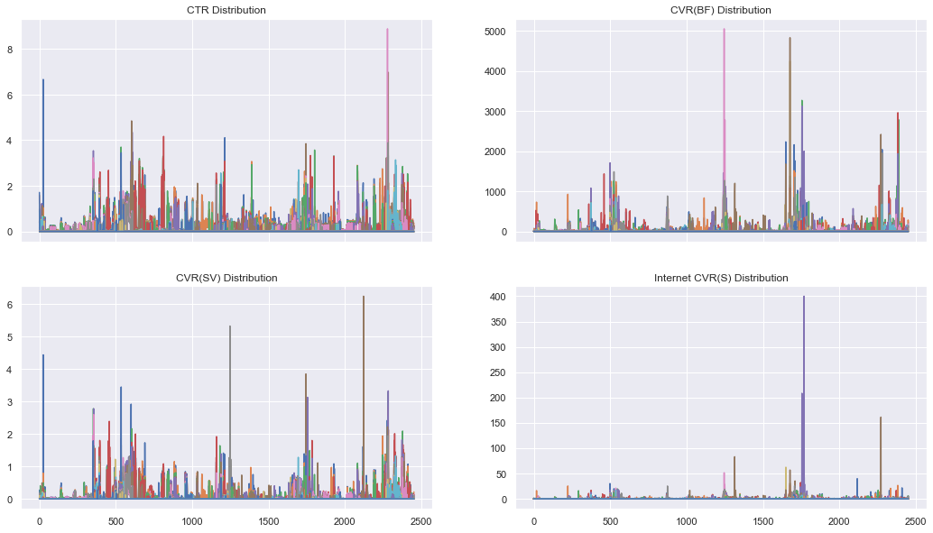

We can see that CVR(BF) and Internet_CVR(S) have a couple of large values. A reasonable cutoff point to eliminate the outliers seems to be 1,250 and 75 for CVR(BF) and Internet CVR(S), respectively.

In [ ]:

week_data[cvrbf_w]**.**describe()

Out[ ]:

|  | **CVR(BF)_W0** | **CVR(BF)_W1** | **CVR(BF)_W2** | **CVR(BF)_W3** | **CVR(BF)_W4** | **CVR(BF)_W5** | **CVR(BF)_W6** | **CVR(BF)_W7** | **CVR(BF)_W8** | **CVR(BF)_W9** | **CVR(BF)_W10** | **CVR(BF)_W11** | **CVR(BF)_W12** | **CVR(BF)_W13** | **CVR(BF)_W14** | **CVR(BF)_W15** | **CVR(BF)_W16** | **CVR(BF)_W17** | **CVR(BF)_W18** | **CVR(BF)_W19** | **CVR(BF)_W20** | **CVR(BF)_W21** | **CVR(BF)_W22** | **CVR(BF)_W23** | **CVR(BF)_W24** | **CVR(BF)_W25** | **CVR(BF)_W26** | **CVR(BF)_W27** | **CVR(BF)_W28** | **CVR(BF)_W29** | **CVR(BF)_W30** | **CVR(BF)_W31** | **CVR(BF)_W32** | **CVR(BF)_W33** | **CVR(BF)_W34** | **CVR(BF)_W35** | **CVR(BF)_W36** | **CVR(BF)_W37** | **CVR(BF)_W38** | **CVR(BF)_W39** | **CVR(BF)_W40** |
| --- | --- | --- | --- | --- | --- | --- | --- | --- | --- | --- | --- | --- | --- | --- | --- | --- | --- | --- | --- | --- | --- | --- | --- | --- | --- | --- | --- | --- | --- | --- | --- | --- | --- | --- | --- | --- | --- | --- | --- | --- | --- |
| **count** | 2452.000000 | 2452.000000 | 2452.000000 | 2452.000000 | 2452.000000 | 2452.000000 | 2452.000000 | 2452.000000 | 2452.000000 | 2452.000000 | 2452.000000 | 2452.000000 | 2452.000000 | 2452.000000 | 2452.000000 | 2452.000000 | 2452.000000 | 2452.000000 | 2452.000000 | 2452.000000 | 2452.000000 | 2452.000000 | 2452.000000 | 2452.000000 | 2452.000000 | 2452.000000 | 2452.000000 | 2452.000000 | 2452.000000 | 2452.000000 | 2452.000000 | 2452.000000 | 2452.000000 | 2452.000000 | 2452.000000 | 2452.000000 | 2452.000000 | 2452.000000 | 2452.000000 | 2452.000000 | 2452.000000 |
| **mean** | 43.154519 | 55.199148 | 51.520697 | 49.591338 | 42.393911 | 27.840469 | 24.846122 | 22.797292 | 15.987973 | 11.591754 | 10.340224 | 7.326175 | 6.843034 | 5.866256 | 5.722467 | 6.745836 | 3.651081 | 3.330636 | 3.133723 | 3.298691 | 2.383976 | 2.463242 | 2.478352 | 1.829127 | 1.538377 | 0.893560 | 0.794992 | 1.075208 | 0.550734 | 0.619772 | 0.596676 | 0.615310 | 0.569833 | 0.593075 | 0.574800 | 0.565942 | 0.580131 | 0.740257 | 0.517039 | 0.590653 | 0.190701 |
| **std** | 110.044847 | 103.795505 | 130.818271 | 133.429821 | 140.316149 | 96.747202 | 144.299556 | 103.777552 | 115.869319 | 54.809532 | 68.929092 | 54.139439 | 50.042656 | 49.749934 | 56.887465 | 108.265699 | 29.207256 | 23.154899 | 24.054969 | 26.087355 | 18.635247 | 19.769091 | 20.679083 | 14.878859 | 14.772969 | 10.509167 | 10.122153 | 14.670547 | 9.190841 | 10.107874 | 9.494659 | 9.910066 | 9.103357 | 9.495626 | 9.157465 | 8.816378 | 9.185812 | 12.539549 | 10.717221 | 16.364191 | 7.113078 |
| **min** | 0.000000 | 0.000000 | 0.000000 | 0.000000 | 0.000000 | 0.000000 | 0.000000 | 0.000000 | 0.000000 | 0.000000 | 0.000000 | 0.000000 | 0.000000 | 0.000000 | 0.000000 | 0.000000 | 0.000000 | 0.000000 | 0.000000 | 0.000000 | 0.000000 | 0.000000 | 0.000000 | 0.000000 | 0.000000 | 0.000000 | 0.000000 | 0.000000 | 0.000000 | 0.000000 | 0.000000 | 0.000000 | 0.000000 | 0.000000 | 0.000000 | 0.000000 | 0.000000 | 0.000000 | 0.000000 | 0.000000 | 0.000000 |
| **25%** | 4.220000 | 6.687500 | 2.405000 | 0.000000 | 0.000000 | 0.000000 | 0.000000 | 0.000000 | 0.000000 | 0.000000 | 0.000000 | 0.000000 | 0.000000 | 0.000000 | 0.000000 | 0.000000 | 0.000000 | 0.000000 | 0.000000 | 0.000000 | 0.000000 | 0.000000 | 0.000000 | 0.000000 | 0.000000 | 0.000000 | 0.000000 | 0.000000 | 0.000000 | 0.000000 | 0.000000 | 0.000000 | 0.000000 | 0.000000 | 0.000000 | 0.000000 | 0.000000 | 0.000000 | 0.000000 | 0.000000 | 0.000000 |
| **50%** | 13.840000 | 19.770000 | 16.030000 | 10.425000 | 3.125000 | 0.000000 | 0.000000 | 0.000000 | 0.000000 | 0.000000 | 0.000000 | 0.000000 | 0.000000 | 0.000000 | 0.000000 | 0.000000 | 0.000000 | 0.000000 | 0.000000 | 0.000000 | 0.000000 | 0.000000 | 0.000000 | 0.000000 | 0.000000 | 0.000000 | 0.000000 | 0.000000 | 0.000000 | 0.000000 | 0.000000 | 0.000000 | 0.000000 | 0.000000 | 0.000000 | 0.000000 | 0.000000 | 0.000000 | 0.000000 | 0.000000 | 0.000000 |
| **75%** | 40.927500 | 61.610000 | 53.527500 | 42.757500 | 29.177500 | 18.045000 | 11.752500 | 0.000000 | 0.000000 | 0.000000 | 0.000000 | 0.000000 | 0.000000 | 0.000000 | 0.000000 | 0.000000 | 0.000000 | 0.000000 | 0.000000 | 0.000000 | 0.000000 | 0.000000 | 0.000000 | 0.000000 | 0.000000 | 0.000000 | 0.000000 | 0.000000 | 0.000000 | 0.000000 | 0.000000 | 0.000000 | 0.000000 | 0.000000 | 0.000000 | 0.000000 | 0.000000 | 0.000000 | 0.000000 | 0.000000 | 0.000000 |
| **max** | 2159.830000 | 1514.230000 | 3267.970000 | 2960.530000 | 3125.000000 | 2419.350000 | 5051.550000 | 1951.220000 | 4245.280000 | 1229.090000 | 2233.680000 | 1239.710000 | 1256.340000 | 1090.600000 | 1707.480000 | 4829.550000 | 817.030000 | 647.750000 | 662.690000 | 842.860000 | 483.630000 | 507.940000 | 595.760000 | 263.240000 | 288.200000 | 249.800000 | 241.810000 | 381.370000 | 277.240000 | 287.440000 | 261.390000 | 248.850000 | 229.290000 | 258.640000 | 235.310000 | 214.710000 | 241.610000 | 318.440000 | 364.000000 | 715.460000 | 319.750000 |

The first couple of weeks, CVR(BF) reaches very large maximums and begins to decrease after week 15.

In [ ]:

*# Outliers*  
week_data[week_data['CVR(BF)_W15'] **>** 1000]

Out[ ]:

|  | **CTR_W0** | **CTR_W1** | **CTR_W2** | **CTR_W3** | **CTR_W4** | **CTR_W5** | **CTR_W6** | **CTR_W7** | **CTR_W8** | **CTR_W9** | **CTR_W10** | **CTR_W11** | **CTR_W12** | **CTR_W13** | **CTR_W14** | **CTR_W15** | **CTR_W16** | **CTR_W17** | **CTR_W18** | **CTR_W19** | **CTR_W20** | **CTR_W21** | **CTR_W22** | **CTR_W23** | **CTR_W24** | **CTR_W25** | **CTR_W26** | **CTR_W27** | **CTR_W28** | **CTR_W29** | **CTR_W30** | **CTR_W31** | **CTR_W32** | **CTR_W33** | **CTR_W34** | **CTR_W35** | **CTR_W36** | **CTR_W37** | **CTR_W38** | **CTR_W39** | **CTR_W40** | **CVR(BF)_W0** | **CVR(BF)_W1** | **CVR(BF)_W2** | **CVR(BF)_W3** | **CVR(BF)_W4** | **CVR(BF)_W5** | **CVR(BF)_W6** | **CVR(BF)_W7** | **CVR(BF)_W8** | **CVR(BF)_W9** | **CVR(BF)_W10** | **CVR(BF)_W11** | **CVR(BF)_W12** | **CVR(BF)_W13** | **CVR(BF)_W14** | **CVR(BF)_W15** | **CVR(BF)_W16** | **CVR(BF)_W17** | **CVR(BF)_W18** | **CVR(BF)_W19** | **CVR(BF)_W20** | **CVR(BF)_W21** | **CVR(BF)_W22** | **CVR(BF)_W23** | **CVR(BF)_W24** | **CVR(BF)_W25** | **CVR(BF)_W26** | **CVR(BF)_W27** | **CVR(BF)_W28** | **CVR(BF)_W29** | **CVR(BF)_W30** | **CVR(BF)_W31** | **CVR(BF)_W32** | **CVR(BF)_W33** | **CVR(BF)_W34** | **CVR(BF)_W35** | **CVR(BF)_W36** | **CVR(BF)_W37** | **CVR(BF)_W38** | **CVR(BF)_W39** | **CVR(BF)_W40** | **CVR(SV)_W0** | **CVR(SV)_W1** | **CVR(SV)_W2** | **CVR(SV)_W3** | **CVR(SV)_W4** | **CVR(SV)_W5** | **CVR(SV)_W6** | **CVR(SV)_W7** | **CVR(SV)_W8** | **CVR(SV)_W9** | **CVR(SV)_W10** | **CVR(SV)_W11** | **CVR(SV)_W12** | **CVR(SV)_W13** | **CVR(SV)_W14** | **CVR(SV)_W15** | **CVR(SV)_W16** | **CVR(SV)_W17** | **CVR(SV)_W18** | **CVR(SV)_W19** | **CVR(SV)_W20** | **CVR(SV)_W21** | **CVR(SV)_W22** | **CVR(SV)_W23** | **CVR(SV)_W24** | **CVR(SV)_W25** | **CVR(SV)_W26** | **CVR(SV)_W27** | **CVR(SV)_W28** | **CVR(SV)_W29** | **CVR(SV)_W30** | **CVR(SV)_W31** | **CVR(SV)_W32** | **CVR(SV)_W33** | **CVR(SV)_W34** | **CVR(SV)_W35** | **CVR(SV)_W36** | **CVR(SV)_W37** | **CVR(SV)_W38** | **CVR(SV)_W39** | **CVR(SV)_W40** | **Internet_CVR(S)_W0** | **Internet_CVR(S)_W1** | **Internet_CVR(S)_W2** | **Internet_CVR(S)_W3** | **Internet_CVR(S)_W4** | **Internet_CVR(S)_W5** | **Internet_CVR(S)_W6** | **Internet_CVR(S)_W7** | **Internet_CVR(S)_W8** | **Internet_CVR(S)_W9** | **Internet_CVR(S)_W10** | **Internet_CVR(S)_W11** | **Internet_CVR(S)_W12** | **Internet_CVR(S)_W13** | **Internet_CVR(S)_W14** | **Internet_CVR(S)_W15** | **Internet_CVR(S)_W16** | **Internet_CVR(S)_W17** | **Internet_CVR(S)_W18** | **Internet_CVR(S)_W19** | **Internet_CVR(S)_W20** | **Internet_CVR(S)_W21** | **Internet_CVR(S)_W22** | **Internet_CVR(S)_W23** | **Internet_CVR(S)_W24** | **Internet_CVR(S)_W25** | **Internet_CVR(S)_W26** | **Internet_CVR(S)_W27** | **Internet_CVR(S)_W28** | **Internet_CVR(S)_W29** | **Internet_CVR(S)_W30** | **Internet_CVR(S)_W31** | **Internet_CVR(S)_W32** | **Internet_CVR(S)_W33** | **Internet_CVR(S)_W34** | **Internet_CVR(S)_W35** | **Internet_CVR(S)_W36** | **Internet_CVR(S)_W37** | **Internet_CVR(S)_W38** | **Internet_CVR(S)_W39** | **Internet_CVR(S)_W40** | **Impressions_W0** | **Impressions_W1** | **Impressions_W2** | **Impressions_W3** | **Impressions_W4** | **Impressions_W5** | **Impressions_W6** | **Impressions_W7** | **Impressions_W8** | **Impressions_W9** | **Impressions_W10** | **Impressions_W11** | **Impressions_W12** | **Impressions_W13** | **Impressions_W14** | **Impressions_W15** | **Impressions_W16** | **Impressions_W17** | **Impressions_W18** | **Impressions_W19** | **Impressions_W20** | **Impressions_W21** | **Impressions_W22** | **Impressions_W23** | **Impressions_W24** | **Impressions_W25** | **Impressions_W26** | **Impressions_W27** | **Impressions_W28** | **Impressions_W29** | **Impressions_W30** | **Impressions_W31** | **Impressions_W32** | **Impressions_W33** | **Impressions_W34** | **Impressions_W35** | **Impressions_W36** | **Impressions_W37** | **Impressions_W38** | **Impressions_W39** | **Impressions_W40** | **Spend_W0** | **Spend_W1** | **Spend_W2** | **Spend_W3** | **Spend_W4** | **Spend_W5** | **Spend_W6** | **Spend_W7** | **Spend_W8** | **Spend_W9** | **Spend_W10** | **Spend_W11** | **Spend_W12** | **Spend_W13** | **Spend_W14** | **Spend_W15** | **Spend_W16** | **Spend_W17** | **Spend_W18** | **Spend_W19** | **Spend_W20** | **Spend_W21** | **Spend_W22** | **Spend_W23** | **Spend_W24** | **Spend_W25** | **Spend_W26** | **Spend_W27** | **Spend_W28** | **Spend_W29** | **Spend_W30** | **Spend_W31** | **Spend_W32** | **Spend_W33** | **Spend_W34** | **Spend_W35** | **Spend_W36** | **Spend_W37** | **Spend_W38** | **Spend_W39** | **Spend_W40** |
| --- | --- | --- | --- | --- | --- | --- | --- | --- | --- | --- | --- | --- | --- | --- | --- | --- | --- | --- | --- | --- | --- | --- | --- | --- | --- | --- | --- | --- | --- | --- | --- | --- | --- | --- | --- | --- | --- | --- | --- | --- | --- | --- | --- | --- | --- | --- | --- | --- | --- | --- | --- | --- | --- | --- | --- | --- | --- | --- | --- | --- | --- | --- | --- | --- | --- | --- | --- | --- | --- | --- | --- | --- | --- | --- | --- | --- | --- | --- | --- | --- | --- | --- | --- | --- | --- | --- | --- | --- | --- | --- | --- | --- | --- | --- | --- | --- | --- | --- | --- | --- | --- | --- | --- | --- | --- | --- | --- | --- | --- | --- | --- | --- | --- | --- | --- | --- | --- | --- | --- | --- | --- | --- | --- | --- | --- | --- | --- | --- | --- | --- | --- | --- | --- | --- | --- | --- | --- | --- | --- | --- | --- | --- | --- | --- | --- | --- | --- | --- | --- | --- | --- | --- | --- | --- | --- | --- | --- | --- | --- | --- | --- | --- | --- | --- | --- | --- | --- | --- | --- | --- | --- | --- | --- | --- | --- | --- | --- | --- | --- | --- | --- | --- | --- | --- | --- | --- | --- | --- | --- | --- | --- | --- | --- | --- | --- | --- | --- | --- | --- | --- | --- | --- | --- | --- | --- | --- | --- | --- | --- | --- | --- | --- | --- | --- | --- | --- | --- | --- | --- | --- | --- | --- | --- | --- | --- | --- | --- | --- | --- | --- | --- | --- | --- | --- | --- | --- | --- | --- | --- | --- | --- | --- | --- | --- | --- | --- |
| **7617** | 0.44 | 0.34 | 0.32 | 0.33 | 0.25 | 0.53 | 0.38 | 0.30 | 0.70 | 0.67 | 0.34 | 0.51 | 0.55 | 0.31 | 0.70 | 0.44 | 0.0 | 0.0 | 0.0 | 0.0 | 0.0 | 0.0 | 0.0 | 0.0 | 0.0 | 0.0 | 0.0 | 0.0 | 0.0 | 0.0 | 0.0 | 0.0 | 0.0 | 0.0 | 0.0 | 0.0 | 0.0 | 0.0 | 0.0 | 0.0 | 0.0 | 286.36 | 301.12 | 301.63 | 313.32 | 334.81 | 144.03 | 188.62 | 431.47 | 1860.27 | 505.05 | 2233.68 | 126.74 | 237.15 | 998.75 | 1084.88 | 1679.93 | 0.0 | 0.0 | 0.0 | 0.0 | 0.0 | 0.0 | 0.0 | 0.0 | 0.0 | 0.0 | 0.0 | 0.0 | 0.0 | 0.0 | 0.0 | 0.0 | 0.0 | 0.0 | 0.0 | 0.0 | 0.0 | 0.0 | 0.0 | 0.0 | 0.0 | 0.22 | 0.15 | 0.14 | 0.11 | 0.06 | 0.10 | 0.11 | 0.15 | 0.45 | 0.34 | 0.17 | 0.38 | 0.40 | 0.25 | 0.51 | 0.18 | 0.0 | 0.0 | 0.0 | 0.0 | 0.0 | 0.0 | 0.0 | 0.0 | 0.0 | 0.0 | 0.0 | 0.0 | 0.0 | 0.0 | 0.0 | 0.0 | 0.0 | 0.0 | 0.0 | 0.0 | 0.0 | 0.0 | 0.0 | 0.0 | 0.0 | 0.0 | 4.10 | 2.57 | 5.59 | 5.20 | 2.52 | 2.92 | 7.61 | 33.07 | 0.0 | 0.0 | 0.0 | 0.0 | 12.48 | 12.76 | 17.68 | 0.0 | 0.0 | 0.0 | 0.0 | 0.0 | 0.0 | 0.0 | 0.0 | 0.0 | 0.0 | 0.0 | 0.0 | 0.0 | 0.0 | 0.0 | 0.0 | 0.0 | 0.0 | 0.0 | 0.0 | 0.0 | 0.0 | 0.0 | 0.0 | 0.0 | 13270.0 | 78041.0 | 77910.0 | 82343.0 | 88408.0 | 71512.0 | 68391.0 | 63041.0 | 2419.0 | 594.0 | 582.0 | 789.0 | 1265.0 | 1602.0 | 1567.0 | 1131.0 | 0.0 | 0.0 | 0.0 | 0.0 | 0.0 | 0.0 | 0.0 | 0.0 | 0.0 | 0.0 | 0.0 | 0.0 | 0.0 | 0.0 | 0.0 | 0.0 | 0.0 | 0.0 | 0.0 | 0.0 | 0.0 | 0.0 | 0.0 | 0.0 | 0.0 | 257.0 | 1858.0 | 1928.0 | 1969.0 | 1978.0 | 1843.0 | 1665.0 | 1499.0 | 81.0 | 18.0 | 23.0 | 25.0 | 42.0 | 53.0 | 68.0 | 47.0 | 0.0 | 0.0 | 0.0 | 0.0 | 0.0 | 0.0 | 0.0 | 0.0 | 0.0 | 0.0 | 0.0 | 0.0 | 0.0 | 0.0 | 0.0 | 0.0 | 0.0 | 0.0 | 0.0 | 0.0 | 0.0 | 0.0 | 0.0 | 0.0 | 0.0 |
| **7645** | 0.11 | 0.32 | 0.31 | 0.38 | 0.26 | 0.81 | 0.39 | 0.35 | 1.42 | 0.08 | 0.24 | 0.33 | 0.45 | 0.84 | 0.82 | 0.28 | 0.0 | 0.0 | 0.0 | 0.0 | 0.0 | 0.0 | 0.0 | 0.0 | 0.0 | 0.0 | 0.0 | 0.0 | 0.0 | 0.0 | 0.0 | 0.0 | 0.0 | 0.0 | 0.0 | 0.0 | 0.0 | 0.0 | 0.0 | 0.0 | 0.0 | 224.22 | 249.71 | 162.73 | 0.00 | 1164.98 | 240.73 | 631.94 | 1384.26 | 4245.28 | 165.56 | 122.25 | 467.29 | 227.27 | 1090.60 | 273.97 | 4829.55 | 0.0 | 0.0 | 0.0 | 0.0 | 0.0 | 0.0 | 0.0 | 0.0 | 0.0 | 0.0 | 0.0 | 0.0 | 0.0 | 0.0 | 0.0 | 0.0 | 0.0 | 0.0 | 0.0 | 0.0 | 0.0 | 0.0 | 0.0 | 0.0 | 0.0 | 0.11 | 0.15 | 0.14 | 0.21 | 0.08 | 0.21 | 0.16 | 0.22 | 0.63 | 0.08 | 0.00 | 0.27 | 0.08 | 0.59 | 0.55 | 0.28 | 0.0 | 0.0 | 0.0 | 0.0 | 0.0 | 0.0 | 0.0 | 0.0 | 0.0 | 0.0 | 0.0 | 0.0 | 0.0 | 0.0 | 0.0 | 0.0 | 0.0 | 0.0 | 0.0 | 0.0 | 0.0 | 0.0 | 0.0 | 0.0 | 0.0 | 0.0 | 9.99 | 0.00 | 0.00 | 30.06 | 19.82 | 8.54 | 13.34 | 31.45 | 0.0 | 0.0 | 26.7 | 0.0 | 16.78 | 0.00 | 56.82 | 0.0 | 0.0 | 0.0 | 0.0 | 0.0 | 0.0 | 0.0 | 0.0 | 0.0 | 0.0 | 0.0 | 0.0 | 0.0 | 0.0 | 0.0 | 0.0 | 0.0 | 0.0 | 0.0 | 0.0 | 0.0 | 0.0 | 0.0 | 0.0 | 0.0 | 892.0 | 6007.0 | 4916.0 | 2395.0 | 2661.0 | 7062.0 | 11710.0 | 5996.0 | 636.0 | 1208.0 | 818.0 | 1498.0 | 1320.0 | 1192.0 | 730.0 | 352.0 | 0.0 | 0.0 | 0.0 | 0.0 | 0.0 | 0.0 | 0.0 | 0.0 | 0.0 | 0.0 | 0.0 | 0.0 | 0.0 | 0.0 | 0.0 | 0.0 | 0.0 | 0.0 | 0.0 | 0.0 | 0.0 | 0.0 | 0.0 | 0.0 | 0.0 | 18.0 | 161.0 | 138.0 | 69.0 | 97.0 | 247.0 | 366.0 | 184.0 | 27.0 | 36.0 | 30.0 | 49.0 | 44.0 | 43.0 | 31.0 | 15.0 | 0.0 | 0.0 | 0.0 | 0.0 | 0.0 | 0.0 | 0.0 | 0.0 | 0.0 | 0.0 | 0.0 | 0.0 | 0.0 | 0.0 | 0.0 | 0.0 | 0.0 | 0.0 | 0.0 | 0.0 | 0.0 | 0.0 | 0.0 | 0.0 | 0.0 |

In [ ]:

*# Non-outliers*  
week_data[week_data['CVR(BF)_W15'] **<** 1000]**.**head()

Out[ ]:

|  | **CTR_W0** | **CTR_W1** | **CTR_W2** | **CTR_W3** | **CTR_W4** | **CTR_W5** | **CTR_W6** | **CTR_W7** | **CTR_W8** | **CTR_W9** | **CTR_W10** | **CTR_W11** | **CTR_W12** | **CTR_W13** | **CTR_W14** | **CTR_W15** | **CTR_W16** | **CTR_W17** | **CTR_W18** | **CTR_W19** | **CTR_W20** | **CTR_W21** | **CTR_W22** | **CTR_W23** | **CTR_W24** | **CTR_W25** | **CTR_W26** | **CTR_W27** | **CTR_W28** | **CTR_W29** | **CTR_W30** | **CTR_W31** | **CTR_W32** | **CTR_W33** | **CTR_W34** | **CTR_W35** | **CTR_W36** | **CTR_W37** | **CTR_W38** | **CTR_W39** | **CTR_W40** | **CVR(BF)_W0** | **CVR(BF)_W1** | **CVR(BF)_W2** | **CVR(BF)_W3** | **CVR(BF)_W4** | **CVR(BF)_W5** | **CVR(BF)_W6** | **CVR(BF)_W7** | **CVR(BF)_W8** | **CVR(BF)_W9** | **CVR(BF)_W10** | **CVR(BF)_W11** | **CVR(BF)_W12** | **CVR(BF)_W13** | **CVR(BF)_W14** | **CVR(BF)_W15** | **CVR(BF)_W16** | **CVR(BF)_W17** | **CVR(BF)_W18** | **CVR(BF)_W19** | **CVR(BF)_W20** | **CVR(BF)_W21** | **CVR(BF)_W22** | **CVR(BF)_W23** | **CVR(BF)_W24** | **CVR(BF)_W25** | **CVR(BF)_W26** | **CVR(BF)_W27** | **CVR(BF)_W28** | **CVR(BF)_W29** | **CVR(BF)_W30** | **CVR(BF)_W31** | **CVR(BF)_W32** | **CVR(BF)_W33** | **CVR(BF)_W34** | **CVR(BF)_W35** | **CVR(BF)_W36** | **CVR(BF)_W37** | **CVR(BF)_W38** | **CVR(BF)_W39** | **CVR(BF)_W40** | **CVR(SV)_W0** | **CVR(SV)_W1** | **CVR(SV)_W2** | **CVR(SV)_W3** | **CVR(SV)_W4** | **CVR(SV)_W5** | **CVR(SV)_W6** | **CVR(SV)_W7** | **CVR(SV)_W8** | **CVR(SV)_W9** | **CVR(SV)_W10** | **CVR(SV)_W11** | **CVR(SV)_W12** | **CVR(SV)_W13** | **CVR(SV)_W14** | **CVR(SV)_W15** | **CVR(SV)_W16** | **CVR(SV)_W17** | **CVR(SV)_W18** | **CVR(SV)_W19** | **CVR(SV)_W20** | **CVR(SV)_W21** | **CVR(SV)_W22** | **CVR(SV)_W23** | **CVR(SV)_W24** | **CVR(SV)_W25** | **CVR(SV)_W26** | **CVR(SV)_W27** | **CVR(SV)_W28** | **CVR(SV)_W29** | **CVR(SV)_W30** | **CVR(SV)_W31** | **CVR(SV)_W32** | **CVR(SV)_W33** | **CVR(SV)_W34** | **CVR(SV)_W35** | **CVR(SV)_W36** | **CVR(SV)_W37** | **CVR(SV)_W38** | **CVR(SV)_W39** | **CVR(SV)_W40** | **Internet_CVR(S)_W0** | **Internet_CVR(S)_W1** | **Internet_CVR(S)_W2** | **Internet_CVR(S)_W3** | **Internet_CVR(S)_W4** | **Internet_CVR(S)_W5** | **Internet_CVR(S)_W6** | **Internet_CVR(S)_W7** | **Internet_CVR(S)_W8** | **Internet_CVR(S)_W9** | **Internet_CVR(S)_W10** | **Internet_CVR(S)_W11** | **Internet_CVR(S)_W12** | **Internet_CVR(S)_W13** | **Internet_CVR(S)_W14** | **Internet_CVR(S)_W15** | **Internet_CVR(S)_W16** | **Internet_CVR(S)_W17** | **Internet_CVR(S)_W18** | **Internet_CVR(S)_W19** | **Internet_CVR(S)_W20** | **Internet_CVR(S)_W21** | **Internet_CVR(S)_W22** | **Internet_CVR(S)_W23** | **Internet_CVR(S)_W24** | **Internet_CVR(S)_W25** | **Internet_CVR(S)_W26** | **Internet_CVR(S)_W27** | **Internet_CVR(S)_W28** | **Internet_CVR(S)_W29** | **Internet_CVR(S)_W30** | **Internet_CVR(S)_W31** | **Internet_CVR(S)_W32** | **Internet_CVR(S)_W33** | **Internet_CVR(S)_W34** | **Internet_CVR(S)_W35** | **Internet_CVR(S)_W36** | **Internet_CVR(S)_W37** | **Internet_CVR(S)_W38** | **Internet_CVR(S)_W39** | **Internet_CVR(S)_W40** | **Impressions_W0** | **Impressions_W1** | **Impressions_W2** | **Impressions_W3** | **Impressions_W4** | **Impressions_W5** | **Impressions_W6** | **Impressions_W7** | **Impressions_W8** | **Impressions_W9** | **Impressions_W10** | **Impressions_W11** | **Impressions_W12** | **Impressions_W13** | **Impressions_W14** | **Impressions_W15** | **Impressions_W16** | **Impressions_W17** | **Impressions_W18** | **Impressions_W19** | **Impressions_W20** | **Impressions_W21** | **Impressions_W22** | **Impressions_W23** | **Impressions_W24** | **Impressions_W25** | **Impressions_W26** | **Impressions_W27** | **Impressions_W28** | **Impressions_W29** | **Impressions_W30** | **Impressions_W31** | **Impressions_W32** | **Impressions_W33** | **Impressions_W34** | **Impressions_W35** | **Impressions_W36** | **Impressions_W37** | **Impressions_W38** | **Impressions_W39** | **Impressions_W40** | **Spend_W0** | **Spend_W1** | **Spend_W2** | **Spend_W3** | **Spend_W4** | **Spend_W5** | **Spend_W6** | **Spend_W7** | **Spend_W8** | **Spend_W9** | **Spend_W10** | **Spend_W11** | **Spend_W12** | **Spend_W13** | **Spend_W14** | **Spend_W15** | **Spend_W16** | **Spend_W17** | **Spend_W18** | **Spend_W19** | **Spend_W20** | **Spend_W21** | **Spend_W22** | **Spend_W23** | **Spend_W24** | **Spend_W25** | **Spend_W26** | **Spend_W27** | **Spend_W28** | **Spend_W29** | **Spend_W30** | **Spend_W31** | **Spend_W32** | **Spend_W33** | **Spend_W34** | **Spend_W35** | **Spend_W36** | **Spend_W37** | **Spend_W38** | **Spend_W39** | **Spend_W40** |
| --- | --- | --- | --- | --- | --- | --- | --- | --- | --- | --- | --- | --- | --- | --- | --- | --- | --- | --- | --- | --- | --- | --- | --- | --- | --- | --- | --- | --- | --- | --- | --- | --- | --- | --- | --- | --- | --- | --- | --- | --- | --- | --- | --- | --- | --- | --- | --- | --- | --- | --- | --- | --- | --- | --- | --- | --- | --- | --- | --- | --- | --- | --- | --- | --- | --- | --- | --- | --- | --- | --- | --- | --- | --- | --- | --- | --- | --- | --- | --- | --- | --- | --- | --- | --- | --- | --- | --- | --- | --- | --- | --- | --- | --- | --- | --- | --- | --- | --- | --- | --- | --- | --- | --- | --- | --- | --- | --- | --- | --- | --- | --- | --- | --- | --- | --- | --- | --- | --- | --- | --- | --- | --- | --- | --- | --- | --- | --- | --- | --- | --- | --- | --- | --- | --- | --- | --- | --- | --- | --- | --- | --- | --- | --- | --- | --- | --- | --- | --- | --- | --- | --- | --- | --- | --- | --- | --- | --- | --- | --- | --- | --- | --- | --- | --- | --- | --- | --- | --- | --- | --- | --- | --- | --- | --- | --- | --- | --- | --- | --- | --- | --- | --- | --- | --- | --- | --- | --- | --- | --- | --- | --- | --- | --- | --- | --- | --- | --- | --- | --- | --- | --- | --- | --- | --- | --- | --- | --- | --- | --- | --- | --- | --- | --- | --- | --- | --- | --- | --- | --- | --- | --- | --- | --- | --- | --- | --- | --- | --- | --- | --- | --- | --- | --- | --- | --- | --- | --- | --- | --- | --- | --- | --- | --- | --- | --- | --- |
| **0** | 0.98 | 1.58 | 0.00 | 0.00 | 0.13 | 0.43 | 0.48 | 0.43 | 0.41 | 0.9 | 1.71 | 0.0 | 0.0 | 0.0 | 0.0 | 0.0 | 0.0 | 0.0 | 0.0 | 0.0 | 0.0 | 0.0 | 0.0 | 0.0 | 0.0 | 0.0 | 0.0 | 0.0 | 0.0 | 0.0 | 0.0 | 0.0 | 0.0 | 0.0 | 0.0 | 0.0 | 0.0 | 0.0 | 0.0 | 0.0 | 0.0 | 0.00 | 0.00 | 0.00 | 0.00 | 0.00 | 0.00 | 0.00 | 0.00 | 0.00 | 0.0 | 0.0 | 0.0 | 0.0 | 0.0 | 0.0 | 0.0 | 0.0 | 0.0 | 0.0 | 0.0 | 0.0 | 0.0 | 0.0 | 0.0 | 0.0 | 0.0 | 0.0 | 0.0 | 0.0 | 0.0 | 0.0 | 0.0 | 0.0 | 0.0 | 0.0 | 0.0 | 0.0 | 0.0 | 0.0 | 0.0 | 0.0 | 0.00 | 0.00 | 0.00 | 0.00 | 0.00 | 0.00 | 0.00 | 0.00 | 0.00 | 0.0 | 0.0 | 0.0 | 0.0 | 0.0 | 0.0 | 0.0 | 0.0 | 0.0 | 0.0 | 0.0 | 0.0 | 0.0 | 0.0 | 0.0 | 0.0 | 0.0 | 0.0 | 0.0 | 0.0 | 0.0 | 0.0 | 0.0 | 0.0 | 0.0 | 0.0 | 0.0 | 0.0 | 0.0 | 0.0 | 0.0 | 0.0 | 0.0 | 0.0 | 0.00 | 0.00 | 0.00 | 0.00 | 0.00 | 0.00 | 0.0 | 0.0 | 0.0 | 0.0 | 0.0 | 0.0 | 0.0 | 0.0 | 0.0 | 0.0 | 0.0 | 0.0 | 0.0 | 0.0 | 0.0 | 0.0 | 0.0 | 0.0 | 0.0 | 0.0 | 0.0 | 0.0 | 0.0 | 0.0 | 0.0 | 0.0 | 0.0 | 0.0 | 0.0 | 0.0 | 0.0 | 0.0 | 0.0 | 205.0 | 317.0 | 417.0 | 403.0 | 797.0 | 41890.0 | 83865.0 | 68932.0 | 7236.0 | 111.0 | 117.0 | 229.0 | 210.0 | 0.0 | 0.0 | 0.0 | 0.0 | 0.0 | 0.0 | 0.0 | 0.0 | 0.0 | 0.0 | 0.0 | 0.0 | 0.0 | 0.0 | 0.0 | 0.0 | 0.0 | 0.0 | 0.0 | 0.0 | 0.0 | 0.0 | 0.0 | 0.0 | 0.0 | 0.0 | 0.0 | 0.0 | 2.0 | 3.0 | 4.0 | 4.0 | 22.0 | 853.0 | 1692.0 | 1394.0 | 150.0 | 3.0 | 4.0 | 7.0 | 6.0 | 0.0 | 0.0 | 0.0 | 0.0 | 0.0 | 0.0 | 0.0 | 0.0 | 0.0 | 0.0 | 0.0 | 0.0 | 0.0 | 0.0 | 0.0 | 0.0 | 0.0 | 0.0 | 0.0 | 0.0 | 0.0 | 0.0 | 0.0 | 0.0 | 0.0 | 0.0 | 0.0 | 0.0 |
| **8** | 0.49 | 0.35 | 0.26 | 0.27 | 0.27 | 0.26 | 0.23 | 0.24 | 0.23 | 0.0 | 0.00 | 0.0 | 0.0 | 0.0 | 0.0 | 0.0 | 0.0 | 0.0 | 0.0 | 0.0 | 0.0 | 0.0 | 0.0 | 0.0 | 0.0 | 0.0 | 0.0 | 0.0 | 0.0 | 0.0 | 0.0 | 0.0 | 0.0 | 0.0 | 0.0 | 0.0 | 0.0 | 0.0 | 0.0 | 0.0 | 0.0 | 37.77 | 35.93 | 34.39 | 17.91 | 25.14 | 21.20 | 16.44 | 25.02 | 11.82 | 0.0 | 0.0 | 0.0 | 0.0 | 0.0 | 0.0 | 0.0 | 0.0 | 0.0 | 0.0 | 0.0 | 0.0 | 0.0 | 0.0 | 0.0 | 0.0 | 0.0 | 0.0 | 0.0 | 0.0 | 0.0 | 0.0 | 0.0 | 0.0 | 0.0 | 0.0 | 0.0 | 0.0 | 0.0 | 0.0 | 0.0 | 0.0 | 0.27 | 0.15 | 0.11 | 0.12 | 0.11 | 0.09 | 0.08 | 0.10 | 0.09 | 0.0 | 0.0 | 0.0 | 0.0 | 0.0 | 0.0 | 0.0 | 0.0 | 0.0 | 0.0 | 0.0 | 0.0 | 0.0 | 0.0 | 0.0 | 0.0 | 0.0 | 0.0 | 0.0 | 0.0 | 0.0 | 0.0 | 0.0 | 0.0 | 0.0 | 0.0 | 0.0 | 0.0 | 0.0 | 0.0 | 0.0 | 0.0 | 0.0 | 0.0 | 1.49 | 0.17 | 0.17 | 0.16 | 0.15 | 0.15 | 0.0 | 0.0 | 0.0 | 0.0 | 0.0 | 0.0 | 0.0 | 0.0 | 0.0 | 0.0 | 0.0 | 0.0 | 0.0 | 0.0 | 0.0 | 0.0 | 0.0 | 0.0 | 0.0 | 0.0 | 0.0 | 0.0 | 0.0 | 0.0 | 0.0 | 0.0 | 0.0 | 0.0 | 0.0 | 0.0 | 0.0 | 0.0 | 0.0 | 63550.0 | 125249.0 | 107590.0 | 117234.0 | 119314.0 | 127372.0 | 133784.0 | 131902.0 | 33827.0 | 0.0 | 0.0 | 0.0 | 0.0 | 0.0 | 0.0 | 0.0 | 0.0 | 0.0 | 0.0 | 0.0 | 0.0 | 0.0 | 0.0 | 0.0 | 0.0 | 0.0 | 0.0 | 0.0 | 0.0 | 0.0 | 0.0 | 0.0 | 0.0 | 0.0 | 0.0 | 0.0 | 0.0 | 0.0 | 0.0 | 0.0 | 0.0 | 1724.0 | 3344.0 | 3110.0 | 3327.0 | 3340.0 | 3529.0 | 3526.0 | 3518.0 | 1162.0 | 0.0 | 0.0 | 0.0 | 0.0 | 0.0 | 0.0 | 0.0 | 0.0 | 0.0 | 0.0 | 0.0 | 0.0 | 0.0 | 0.0 | 0.0 | 0.0 | 0.0 | 0.0 | 0.0 | 0.0 | 0.0 | 0.0 | 0.0 | 0.0 | 0.0 | 0.0 | 0.0 | 0.0 | 0.0 | 0.0 | 0.0 | 0.0 |
| **9** | 0.66 | 0.57 | 0.61 | 0.58 | 0.51 | 0.58 | 0.53 | 0.54 | 0.49 | 0.0 | 0.00 | 0.0 | 0.0 | 0.0 | 0.0 | 0.0 | 0.0 | 0.0 | 0.0 | 0.0 | 0.0 | 0.0 | 0.0 | 0.0 | 0.0 | 0.0 | 0.0 | 0.0 | 0.0 | 0.0 | 0.0 | 0.0 | 0.0 | 0.0 | 0.0 | 0.0 | 0.0 | 0.0 | 0.0 | 0.0 | 0.0 | 73.04 | 68.23 | 11.60 | 12.68 | 4.76 | 4.06 | 15.88 | 27.41 | 26.50 | 0.0 | 0.0 | 0.0 | 0.0 | 0.0 | 0.0 | 0.0 | 0.0 | 0.0 | 0.0 | 0.0 | 0.0 | 0.0 | 0.0 | 0.0 | 0.0 | 0.0 | 0.0 | 0.0 | 0.0 | 0.0 | 0.0 | 0.0 | 0.0 | 0.0 | 0.0 | 0.0 | 0.0 | 0.0 | 0.0 | 0.0 | 0.0 | 0.07 | 0.10 | 0.08 | 0.09 | 0.07 | 0.04 | 0.05 | 0.04 | 0.09 | 0.0 | 0.0 | 0.0 | 0.0 | 0.0 | 0.0 | 0.0 | 0.0 | 0.0 | 0.0 | 0.0 | 0.0 | 0.0 | 0.0 | 0.0 | 0.0 | 0.0 | 0.0 | 0.0 | 0.0 | 0.0 | 0.0 | 0.0 | 0.0 | 0.0 | 0.0 | 0.0 | 0.0 | 0.0 | 0.0 | 0.0 | 0.0 | 0.0 | 0.0 | 0.93 | 1.01 | 0.00 | 0.00 | 0.00 | 0.00 | 0.0 | 0.0 | 0.0 | 0.0 | 0.0 | 0.0 | 0.0 | 0.0 | 0.0 | 0.0 | 0.0 | 0.0 | 0.0 | 0.0 | 0.0 | 0.0 | 0.0 | 0.0 | 0.0 | 0.0 | 0.0 | 0.0 | 0.0 | 0.0 | 0.0 | 0.0 | 0.0 | 0.0 | 0.0 | 0.0 | 0.0 | 0.0 | 0.0 | 27381.0 | 46901.0 | 43107.0 | 39422.0 | 41999.0 | 49238.0 | 44079.0 | 47429.0 | 7547.0 | 0.0 | 0.0 | 0.0 | 0.0 | 0.0 | 0.0 | 0.0 | 0.0 | 0.0 | 0.0 | 0.0 | 0.0 | 0.0 | 0.0 | 0.0 | 0.0 | 0.0 | 0.0 | 0.0 | 0.0 | 0.0 | 0.0 | 0.0 | 0.0 | 0.0 | 0.0 | 0.0 | 0.0 | 0.0 | 0.0 | 0.0 | 0.0 | 282.0 | 529.0 | 479.0 | 458.0 | 442.0 | 632.0 | 542.0 | 574.0 | 87.0 | 0.0 | 0.0 | 0.0 | 0.0 | 0.0 | 0.0 | 0.0 | 0.0 | 0.0 | 0.0 | 0.0 | 0.0 | 0.0 | 0.0 | 0.0 | 0.0 | 0.0 | 0.0 | 0.0 | 0.0 | 0.0 | 0.0 | 0.0 | 0.0 | 0.0 | 0.0 | 0.0 | 0.0 | 0.0 | 0.0 | 0.0 | 0.0 |
| **10** | 0.37 | 0.36 | 0.37 | 0.22 | 0.24 | 0.23 | 0.19 | 0.20 | 0.16 | 0.0 | 0.00 | 0.0 | 0.0 | 0.0 | 0.0 | 0.0 | 0.0 | 0.0 | 0.0 | 0.0 | 0.0 | 0.0 | 0.0 | 0.0 | 0.0 | 0.0 | 0.0 | 0.0 | 0.0 | 0.0 | 0.0 | 0.0 | 0.0 | 0.0 | 0.0 | 0.0 | 0.0 | 0.0 | 0.0 | 0.0 | 0.0 | 37.37 | 0.00 | 0.00 | 0.00 | 0.00 | 12.11 | 37.05 | 24.60 | 0.00 | 0.0 | 0.0 | 0.0 | 0.0 | 0.0 | 0.0 | 0.0 | 0.0 | 0.0 | 0.0 | 0.0 | 0.0 | 0.0 | 0.0 | 0.0 | 0.0 | 0.0 | 0.0 | 0.0 | 0.0 | 0.0 | 0.0 | 0.0 | 0.0 | 0.0 | 0.0 | 0.0 | 0.0 | 0.0 | 0.0 | 0.0 | 0.0 | 0.22 | 0.09 | 0.15 | 0.06 | 0.04 | 0.02 | 0.05 | 0.18 | 0.10 | 0.0 | 0.0 | 0.0 | 0.0 | 0.0 | 0.0 | 0.0 | 0.0 | 0.0 | 0.0 | 0.0 | 0.0 | 0.0 | 0.0 | 0.0 | 0.0 | 0.0 | 0.0 | 0.0 | 0.0 | 0.0 | 0.0 | 0.0 | 0.0 | 0.0 | 0.0 | 0.0 | 0.0 | 0.0 | 0.0 | 0.0 | 0.0 | 0.0 | 0.0 | 0.00 | 0.00 | 0.00 | 0.00 | 0.00 | 0.00 | 0.0 | 0.0 | 0.0 | 0.0 | 0.0 | 0.0 | 0.0 | 0.0 | 0.0 | 0.0 | 0.0 | 0.0 | 0.0 | 0.0 | 0.0 | 0.0 | 0.0 | 0.0 | 0.0 | 0.0 | 0.0 | 0.0 | 0.0 | 0.0 | 0.0 | 0.0 | 0.0 | 0.0 | 0.0 | 0.0 | 0.0 | 0.0 | 0.0 | 2676.0 | 5540.0 | 5971.0 | 6365.0 | 7127.0 | 8255.0 | 8097.0 | 8131.0 | 1928.0 | 0.0 | 0.0 | 0.0 | 0.0 | 0.0 | 0.0 | 0.0 | 0.0 | 0.0 | 0.0 | 0.0 | 0.0 | 0.0 | 0.0 | 0.0 | 0.0 | 0.0 | 0.0 | 0.0 | 0.0 | 0.0 | 0.0 | 0.0 | 0.0 | 0.0 | 0.0 | 0.0 | 0.0 | 0.0 | 0.0 | 0.0 | 0.0 | 50.0 | 88.0 | 102.0 | 110.0 | 124.0 | 131.0 | 114.0 | 106.0 | 25.0 | 0.0 | 0.0 | 0.0 | 0.0 | 0.0 | 0.0 | 0.0 | 0.0 | 0.0 | 0.0 | 0.0 | 0.0 | 0.0 | 0.0 | 0.0 | 0.0 | 0.0 | 0.0 | 0.0 | 0.0 | 0.0 | 0.0 | 0.0 | 0.0 | 0.0 | 0.0 | 0.0 | 0.0 | 0.0 | 0.0 | 0.0 | 0.0 |
| **11** | 0.00 | 0.00 | 0.00 | 0.00 | 0.00 | 0.00 | 0.00 | 0.00 | 0.00 | 0.0 | 0.00 | 0.0 | 0.0 | 0.0 | 0.0 | 0.0 | 0.0 | 0.0 | 0.0 | 0.0 | 0.0 | 0.0 | 0.0 | 0.0 | 0.0 | 0.0 | 0.0 | 0.0 | 0.0 | 0.0 | 0.0 | 0.0 | 0.0 | 0.0 | 0.0 | 0.0 | 0.0 | 0.0 | 0.0 | 0.0 | 0.0 | 0.00 | 0.00 | 0.00 | 0.00 | 0.00 | 0.00 | 0.00 | 0.00 | 0.00 | 0.0 | 0.0 | 0.0 | 0.0 | 0.0 | 0.0 | 0.0 | 0.0 | 0.0 | 0.0 | 0.0 | 0.0 | 0.0 | 0.0 | 0.0 | 0.0 | 0.0 | 0.0 | 0.0 | 0.0 | 0.0 | 0.0 | 0.0 | 0.0 | 0.0 | 0.0 | 0.0 | 0.0 | 0.0 | 0.0 | 0.0 | 0.0 | 0.00 | 0.00 | 0.00 | 0.00 | 0.00 | 0.00 | 0.00 | 0.00 | 0.00 | 0.0 | 0.0 | 0.0 | 0.0 | 0.0 | 0.0 | 0.0 | 0.0 | 0.0 | 0.0 | 0.0 | 0.0 | 0.0 | 0.0 | 0.0 | 0.0 | 0.0 | 0.0 | 0.0 | 0.0 | 0.0 | 0.0 | 0.0 | 0.0 | 0.0 | 0.0 | 0.0 | 0.0 | 0.0 | 0.0 | 0.0 | 0.0 | 0.0 | 0.0 | 0.00 | 0.00 | 0.00 | 0.00 | 0.00 | 0.00 | 0.0 | 0.0 | 0.0 | 0.0 | 0.0 | 0.0 | 0.0 | 0.0 | 0.0 | 0.0 | 0.0 | 0.0 | 0.0 | 0.0 | 0.0 | 0.0 | 0.0 | 0.0 | 0.0 | 0.0 | 0.0 | 0.0 | 0.0 | 0.0 | 0.0 | 0.0 | 0.0 | 0.0 | 0.0 | 0.0 | 0.0 | 0.0 | 0.0 | 119.0 | 0.0 | 0.0 | 0.0 | 0.0 | 0.0 | 0.0 | 0.0 | 0.0 | 0.0 | 0.0 | 0.0 | 0.0 | 0.0 | 0.0 | 0.0 | 0.0 | 0.0 | 0.0 | 0.0 | 0.0 | 0.0 | 0.0 | 0.0 | 0.0 | 0.0 | 0.0 | 0.0 | 0.0 | 0.0 | 0.0 | 0.0 | 0.0 | 0.0 | 0.0 | 0.0 | 0.0 | 0.0 | 0.0 | 0.0 | 0.0 | 1.0 | 0.0 | 0.0 | 0.0 | 0.0 | 0.0 | 0.0 | 0.0 | 0.0 | 0.0 | 0.0 | 0.0 | 0.0 | 0.0 | 0.0 | 0.0 | 0.0 | 0.0 | 0.0 | 0.0 | 0.0 | 0.0 | 0.0 | 0.0 | 0.0 | 0.0 | 0.0 | 0.0 | 0.0 | 0.0 | 0.0 | 0.0 | 0.0 | 0.0 | 0.0 | 0.0 | 0.0 | 0.0 | 0.0 | 0.0 | 0.0 |

Comparing kpi trends for outlier creatives and non-outlier creatives, we can see that the non-outliers have dramatically less variance and follow a more consistent path relative to the outlier creatives. For this reason, outliers will be dropped in accordance with the threshold stated earlier.

In [ ]:

print(week_data**.**shape)  
*# Drop data points greater than the thresholds*  
**for** col **in** cvrbf_w:  
 week_data **=** week_data[week_data[col] **<** 1250]  
  
**for** col **in** cvrint_w:  
 week_data **=** week_data[week_data[col] **<** 75]  
  
print(week_data**.**shape)

(2452, 246)  
(2425, 246)

A total of 27 creatives were removed because of outlier characteristics. Plotting the same graph below once more shows us no more evidence of outliers.

In [ ]:

*# Quick look at distributions*  
*#week_data.reset_index(drop=True, inplace=True)*  
fig, ax **=** plt**.**subplots(2, 2, figsize**=**(18, 10), sharex**=True**)  
  
week_data**.**reset_index()[ctr_w]**.**plot(ax**=**ax[0,0], legend**=None**)  
ax[0,0]**.**title**.**set_text('CTR Distribution')  
  
week_data**.**reset_index()[cvrbf_w]**.**plot(ax**=**ax[0,1], legend**=None**)  
ax[0,1]**.**title**.**set_text('CVR(BF) Distribution')  
  
week_data**.**reset_index()[cvrsv_w]**.**plot(ax**=**ax[1,0], legend**=None**)  
ax[1,0]**.**title**.**set_text('CVR(SV) Distribution')  
  
week_data**.**reset_index()[cvrint_w]**.**plot(ax**=**ax[1,1], legend**=None**)  
ax[1,1]**.**title**.**set_text('Internet CVR(S) Distribution')  
  
plt**.**show()

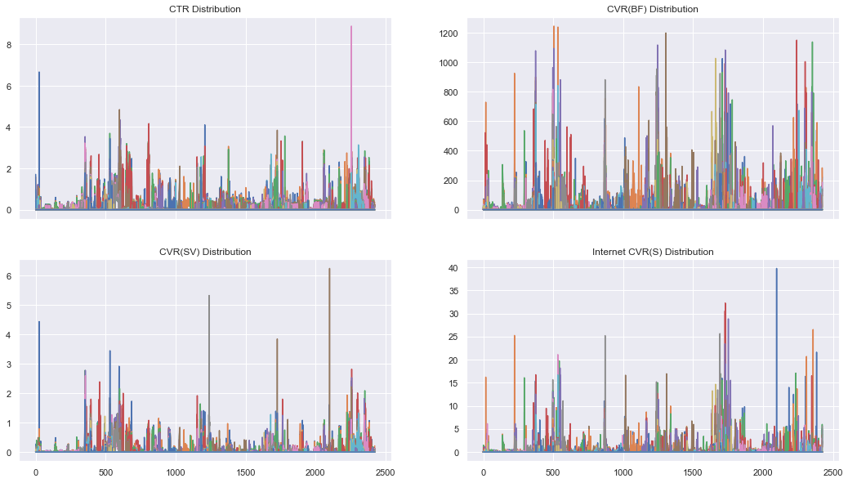

Primary Learning Objectives and Insights¶

PLO - Optimal mix of creatives per Funnel + Publisher¶

In [ ]:

*# Replace week features with cleaned features*  
social_data **=** pd**.**concat([social_data, labeled_social_data**.**iloc[:, 31:]], axis**=**1)  
social_data**.**head()

Out[ ]:

|  | **Creative ID** | **funnel** | **publisher** | **lob** | **product** | **theme** | **kpi_audience** | **creative_versions** | **price** | **price_placement** | **discount** | **offer_placement** | **offer_group** | **asset_type** | **video_type** | **length** | **CTR_W0** | **CTR_W1** | **CTR_W2** | **CTR_W3** | **CTR_W4** | **CTR_W5** | **CTR_W6** | **CTR_W7** | **CTR_W8** | **CTR_W9** | **CTR_W10** | **CTR_W11** | **CTR_W12** | **CTR_W13** | **CTR_W14** | **CTR_W15** | **CTR_W16** | **CTR_W17** | **CTR_W18** | **CTR_W19** | **CTR_W20** | **CTR_W21** | **CTR_W22** | **CTR_W23** | **CTR_W24** | **CTR_W25** | **CTR_W26** | **CTR_W27** | **CTR_W28** | **CTR_W29** | **CTR_W30** | **CTR_W31** | **CTR_W32** | **CTR_W33** | **CTR_W34** | **CTR_W35** | **CTR_W36** | **CTR_W37** | **CTR_W38** | **CTR_W39** | **CTR_W40** | **CTR_W41** | **CTR_W42** | **CTR_W43** | **CTR_W44** | **CTR_W45** | **CTR_W46** | **CTR_W47** | **CVR(BF)_W0** | **CVR(BF)_W1** | **CVR(BF)_W2** | **CVR(BF)_W3** | **CVR(BF)_W4** | **CVR(BF)_W5** | **CVR(BF)_W6** | **CVR(BF)_W7** | **CVR(BF)_W8** | **CVR(BF)_W9** | **CVR(BF)_W10** | **CVR(BF)_W11** | **CVR(BF)_W12** | **CVR(BF)_W13** | **CVR(BF)_W14** | **CVR(BF)_W15** | **CVR(BF)_W16** | **CVR(BF)_W17** | **CVR(BF)_W18** | **CVR(BF)_W19** | **CVR(BF)_W20** | **CVR(BF)_W21** | **CVR(BF)_W22** | **CVR(BF)_W23** | **CVR(BF)_W24** | **CVR(BF)_W25** | **CVR(BF)_W26** | **CVR(BF)_W27** | **CVR(BF)_W28** | **CVR(BF)_W29** | **CVR(BF)_W30** | **CVR(BF)_W31** | **CVR(BF)_W32** | **CVR(BF)_W33** | **CVR(BF)_W34** | **CVR(BF)_W35** | **CVR(BF)_W36** | **CVR(BF)_W37** | **CVR(BF)_W38** | **CVR(BF)_W39** | **CVR(BF)_W40** | **CVR(BF)_W41** | **CVR(BF)_W42** | **CVR(BF)_W43** | **CVR(BF)_W44** | **CVR(BF)_W45** | **CVR(BF)_W46** | **CVR(BF)_W47** | **CVR(SV)_W0** | **CVR(SV)_W1** | **CVR(SV)_W2** | **CVR(SV)_W3** | **CVR(SV)_W4** | **CVR(SV)_W5** | **CVR(SV)_W6** | **CVR(SV)_W7** | **CVR(SV)_W8** | **CVR(SV)_W9** | **CVR(SV)_W10** | **CVR(SV)_W11** | **CVR(SV)_W12** | **CVR(SV)_W13** | **CVR(SV)_W14** | **CVR(SV)_W15** | **CVR(SV)_W16** | **CVR(SV)_W17** | **CVR(SV)_W18** | **CVR(SV)_W19** | **CVR(SV)_W20** | **CVR(SV)_W21** | **CVR(SV)_W22** | **CVR(SV)_W23** | **CVR(SV)_W24** | **CVR(SV)_W25** | **CVR(SV)_W26** | **CVR(SV)_W27** | **CVR(SV)_W28** | **CVR(SV)_W29** | **CVR(SV)_W30** | **CVR(SV)_W31** | **CVR(SV)_W32** | **CVR(SV)_W33** | **CVR(SV)_W34** | **CVR(SV)_W35** | **CVR(SV)_W36** | **CVR(SV)_W37** | **CVR(SV)_W38** | **CVR(SV)_W39** | **CVR(SV)_W40** | **CVR(SV)_W41** | **CVR(SV)_W42** | **CVR(SV)_W43** | **CVR(SV)_W44** | **CVR(SV)_W45** | **CVR(SV)_W46** | **CVR(SV)_W47** | **Internet_CVR(S)_W0** | **Internet_CVR(S)_W1** | **Internet_CVR(S)_W2** | **Internet_CVR(S)_W3** | **Internet_CVR(S)_W4** | **Internet_CVR(S)_W5** | **Internet_CVR(S)_W6** | **Internet_CVR(S)_W7** | **Internet_CVR(S)_W8** | **Internet_CVR(S)_W9** | **Internet_CVR(S)_W10** | **Internet_CVR(S)_W11** | **Internet_CVR(S)_W12** | **Internet_CVR(S)_W13** | **Internet_CVR(S)_W14** | **Internet_CVR(S)_W15** | **Internet_CVR(S)_W16** | **Internet_CVR(S)_W17** | **Internet_CVR(S)_W18** | **Internet_CVR(S)_W19** | **Internet_CVR(S)_W20** | **Internet_CVR(S)_W21** | **Internet_CVR(S)_W22** | **Internet_CVR(S)_W23** | **Internet_CVR(S)_W24** | **Internet_CVR(S)_W25** | **Internet_CVR(S)_W26** | **Internet_CVR(S)_W27** | **Internet_CVR(S)_W28** | **Internet_CVR(S)_W29** | **Internet_CVR(S)_W30** | **Internet_CVR(S)_W31** | **Internet_CVR(S)_W32** | **Internet_CVR(S)_W33** | **Internet_CVR(S)_W34** | **Internet_CVR(S)_W35** | **Internet_CVR(S)_W36** | **Internet_CVR(S)_W37** | **Internet_CVR(S)_W38** | **Internet_CVR(S)_W39** | **Internet_CVR(S)_W40** | **Internet_CVR(S)_W41** | **Internet_CVR(S)_W42** | **Internet_CVR(S)_W43** | **Internet_CVR(S)_W44** | **Internet_CVR(S)_W45** | **Internet_CVR(S)_W46** | **Internet_CVR(S)_W47** | **Impressions_W0** | **Impressions_W1** | **Impressions_W2** | **Impressions_W3** | **Impressions_W4** | **Impressions_W5** | **Impressions_W6** | **Impressions_W7** | **Impressions_W8** | **Impressions_W9** | **Impressions_W10** | **Impressions_W11** | **Impressions_W12** | **Impressions_W13** | **Impressions_W14** | **Impressions_W15** | **Impressions_W16** | **Impressions_W17** | **Impressions_W18** | **Impressions_W19** | **Impressions_W20** | **Impressions_W21** | **Impressions_W22** | **Impressions_W23** | **Impressions_W24** | **Impressions_W25** | **Impressions_W26** | **Impressions_W27** | **Impressions_W28** | **Impressions_W29** | **Impressions_W30** | **Impressions_W31** | **Impressions_W32** | **Impressions_W33** | **Impressions_W34** | **Impressions_W35** | **Impressions_W36** | **Impressions_W37** | **Impressions_W38** | **Impressions_W39** | **Impressions_W40** | **Impressions_W41** | **Impressions_W42** | **Impressions_W43** | **Impressions_W44** | **Impressions_W45** | **Impressions_W46** | **Impressions_W47** | **Spend_W0** | **Spend_W1** | **Spend_W2** | **Spend_W3** | **Spend_W4** | **Spend_W5** | **Spend_W6** | **Spend_W7** | **Spend_W8** | **Spend_W9** | **Spend_W10** | **Spend_W11** | **Spend_W12** | **Spend_W13** | **Spend_W14** | **Spend_W15** | **Spend_W16** | **Spend_W17** | **Spend_W18** | **Spend_W19** | **Spend_W20** | **Spend_W21** | **Spend_W22** | **Spend_W23** | **Spend_W24** | **Spend_W25** | **Spend_W26** | **Spend_W27** | **Spend_W28** | **Spend_W29** | **Spend_W30** | **Spend_W31** | **Spend_W32** | **Spend_W33** | **Spend_W34** | **Spend_W35** | **Spend_W36** | **Spend_W37** | **Spend_W38** | **Spend_W39** | **Spend_W40** | **Spend_W41** | **Spend_W42** | **Spend_W43** | **Spend_W44** | **Spend_W45** | **Spend_W46** | **Spend_W47** |
| --- | --- | --- | --- | --- | --- | --- | --- | --- | --- | --- | --- | --- | --- | --- | --- | --- | --- | --- | --- | --- | --- | --- | --- | --- | --- | --- | --- | --- | --- | --- | --- | --- | --- | --- | --- | --- | --- | --- | --- | --- | --- | --- | --- | --- | --- | --- | --- | --- | --- | --- | --- | --- | --- | --- | --- | --- | --- | --- | --- | --- | --- | --- | --- | --- | --- | --- | --- | --- | --- | --- | --- | --- | --- | --- | --- | --- | --- | --- | --- | --- | --- | --- | --- | --- | --- | --- | --- | --- | --- | --- | --- | --- | --- | --- | --- | --- | --- | --- | --- | --- | --- | --- | --- | --- | --- | --- | --- | --- | --- | --- | --- | --- | --- | --- | --- | --- | --- | --- | --- | --- | --- | --- | --- | --- | --- | --- | --- | --- | --- | --- | --- | --- | --- | --- | --- | --- | --- | --- | --- | --- | --- | --- | --- | --- | --- | --- | --- | --- | --- | --- | --- | --- | --- | --- | --- | --- | --- | --- | --- | --- | --- | --- | --- | --- | --- | --- | --- | --- | --- | --- | --- | --- | --- | --- | --- | --- | --- | --- | --- | --- | --- | --- | --- | --- | --- | --- | --- | --- | --- | --- | --- | --- | --- | --- | --- | --- | --- | --- | --- | --- | --- | --- | --- | --- | --- | --- | --- | --- | --- | --- | --- | --- | --- | --- | --- | --- | --- | --- | --- | --- | --- | --- | --- | --- | --- | --- | --- | --- | --- | --- | --- | --- | --- | --- | --- | --- | --- | --- | --- | --- | --- | --- | --- | --- | --- | --- | --- | --- | --- | --- | --- | --- | --- | --- | --- | --- | --- | --- | --- | --- | --- | --- | --- | --- | --- | --- | --- | --- | --- | --- | --- | --- | --- | --- | --- | --- | --- | --- | --- | --- | --- | --- | --- | --- | --- | --- | --- | --- | --- | --- | --- | --- | --- | --- | --- | --- | --- | --- | --- | --- | --- | --- | --- | --- |
| **0** | Creative 1 | MF | Publisher 1 | LOB 1 | Product 1 | Theme 1 | Audience 1 | Creative 1 | No Price | NaN | 0.0 | NaN | No offer | Vid | Stock | :15 | 0.98 | 1.58 | 0.00 | 0.00 | 0.13 | 0.43 | 0.48 | 0.43 | 0.41 | 0.9 | 1.71 | 0.0 | 0.0 | 0.0 | 0.0 | 0.0 | 0.0 | 0.0 | 0.0 | 0.0 | 0.0 | 0.0 | 0.0 | 0.0 | 0.0 | 0.0 | 0.0 | 0.0 | 0.0 | 0.0 | 0.0 | 0.0 | 0.0 | 0.0 | 0.0 | 0.0 | 0.0 | 0.0 | 0.0 | 0.0 | 0.0 | 0.0 | 0.0 | 0.0 | 0.0 | 0.0 | 0.0 | 0.0 | 0.00 | 0.00 | 0.00 | 0.00 | 0.00 | 0.00 | 0.00 | 0.00 | 0.00 | 0.0 | 0.0 | 0.0 | 0.0 | 0.0 | 0.0 | 0.0 | 0.0 | 0.0 | 0.0 | 0.0 | 0.0 | 0.0 | 0.0 | 0.0 | 0.0 | 0.0 | 0.0 | 0.0 | 0.0 | 0.0 | 0.0 | 0.0 | 0.0 | 0.0 | 0.0 | 0.0 | 0.0 | 0.0 | 0.0 | 0.0 | 0.0 | 0.0 | 0.0 | 0.0 | 0.0 | 0.0 | 0.0 | 0.0 | 0.00 | 0.00 | 0.00 | 0.00 | 0.00 | 0.00 | 0.00 | 0.00 | 0.00 | 0.0 | 0.0 | 0.0 | 0.0 | 0.0 | 0.0 | 0.0 | 0.0 | 0.0 | 0.0 | 0.0 | 0.0 | 0.0 | 0.0 | 0.0 | 0.0 | 0.0 | 0.0 | 0.0 | 0.0 | 0.0 | 0.0 | 0.0 | 0.0 | 0.0 | 0.0 | 0.0 | 0.0 | 0.0 | 0.0 | 0.0 | 0.0 | 0.0 | 0.0 | 0.0 | 0.0 | 0.0 | 0.0 | 0.0 | 0.0 | 0.0 | 0.00 | 0.00 | 0.00 | 0.00 | 0.00 | 0.00 | 0.0 | 0.0 | 0.0 | 0.0 | 0.0 | 0.0 | 0.0 | 0.0 | 0.0 | 0.0 | 0.0 | 0.0 | 0.0 | 0.0 | 0.0 | 0.0 | 0.0 | 0.0 | 0.0 | 0.0 | 0.0 | 0.0 | 0.0 | 0.0 | 0.0 | 0.0 | 0.0 | 0.0 | 0.0 | 0.0 | 0.0 | 0.0 | 0.0 | 0.0 | 0.0 | 0.0 | 0.0 | 0.0 | 0.0 | 0.0 | 205.0 | 317.0 | 417.0 | 403.0 | 797.0 | 41890.0 | 83865.0 | 68932.0 | 7236.0 | 111.0 | 117.0 | 229.0 | 210.0 | 0.0 | 0.0 | 0.0 | 0.0 | 0.0 | 0.0 | 0.0 | 0.0 | 0.0 | 0.0 | 0.0 | 0.0 | 0.0 | 0.0 | 0.0 | 0.0 | 0.0 | 0.0 | 0.0 | 0.0 | 0.0 | 0.0 | 0.0 | 0.0 | 0.0 | 0.0 | 0.0 | 0.0 | 0.0 | 0.0 | 0.0 | 0.0 | 0.0 | 0.0 | 0.0 | 2.0 | 3.0 | 4.0 | 4.0 | 22.0 | 853.0 | 1692.0 | 1394.0 | 150.0 | 3.0 | 4.0 | 7.0 | 6.0 | 0.0 | 0.0 | 0.0 | 0.0 | 0.0 | 0.0 | 0.0 | 0.0 | 0.0 | 0.0 | 0.0 | 0.0 | 0.0 | 0.0 | 0.0 | 0.0 | 0.0 | 0.0 | 0.0 | 0.0 | 0.0 | 0.0 | 0.0 | 0.0 | 0.0 | 0.0 | 0.0 | 0.0 | 0.0 | 0.0 | 0.0 | 0.0 | 0.0 | 0.0 | 0.0 |
| **8** | Creative 9 | MF | Publisher 3 | LOB 1 | Product 1 | Theme 1 | Audience 2 | Creative 1 | No Price | NaN | 0.0 | NaN | No offer | Vid | Stock | :15 | 0.49 | 0.35 | 0.26 | 0.27 | 0.27 | 0.26 | 0.23 | 0.24 | 0.23 | 0.0 | 0.00 | 0.0 | 0.0 | 0.0 | 0.0 | 0.0 | 0.0 | 0.0 | 0.0 | 0.0 | 0.0 | 0.0 | 0.0 | 0.0 | 0.0 | 0.0 | 0.0 | 0.0 | 0.0 | 0.0 | 0.0 | 0.0 | 0.0 | 0.0 | 0.0 | 0.0 | 0.0 | 0.0 | 0.0 | 0.0 | 0.0 | 0.0 | 0.0 | 0.0 | 0.0 | 0.0 | 0.0 | 0.0 | 37.77 | 35.93 | 34.39 | 17.91 | 25.14 | 21.20 | 16.44 | 25.02 | 11.82 | 0.0 | 0.0 | 0.0 | 0.0 | 0.0 | 0.0 | 0.0 | 0.0 | 0.0 | 0.0 | 0.0 | 0.0 | 0.0 | 0.0 | 0.0 | 0.0 | 0.0 | 0.0 | 0.0 | 0.0 | 0.0 | 0.0 | 0.0 | 0.0 | 0.0 | 0.0 | 0.0 | 0.0 | 0.0 | 0.0 | 0.0 | 0.0 | 0.0 | 0.0 | 0.0 | 0.0 | 0.0 | 0.0 | 0.0 | 0.27 | 0.15 | 0.11 | 0.12 | 0.11 | 0.09 | 0.08 | 0.10 | 0.09 | 0.0 | 0.0 | 0.0 | 0.0 | 0.0 | 0.0 | 0.0 | 0.0 | 0.0 | 0.0 | 0.0 | 0.0 | 0.0 | 0.0 | 0.0 | 0.0 | 0.0 | 0.0 | 0.0 | 0.0 | 0.0 | 0.0 | 0.0 | 0.0 | 0.0 | 0.0 | 0.0 | 0.0 | 0.0 | 0.0 | 0.0 | 0.0 | 0.0 | 0.0 | 0.0 | 0.0 | 0.0 | 0.0 | 0.0 | 0.0 | 0.0 | 1.49 | 0.17 | 0.17 | 0.16 | 0.15 | 0.15 | 0.0 | 0.0 | 0.0 | 0.0 | 0.0 | 0.0 | 0.0 | 0.0 | 0.0 | 0.0 | 0.0 | 0.0 | 0.0 | 0.0 | 0.0 | 0.0 | 0.0 | 0.0 | 0.0 | 0.0 | 0.0 | 0.0 | 0.0 | 0.0 | 0.0 | 0.0 | 0.0 | 0.0 | 0.0 | 0.0 | 0.0 | 0.0 | 0.0 | 0.0 | 0.0 | 0.0 | 0.0 | 0.0 | 0.0 | 0.0 | 63550.0 | 125249.0 | 107590.0 | 117234.0 | 119314.0 | 127372.0 | 133784.0 | 131902.0 | 33827.0 | 0.0 | 0.0 | 0.0 | 0.0 | 0.0 | 0.0 | 0.0 | 0.0 | 0.0 | 0.0 | 0.0 | 0.0 | 0.0 | 0.0 | 0.0 | 0.0 | 0.0 | 0.0 | 0.0 | 0.0 | 0.0 | 0.0 | 0.0 | 0.0 | 0.0 | 0.0 | 0.0 | 0.0 | 0.0 | 0.0 | 0.0 | 0.0 | 0.0 | 0.0 | 0.0 | 0.0 | 0.0 | 0.0 | 0.0 | 1724.0 | 3344.0 | 3110.0 | 3327.0 | 3340.0 | 3529.0 | 3526.0 | 3518.0 | 1162.0 | 0.0 | 0.0 | 0.0 | 0.0 | 0.0 | 0.0 | 0.0 | 0.0 | 0.0 | 0.0 | 0.0 | 0.0 | 0.0 | 0.0 | 0.0 | 0.0 | 0.0 | 0.0 | 0.0 | 0.0 | 0.0 | 0.0 | 0.0 | 0.0 | 0.0 | 0.0 | 0.0 | 0.0 | 0.0 | 0.0 | 0.0 | 0.0 | 0.0 | 0.0 | 0.0 | 0.0 | 0.0 | 0.0 | 0.0 |
| **9** | Creative 10 | MF | Publisher 4 | LOB 1 | Product 1 | Theme 1 | Audience 2 | Creative 1 | No Price | NaN | 0.0 | NaN | No offer | Vid | Stock | :15 | 0.66 | 0.57 | 0.61 | 0.58 | 0.51 | 0.58 | 0.53 | 0.54 | 0.49 | 0.0 | 0.00 | 0.0 | 0.0 | 0.0 | 0.0 | 0.0 | 0.0 | 0.0 | 0.0 | 0.0 | 0.0 | 0.0 | 0.0 | 0.0 | 0.0 | 0.0 | 0.0 | 0.0 | 0.0 | 0.0 | 0.0 | 0.0 | 0.0 | 0.0 | 0.0 | 0.0 | 0.0 | 0.0 | 0.0 | 0.0 | 0.0 | 0.0 | 0.0 | 0.0 | 0.0 | 0.0 | 0.0 | 0.0 | 73.04 | 68.23 | 11.60 | 12.68 | 4.76 | 4.06 | 15.88 | 27.41 | 26.50 | 0.0 | 0.0 | 0.0 | 0.0 | 0.0 | 0.0 | 0.0 | 0.0 | 0.0 | 0.0 | 0.0 | 0.0 | 0.0 | 0.0 | 0.0 | 0.0 | 0.0 | 0.0 | 0.0 | 0.0 | 0.0 | 0.0 | 0.0 | 0.0 | 0.0 | 0.0 | 0.0 | 0.0 | 0.0 | 0.0 | 0.0 | 0.0 | 0.0 | 0.0 | 0.0 | 0.0 | 0.0 | 0.0 | 0.0 | 0.07 | 0.10 | 0.08 | 0.09 | 0.07 | 0.04 | 0.05 | 0.04 | 0.09 | 0.0 | 0.0 | 0.0 | 0.0 | 0.0 | 0.0 | 0.0 | 0.0 | 0.0 | 0.0 | 0.0 | 0.0 | 0.0 | 0.0 | 0.0 | 0.0 | 0.0 | 0.0 | 0.0 | 0.0 | 0.0 | 0.0 | 0.0 | 0.0 | 0.0 | 0.0 | 0.0 | 0.0 | 0.0 | 0.0 | 0.0 | 0.0 | 0.0 | 0.0 | 0.0 | 0.0 | 0.0 | 0.0 | 0.0 | 0.0 | 0.0 | 0.93 | 1.01 | 0.00 | 0.00 | 0.00 | 0.00 | 0.0 | 0.0 | 0.0 | 0.0 | 0.0 | 0.0 | 0.0 | 0.0 | 0.0 | 0.0 | 0.0 | 0.0 | 0.0 | 0.0 | 0.0 | 0.0 | 0.0 | 0.0 | 0.0 | 0.0 | 0.0 | 0.0 | 0.0 | 0.0 | 0.0 | 0.0 | 0.0 | 0.0 | 0.0 | 0.0 | 0.0 | 0.0 | 0.0 | 0.0 | 0.0 | 0.0 | 0.0 | 0.0 | 0.0 | 0.0 | 27381.0 | 46901.0 | 43107.0 | 39422.0 | 41999.0 | 49238.0 | 44079.0 | 47429.0 | 7547.0 | 0.0 | 0.0 | 0.0 | 0.0 | 0.0 | 0.0 | 0.0 | 0.0 | 0.0 | 0.0 | 0.0 | 0.0 | 0.0 | 0.0 | 0.0 | 0.0 | 0.0 | 0.0 | 0.0 | 0.0 | 0.0 | 0.0 | 0.0 | 0.0 | 0.0 | 0.0 | 0.0 | 0.0 | 0.0 | 0.0 | 0.0 | 0.0 | 0.0 | 0.0 | 0.0 | 0.0 | 0.0 | 0.0 | 0.0 | 282.0 | 529.0 | 479.0 | 458.0 | 442.0 | 632.0 | 542.0 | 574.0 | 87.0 | 0.0 | 0.0 | 0.0 | 0.0 | 0.0 | 0.0 | 0.0 | 0.0 | 0.0 | 0.0 | 0.0 | 0.0 | 0.0 | 0.0 | 0.0 | 0.0 | 0.0 | 0.0 | 0.0 | 0.0 | 0.0 | 0.0 | 0.0 | 0.0 | 0.0 | 0.0 | 0.0 | 0.0 | 0.0 | 0.0 | 0.0 | 0.0 | 0.0 | 0.0 | 0.0 | 0.0 | 0.0 | 0.0 | 0.0 |
| **10** | Creative 11 | MF | Publisher 5 | LOB 1 | Product 1 | Theme 1 | Audience 2 | Creative 1 | No Price | NaN | 0.0 | NaN | No offer | Vid | Stock | :15 | 0.37 | 0.36 | 0.37 | 0.22 | 0.24 | 0.23 | 0.19 | 0.20 | 0.16 | 0.0 | 0.00 | 0.0 | 0.0 | 0.0 | 0.0 | 0.0 | 0.0 | 0.0 | 0.0 | 0.0 | 0.0 | 0.0 | 0.0 | 0.0 | 0.0 | 0.0 | 0.0 | 0.0 | 0.0 | 0.0 | 0.0 | 0.0 | 0.0 | 0.0 | 0.0 | 0.0 | 0.0 | 0.0 | 0.0 | 0.0 | 0.0 | 0.0 | 0.0 | 0.0 | 0.0 | 0.0 | 0.0 | 0.0 | 37.37 | 0.00 | 0.00 | 0.00 | 0.00 | 12.11 | 37.05 | 24.60 | 0.00 | 0.0 | 0.0 | 0.0 | 0.0 | 0.0 | 0.0 | 0.0 | 0.0 | 0.0 | 0.0 | 0.0 | 0.0 | 0.0 | 0.0 | 0.0 | 0.0 | 0.0 | 0.0 | 0.0 | 0.0 | 0.0 | 0.0 | 0.0 | 0.0 | 0.0 | 0.0 | 0.0 | 0.0 | 0.0 | 0.0 | 0.0 | 0.0 | 0.0 | 0.0 | 0.0 | 0.0 | 0.0 | 0.0 | 0.0 | 0.22 | 0.09 | 0.15 | 0.06 | 0.04 | 0.02 | 0.05 | 0.18 | 0.10 | 0.0 | 0.0 | 0.0 | 0.0 | 0.0 | 0.0 | 0.0 | 0.0 | 0.0 | 0.0 | 0.0 | 0.0 | 0.0 | 0.0 | 0.0 | 0.0 | 0.0 | 0.0 | 0.0 | 0.0 | 0.0 | 0.0 | 0.0 | 0.0 | 0.0 | 0.0 | 0.0 | 0.0 | 0.0 | 0.0 | 0.0 | 0.0 | 0.0 | 0.0 | 0.0 | 0.0 | 0.0 | 0.0 | 0.0 | 0.0 | 0.0 | 0.00 | 0.00 | 0.00 | 0.00 | 0.00 | 0.00 | 0.0 | 0.0 | 0.0 | 0.0 | 0.0 | 0.0 | 0.0 | 0.0 | 0.0 | 0.0 | 0.0 | 0.0 | 0.0 | 0.0 | 0.0 | 0.0 | 0.0 | 0.0 | 0.0 | 0.0 | 0.0 | 0.0 | 0.0 | 0.0 | 0.0 | 0.0 | 0.0 | 0.0 | 0.0 | 0.0 | 0.0 | 0.0 | 0.0 | 0.0 | 0.0 | 0.0 | 0.0 | 0.0 | 0.0 | 0.0 | 2676.0 | 5540.0 | 5971.0 | 6365.0 | 7127.0 | 8255.0 | 8097.0 | 8131.0 | 1928.0 | 0.0 | 0.0 | 0.0 | 0.0 | 0.0 | 0.0 | 0.0 | 0.0 | 0.0 | 0.0 | 0.0 | 0.0 | 0.0 | 0.0 | 0.0 | 0.0 | 0.0 | 0.0 | 0.0 | 0.0 | 0.0 | 0.0 | 0.0 | 0.0 | 0.0 | 0.0 | 0.0 | 0.0 | 0.0 | 0.0 | 0.0 | 0.0 | 0.0 | 0.0 | 0.0 | 0.0 | 0.0 | 0.0 | 0.0 | 50.0 | 88.0 | 102.0 | 110.0 | 124.0 | 131.0 | 114.0 | 106.0 | 25.0 | 0.0 | 0.0 | 0.0 | 0.0 | 0.0 | 0.0 | 0.0 | 0.0 | 0.0 | 0.0 | 0.0 | 0.0 | 0.0 | 0.0 | 0.0 | 0.0 | 0.0 | 0.0 | 0.0 | 0.0 | 0.0 | 0.0 | 0.0 | 0.0 | 0.0 | 0.0 | 0.0 | 0.0 | 0.0 | 0.0 | 0.0 | 0.0 | 0.0 | 0.0 | 0.0 | 0.0 | 0.0 | 0.0 | 0.0 |
| **11** | Creative 12 | LF | Publisher 5 | LOB 1 | Product 2 | Theme 1 | Audience 2 | Creative 2 | Price 1 | NaN | 0.0 | NaN | No offer | Vid | Stock | :15 | 0.00 | 0.00 | 0.00 | 0.00 | 0.00 | 0.00 | 0.00 | 0.00 | 0.00 | 0.0 | 0.00 | 0.0 | 0.0 | 0.0 | 0.0 | 0.0 | 0.0 | 0.0 | 0.0 | 0.0 | 0.0 | 0.0 | 0.0 | 0.0 | 0.0 | 0.0 | 0.0 | 0.0 | 0.0 | 0.0 | 0.0 | 0.0 | 0.0 | 0.0 | 0.0 | 0.0 | 0.0 | 0.0 | 0.0 | 0.0 | 0.0 | 0.0 | 0.0 | 0.0 | 0.0 | 0.0 | 0.0 | 0.0 | 0.00 | 0.00 | 0.00 | 0.00 | 0.00 | 0.00 | 0.00 | 0.00 | 0.00 | 0.0 | 0.0 | 0.0 | 0.0 | 0.0 | 0.0 | 0.0 | 0.0 | 0.0 | 0.0 | 0.0 | 0.0 | 0.0 | 0.0 | 0.0 | 0.0 | 0.0 | 0.0 | 0.0 | 0.0 | 0.0 | 0.0 | 0.0 | 0.0 | 0.0 | 0.0 | 0.0 | 0.0 | 0.0 | 0.0 | 0.0 | 0.0 | 0.0 | 0.0 | 0.0 | 0.0 | 0.0 | 0.0 | 0.0 | 0.00 | 0.00 | 0.00 | 0.00 | 0.00 | 0.00 | 0.00 | 0.00 | 0.00 | 0.0 | 0.0 | 0.0 | 0.0 | 0.0 | 0.0 | 0.0 | 0.0 | 0.0 | 0.0 | 0.0 | 0.0 | 0.0 | 0.0 | 0.0 | 0.0 | 0.0 | 0.0 | 0.0 | 0.0 | 0.0 | 0.0 | 0.0 | 0.0 | 0.0 | 0.0 | 0.0 | 0.0 | 0.0 | 0.0 | 0.0 | 0.0 | 0.0 | 0.0 | 0.0 | 0.0 | 0.0 | 0.0 | 0.0 | 0.0 | 0.0 | 0.00 | 0.00 | 0.00 | 0.00 | 0.00 | 0.00 | 0.0 | 0.0 | 0.0 | 0.0 | 0.0 | 0.0 | 0.0 | 0.0 | 0.0 | 0.0 | 0.0 | 0.0 | 0.0 | 0.0 | 0.0 | 0.0 | 0.0 | 0.0 | 0.0 | 0.0 | 0.0 | 0.0 | 0.0 | 0.0 | 0.0 | 0.0 | 0.0 | 0.0 | 0.0 | 0.0 | 0.0 | 0.0 | 0.0 | 0.0 | 0.0 | 0.0 | 0.0 | 0.0 | 0.0 | 0.0 | 119.0 | 0.0 | 0.0 | 0.0 | 0.0 | 0.0 | 0.0 | 0.0 | 0.0 | 0.0 | 0.0 | 0.0 | 0.0 | 0.0 | 0.0 | 0.0 | 0.0 | 0.0 | 0.0 | 0.0 | 0.0 | 0.0 | 0.0 | 0.0 | 0.0 | 0.0 | 0.0 | 0.0 | 0.0 | 0.0 | 0.0 | 0.0 | 0.0 | 0.0 | 0.0 | 0.0 | 0.0 | 0.0 | 0.0 | 0.0 | 0.0 | 0.0 | 0.0 | 0.0 | 0.0 | 0.0 | 0.0 | 0.0 | 1.0 | 0.0 | 0.0 | 0.0 | 0.0 | 0.0 | 0.0 | 0.0 | 0.0 | 0.0 | 0.0 | 0.0 | 0.0 | 0.0 | 0.0 | 0.0 | 0.0 | 0.0 | 0.0 | 0.0 | 0.0 | 0.0 | 0.0 | 0.0 | 0.0 | 0.0 | 0.0 | 0.0 | 0.0 | 0.0 | 0.0 | 0.0 | 0.0 | 0.0 | 0.0 | 0.0 | 0.0 | 0.0 | 0.0 | 0.0 | 0.0 | 0.0 | 0.0 | 0.0 | 0.0 | 0.0 | 0.0 | 0.0 |

In [ ]:

*# Create week features for in market creatives*  
**for** idx, week **in** enumerate(social_data[ctr_w]**.**columns):  
 social_data[f'In_Market_W{idx}'] **=** social_data[week]**.**apply(**lambda** x: 1 **if** x **>** 0 **else** 0)  
  
social_data**.**iloc[:, **-**41:]**.**head()

Out[ ]:

|  | **In_Market_W0** | **In_Market_W1** | **In_Market_W2** | **In_Market_W3** | **In_Market_W4** | **In_Market_W5** | **In_Market_W6** | **In_Market_W7** | **In_Market_W8** | **In_Market_W9** | **In_Market_W10** | **In_Market_W11** | **In_Market_W12** | **In_Market_W13** | **In_Market_W14** | **In_Market_W15** | **In_Market_W16** | **In_Market_W17** | **In_Market_W18** | **In_Market_W19** | **In_Market_W20** | **In_Market_W21** | **In_Market_W22** | **In_Market_W23** | **In_Market_W24** | **In_Market_W25** | **In_Market_W26** | **In_Market_W27** | **In_Market_W28** | **In_Market_W29** | **In_Market_W30** | **In_Market_W31** | **In_Market_W32** | **In_Market_W33** | **In_Market_W34** | **In_Market_W35** | **In_Market_W36** | **In_Market_W37** | **In_Market_W38** | **In_Market_W39** | **In_Market_W40** |
| --- | --- | --- | --- | --- | --- | --- | --- | --- | --- | --- | --- | --- | --- | --- | --- | --- | --- | --- | --- | --- | --- | --- | --- | --- | --- | --- | --- | --- | --- | --- | --- | --- | --- | --- | --- | --- | --- | --- | --- | --- | --- |
| **0** | 1 | 1 | 0 | 0 | 1 | 1 | 1 | 1 | 1 | 1 | 1 | 0 | 0 | 0 | 0 | 0 | 0 | 0 | 0 | 0 | 0 | 0 | 0 | 0 | 0 | 0 | 0 | 0 | 0 | 0 | 0 | 0 | 0 | 0 | 0 | 0 | 0 | 0 | 0 | 0 | 0 |
| **8** | 1 | 1 | 1 | 1 | 1 | 1 | 1 | 1 | 1 | 0 | 0 | 0 | 0 | 0 | 0 | 0 | 0 | 0 | 0 | 0 | 0 | 0 | 0 | 0 | 0 | 0 | 0 | 0 | 0 | 0 | 0 | 0 | 0 | 0 | 0 | 0 | 0 | 0 | 0 | 0 | 0 |
| **9** | 1 | 1 | 1 | 1 | 1 | 1 | 1 | 1 | 1 | 0 | 0 | 0 | 0 | 0 | 0 | 0 | 0 | 0 | 0 | 0 | 0 | 0 | 0 | 0 | 0 | 0 | 0 | 0 | 0 | 0 | 0 | 0 | 0 | 0 | 0 | 0 | 0 | 0 | 0 | 0 | 0 |
| **10** | 1 | 1 | 1 | 1 | 1 | 1 | 1 | 1 | 1 | 0 | 0 | 0 | 0 | 0 | 0 | 0 | 0 | 0 | 0 | 0 | 0 | 0 | 0 | 0 | 0 | 0 | 0 | 0 | 0 | 0 | 0 | 0 | 0 | 0 | 0 | 0 | 0 | 0 | 0 | 0 | 0 |
| **11** | 0 | 0 | 0 | 0 | 0 | 0 | 0 | 0 | 0 | 0 | 0 | 0 | 0 | 0 | 0 | 0 | 0 | 0 | 0 | 0 | 0 | 0 | 0 | 0 | 0 | 0 | 0 | 0 | 0 | 0 | 0 | 0 | 0 | 0 | 0 | 0 | 0 | 0 | 0 | 0 | 0 |

In [ ]:

*# Find number of creatives per week and average KPI per week by funnel and publisher*  
in_market_w **=** [col **for** col **in** social_data**.**columns **if** col**.**startswith('In_Market')]  
in_market_creatives_df **=** social_data**.**groupby(['funnel', 'publisher'])[in_market_w]**.**agg('sum')  
kpi_creatives_df **=** social_data**.**groupby(['funnel', 'publisher'])[ctr_w **+** cvrbf_w **+** cvrsv_w **+** cvrint_w]**.**agg('mean')  
  
creatives_df **=** pd**.**concat([in_market_creatives_df, kpi_creatives_df], axis**=**1)  
creatives_df

Out[ ]:

|  |  | **In_Market_W0** | **In_Market_W1** | **In_Market_W2** | **In_Market_W3** | **In_Market_W4** | **In_Market_W5** | **In_Market_W6** | **In_Market_W7** | **In_Market_W8** | **In_Market_W9** | **In_Market_W10** | **In_Market_W11** | **In_Market_W12** | **In_Market_W13** | **In_Market_W14** | **In_Market_W15** | **In_Market_W16** | **In_Market_W17** | **In_Market_W18** | **In_Market_W19** | **In_Market_W20** | **In_Market_W21** | **In_Market_W22** | **In_Market_W23** | **In_Market_W24** | **In_Market_W25** | **In_Market_W26** | **In_Market_W27** | **In_Market_W28** | **In_Market_W29** | **In_Market_W30** | **In_Market_W31** | **In_Market_W32** | **In_Market_W33** | **In_Market_W34** | **In_Market_W35** | **In_Market_W36** | **In_Market_W37** | **In_Market_W38** | **In_Market_W39** | **In_Market_W40** | **CTR_W0** | **CTR_W1** | **CTR_W2** | **CTR_W3** | **CTR_W4** | **CTR_W5** | **CTR_W6** | **CTR_W7** | **CTR_W8** | **CTR_W9** | **CTR_W10** | **CTR_W11** | **CTR_W12** | **CTR_W13** | **CTR_W14** | **CTR_W15** | **CTR_W16** | **CTR_W17** | **CTR_W18** | **CTR_W19** | **CTR_W20** | **CTR_W21** | **CTR_W22** | **CTR_W23** | **CTR_W24** | **CTR_W25** | **CTR_W26** | **CTR_W27** | **CTR_W28** | **CTR_W29** | **CTR_W30** | **CTR_W31** | **CTR_W32** | **CTR_W33** | **CTR_W34** | **CTR_W35** | **CTR_W36** | **CTR_W37** | **CTR_W38** | **CTR_W39** | **CTR_W40** | **CVR(BF)_W0** | **CVR(BF)_W1** | **CVR(BF)_W2** | **CVR(BF)_W3** | **CVR(BF)_W4** | **CVR(BF)_W5** | **CVR(BF)_W6** | **CVR(BF)_W7** | **CVR(BF)_W8** | **CVR(BF)_W9** | **CVR(BF)_W10** | **CVR(BF)_W11** | **CVR(BF)_W12** | **CVR(BF)_W13** | **CVR(BF)_W14** | **CVR(BF)_W15** | **CVR(BF)_W16** | **CVR(BF)_W17** | **CVR(BF)_W18** | **CVR(BF)_W19** | **CVR(BF)_W20** | **CVR(BF)_W21** | **CVR(BF)_W22** | **CVR(BF)_W23** | **CVR(BF)_W24** | **CVR(BF)_W25** | **CVR(BF)_W26** | **CVR(BF)_W27** | **CVR(BF)_W28** | **CVR(BF)_W29** | **CVR(BF)_W30** | **CVR(BF)_W31** | **CVR(BF)_W32** | **CVR(BF)_W33** | **CVR(BF)_W34** | **CVR(BF)_W35** | **CVR(BF)_W36** | **CVR(BF)_W37** | **CVR(BF)_W38** | **CVR(BF)_W39** | **CVR(BF)_W40** | **CVR(SV)_W0** | **CVR(SV)_W1** | **CVR(SV)_W2** | **CVR(SV)_W3** | **CVR(SV)_W4** | **CVR(SV)_W5** | **CVR(SV)_W6** | **CVR(SV)_W7** | **CVR(SV)_W8** | **CVR(SV)_W9** | **CVR(SV)_W10** | **CVR(SV)_W11** | **CVR(SV)_W12** | **CVR(SV)_W13** | **CVR(SV)_W14** | **CVR(SV)_W15** | **CVR(SV)_W16** | **CVR(SV)_W17** | **CVR(SV)_W18** | **CVR(SV)_W19** | **CVR(SV)_W20** | **CVR(SV)_W21** | **CVR(SV)_W22** | **CVR(SV)_W23** | **CVR(SV)_W24** | **CVR(SV)_W25** | **CVR(SV)_W26** | **CVR(SV)_W27** | **CVR(SV)_W28** | **CVR(SV)_W29** | **CVR(SV)_W30** | **CVR(SV)_W31** | **CVR(SV)_W32** | **CVR(SV)_W33** | **CVR(SV)_W34** | **CVR(SV)_W35** | **CVR(SV)_W36** | **CVR(SV)_W37** | **CVR(SV)_W38** | **CVR(SV)_W39** | **CVR(SV)_W40** | **Internet_CVR(S)_W0** | **Internet_CVR(S)_W1** | **Internet_CVR(S)_W2** | **Internet_CVR(S)_W3** | **Internet_CVR(S)_W4** | **Internet_CVR(S)_W5** | **Internet_CVR(S)_W6** | **Internet_CVR(S)_W7** | **Internet_CVR(S)_W8** | **Internet_CVR(S)_W9** | **Internet_CVR(S)_W10** | **Internet_CVR(S)_W11** | **Internet_CVR(S)_W12** | **Internet_CVR(S)_W13** | **Internet_CVR(S)_W14** | **Internet_CVR(S)_W15** | **Internet_CVR(S)_W16** | **Internet_CVR(S)_W17** | **Internet_CVR(S)_W18** | **Internet_CVR(S)_W19** | **Internet_CVR(S)_W20** | **Internet_CVR(S)_W21** | **Internet_CVR(S)_W22** | **Internet_CVR(S)_W23** | **Internet_CVR(S)_W24** | **Internet_CVR(S)_W25** | **Internet_CVR(S)_W26** | **Internet_CVR(S)_W27** | **Internet_CVR(S)_W28** | **Internet_CVR(S)_W29** | **Internet_CVR(S)_W30** | **Internet_CVR(S)_W31** | **Internet_CVR(S)_W32** | **Internet_CVR(S)_W33** | **Internet_CVR(S)_W34** | **Internet_CVR(S)_W35** | **Internet_CVR(S)_W36** | **Internet_CVR(S)_W37** | **Internet_CVR(S)_W38** | **Internet_CVR(S)_W39** | **Internet_CVR(S)_W40** |
| --- | --- | --- | --- | --- | --- | --- | --- | --- | --- | --- | --- | --- | --- | --- | --- | --- | --- | --- | --- | --- | --- | --- | --- | --- | --- | --- | --- | --- | --- | --- | --- | --- | --- | --- | --- | --- | --- | --- | --- | --- | --- | --- | --- | --- | --- | --- | --- | --- | --- | --- | --- | --- | --- | --- | --- | --- | --- | --- | --- | --- | --- | --- | --- | --- | --- | --- | --- | --- | --- | --- | --- | --- | --- | --- | --- | --- | --- | --- | --- | --- | --- | --- | --- | --- | --- | --- | --- | --- | --- | --- | --- | --- | --- | --- | --- | --- | --- | --- | --- | --- | --- | --- | --- | --- | --- | --- | --- | --- | --- | --- | --- | --- | --- | --- | --- | --- | --- | --- | --- | --- | --- | --- | --- | --- | --- | --- | --- | --- | --- | --- | --- | --- | --- | --- | --- | --- | --- | --- | --- | --- | --- | --- | --- | --- | --- | --- | --- | --- | --- | --- | --- | --- | --- | --- | --- | --- | --- | --- | --- | --- | --- | --- | --- | --- | --- | --- | --- | --- | --- | --- | --- | --- | --- | --- | --- | --- | --- | --- | --- | --- | --- | --- | --- | --- | --- | --- | --- | --- | --- | --- | --- | --- | --- | --- | --- | --- | --- | --- | --- | --- | --- | --- | --- | --- | --- | --- |
| **funnel** | **publisher** |  |  |  |  |  |  |  |  |  |  |  |  |  |  |  |  |  |  |  |  |  |  |  |  |  |  |  |  |  |  |  |  |  |  |  |  |  |  |  |  |  |  |  |  |  |  |  |  |  |  |  |  |  |  |  |  |  |  |  |  |  |  |  |  |  |  |  |  |  |  |  |  |  |  |  |  |  |  |  |  |  |  |  |  |  |  |  |  |  |  |  |  |  |  |  |  |  |  |  |  |  |  |  |  |  |  |  |  |  |  |  |  |  |  |  |  |  |  |  |  |  |  |  |  |  |  |  |  |  |  |  |  |  |  |  |  |  |  |  |  |  |  |  |  |  |  |  |  |  |  |  |  |  |  |  |  |  |  |  |  |  |  |  |  |  |  |  |  |  |  |  |  |  |  |  |  |  |  |  |  |  |  |  |  |  |  |  |  |  |  |  |  |  |  |  |  |  |  |  |  |  |  |  |  |  |
| **LF** | **Publisher 1** | 0 | 0 | 0 | 0 | 0 | 0 | 0 | 0 | 0 | 0 | 0 | 0 | 0 | 0 | 0 | 0 | 0 | 0 | 0 | 0 | 0 | 0 | 0 | 0 | 0 | 0 | 0 | 0 | 0 | 0 | 0 | 0 | 0 | 0 | 0 | 0 | 0 | 0 | 0 | 0 | 0 | 0.000000 | 0.000000 | 0.000000 | 0.000000 | 0.000000 | 0.000000 | 0.000000 | 0.000000 | 0.000000 | 0.000000 | 0.000000 | 0.000000 | 0.000000 | 0.000000 | 0.000000 | 0.000000 | 0.000000 | 0.000000 | 0.000000 | 0.000000 | 0.000000 | 0.000000 | 0.000000 | 0.000000 | 0.000000 | 0.000000 | 0.000000 | 0.000000 | 0.000000 | 0.00000 | 0.000000 | 0.000000 | 0.000000 | 0.000000 | 0.000000 | 0.000000 | 0.000000 | 0.000000 | 0.000000 | 0.000000 | 0.000000 | 0.000000 | 0.000000 | 0.000000 | 0.000000 | 0.000000 | 0.000000 | 0.000000 | 0.000000 | 0.000000 | 0.000000 | 0.000000 | 0.000000 | 0.000000 | 0.000000 | 0.000000 | 0.000000 | 0.000000 | 0.000000 | 0.000000 | 0.000000 | 0.000000 | 0.000000 | 0.000000 | 0.000000 | 0.000000 | 0.000000 | 0.000000 | 0.000000 | 0.000000 | 0.000000 | 0.000000 | 0.000000 | 0.000000 | 0.000000 | 0.000000 | 0.000000 | 0.00000 | 0.000000 | 0.000000 | 0.000000 | 0.000000 | 0.000000 | 0.000000 | 0.000000 | 0.000000 | 0.000000 | 0.000000 | 0.000000 | 0.000000 | 0.000000 | 0.000000 | 0.000000 | 0.000000 | 0.000000 | 0.000000 | 0.000000 | 0.000000 | 0.000000 | 0.000000 | 0.000000 | 0.000000 | 0.000000 | 0.000000 | 0.000000 | 0.000000 | 0.000000 | 0.000000 | 0.000000 | 0.000000 | 0.000000 | 0.000000 | 0.000000 | 0.000000 | 0.000000 | 0.000000 | 0.000000 | 0.000000 | 0.000000 | 0.000000 | 0.00000 | 0.00000 | 0.000000 | 0.000000 | 0.000000 | 0.000000 | 0.000000 | 0.000000 | 0.000000 | 0.000000 | 0.000000 | 0.000000 | 0.000000 | 0.000000 | 0.000000 | 0.000000 | 0.000000 | 0.000000 | 0.000000 | 0.000000 | 0.000000 | 0.000000 | 0.000000 | 0.000000 | 0.000000 | 0.000000 | 0.000000 | 0.000000 | 0.000000 | 0.000000 | 0.000000 | 0.000000 | 0.000000 | 0.000000 | 0.000000 | 0.000000 | 0.00000 | 0.000000 | 0.000000 | 0.000000 | 0.000000 | 0.00 | 0.000000 | 0.000000 |
| **Publisher 12** | 5 | 5 | 5 | 4 | 0 | 0 | 0 | 0 | 0 | 0 | 0 | 0 | 0 | 0 | 0 | 0 | 0 | 0 | 0 | 0 | 0 | 0 | 0 | 0 | 0 | 0 | 0 | 0 | 0 | 0 | 0 | 0 | 0 | 0 | 0 | 0 | 0 | 0 | 0 | 0 | 0 | 1.362000 | 1.418000 | 1.412000 | 0.790000 | 0.000000 | 0.000000 | 0.000000 | 0.000000 | 0.000000 | 0.000000 | 0.000000 | 0.000000 | 0.000000 | 0.000000 | 0.000000 | 0.000000 | 0.000000 | 0.000000 | 0.000000 | 0.000000 | 0.000000 | 0.000000 | 0.000000 | 0.000000 | 0.000000 | 0.000000 | 0.000000 | 0.000000 | 0.000000 | 0.00000 | 0.000000 | 0.000000 | 0.000000 | 0.000000 | 0.000000 | 0.000000 | 0.000000 | 0.000000 | 0.000000 | 0.000000 | 0.000000 | 0.642000 | 0.678000 | 2.412000 | 1.944000 | 0.000000 | 0.000000 | 0.000000 | 0.000000 | 0.000000 | 0.000000 | 0.000000 | 0.000000 | 0.000000 | 0.000000 | 0.000000 | 0.000000 | 0.000000 | 0.000000 | 0.000000 | 0.000000 | 0.000000 | 0.000000 | 0.000000 | 0.000000 | 0.000000 | 0.000000 | 0.000000 | 0.000000 | 0.000000 | 0.000000 | 0.000000 | 0.000000 | 0.000000 | 0.000000 | 0.000000 | 0.000000 | 0.00000 | 0.000000 | 0.000000 | 0.000000 | 0.000000 | 0.018000 | 0.018000 | 0.046000 | 0.026000 | 0.000000 | 0.000000 | 0.000000 | 0.000000 | 0.000000 | 0.000000 | 0.000000 | 0.000000 | 0.000000 | 0.000000 | 0.000000 | 0.000000 | 0.000000 | 0.000000 | 0.000000 | 0.000000 | 0.000000 | 0.000000 | 0.000000 | 0.000000 | 0.000000 | 0.000000 | 0.000000 | 0.000000 | 0.000000 | 0.000000 | 0.000000 | 0.000000 | 0.000000 | 0.000000 | 0.000000 | 0.000000 | 0.000000 | 0.000000 | 0.00000 | 0.00000 | 0.000000 | 0.008000 | 0.072000 | 0.426000 | 0.504000 | 0.000000 | 0.000000 | 0.000000 | 0.000000 | 0.000000 | 0.000000 | 0.000000 | 0.000000 | 0.000000 | 0.000000 | 0.000000 | 0.000000 | 0.000000 | 0.000000 | 0.000000 | 0.000000 | 0.000000 | 0.000000 | 0.000000 | 0.000000 | 0.000000 | 0.000000 | 0.000000 | 0.000000 | 0.000000 | 0.000000 | 0.000000 | 0.000000 | 0.000000 | 0.00000 | 0.000000 | 0.000000 | 0.000000 | 0.000000 | 0.00 | 0.000000 | 0.000000 |
| **Publisher 3** | 236 | 233 | 204 | 170 | 148 | 110 | 80 | 59 | 42 | 32 | 27 | 17 | 17 | 12 | 10 | 10 | 7 | 7 | 7 | 7 | 6 | 6 | 5 | 3 | 3 | 0 | 0 | 0 | 0 | 0 | 0 | 0 | 0 | 0 | 0 | 0 | 0 | 0 | 0 | 0 | 0 | 0.255413 | 0.205041 | 0.184835 | 0.149091 | 0.138636 | 0.099504 | 0.069421 | 0.046694 | 0.040950 | 0.022851 | 0.017893 | 0.012149 | 0.012893 | 0.010579 | 0.011488 | 0.008802 | 0.005826 | 0.006446 | 0.006033 | 0.007149 | 0.005124 | 0.003843 | 0.003595 | 0.002727 | 0.001322 | 0.000000 | 0.000000 | 0.000000 | 0.000000 | 0.00000 | 0.000000 | 0.000000 | 0.000000 | 0.000000 | 0.000000 | 0.000000 | 0.000000 | 0.000000 | 0.000000 | 0.000000 | 0.000000 | 194.454959 | 223.119545 | 189.561860 | 175.956116 | 191.057893 | 108.757810 | 120.419793 | 89.495289 | 80.644587 | 37.855289 | 42.076116 | 33.444835 | 28.515455 | 27.975868 | 28.552686 | 42.192562 | 12.121901 | 8.101653 | 10.034793 | 8.747769 | 6.153719 | 7.186736 | 6.352810 | 2.506240 | 3.000165 | 0.000000 | 0.000000 | 0.000000 | 0.000000 | 0.000000 | 0.000000 | 0.000000 | 0.000000 | 0.000000 | 0.000000 | 0.000000 | 0.00000 | 0.000000 | 0.000000 | 0.000000 | 0.000000 | 0.135909 | 0.095785 | 0.091322 | 0.068884 | 0.071116 | 0.040868 | 0.032149 | 0.021612 | 0.020537 | 0.008760 | 0.006529 | 0.006694 | 0.005992 | 0.006818 | 0.006570 | 0.004215 | 0.002149 | 0.001736 | 0.001901 | 0.001860 | 0.001364 | 0.001281 | 0.001033 | 0.000537 | 0.000124 | 0.000000 | 0.000000 | 0.000000 | 0.000000 | 0.000000 | 0.000000 | 0.000000 | 0.000000 | 0.000000 | 0.000000 | 0.000000 | 0.000000 | 0.000000 | 0.00000 | 0.00000 | 0.000000 | 2.160496 | 2.855992 | 2.864628 | 2.541281 | 5.048017 | 1.987686 | 1.464008 | 1.317231 | 1.112521 | 0.546281 | 0.620950 | 0.564587 | 0.364008 | 0.336570 | 0.350992 | 0.552686 | 0.231198 | 0.098182 | 0.123099 | 0.155248 | 0.071818 | 0.086322 | 0.080496 | 0.019876 | 0.043926 | 0.000000 | 0.000000 | 0.000000 | 0.000000 | 0.000000 | 0.000000 | 0.000000 | 0.000000 | 0.00000 | 0.000000 | 0.000000 | 0.000000 | 0.000000 | 0.00 | 0.000000 | 0.000000 |
| **Publisher 4** | 176 | 175 | 158 | 139 | 123 | 96 | 68 | 60 | 43 | 30 | 29 | 20 | 20 | 12 | 12 | 12 | 12 | 12 | 12 | 12 | 12 | 12 | 12 | 12 | 12 | 12 | 12 | 12 | 11 | 11 | 11 | 11 | 11 | 11 | 11 | 11 | 11 | 11 | 7 | 5 | 2 | 0.372938 | 0.360565 | 0.304181 | 0.263898 | 0.233672 | 0.187966 | 0.138305 | 0.123955 | 0.092542 | 0.068305 | 0.063672 | 0.042655 | 0.042090 | 0.025424 | 0.024124 | 0.024859 | 0.024802 | 0.025254 | 0.024746 | 0.025876 | 0.026328 | 0.025593 | 0.024350 | 0.023559 | 0.023107 | 0.023333 | 0.023220 | 0.024350 | 0.022768 | 0.02322 | 0.023503 | 0.024011 | 0.024237 | 0.024237 | 0.024972 | 0.024859 | 0.023277 | 0.023672 | 0.016215 | 0.011017 | 0.005989 | 86.005593 | 124.828588 | 115.874350 | 107.384576 | 111.647684 | 86.716384 | 61.820847 | 82.920678 | 39.270452 | 28.360508 | 29.900452 | 23.891017 | 25.060734 | 14.960452 | 12.811299 | 6.958983 | 7.304859 | 7.743842 | 7.939774 | 8.088192 | 7.503672 | 8.110847 | 8.383220 | 7.941469 | 7.793164 | 7.405424 | 7.949379 | 9.749831 | 7.629379 | 8.585763 | 8.265819 | 8.523955 | 7.893955 | 8.215932 | 7.962768 | 7.840056 | 8.03661 | 10.254859 | 7.162599 | 8.182373 | 2.641808 | 0.125989 | 0.175876 | 0.170734 | 0.143955 | 0.154011 | 0.131695 | 0.096497 | 0.143277 | 0.056384 | 0.042768 | 0.038644 | 0.033842 | 0.034859 | 0.018927 | 0.019379 | 0.012938 | 0.013051 | 0.014633 | 0.014633 | 0.014576 | 0.015028 | 0.016723 | 0.014576 | 0.015593 | 0.017119 | 0.014407 | 0.014407 | 0.014350 | 0.013164 | 0.010395 | 0.009887 | 0.009096 | 0.008023 | 0.008136 | 0.008023 | 0.007966 | 0.008023 | 0.009492 | 0.00661 | 0.00661 | 0.002486 | 0.825989 | 1.473390 | 1.552090 | 1.439492 | 1.671130 | 1.153220 | 0.873785 | 1.046328 | 0.526610 | 0.351469 | 0.330226 | 0.381299 | 0.400621 | 0.308249 | 0.231808 | 0.112203 | 0.095819 | 0.109379 | 0.118814 | 0.125819 | 0.098418 | 0.094011 | 0.089153 | 0.087853 | 0.114011 | 0.105424 | 0.097119 | 0.112599 | 0.072542 | 0.076723 | 0.084915 | 0.090113 | 0.062599 | 0.08113 | 0.080169 | 0.069718 | 0.076045 | 0.096667 | 0.06 | 0.080395 | 0.016667 |
| **Publisher 5** | 4 | 6 | 4 | 4 | 1 | 0 | 0 | 0 | 0 | 0 | 0 | 0 | 0 | 0 | 0 | 0 | 0 | 0 | 0 | 0 | 0 | 0 | 0 | 0 | 0 | 0 | 0 | 0 | 0 | 0 | 0 | 0 | 0 | 0 | 0 | 0 | 0 | 0 | 0 | 0 | 0 | 0.073333 | 0.126667 | 0.056667 | 0.104444 | 0.135556 | 0.000000 | 0.000000 | 0.000000 | 0.000000 | 0.000000 | 0.000000 | 0.000000 | 0.000000 | 0.000000 | 0.000000 | 0.000000 | 0.000000 | 0.000000 | 0.000000 | 0.000000 | 0.000000 | 0.000000 | 0.000000 | 0.000000 | 0.000000 | 0.000000 | 0.000000 | 0.000000 | 0.000000 | 0.00000 | 0.000000 | 0.000000 | 0.000000 | 0.000000 | 0.000000 | 0.000000 | 0.000000 | 0.000000 | 0.000000 | 0.000000 | 0.000000 | 19.430000 | 20.614444 | 30.915556 | 4.011111 | 0.000000 | 0.000000 | 0.000000 | 0.000000 | 0.000000 | 0.000000 | 0.000000 | 0.000000 | 0.000000 | 0.000000 | 0.000000 | 0.000000 | 0.000000 | 0.000000 | 0.000000 | 0.000000 | 0.000000 | 0.000000 | 0.000000 | 0.000000 | 0.000000 | 0.000000 | 0.000000 | 0.000000 | 0.000000 | 0.000000 | 0.000000 | 0.000000 | 0.000000 | 0.000000 | 0.000000 | 0.000000 | 0.00000 | 0.000000 | 0.000000 | 0.000000 | 0.000000 | 0.021111 | 0.026667 | 0.073333 | 0.013333 | 0.000000 | 0.000000 | 0.000000 | 0.000000 | 0.000000 | 0.000000 | 0.000000 | 0.000000 | 0.000000 | 0.000000 | 0.000000 | 0.000000 | 0.000000 | 0.000000 | 0.000000 | 0.000000 | 0.000000 | 0.000000 | 0.000000 | 0.000000 | 0.000000 | 0.000000 | 0.000000 | 0.000000 | 0.000000 | 0.000000 | 0.000000 | 0.000000 | 0.000000 | 0.000000 | 0.000000 | 0.000000 | 0.000000 | 0.000000 | 0.00000 | 0.00000 | 0.000000 | 0.104444 | 0.195556 | 0.356667 | 0.111111 | 0.000000 | 0.000000 | 0.000000 | 0.000000 | 0.000000 | 0.000000 | 0.000000 | 0.000000 | 0.000000 | 0.000000 | 0.000000 | 0.000000 | 0.000000 | 0.000000 | 0.000000 | 0.000000 | 0.000000 | 0.000000 | 0.000000 | 0.000000 | 0.000000 | 0.000000 | 0.000000 | 0.000000 | 0.000000 | 0.000000 | 0.000000 | 0.000000 | 0.000000 | 0.00000 | 0.000000 | 0.000000 | 0.000000 | 0.000000 | 0.00 | 0.000000 | 0.000000 |
| **MF** | **Publisher 1** | 2 | 1 | 0 | 0 | 1 | 1 | 1 | 1 | 1 | 1 | 1 | 0 | 0 | 0 | 0 | 0 | 0 | 0 | 0 | 0 | 0 | 0 | 0 | 0 | 0 | 0 | 0 | 0 | 0 | 0 | 0 | 0 | 0 | 0 | 0 | 0 | 0 | 0 | 0 | 0 | 0 | 0.915000 | 0.790000 | 0.000000 | 0.000000 | 0.065000 | 0.215000 | 0.240000 | 0.215000 | 0.205000 | 0.450000 | 0.855000 | 0.000000 | 0.000000 | 0.000000 | 0.000000 | 0.000000 | 0.000000 | 0.000000 | 0.000000 | 0.000000 | 0.000000 | 0.000000 | 0.000000 | 0.000000 | 0.000000 | 0.000000 | 0.000000 | 0.000000 | 0.000000 | 0.00000 | 0.000000 | 0.000000 | 0.000000 | 0.000000 | 0.000000 | 0.000000 | 0.000000 | 0.000000 | 0.000000 | 0.000000 | 0.000000 | 0.000000 | 0.000000 | 0.000000 | 0.000000 | 0.000000 | 0.000000 | 0.000000 | 0.000000 | 0.000000 | 0.000000 | 0.000000 | 0.000000 | 0.000000 | 0.000000 | 0.000000 | 0.000000 | 0.000000 | 0.000000 | 0.000000 | 0.000000 | 0.000000 | 0.000000 | 0.000000 | 0.000000 | 0.000000 | 0.000000 | 0.000000 | 0.000000 | 0.000000 | 0.000000 | 0.000000 | 0.000000 | 0.000000 | 0.000000 | 0.000000 | 0.000000 | 0.00000 | 0.000000 | 0.000000 | 0.000000 | 0.000000 | 0.000000 | 0.000000 | 0.000000 | 0.000000 | 0.000000 | 0.000000 | 0.000000 | 0.000000 | 0.000000 | 0.000000 | 0.000000 | 0.000000 | 0.000000 | 0.000000 | 0.000000 | 0.000000 | 0.000000 | 0.000000 | 0.000000 | 0.000000 | 0.000000 | 0.000000 | 0.000000 | 0.000000 | 0.000000 | 0.000000 | 0.000000 | 0.000000 | 0.000000 | 0.000000 | 0.000000 | 0.000000 | 0.000000 | 0.000000 | 0.000000 | 0.000000 | 0.000000 | 0.000000 | 0.00000 | 0.00000 | 0.000000 | 0.000000 | 0.000000 | 0.000000 | 0.000000 | 0.000000 | 0.000000 | 0.000000 | 0.000000 | 0.000000 | 0.000000 | 0.000000 | 0.000000 | 0.000000 | 0.000000 | 0.000000 | 0.000000 | 0.000000 | 0.000000 | 0.000000 | 0.000000 | 0.000000 | 0.000000 | 0.000000 | 0.000000 | 0.000000 | 0.000000 | 0.000000 | 0.000000 | 0.000000 | 0.000000 | 0.000000 | 0.000000 | 0.000000 | 0.00000 | 0.000000 | 0.000000 | 0.000000 | 0.000000 | 0.00 | 0.000000 | 0.000000 |
| **Publisher 3** | 310 | 308 | 289 | 249 | 152 | 125 | 85 | 72 | 42 | 39 | 20 | 6 | 6 | 4 | 4 | 4 | 4 | 4 | 4 | 3 | 4 | 4 | 2 | 2 | 1 | 1 | 1 | 0 | 0 | 0 | 0 | 0 | 0 | 0 | 0 | 0 | 0 | 0 | 0 | 0 | 0 | 1.137165 | 1.118692 | 1.248567 | 1.071308 | 0.604735 | 0.499470 | 0.313240 | 0.248505 | 0.159097 | 0.159907 | 0.075514 | 0.010436 | 0.014611 | 0.007695 | 0.007290 | 0.007601 | 0.007664 | 0.008785 | 0.008442 | 0.009657 | 0.011807 | 0.009502 | 0.004361 | 0.002928 | 0.003209 | 0.001433 | 0.001838 | 0.000000 | 0.000000 | 0.00000 | 0.000000 | 0.000000 | 0.000000 | 0.000000 | 0.000000 | 0.000000 | 0.000000 | 0.000000 | 0.000000 | 0.000000 | 0.000000 | 30.248847 | 42.460748 | 54.770031 | 57.806262 | 32.064050 | 22.319315 | 10.178505 | 18.409346 | 4.073489 | 8.288162 | 1.652274 | 0.221184 | 0.369252 | 0.381121 | 0.339875 | 0.532741 | 0.634735 | 0.442648 | 0.313769 | 0.000000 | 0.000000 | 0.610841 | 0.000000 | 0.000000 | 0.000000 | 0.000000 | 0.000000 | 0.000000 | 0.000000 | 0.000000 | 0.000000 | 0.000000 | 0.000000 | 0.000000 | 0.000000 | 0.000000 | 0.00000 | 0.000000 | 0.000000 | 0.000000 | 0.000000 | 0.655047 | 0.646604 | 0.617103 | 0.545265 | 0.312804 | 0.233551 | 0.155171 | 0.131340 | 0.062212 | 0.059065 | 0.044424 | 0.004486 | 0.006075 | 0.003894 | 0.003801 | 0.003614 | 0.003832 | 0.004704 | 0.004424 | 0.003551 | 0.007913 | 0.004891 | 0.002710 | 0.002056 | 0.002492 | 0.000966 | 0.001838 | 0.000000 | 0.000000 | 0.000000 | 0.000000 | 0.000000 | 0.000000 | 0.000000 | 0.000000 | 0.000000 | 0.000000 | 0.000000 | 0.00000 | 0.00000 | 0.000000 | 0.350436 | 0.309875 | 0.233956 | 0.230405 | 0.087040 | 0.568972 | 0.059720 | 0.098162 | 0.012087 | 0.015514 | 0.018255 | 0.002305 | 0.002181 | 0.004174 | 0.006511 | 0.007196 | 0.000000 | 0.006511 | 0.002118 | 0.000000 | 0.000000 | 0.000000 | 0.000000 | 0.000000 | 0.000000 | 0.000000 | 0.000000 | 0.000000 | 0.000000 | 0.000000 | 0.000000 | 0.000000 | 0.000000 | 0.00000 | 0.000000 | 0.000000 | 0.000000 | 0.000000 | 0.00 | 0.000000 | 0.000000 |
| **Publisher 4** | 213 | 211 | 198 | 187 | 124 | 96 | 88 | 70 | 51 | 47 | 23 | 13 | 11 | 11 | 6 | 6 | 6 | 6 | 6 | 6 | 6 | 6 | 2 | 2 | 2 | 2 | 1 | 0 | 0 | 0 | 0 | 0 | 0 | 0 | 0 | 0 | 0 | 0 | 0 | 0 | 0 | 0.486056 | 0.446432 | 0.427934 | 0.399577 | 0.263005 | 0.218122 | 0.198638 | 0.157746 | 0.110469 | 0.103568 | 0.049484 | 0.026573 | 0.019812 | 0.022394 | 0.011690 | 0.012770 | 0.012300 | 0.010939 | 0.010939 | 0.012347 | 0.014648 | 0.013192 | 0.005164 | 0.004883 | 0.004742 | 0.004789 | 0.003333 | 0.000000 | 0.000000 | 0.00000 | 0.000000 | 0.000000 | 0.000000 | 0.000000 | 0.000000 | 0.000000 | 0.000000 | 0.000000 | 0.000000 | 0.000000 | 0.000000 | 56.694507 | 86.779859 | 82.547512 | 95.583521 | 44.191690 | 29.263897 | 26.333756 | 26.165634 | 16.296150 | 16.819812 | 9.202160 | 4.604319 | 3.265446 | 4.440563 | 2.766761 | 3.991033 | 2.451925 | 2.439812 | 2.320188 | 2.603192 | 1.074038 | 1.214413 | 0.312582 | 0.330657 | 0.147700 | 0.414038 | 0.448216 | 0.000000 | 0.000000 | 0.000000 | 0.000000 | 0.000000 | 0.000000 | 0.000000 | 0.000000 | 0.000000 | 0.00000 | 0.000000 | 0.000000 | 0.000000 | 0.000000 | 0.181596 | 0.233239 | 0.220610 | 0.252958 | 0.104554 | 0.116009 | 0.083239 | 0.076197 | 0.047887 | 0.045540 | 0.020939 | 0.010188 | 0.008826 | 0.010376 | 0.006667 | 0.005869 | 0.004789 | 0.004225 | 0.003427 | 0.003192 | 0.002160 | 0.002864 | 0.000657 | 0.000516 | 0.000141 | 0.000516 | 0.000188 | 0.000000 | 0.000000 | 0.000000 | 0.000000 | 0.000000 | 0.000000 | 0.000000 | 0.000000 | 0.000000 | 0.000000 | 0.000000 | 0.00000 | 0.00000 | 0.000000 | 0.515352 | 0.797700 | 0.783005 | 0.956667 | 0.410798 | 0.256291 | 0.275540 | 0.276948 | 0.163521 | 0.146244 | 0.087512 | 0.056573 | 0.043521 | 0.115023 | 0.047981 | 0.049296 | 0.014272 | 0.012441 | 0.030939 | 0.019249 | 0.013099 | 0.008216 | 0.006526 | 0.000000 | 0.001127 | 0.002723 | 0.000000 | 0.000000 | 0.000000 | 0.000000 | 0.000000 | 0.000000 | 0.000000 | 0.00000 | 0.000000 | 0.000000 | 0.000000 | 0.000000 | 0.00 | 0.000000 | 0.000000 |
| **Publisher 5** | 50 | 47 | 37 | 26 | 22 | 13 | 9 | 7 | 7 | 4 | 3 | 3 | 2 | 1 | 1 | 0 | 0 | 0 | 0 | 0 | 0 | 0 | 0 | 0 | 0 | 0 | 0 | 0 | 0 | 0 | 0 | 0 | 0 | 0 | 0 | 0 | 0 | 0 | 0 | 0 | 0 | 0.637000 | 0.711200 | 0.594400 | 0.416200 | 0.336600 | 0.150400 | 0.107000 | 0.077400 | 0.063400 | 0.041600 | 0.020000 | 0.021000 | 0.033600 | 0.004400 | 0.004800 | 0.000000 | 0.000000 | 0.000000 | 0.000000 | 0.000000 | 0.000000 | 0.000000 | 0.000000 | 0.000000 | 0.000000 | 0.000000 | 0.000000 | 0.000000 | 0.000000 | 0.00000 | 0.000000 | 0.000000 | 0.000000 | 0.000000 | 0.000000 | 0.000000 | 0.000000 | 0.000000 | 0.000000 | 0.000000 | 0.000000 | 7.746000 | 13.660600 | 21.787600 | 5.827000 | 6.352000 | 1.853600 | 3.763800 | 1.498800 | 1.142600 | 0.982800 | 0.618800 | 0.548000 | 0.074400 | 0.210400 | 0.111200 | 0.000000 | 0.000000 | 0.000000 | 0.000000 | 0.000000 | 0.000000 | 0.000000 | 0.000000 | 0.000000 | 0.000000 | 0.000000 | 0.000000 | 0.000000 | 0.000000 | 0.000000 | 0.000000 | 0.000000 | 0.000000 | 0.000000 | 0.000000 | 0.000000 | 0.00000 | 0.000000 | 0.000000 | 0.000000 | 0.000000 | 0.044400 | 0.062400 | 0.051200 | 0.019000 | 0.033000 | 0.011800 | 0.010000 | 0.008200 | 0.005400 | 0.004200 | 0.001800 | 0.002400 | 0.000400 | 0.001000 | 0.000600 | 0.000000 | 0.000000 | 0.000000 | 0.000000 | 0.000000 | 0.000000 | 0.000000 | 0.000000 | 0.000000 | 0.000000 | 0.000000 | 0.000000 | 0.000000 | 0.000000 | 0.000000 | 0.000000 | 0.000000 | 0.000000 | 0.000000 | 0.000000 | 0.000000 | 0.000000 | 0.000000 | 0.00000 | 0.00000 | 0.000000 | 0.043400 | 0.263400 | 0.051000 | 0.130000 | 0.125400 | 0.011600 | 0.085800 | 0.018200 | 0.041600 | 0.019000 | 0.000000 | 0.019800 | 0.000000 | 0.000000 | 0.000000 | 0.000000 | 0.000000 | 0.000000 | 0.000000 | 0.000000 | 0.000000 | 0.000000 | 0.000000 | 0.000000 | 0.000000 | 0.000000 | 0.000000 | 0.000000 | 0.000000 | 0.000000 | 0.000000 | 0.000000 | 0.000000 | 0.00000 | 0.000000 | 0.000000 | 0.000000 | 0.000000 | 0.00 | 0.000000 | 0.000000 |
| **UF** | **Publisher 1** | 68 | 68 | 60 | 53 | 40 | 24 | 17 | 13 | 11 | 6 | 6 | 6 | 6 | 6 | 6 | 6 | 6 | 0 | 0 | 0 | 0 | 0 | 0 | 0 | 0 | 0 | 0 | 0 | 0 | 0 | 0 | 0 | 0 | 0 | 0 | 0 | 0 | 0 | 0 | 0 | 0 | 0.280435 | 0.258696 | 0.203768 | 0.160725 | 0.136377 | 0.078261 | 0.040580 | 0.048116 | 0.022609 | 0.017246 | 0.011304 | 0.016667 | 0.013768 | 0.015072 | 0.016232 | 0.021014 | 0.017391 | 0.000000 | 0.000000 | 0.000000 | 0.000000 | 0.000000 | 0.000000 | 0.000000 | 0.000000 | 0.000000 | 0.000000 | 0.000000 | 0.000000 | 0.00000 | 0.000000 | 0.000000 | 0.000000 | 0.000000 | 0.000000 | 0.000000 | 0.000000 | 0.000000 | 0.000000 | 0.000000 | 0.000000 | 1.498116 | 1.141594 | 1.972609 | 1.128406 | 0.993768 | 0.404348 | 0.129710 | 0.042319 | 0.000000 | 0.000000 | 0.000000 | 0.000000 | 0.000000 | 0.000000 | 0.000000 | 0.000000 | 0.000000 | 0.000000 | 0.000000 | 0.000000 | 0.000000 | 0.000000 | 0.000000 | 0.000000 | 0.000000 | 0.000000 | 0.000000 | 0.000000 | 0.000000 | 0.000000 | 0.000000 | 0.000000 | 0.000000 | 0.000000 | 0.000000 | 0.000000 | 0.00000 | 0.000000 | 0.000000 | 0.000000 | 0.000000 | 0.021159 | 0.031159 | 0.028696 | 0.018261 | 0.014638 | 0.005362 | 0.000725 | 0.000145 | 0.000435 | 0.000000 | 0.000000 | 0.000000 | 0.000000 | 0.000000 | 0.000000 | 0.000000 | 0.000000 | 0.000000 | 0.000000 | 0.000000 | 0.000000 | 0.000000 | 0.000000 | 0.000000 | 0.000000 | 0.000000 | 0.000000 | 0.000000 | 0.000000 | 0.000000 | 0.000000 | 0.000000 | 0.000000 | 0.000000 | 0.000000 | 0.000000 | 0.000000 | 0.000000 | 0.00000 | 0.00000 | 0.000000 | 0.009565 | 0.036232 | 0.097101 | 0.019710 | 0.002754 | 0.023333 | 0.000435 | 0.003188 | 0.000000 | 0.000000 | 0.000000 | 0.000000 | 0.000000 | 0.000000 | 0.000000 | 0.000000 | 0.000000 | 0.000000 | 0.000000 | 0.000000 | 0.000000 | 0.000000 | 0.000000 | 0.000000 | 0.000000 | 0.000000 | 0.000000 | 0.000000 | 0.000000 | 0.000000 | 0.000000 | 0.000000 | 0.000000 | 0.00000 | 0.000000 | 0.000000 | 0.000000 | 0.000000 | 0.00 | 0.000000 | 0.000000 |
| **Publisher 12** | 44 | 40 | 29 | 25 | 18 | 14 | 14 | 13 | 14 | 11 | 8 | 6 | 6 | 6 | 6 | 6 | 6 | 4 | 4 | 4 | 4 | 4 | 4 | 0 | 0 | 0 | 0 | 0 | 0 | 0 | 0 | 0 | 0 | 0 | 0 | 0 | 0 | 0 | 0 | 0 | 0 | 0.580227 | 0.526136 | 0.376591 | 0.318409 | 0.253182 | 0.224318 | 0.241364 | 0.286364 | 0.205227 | 0.212045 | 0.085000 | 0.064773 | 0.060455 | 0.056364 | 0.057955 | 0.060909 | 0.060000 | 0.047955 | 0.057500 | 0.051136 | 0.050682 | 0.048864 | 0.044318 | 0.000000 | 0.000000 | 0.000000 | 0.000000 | 0.000000 | 0.000000 | 0.00000 | 0.000000 | 0.000000 | 0.000000 | 0.000000 | 0.000000 | 0.000000 | 0.000000 | 0.000000 | 0.000000 | 0.000000 | 0.000000 | 1.857500 | 1.430455 | 1.111364 | 1.047273 | 0.780455 | 0.335909 | 0.499091 | 0.369318 | 0.489318 | 0.200455 | 1.987955 | 0.176818 | 0.223409 | 0.080455 | 0.131136 | 0.299545 | 0.355909 | 0.148864 | 0.178864 | 0.108182 | 0.040000 | 0.040909 | 0.342727 | 0.000000 | 0.000000 | 0.000000 | 0.000000 | 0.000000 | 0.000000 | 0.000000 | 0.000000 | 0.000000 | 0.000000 | 0.000000 | 0.000000 | 0.000000 | 0.00000 | 0.000000 | 0.000000 | 0.000000 | 0.000000 | 0.014091 | 0.018409 | 0.015455 | 0.011591 | 0.005455 | 0.002500 | 0.003182 | 0.002727 | 0.004091 | 0.032273 | 0.005455 | 0.001364 | 0.001818 | 0.002500 | 0.001818 | 0.001818 | 0.001591 | 0.001364 | 0.000909 | 0.001136 | 0.001591 | 0.001364 | 0.000909 | 0.000000 | 0.000000 | 0.000000 | 0.000000 | 0.000000 | 0.000000 | 0.000000 | 0.000000 | 0.000000 | 0.000000 | 0.000000 | 0.000000 | 0.000000 | 0.000000 | 0.000000 | 0.00000 | 0.00000 | 0.000000 | 0.494091 | 0.162727 | 0.113864 | 0.142727 | 0.094318 | 0.044545 | 0.037727 | 0.045000 | 0.016818 | 0.038864 | 0.044091 | 0.017727 | 0.010909 | 0.000000 | 0.012955 | 0.052727 | 0.003409 | 0.042273 | 0.029091 | 0.007727 | 0.005000 | 0.005455 | 0.008182 | 0.000000 | 0.000000 | 0.000000 | 0.000000 | 0.000000 | 0.000000 | 0.000000 | 0.000000 | 0.000000 | 0.000000 | 0.00000 | 0.000000 | 0.000000 | 0.000000 | 0.000000 | 0.00 | 0.000000 | 0.000000 |
| **Publisher 15** | 15 | 15 | 14 | 13 | 12 | 7 | 3 | 0 | 0 | 0 | 0 | 0 | 0 | 0 | 0 | 0 | 0 | 0 | 0 | 0 | 0 | 0 | 0 | 0 | 0 | 0 | 0 | 0 | 0 | 0 | 0 | 0 | 0 | 0 | 0 | 0 | 0 | 0 | 0 | 0 | 0 | 0.097333 | 0.096000 | 0.088000 | 0.084667 | 0.077333 | 0.050000 | 0.018000 | 0.000000 | 0.000000 | 0.000000 | 0.000000 | 0.000000 | 0.000000 | 0.000000 | 0.000000 | 0.000000 | 0.000000 | 0.000000 | 0.000000 | 0.000000 | 0.000000 | 0.000000 | 0.000000 | 0.000000 | 0.000000 | 0.000000 | 0.000000 | 0.000000 | 0.000000 | 0.00000 | 0.000000 | 0.000000 | 0.000000 | 0.000000 | 0.000000 | 0.000000 | 0.000000 | 0.000000 | 0.000000 | 0.000000 | 0.000000 | 0.000000 | 0.000000 | 0.000000 | 0.000000 | 0.000000 | 0.000000 | 0.000000 | 0.000000 | 0.000000 | 0.000000 | 0.000000 | 0.000000 | 0.000000 | 0.000000 | 0.000000 | 0.000000 | 0.000000 | 0.000000 | 0.000000 | 0.000000 | 0.000000 | 0.000000 | 0.000000 | 0.000000 | 0.000000 | 0.000000 | 0.000000 | 0.000000 | 0.000000 | 0.000000 | 0.000000 | 0.000000 | 0.000000 | 0.000000 | 0.000000 | 0.000000 | 0.00000 | 0.000000 | 0.000000 | 0.000000 | 0.000000 | 0.000000 | 0.000000 | 0.000000 | 0.000000 | 0.000000 | 0.000000 | 0.000000 | 0.000000 | 0.000000 | 0.000000 | 0.000000 | 0.000000 | 0.000000 | 0.000000 | 0.000000 | 0.000000 | 0.000000 | 0.000000 | 0.000000 | 0.000000 | 0.000000 | 0.000000 | 0.000000 | 0.000000 | 0.000000 | 0.000000 | 0.000000 | 0.000000 | 0.000000 | 0.000000 | 0.000000 | 0.000000 | 0.000000 | 0.000000 | 0.000000 | 0.000000 | 0.000000 | 0.000000 | 0.00000 | 0.00000 | 0.000000 | 0.000000 | 0.000000 | 0.000000 | 0.000000 | 0.000000 | 0.000000 | 0.000000 | 0.000000 | 0.000000 | 0.000000 | 0.000000 | 0.000000 | 0.000000 | 0.000000 | 0.000000 | 0.000000 | 0.000000 | 0.000000 | 0.000000 | 0.000000 | 0.000000 | 0.000000 | 0.000000 | 0.000000 | 0.000000 | 0.000000 | 0.000000 | 0.000000 | 0.000000 | 0.000000 | 0.000000 | 0.000000 | 0.000000 | 0.00000 | 0.000000 | 0.000000 | 0.000000 | 0.000000 | 0.00 | 0.000000 | 0.000000 |
| **Publisher 18** | 4 | 4 | 4 | 4 | 4 | 4 | 4 | 4 | 4 | 4 | 4 | 2 | 2 | 2 | 2 | 2 | 2 | 0 | 0 | 0 | 0 | 0 | 0 | 0 | 0 | 0 | 0 | 0 | 0 | 0 | 0 | 0 | 0 | 0 | 0 | 0 | 0 | 0 | 0 | 0 | 0 | 0.290000 | 0.305000 | 0.302500 | 0.292500 | 0.305000 | 0.305000 | 0.300000 | 0.292500 | 0.285000 | 0.292500 | 0.285000 | 0.142500 | 0.142500 | 0.117500 | 0.115000 | 0.125000 | 0.125000 | 0.000000 | 0.000000 | 0.000000 | 0.000000 | 0.000000 | 0.000000 | 0.000000 | 0.000000 | 0.000000 | 0.000000 | 0.000000 | 0.000000 | 0.00000 | 0.000000 | 0.000000 | 0.000000 | 0.000000 | 0.000000 | 0.000000 | 0.000000 | 0.000000 | 0.000000 | 0.000000 | 0.000000 | 0.000000 | 0.000000 | 0.000000 | 0.000000 | 0.000000 | 0.000000 | 0.000000 | 0.000000 | 0.000000 | 0.000000 | 0.000000 | 0.000000 | 0.000000 | 0.000000 | 0.000000 | 0.000000 | 0.000000 | 0.000000 | 0.000000 | 0.000000 | 0.000000 | 0.000000 | 0.000000 | 0.000000 | 0.000000 | 0.000000 | 0.000000 | 0.000000 | 0.000000 | 0.000000 | 0.000000 | 0.000000 | 0.000000 | 0.000000 | 0.000000 | 0.000000 | 0.00000 | 0.000000 | 0.000000 | 0.000000 | 0.000000 | 0.000000 | 0.000000 | 0.000000 | 0.000000 | 0.000000 | 0.000000 | 0.000000 | 0.000000 | 0.000000 | 0.000000 | 0.000000 | 0.000000 | 0.000000 | 0.000000 | 0.000000 | 0.000000 | 0.000000 | 0.000000 | 0.000000 | 0.000000 | 0.000000 | 0.000000 | 0.000000 | 0.000000 | 0.000000 | 0.000000 | 0.000000 | 0.000000 | 0.000000 | 0.000000 | 0.000000 | 0.000000 | 0.000000 | 0.000000 | 0.000000 | 0.000000 | 0.000000 | 0.000000 | 0.00000 | 0.00000 | 0.000000 | 0.000000 | 0.000000 | 0.000000 | 0.000000 | 0.000000 | 0.000000 | 0.000000 | 0.000000 | 0.000000 | 0.000000 | 0.000000 | 0.000000 | 0.000000 | 0.000000 | 0.000000 | 0.000000 | 0.000000 | 0.000000 | 0.000000 | 0.000000 | 0.000000 | 0.000000 | 0.000000 | 0.000000 | 0.000000 | 0.000000 | 0.000000 | 0.000000 | 0.000000 | 0.000000 | 0.000000 | 0.000000 | 0.000000 | 0.00000 | 0.000000 | 0.000000 | 0.000000 | 0.000000 | 0.00 | 0.000000 | 0.000000 |
| **Publisher 3** | 601 | 570 | 515 | 438 | 349 | 259 | 217 | 143 | 128 | 116 | 88 | 58 | 58 | 58 | 57 | 52 | 48 | 48 | 36 | 36 | 25 | 22 | 22 | 16 | 8 | 8 | 6 | 6 | 0 | 0 | 0 | 0 | 0 | 0 | 0 | 0 | 0 | 0 | 0 | 0 | 0 | 0.105439 | 0.094395 | 0.084826 | 0.073715 | 0.062869 | 0.045207 | 0.037197 | 0.018458 | 0.014643 | 0.012968 | 0.009519 | 0.006517 | 0.006169 | 0.006335 | 0.005970 | 0.005456 | 0.004693 | 0.004842 | 0.003234 | 0.003151 | 0.002090 | 0.001675 | 0.001808 | 0.001244 | 0.000547 | 0.000829 | 0.000365 | 0.000498 | 0.000000 | 0.00000 | 0.000000 | 0.000000 | 0.000000 | 0.000000 | 0.000000 | 0.000000 | 0.000000 | 0.000000 | 0.000000 | 0.000000 | 0.000000 | 12.212852 | 14.315041 | 12.008657 | 10.215622 | 7.836036 | 6.537695 | 5.708706 | 4.350348 | 3.844113 | 3.589469 | 4.408905 | 2.322786 | 1.792769 | 1.925323 | 2.135058 | 1.592206 | 1.417612 | 1.766766 | 0.838458 | 0.844859 | 0.605605 | 0.470149 | 0.543449 | 0.409320 | 0.184345 | 0.126434 | 0.114312 | 0.063367 | 0.000000 | 0.000000 | 0.000000 | 0.000000 | 0.000000 | 0.000000 | 0.000000 | 0.000000 | 0.00000 | 0.000000 | 0.000000 | 0.000000 | 0.000000 | 0.019784 | 0.016600 | 0.013201 | 0.011128 | 0.010265 | 0.007065 | 0.005406 | 0.002687 | 0.002172 | 0.001924 | 0.001625 | 0.001111 | 0.001028 | 0.001294 | 0.001161 | 0.000879 | 0.000796 | 0.000746 | 0.000564 | 0.000564 | 0.000348 | 0.000365 | 0.000415 | 0.000282 | 0.000100 | 0.000199 | 0.000066 | 0.000066 | 0.000000 | 0.000000 | 0.000000 | 0.000000 | 0.000000 | 0.000000 | 0.000000 | 0.000000 | 0.000000 | 0.000000 | 0.00000 | 0.00000 | 0.000000 | 0.119303 | 0.136567 | 0.124643 | 0.088905 | 0.092968 | 0.058789 | 0.057131 | 0.051708 | 0.048342 | 0.036136 | 0.059386 | 0.018541 | 0.025473 | 0.020182 | 0.018939 | 0.011343 | 0.017430 | 0.022322 | 0.011973 | 0.013549 | 0.007877 | 0.005274 | 0.007446 | 0.006899 | 0.000547 | 0.001973 | 0.003317 | 0.002189 | 0.000000 | 0.000000 | 0.000000 | 0.000000 | 0.000000 | 0.00000 | 0.000000 | 0.000000 | 0.000000 | 0.000000 | 0.00 | 0.000000 | 0.000000 |
| **Publisher 4** | 489 | 478 | 436 | 370 | 336 | 261 | 227 | 156 | 153 | 143 | 124 | 95 | 90 | 86 | 84 | 79 | 75 | 75 | 59 | 58 | 44 | 40 | 40 | 33 | 22 | 10 | 7 | 6 | 0 | 0 | 0 | 0 | 0 | 0 | 0 | 0 | 0 | 0 | 0 | 0 | 0 | 0.313313 | 0.307526 | 0.265849 | 0.219980 | 0.200573 | 0.155440 | 0.134928 | 0.099571 | 0.097342 | 0.092924 | 0.081063 | 0.058875 | 0.055767 | 0.052413 | 0.053824 | 0.049693 | 0.046851 | 0.048323 | 0.038609 | 0.036339 | 0.029632 | 0.026360 | 0.024785 | 0.019448 | 0.014192 | 0.007914 | 0.005930 | 0.004110 | 0.000000 | 0.00000 | 0.000000 | 0.000000 | 0.000000 | 0.000000 | 0.000000 | 0.000000 | 0.000000 | 0.000000 | 0.000000 | 0.000000 | 0.000000 | 24.928978 | 32.629898 | 29.753783 | 27.556053 | 24.955235 | 17.884663 | 16.320941 | 10.491472 | 10.948773 | 11.539305 | 9.150164 | 6.177485 | 6.882188 | 5.357751 | 5.607423 | 6.055562 | 6.015583 | 6.204560 | 5.410245 | 6.899489 | 4.842352 | 4.129734 | 5.238262 | 4.408221 | 3.116667 | 1.463845 | 0.772761 | 1.784213 | 0.000000 | 0.000000 | 0.000000 | 0.000000 | 0.000000 | 0.000000 | 0.000000 | 0.000000 | 0.00000 | 0.000000 | 0.000000 | 0.000000 | 0.000000 | 0.047771 | 0.063497 | 0.056728 | 0.051329 | 0.050348 | 0.037198 | 0.036135 | 0.023906 | 0.025174 | 0.022311 | 0.019018 | 0.013967 | 0.012577 | 0.009775 | 0.009693 | 0.009571 | 0.008814 | 0.010593 | 0.007464 | 0.008119 | 0.006053 | 0.005910 | 0.006789 | 0.005297 | 0.004110 | 0.001902 | 0.001472 | 0.003292 | 0.000000 | 0.000000 | 0.000000 | 0.000000 | 0.000000 | 0.000000 | 0.000000 | 0.000000 | 0.000000 | 0.000000 | 0.00000 | 0.00000 | 0.000000 | 0.195256 | 0.279632 | 0.246421 | 0.232168 | 0.233620 | 0.158262 | 0.124397 | 0.098078 | 0.103640 | 0.102168 | 0.080470 | 0.055358 | 0.058282 | 0.046155 | 0.045706 | 0.037485 | 0.062924 | 0.063436 | 0.040020 | 0.046421 | 0.040245 | 0.034519 | 0.059325 | 0.033538 | 0.029591 | 0.012720 | 0.000000 | 0.044233 | 0.000000 | 0.000000 | 0.000000 | 0.000000 | 0.000000 | 0.00000 | 0.000000 | 0.000000 | 0.000000 | 0.000000 | 0.00 | 0.000000 | 0.000000 |
| **Publisher 5** | 180 | 176 | 152 | 109 | 90 | 66 | 60 | 38 | 27 | 26 | 27 | 21 | 19 | 19 | 18 | 18 | 17 | 16 | 17 | 13 | 13 | 13 | 13 | 0 | 0 | 0 | 0 | 0 | 0 | 0 | 0 | 0 | 0 | 0 | 0 | 0 | 0 | 0 | 0 | 0 | 0 | 0.092404 | 0.088365 | 0.063750 | 0.054183 | 0.046106 | 0.035144 | 0.031106 | 0.015048 | 0.012260 | 0.012885 | 0.013558 | 0.009567 | 0.007500 | 0.007452 | 0.007260 | 0.006971 | 0.007067 | 0.006683 | 0.006538 | 0.005673 | 0.004952 | 0.005000 | 0.004663 | 0.000000 | 0.000000 | 0.000000 | 0.000000 | 0.000000 | 0.000000 | 0.00000 | 0.000000 | 0.000000 | 0.000000 | 0.000000 | 0.000000 | 0.000000 | 0.000000 | 0.000000 | 0.000000 | 0.000000 | 0.000000 | 6.936923 | 7.418558 | 6.854375 | 4.799856 | 4.317692 | 1.806442 | 1.538606 | 1.123846 | 0.992163 | 0.643942 | 0.661442 | 0.639856 | 0.810481 | 0.493990 | 0.552500 | 0.687019 | 0.903269 | 0.325721 | 0.462212 | 0.467692 | 0.310288 | 0.507548 | 0.407885 | 0.000000 | 0.000000 | 0.000000 | 0.000000 | 0.000000 | 0.000000 | 0.000000 | 0.000000 | 0.000000 | 0.000000 | 0.000000 | 0.000000 | 0.000000 | 0.00000 | 0.000000 | 0.000000 | 0.000000 | 0.000000 | 0.024231 | 0.025625 | 0.022981 | 0.017452 | 0.016587 | 0.010673 | 0.009135 | 0.008462 | 0.004904 | 0.005913 | 0.003558 | 0.003750 | 0.003077 | 0.002356 | 0.002740 | 0.002692 | 0.001683 | 0.001538 | 0.001683 | 0.001587 | 0.001250 | 0.001587 | 0.001827 | 0.000000 | 0.000000 | 0.000000 | 0.000000 | 0.000000 | 0.000000 | 0.000000 | 0.000000 | 0.000000 | 0.000000 | 0.000000 | 0.000000 | 0.000000 | 0.000000 | 0.000000 | 0.00000 | 0.00000 | 0.000000 | 0.076010 | 0.108365 | 0.080096 | 0.068606 | 0.055625 | 0.034471 | 0.024952 | 0.041731 | 0.016538 | 0.012981 | 0.013029 | 0.037115 | 0.017981 | 0.004519 | 0.013029 | 0.032452 | 0.006154 | 0.005481 | 0.008990 | 0.002452 | 0.003798 | 0.045096 | 0.004808 | 0.000000 | 0.000000 | 0.000000 | 0.000000 | 0.000000 | 0.000000 | 0.000000 | 0.000000 | 0.000000 | 0.000000 | 0.00000 | 0.000000 | 0.000000 | 0.000000 | 0.000000 | 0.00 | 0.000000 | 0.000000 |

In [ ]:

*# Number of Creatives vs CTR - first two months*  
**for** i **in** range(8):  
 plt**.**subplots(figsize**=**(14, 4))  
  
 ax **=** creatives_df[f'In_Market_W{i}']**.**plot(kind**=**'bar')  
 ax**.**set_xlabel('Funnel, Publisher')  
 ax**.**set_xticklabels(ax**.**get_xticks(), rotation**=**45)  
 ax**.**set_ylabel('# of Creatives', color**=**'blue', fontsize**=**14)  
  
 ax2 **=** ax**.**twinx()  
  
 creatives_df[f'CTR_W{i}']**.**plot(ax**=**ax2, color**=**'red', style**=**'o-')  
 ax2**.**set_ylabel('CTR', color**=**'red', fontsize**=**14)  
  
 plt**.**title(f'# of Creatives & Average CTR by Funnel + Publisher - Week {i}', fontsize**=**14)  
 ax**.**grid(**False**)  
 ax2**.**grid(**False**)  
  
 plt**.**show()

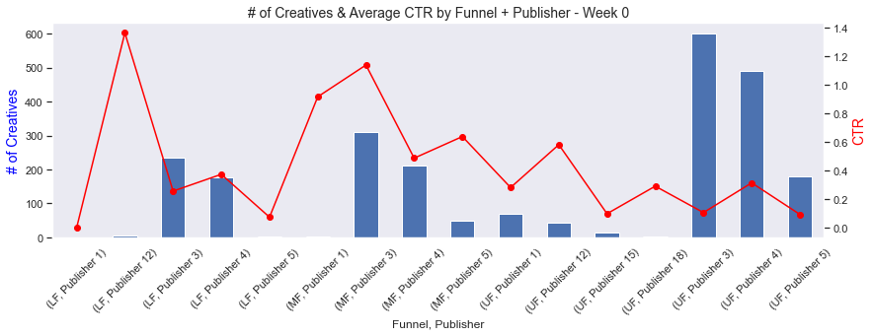

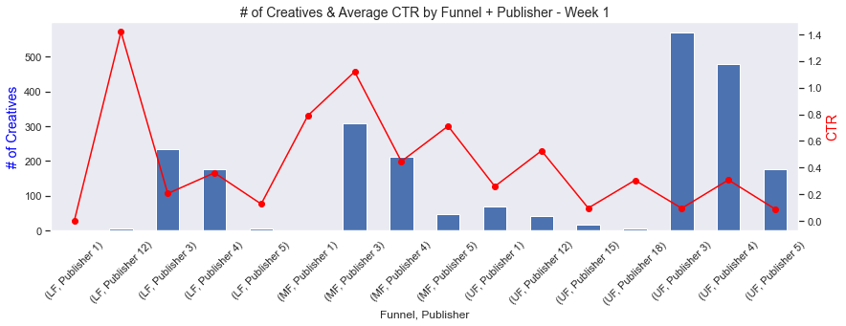

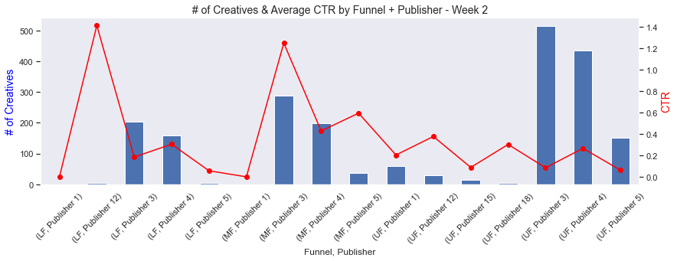

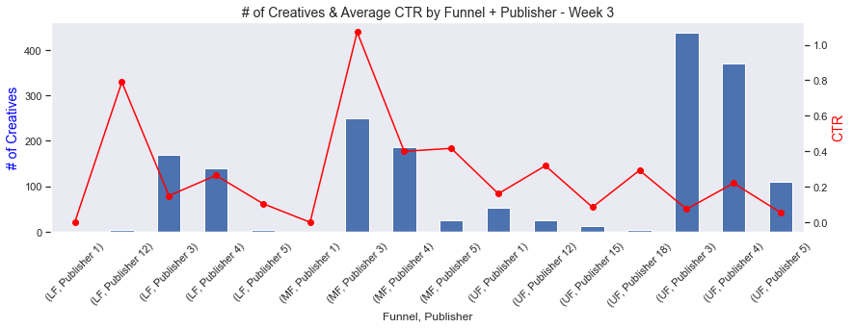

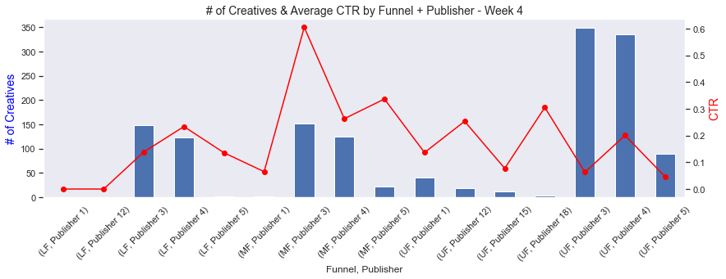

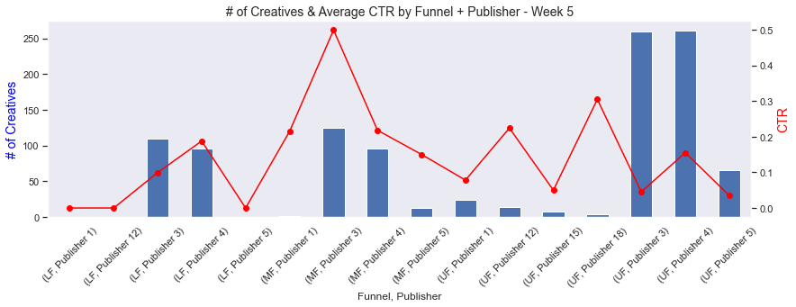

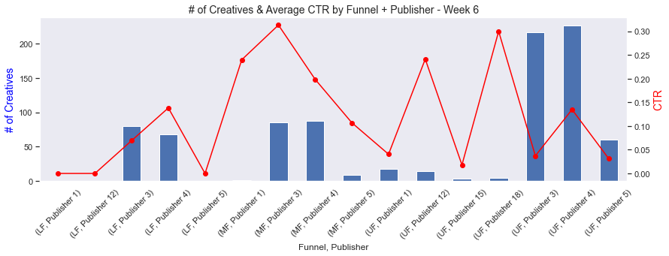

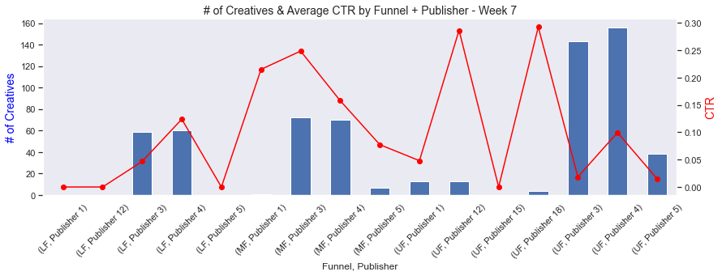

In [ ]:

*# Number of Creatives vs Buy Flow CVR - first two months*  
**for** i **in** range(8):  
 plt**.**subplots(figsize**=**(14, 4))  
  
 ax **=** creatives_df[f'In_Market_W{i}']**.**plot(kind**=**'bar')  
 ax**.**set_xlabel('Funnel, Publisher')  
 ax**.**set_xticklabels(ax**.**get_xticks(), rotation**=**45)  
 ax**.**set_ylabel('# of Creatives', color**=**'blue', fontsize**=**14)  
  
 ax2 **=** ax**.**twinx()  
  
 creatives_df[f'CVR(BF)_W{i}']**.**plot(ax**=**ax2, color**=**'red', style**=**'o-')  
 ax2**.**set_ylabel('CVRBF', color**=**'red', fontsize**=**14)  
  
 plt**.**title(f'# of Creatives & Average CVRBF by Funnel + Publisher - Week {i}', fontsize**=**14)  
 ax**.**grid(**False**)  
 ax2**.**grid(**False**)  
  
 plt**.**show()

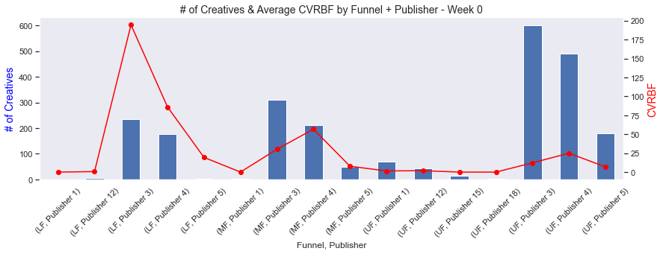

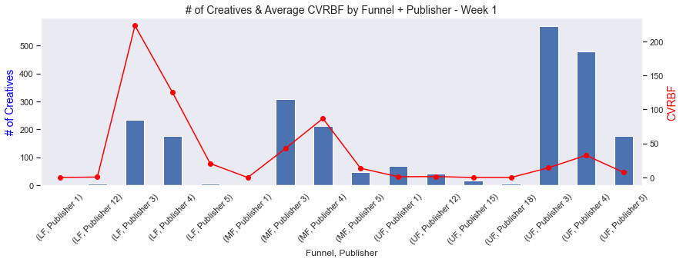

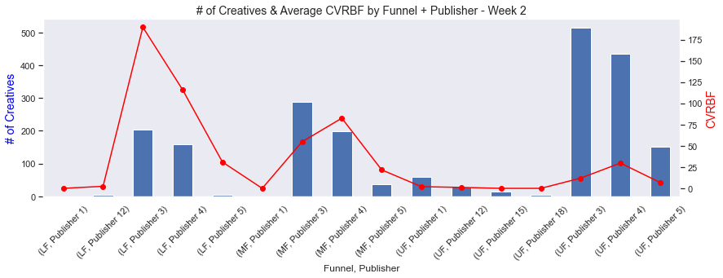

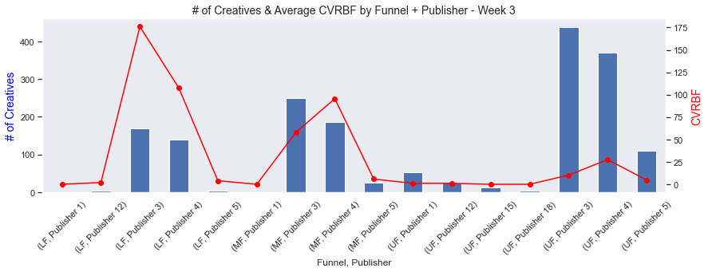

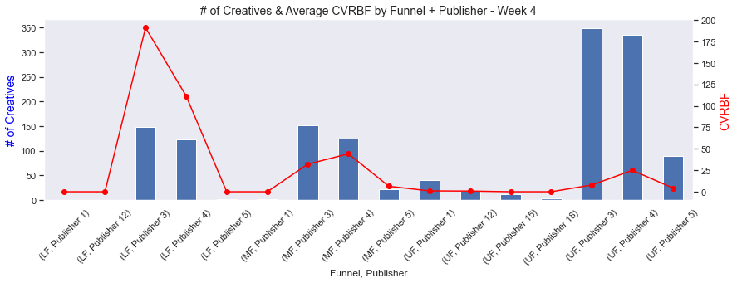

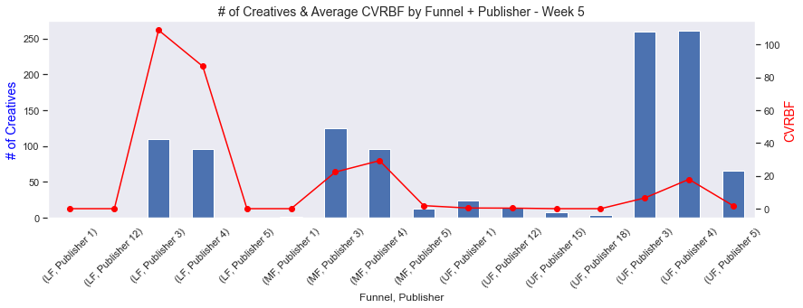

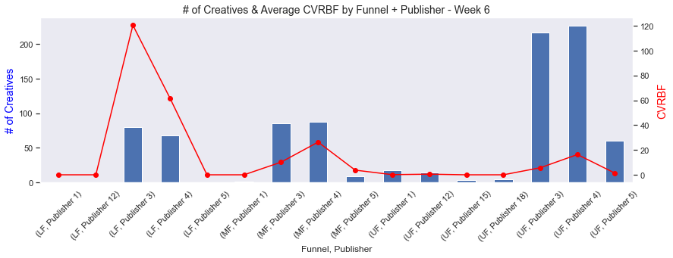

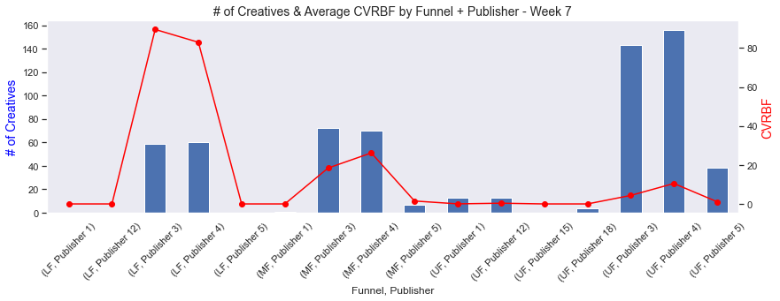

In [ ]:

*# Number of Creatives vs Site Visit CVR - first two months*  
**for** i **in** range(8):  
 plt**.**subplots(figsize**=**(14, 4))  
  
 ax **=** creatives_df[f'In_Market_W{i}']**.**plot(kind**=**'bar')  
 ax**.**set_xlabel('Funnel, Publisher')  
 ax**.**set_xticklabels(ax**.**get_xticks(), rotation**=**45)  
 ax**.**set_ylabel('# of Creatives', color**=**'blue', fontsize**=**14)  
  
 ax2 **=** ax**.**twinx()  
  
 creatives_df[f'CVR(SV)_W{i}']**.**plot(ax**=**ax2, color**=**'red', style**=**'o-')  
 ax2**.**set_ylabel('Site Visit CVR', color**=**'red', fontsize**=**14)  
  
 plt**.**title(f'# of Creatives & Average Site Visit CVR by Funnel + Publisher - Week {i}', fontsize**=**14)  
 ax**.**grid(**False**)  
 ax2**.**grid(**False**)  
  
 plt**.**show()

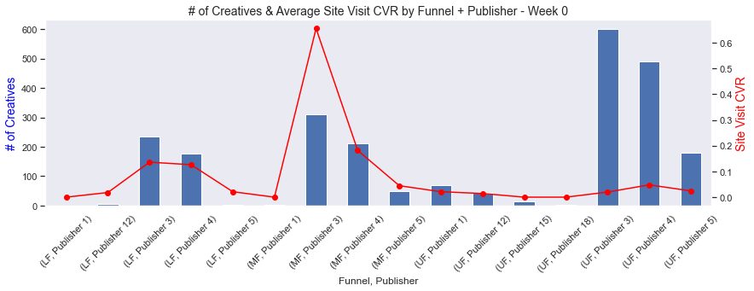

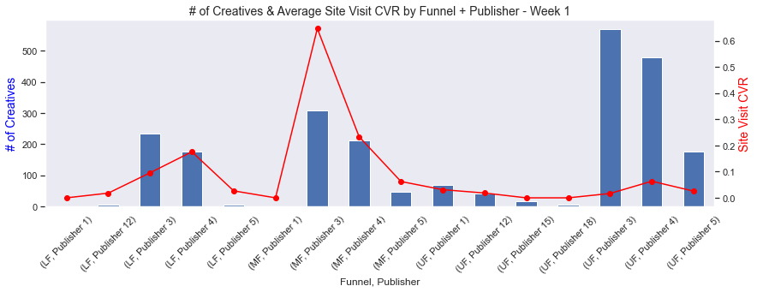

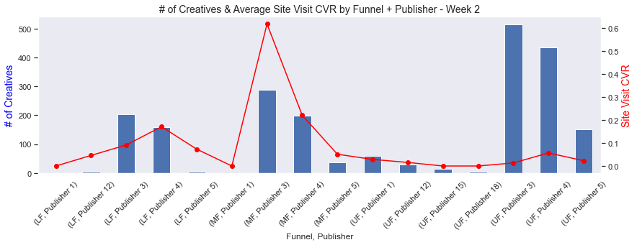

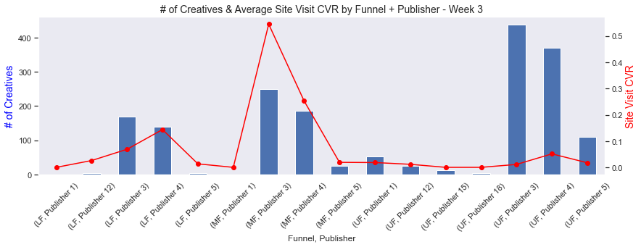

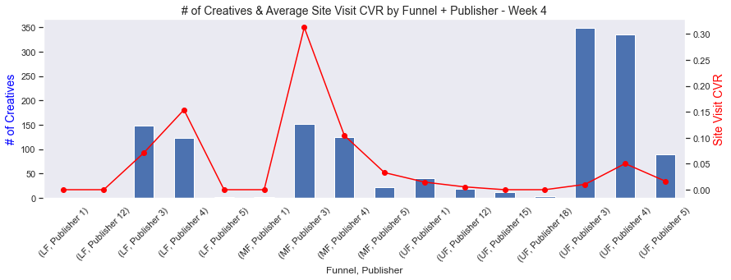

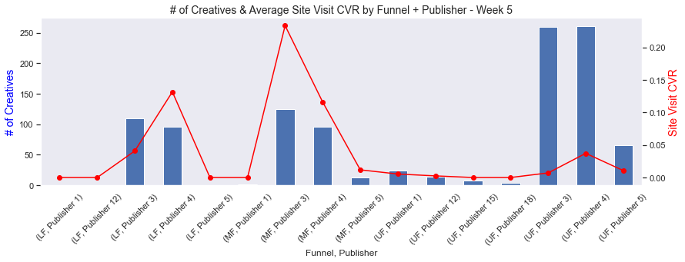

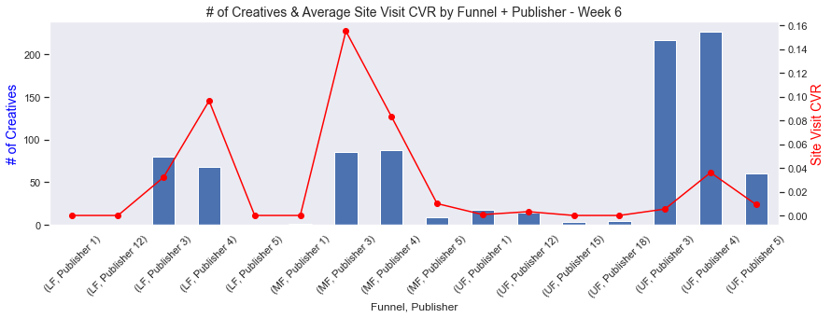

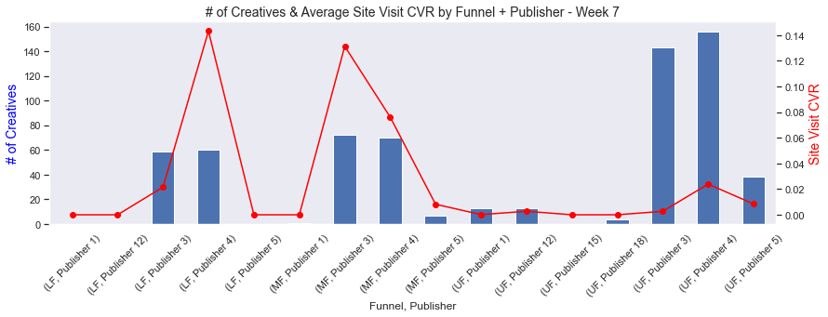

In [ ]:

*# Number of Creatives vs Sales CVR - first two months*  
**for** i **in** range(8):  
 plt**.**subplots(figsize**=**(14, 4))  
  
 ax **=** creatives_df[f'In_Market_W{i}']**.**plot(kind**=**'bar')  
 ax**.**set_xlabel('Funnel, Publisher')  
 ax**.**set_xticklabels(ax**.**get_xticks(), rotation**=**45)  
 ax**.**set_ylabel('# of Creatives', color**=**'blue', fontsize**=**14)  
  
 ax2 **=** ax**.**twinx()  
  
 creatives_df[f'Internet_CVR(S)_W{i}']**.**plot(ax**=**ax2, color**=**'red', style**=**'o-')  
 ax2**.**set_ylabel('Sales CVR', color**=**'red', fontsize**=**14)  
  
 plt**.**title(f'# of Creatives & Average Sales CVR by Funnel + Publisher - Week {i}', fontsize**=**14)  
 ax**.**grid(**False**)  
 ax2**.**grid(**False**)  
  
 plt**.**show()

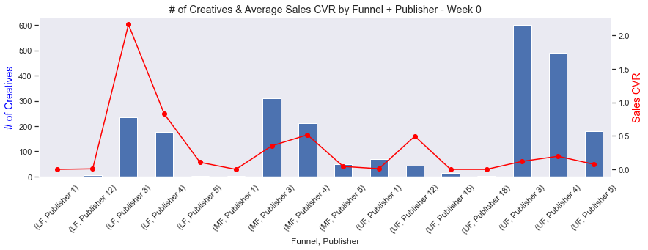

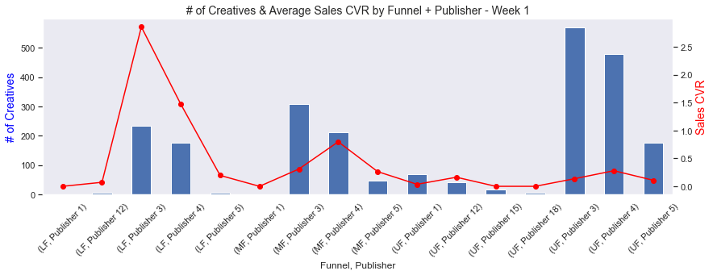

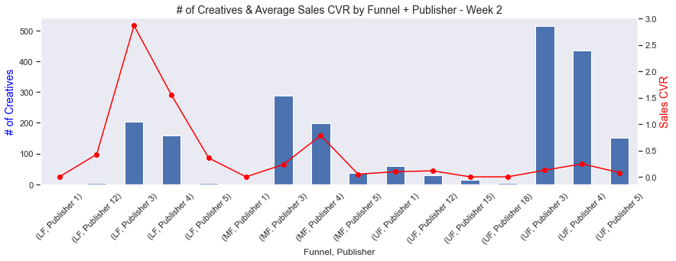

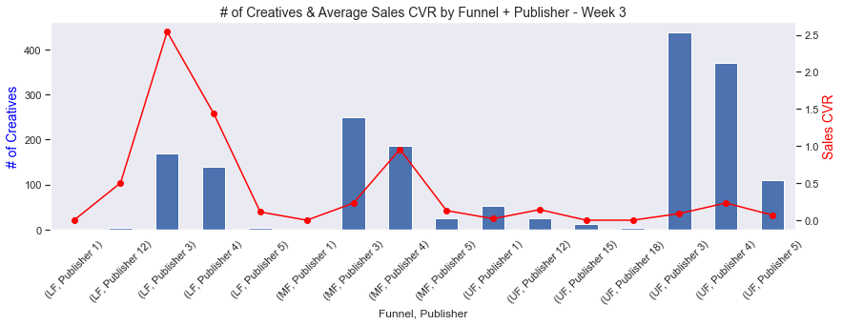

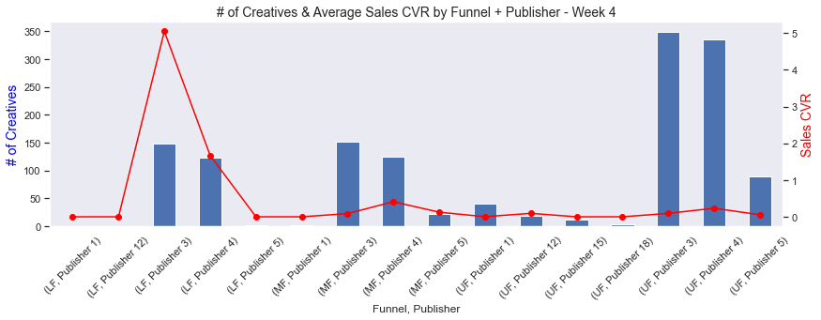

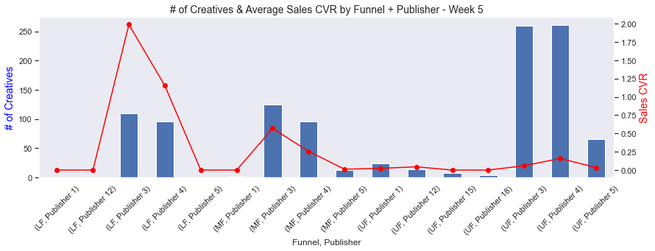

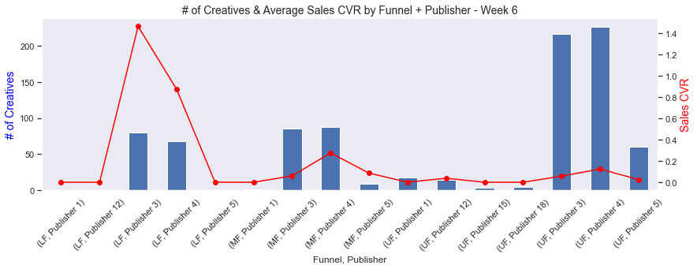

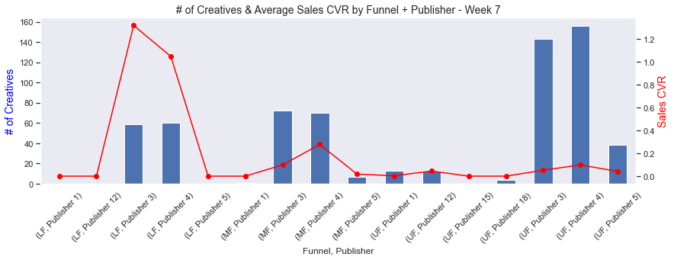

From the graphs above, it seems like publisher 3 and 4 are most influential for all but CTR KPIs. However, this may be because there are not many creatives at other publishers to begin with. One thing to experiment with is increasing the number of creatives at a specific funnel and publisher in an attempt to increase a certain KPI. For instance, if trying to increase sales CVR, increasing the number of creatives in the LF using publisher 1, 12 and 5 could prove useful.

What's the average KPI behaviour after launch?

In [ ]:

*# Plot weekly means*  
ctr_means **=** np**.**mean(week_data[ctr_w])  
cvrbf_means **=** np**.**mean(week_data[cvrbf_w])  
cvrsv_means **=** np**.**mean(week_data[cvrsv_w])  
cvrint_means **=** np**.**mean(week_data[cvrint_w])  
  
kpis **=** {  
 'CTR': ctr_means**.**values,  
 'Buy Flow CVR': cvrbf_means**.**values,  
 'Site Visit CVR': cvrsv_means**.**values,  
 'Sales CVR': cvrint_means**.**values  
}  
  
kpi_means_df **=** pd**.**DataFrame(kpis)  
  
fig, ax **=** plt**.**subplots(2, 2, figsize**=**(14, 6), sharex**=True**)  
fig**.**suptitle('Average Weekly KPIs', fontsize**=**14)  
  
sns**.**lineplot(x**=**range(41), y**=**'CTR', data**=**kpi_means_df, ax**=**ax[0,0])  
ax[0,0]**.**set_title('CTR')  
ax[0,0]**.**set_xlabel('Weeks Since Launch')  
ax[0,0]**.**set_ylabel('')  
  
sns**.**lineplot(x**=**range(41), y**=**'Buy Flow CVR', data**=**kpi_means_df, ax**=**ax[0,1])  
ax[0,1]**.**set_title('Buy Flow CVR')  
ax[0,1]**.**set_xlabel('Weeks Since Launch')  
ax[0,1]**.**set_ylabel('')  
  
sns**.**lineplot(x**=**range(41), y**=**'Site Visit CVR', data**=**kpi_means_df, ax**=**ax[1,0])  
ax[1,0]**.**set_title('Site Visit CVR')  
ax[1,0]**.**set_xlabel('Weeks Since Launch')  
ax[1,0]**.**set_ylabel('')  
  
sns**.**lineplot(x**=**range(41), y**=**'Sales CVR', data**=**kpi_means_df, ax**=**ax[1,1])  
ax[1,1]**.**set_title('Sales CVR')  
ax[1,1]**.**set_xlabel('Weeks Since Launch')  
ax[1,1]**.**set_ylabel('')  
  
plt**.**show()

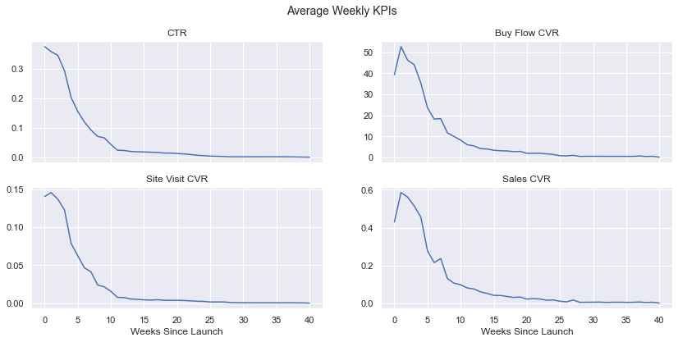

CTRs fall immediately upon launch, whereas BF, SV, and sales increases for a short period. This behaviour seems normal since some people may visit the website but not necessarily by clicking on the creative ad itself. We also see that a creatives life cycle begins to end near week 10 where the "elbow" or "kink" is located.

PLO - Impact of number of creatives in market on performance¶

In [ ]:

*# Find number of creatives in market per week*  
n_creatives_w **=** [f'N_Creatives_W{i}' **for** i **in** range(41)]  
  
n_creatives **=** week_data[ctr_w]**.**astype(bool)**.**sum(axis**=**0)  
n_creatives**.**index **=** n_creatives_w  
n_creatives**.**to_frame()**.**T

Out[ ]:

|  | **N_Creatives_W0** | **N_Creatives_W1** | **N_Creatives_W2** | **N_Creatives_W3** | **N_Creatives_W4** | **N_Creatives_W5** | **N_Creatives_W6** | **N_Creatives_W7** | **N_Creatives_W8** | **N_Creatives_W9** | **N_Creatives_W10** | **N_Creatives_W11** | **N_Creatives_W12** | **N_Creatives_W13** | **N_Creatives_W14** | **N_Creatives_W15** | **N_Creatives_W16** | **N_Creatives_W17** | **N_Creatives_W18** | **N_Creatives_W19** | **N_Creatives_W20** | **N_Creatives_W21** | **N_Creatives_W22** | **N_Creatives_W23** | **N_Creatives_W24** | **N_Creatives_W25** | **N_Creatives_W26** | **N_Creatives_W27** | **N_Creatives_W28** | **N_Creatives_W29** | **N_Creatives_W30** | **N_Creatives_W31** | **N_Creatives_W32** | **N_Creatives_W33** | **N_Creatives_W34** | **N_Creatives_W35** | **N_Creatives_W36** | **N_Creatives_W37** | **N_Creatives_W38** | **N_Creatives_W39** | **N_Creatives_W40** |
| --- | --- | --- | --- | --- | --- | --- | --- | --- | --- | --- | --- | --- | --- | --- | --- | --- | --- | --- | --- | --- | --- | --- | --- | --- | --- | --- | --- | --- | --- | --- | --- | --- | --- | --- | --- | --- | --- | --- | --- | --- | --- |
| **0** | 2370 | 2311 | 2079 | 1764 | 1396 | 1052 | 853 | 622 | 511 | 448 | 351 | 241 | 231 | 211 | 201 | 190 | 180 | 169 | 142 | 136 | 111 | 104 | 97 | 67 | 47 | 33 | 27 | 24 | 11 | 11 | 11 | 11 | 11 | 11 | 11 | 11 | 11 | 11 | 7 | 5 | 2 |

In [ ]:

creatives_df2 **=** pd**.**DataFrame(  
 {'n_creatives': n_creatives**.**values,  
 'ctr_means': ctr_means**.**values,  
 'cvrbf_means': cvrbf_means**.**values,  
 'cvrsv_means': cvrsv_means**.**values,  
 'sales_cvr_means': cvrint_means**.**values}  
)  
creatives_df2**.**reset_index(drop**=True**, inplace**=True**)  
creatives_df2**.**head()

Out[ ]:

|  | **n_creatives** | **ctr_means** | **cvrbf_means** | **cvrsv_means** | **sales_cvr_means** |
| --- | --- | --- | --- | --- | --- |
| **0** | 2370 | 0.374186 | 39.272953 | 0.140441 | 0.429555 |
| **1** | 2311 | 0.357175 | 52.604816 | 0.145592 | 0.585678 |
| **2** | 2079 | 0.344800 | 46.170140 | 0.136816 | 0.562004 |
| **3** | 1764 | 0.292899 | 44.055353 | 0.122841 | 0.514986 |
| **4** | 1396 | 0.202293 | 35.272214 | 0.078685 | 0.455427 |

In [ ]:

*# Plot number of creatives against KPIs*  
fig, ax **=** plt**.**subplots(2, 2, figsize**=**(18, 10), sharex**=True**)  
  
sns**.**regplot(x**=**'n_creatives', y**=**'ctr_means', data**=**creatives_df2, ax**=**ax[0,0])  
ax[0,0]**.**set_title('Average CTR vs Creatives')  
ax[0,0]**.**set_ylabel('CTR')  
  
sns**.**regplot(x**=**'n_creatives', y**=**'cvrbf_means', data**=**creatives_df2, ax**=**ax[0,1])  
ax[0,1]**.**set_title('Average Buy Flow CVR vs Creatives')  
ax[0,1]**.**set_ylabel('Buy Flow CVR')  
  
sns**.**regplot(x**=**'n_creatives', y**=**'cvrsv_means', data**=**creatives_df2, ax**=**ax[1,0])  
ax[1,0]**.**set_title('Average Site Visit CVR vs Creatives')  
ax[1,0]**.**set_ylabel('Site Visit CVR')  
  
sns**.**regplot(x**=**'n_creatives', y**=**'sales_cvr_means', data**=**creatives_df2, ax**=**ax[1,1])  
ax[1,1]**.**set_title('Average Sales CVR vs Creatives')  
ax[1,1]**.**set_ylabel('Sales CVR')  
  
plt**.**show()

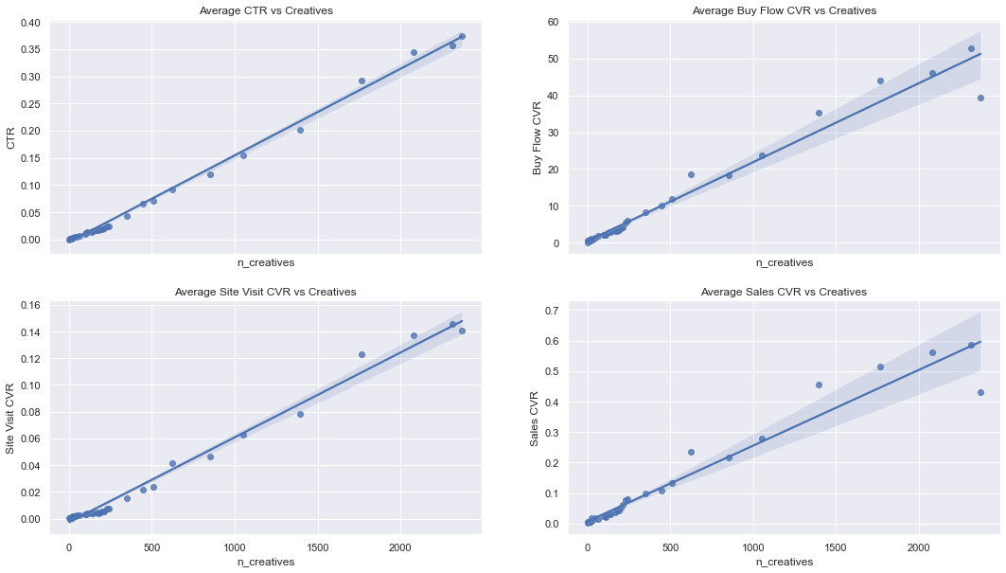

In [ ]:

creatives_df2**.**corr()

Out[ ]:

|  | **n_creatives** | **ctr_means** | **cvrbf_means** | **cvrsv_means** | **sales_cvr_means** |
| --- | --- | --- | --- | --- | --- |
| **n_creatives** | 1.000000 | 0.997729 | 0.985216 | 0.994686 | 0.976511 |
| **ctr_means** | 0.997729 | 1.000000 | 0.983302 | 0.998449 | 0.973790 |
| **cvrbf_means** | 0.985216 | 0.983302 | 1.000000 | 0.987495 | 0.997707 |
| **cvrsv_means** | 0.994686 | 0.998449 | 0.987495 | 1.000000 | 0.978633 |
| **sales_cvr_means** | 0.976511 | 0.973790 | 0.997707 | 0.978633 | 1.000000 |

The number of creatives in market is highly correlated with average KPIs so, theoretically, increasing the number of creatives also increases KPI.

Additional Analysis¶

Data Variables¶

In [ ]:

*# Remove week features*  
social_data **=** social_data**.**iloc[:, :16]  
social_data**.**info()

<class 'pandas.core.frame.DataFrame'>  
Int64Index: 2452 entries, 0 to 13216  
Data columns (total 16 columns):  
 # Column Non-Null Count Dtype   
--- ------ -------------- -----   
 0 Creative ID 2452 non-null object   
 1 funnel 2452 non-null object   
 2 publisher 2452 non-null object   
 3 lob 2452 non-null object   
 4 product 2452 non-null object   
 5 theme 2452 non-null object   
 6 kpi_audience 2452 non-null object   
 7 creative_versions 2452 non-null object   
 8 price 2452 non-null object   
 9 price_placement 1242 non-null object   
 10 discount 2452 non-null float64  
 11 offer_placement 1242 non-null object   
 12 offer_group 2452 non-null object   
 13 asset_type 2452 non-null object   
 14 video_type 2360 non-null object   
 15 length 2452 non-null object   
dtypes: float64(1), object(15)  
memory usage: 325.7+ KB

In [ ]:

social_data**.**describe(include**=**'object')

Out[ ]:

|  | **Creative ID** | **funnel** | **publisher** | **lob** | **product** | **theme** | **kpi_audience** | **creative_versions** | **price** | **price_placement** | **offer_placement** | **offer_group** | **asset_type** | **video_type** | **length** |
| --- | --- | --- | --- | --- | --- | --- | --- | --- | --- | --- | --- | --- | --- | --- | --- |
| **count** | 2452 | 2452 | 2452 | 2452 | 2452 | 2452 | 2452 | 2452 | 2452 | 1242 | 1242 | 2452 | 2452 | 2360 | 2452 |
| **unique** | 2452 | 3 | 7 | 2 | 7 | 14 | 15 | 12 | 8 | 5 | 7 | 7 | 5 | 6 | 7 |
| **top** | Creative 1 | UF | Publisher 3 | LOB 1 | Product 3 | Theme 2 | Audience 1 | Creative 3 | No Price | No Price | No Offer | No offer | Vid | Live Action | :15 |
| **freq** | 1 | 1432 | 1166 | 1653 | 938 | 1157 | 1052 | 900 | 1342 | 574 | 559 | 2159 | 2355 | 1030 | 1132 |

In [ ]:

social_data**.**describe(include**=**'float')

Out[ ]:

|  | **discount** |
| --- | --- |
| **count** | 2452.00000 |
| **mean** | 5.09584 |
| **std** | 7.51043 |
| **min** | 0.00000 |
| **25%** | 0.00000 |
| **50%** | 0.00000 |
| **75%** | 10.00000 |
| **max** | 25.00000 |

In [ ]:

social_data**.**duplicated()**.**any()

Out[ ]:

False

In [ ]:

*# Visualize proportions*  
cat_data **=** social_data**.**drop(columns**=**'discount')**.**fillna(np**.**nan)  
**for** col **in** cat_data**.**columns[1:]:  
 *# Get proportions*  
 means **=** social_data[col]**.**value_counts(normalize**=True**)  
  
 *# Formatting condition*  
 **if** len(means) **>** 4:  
 plt**.**figure(figsize**=**(12, 6))  
 plt**.**xticks(rotation**=**45)  
  
 *# Plot*  
 sns**.**barplot(x**=**means**.**index, y**=**col, data**=**means**.**to_frame())  
 plt**.**title(f'{col**.**capitalize()} Proportions')  
 plt**.**ylabel(f'P({col**.**capitalize()} = x)')  
 plt**.**yticks()  
 plt**.**show()

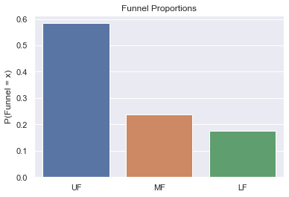

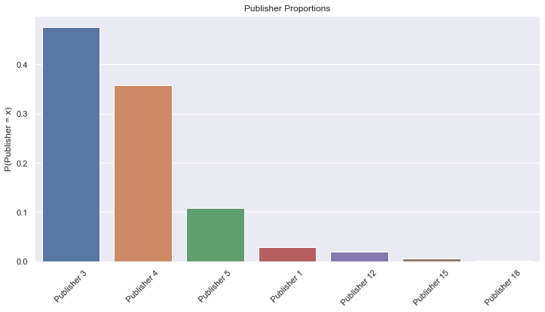

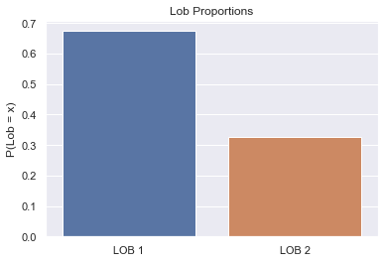

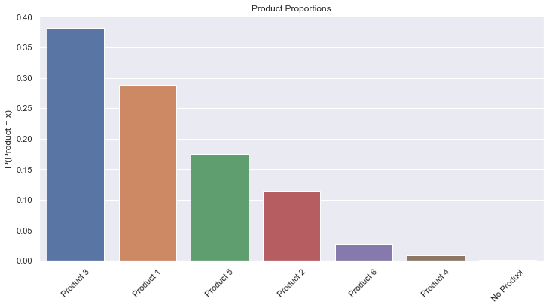

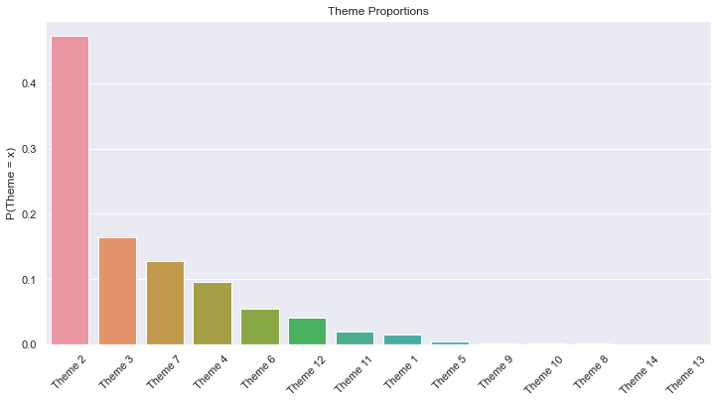

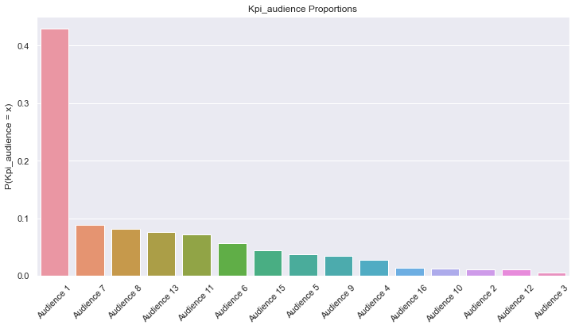

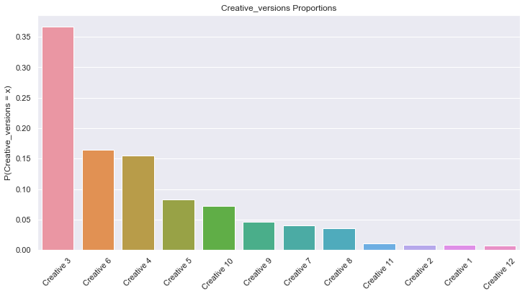

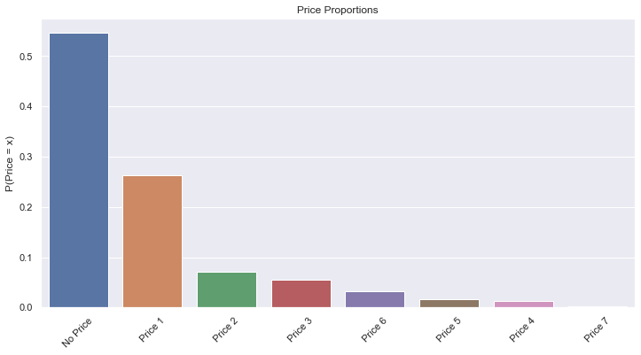

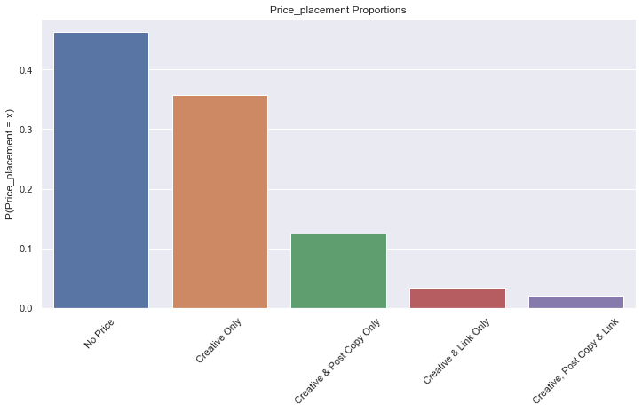

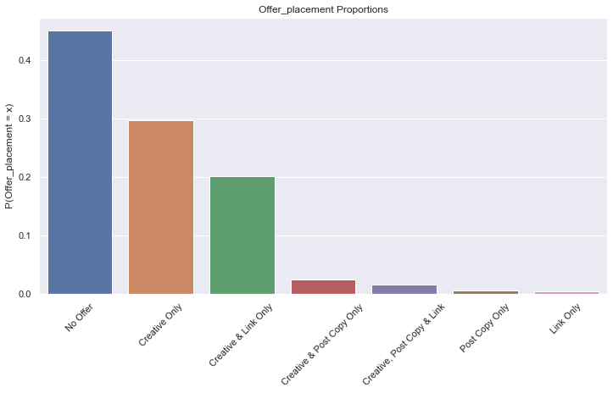

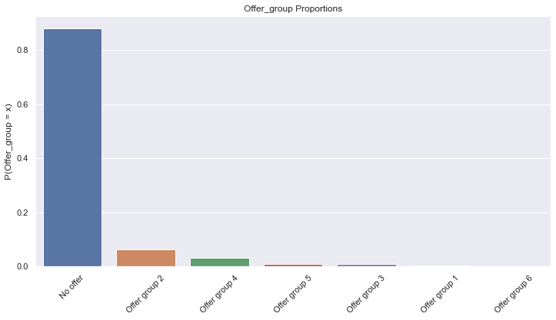

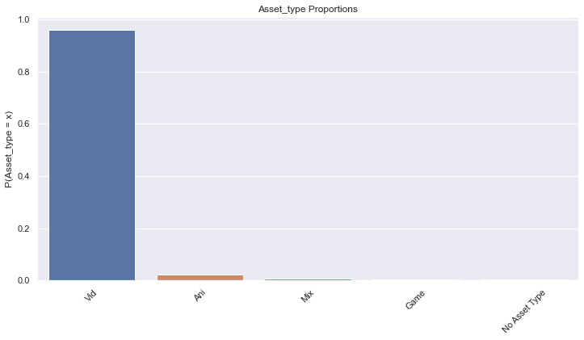

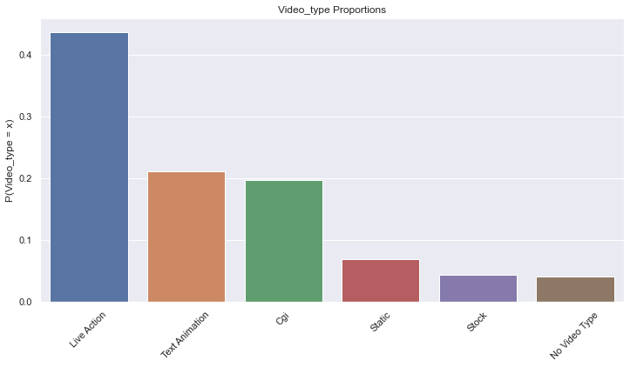

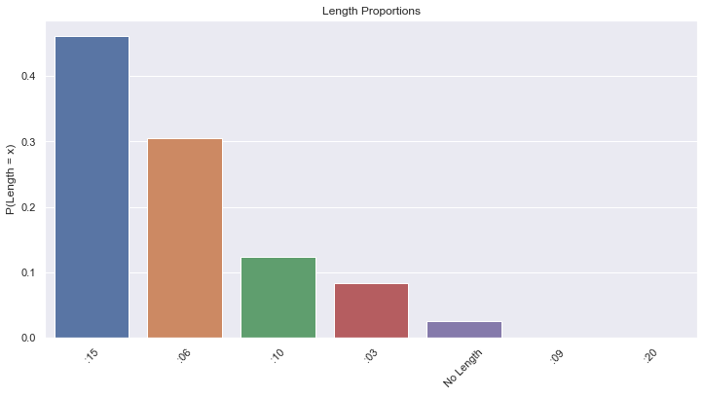

Offer_group and Asset_type both contain a value that occurs over 80% of the time in the data. Since the other values are rare, there is no way to "balance" the data. These features will likely not prove useful in predicting. Features publisher, product, theme, creative_versions, price, price_placement, offer_placement and length will be tweaked slightly in an attempt to have more balanced outcomes.

In [ ]:

*# Unbalanced variables*  
publishers **=** ['Publisher 1', 'Publisher 12', 'Publisher 15', 'Publisher 18']  
products **=** ['Product 4', 'Product 6', 'No Product']  
themes **=** ['Theme 1', 'Theme 5', 'Theme 8', 'Theme 9', 'Theme 10', 'Theme 13', 'Theme 14']  
audiences **=** ['Audience 2', 'Audience 3', 'Audience 10', 'Audience 12', 'Audience 16']  
creative_vers **=** ['Creative 1', 'Creative 2', 'Creative 11', 'Creative 12']  
prices **=** ['Price 2', 'Price 3', 'Price 4', 'Price 5', 'Price 6', 'Price 7']  
price_placements **=** ['Creative & Link Only', 'Creative, Post Copy & Link']  
offer_placements **=** ['Creative & Post Copy Only', 'Creative, Post Copy & Link', 'Post Copy Only', 'Link Only']  
lengths **=** ['No Length', ':09', ':20']  
  
social_data['publisher'] **=** social_data['publisher']**.**replace(publishers, 'Other')  
social_data['product'] **=** social_data['product']**.**replace(products, 'Other')  
social_data['theme'] **=** social_data['theme']**.**replace(themes, 'Other')  
social_data['kpi_audience'] **=** social_data['kpi_audience']**.**replace(audiences, 'Other')  
social_data['creative_versions'] **=** social_data['creative_versions']**.**replace(creative_vers, 'Other')  
social_data['price'] **=** social_data['price']**.**replace(prices, 'Other')  
social_data['price_placement'] **=** social_data['price_placement']**.**replace(price_placements, 'Other')  
social_data['offer_placement'] **=** social_data['offer_placement']**.**replace(offer_placements, 'Other')  
social_data['length'] **=** social_data['length']**.**replace(lengths, 'Other')

In [ ]:

*# Visualize proportions*  
cat_data **=** social_data**.**drop(columns**=**['discount', 'offer_group', 'asset_type'])**.**fillna(np**.**nan)  
**for** col **in** cat_data**.**columns[1:]:  
 *# Get proportions*  
 means **=** social_data[col]**.**value_counts(normalize**=True**)  
  
 *# Formatting condition*  
 **if** len(means) **>** 3:  
 plt**.**figure(figsize**=**(12, 6))  
 plt**.**xticks(rotation**=**45)  
  
 *# Plot*  
 sns**.**barplot(x**=**means**.**index, y**=**col, data**=**means**.**to_frame())  
 plt**.**title(f'{col**.**capitalize()} Proportions')  
 plt**.**ylabel(f'P({col**.**capitalize()} = x)')  
 plt**.**yticks()  
 plt**.**show()



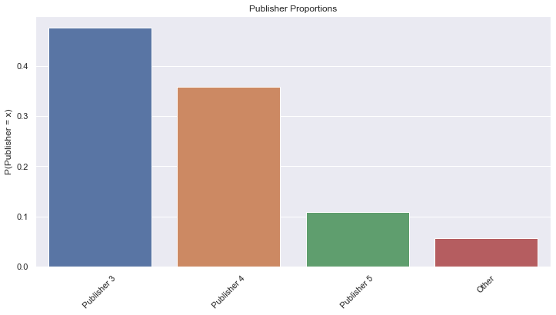



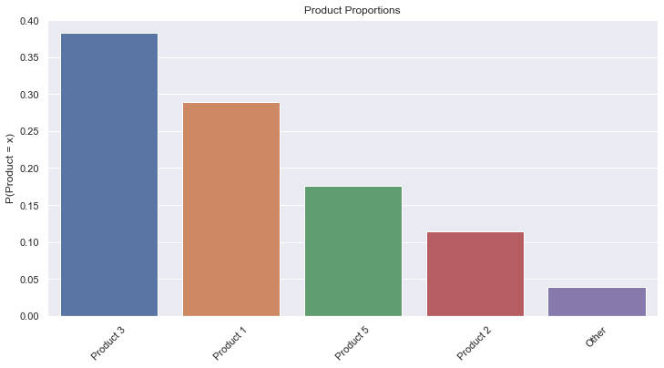

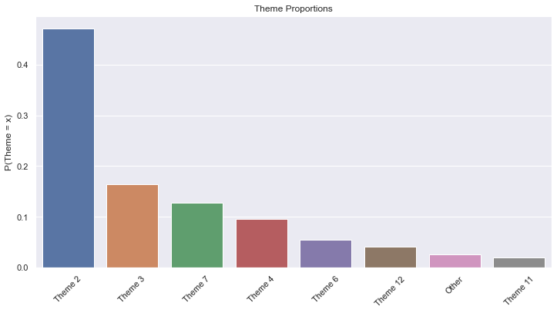

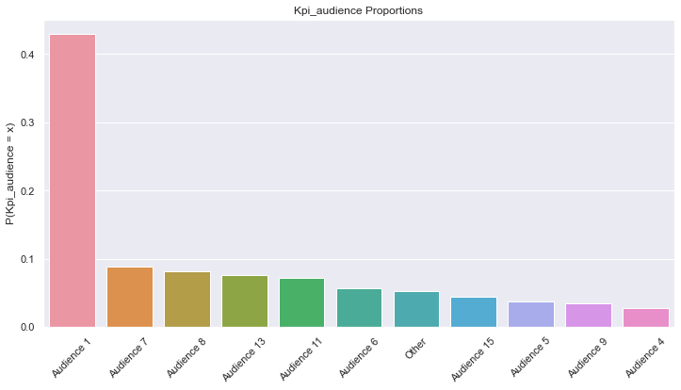

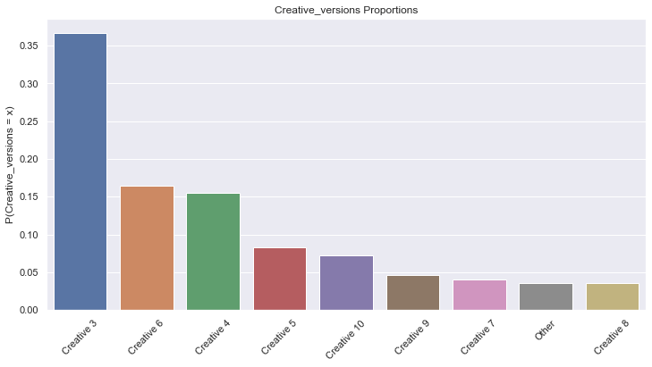

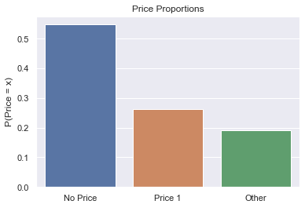

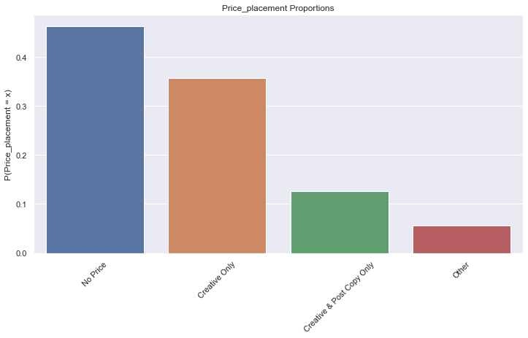

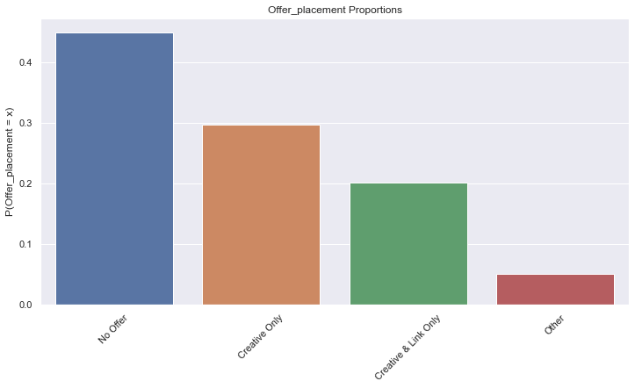



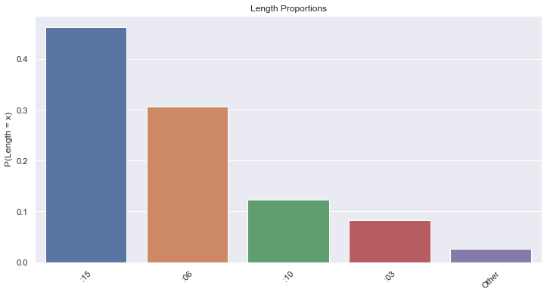

In [ ]:

*# Check for anomalies*  
social_data[social_data**.**discount **<** 0]**.**shape

Out[ ]:

(0, 16)

In [ ]:

*# Check for anomalies*  
social_data[(social_data**.**price_placement **==** 'No Price') **&** (social_data**.**discount **>** 0)]

Out[ ]:

|  | **Creative ID** | **funnel** | **publisher** | **lob** | **product** | **theme** | **kpi_audience** | **creative_versions** | **price** | **price_placement** | **discount** | **offer_placement** | **offer_group** | **asset_type** | **video_type** | **length** |
| --- | --- | --- | --- | --- | --- | --- | --- | --- | --- | --- | --- | --- | --- | --- | --- | --- |
| **2150** | Creative 2151 | UF | Publisher 5 | LOB 1 | Product 1 | Theme 2 | Audience 11 | Creative 5 | No Price | No Price | 10.0 | Other | No offer | Vid | Live Action | :15 |

There seems to be only one creative where there is no price, yet there is a discount. Since it's only one creative, we can simply change the discount value to 0.

In [ ]:

social_data**.**loc[2150, 'discount'] **=** 0

Get data ready for modelling¶

In [ ]:

*# One hot encode new social channel data and add new feature*  
final_dummy_data **=** pd**.**get_dummies(social_data, columns**=**cat_data**.**columns[1:], drop_first**=True**)**.**drop(columns**=**['offer_group', 'asset_type'])  
final_dummy_data['discount_applied'] **=** final_dummy_data['discount']**.**apply(**lambda** x: 1 **if** x **>** 0 **else** 0)  
  
labeled_social_data**.**drop(columns**=**['offer_group', 'asset_type'], inplace**=True**)  
labeled_social_data['discount_applied'] **=** labeled_social_data['discount']**.**apply(**lambda** x: 1 **if** x **>** 0 **else** 0)  
  
*# Remove W41 to W47*  
**for** week **in** labeled_social_data**.**columns:  
 **if** week[**-**3:] **in** weeks_to_drop:  
 labeled_social_data**.**drop(columns**=**week, inplace**=True**)

In [ ]:

final_dummy_data **=** pd**.**merge(  
 final_dummy_data**.**reset_index(),  
 week_data**.**reset_index(),  
 how**=**'inner',  
 left_on**=**'index',  
 right_on**=**'index'  
)  
final_dummy_data**.**drop(columns**=**'index', inplace**=True**)  
  
final_labeled_social_data **=** pd**.**merge(  
 labeled_social_data**.**reset_index(),  
 week_data**.**reset_index()[['index']],  
 how**=**'inner',  
 left_on**=**'index',  
 right_on**=**'index'  
)  
  
*# Drop bad features for modelling*  
*# to_drop = ['index', 'Mean_Spend', 'total_spend', 'total_Impressions', 'Mean_CTR',*  
*# 'Mean_CVRS', 'Mean_CVRBF', 'Mean_CVRSV', 'Peak_CTR', 'Peak_CVRS', 'Peak_CVRBF',*  
*# 'Peak_CVRSV' ,'Med_CTR', 'Med_CVRS', 'Med_CVRBF', 'Med_CVRSV'*  
*# ]*  
  
*# final_labeled_social_data.drop(columns=to_drop, inplace=True)*

In [ ]:

*# Reorder discount_applied column*  
discount **=** final_labeled_social_data**.**iloc[:, **-**1]  
final_labeled_social_data **=** final_labeled_social_data**.**iloc[:, :14]  
final_labeled_social_data **=** pd**.**concat(  
 [final_labeled_social_data**.**reset_index(),discount**.**reset_index(), week_data**.**reset_index()], axis**=**1  
)  
final_labeled_social_data**.**drop(columns**=**'index', inplace**=True**)

In [ ]:

final_dummy_data**.**to_csv('ML_data/dummy_ml.csv', index**=False**)  
final_labeled_social_data**.**to_csv('ML_data/labeled_ml.csv', index**=False**)

KPI + Impressions and Spending Distributions¶

In [ ]:

week_data**.**reset_index(drop**=True**, inplace**=True**)

In [ ]:

*# Plot distributions of click through rate*  
**for** idx, ctr **in** enumerate(ctr_w):  
 plt**.**figure(figsize**=**(20, 6))  
 week_data[ctr]**.**plot()  
 plt**.**title(f'CTR Week {idx} Distribution')  
 plt**.**xlabel('Creative')  
 plt**.**ylabel('CTR')  
 plt**.**show()

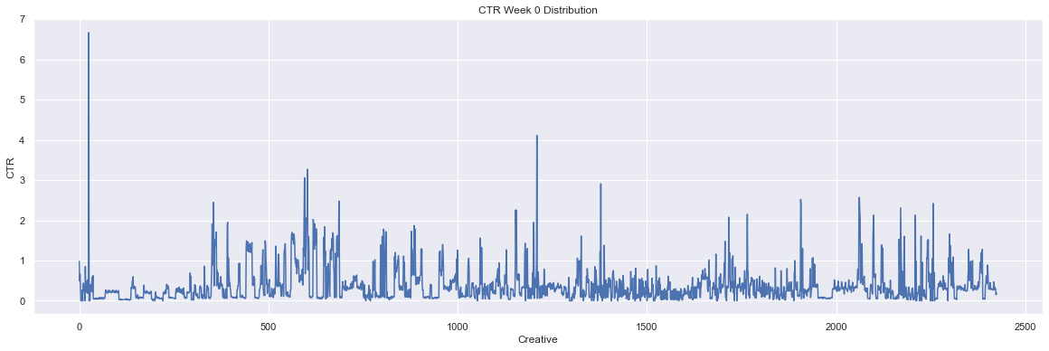

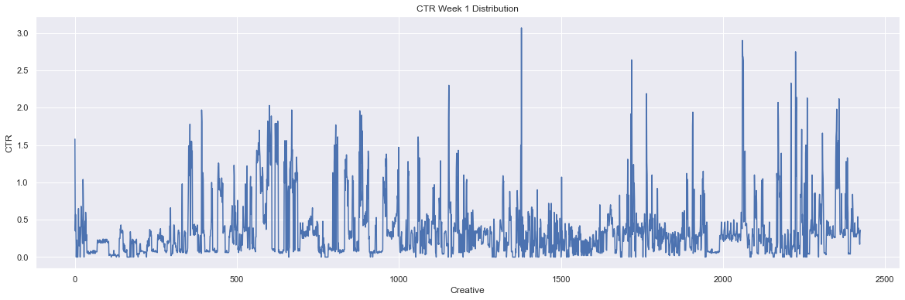

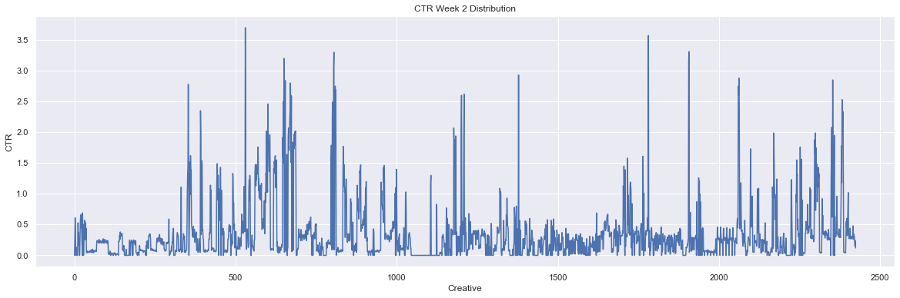

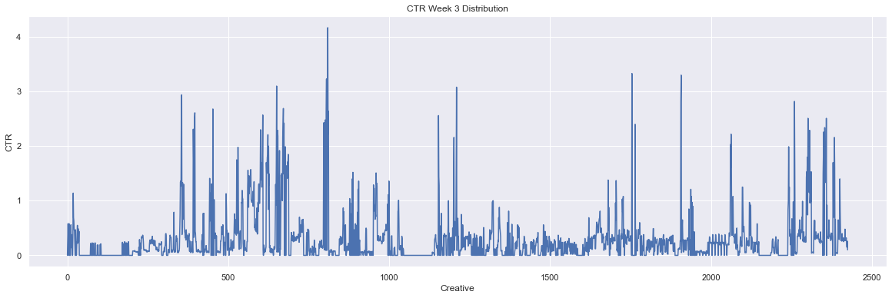

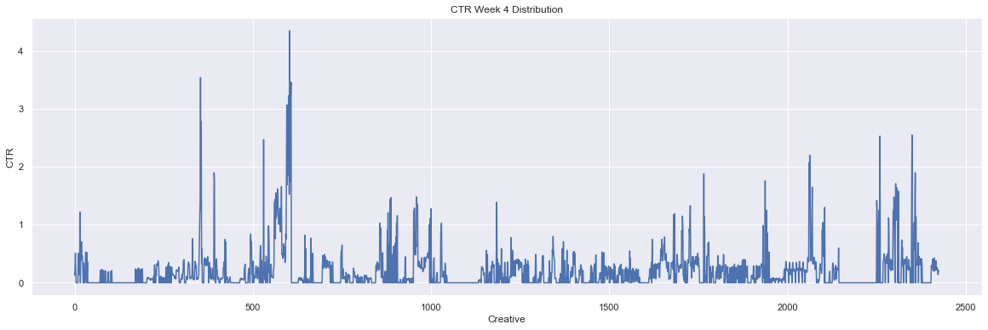

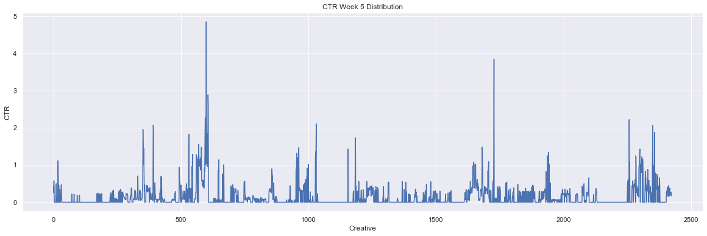

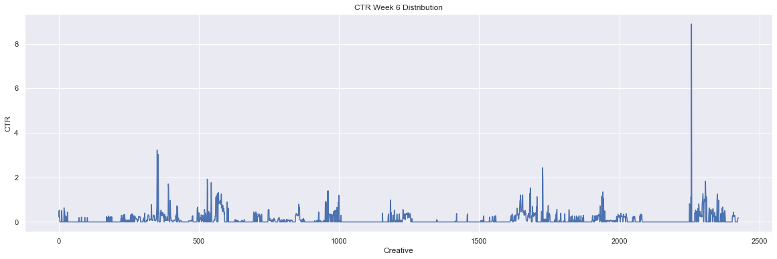

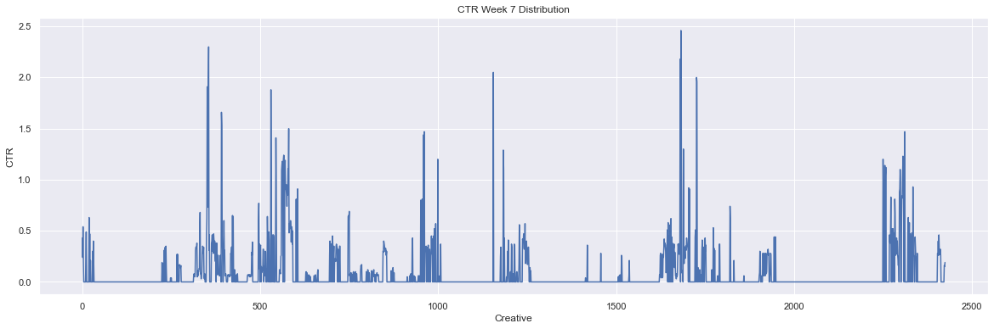

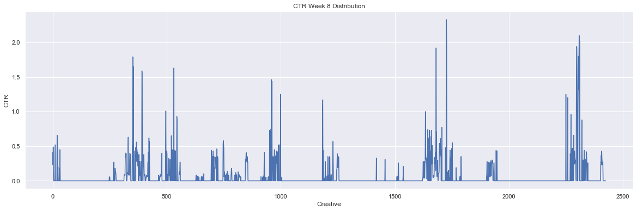

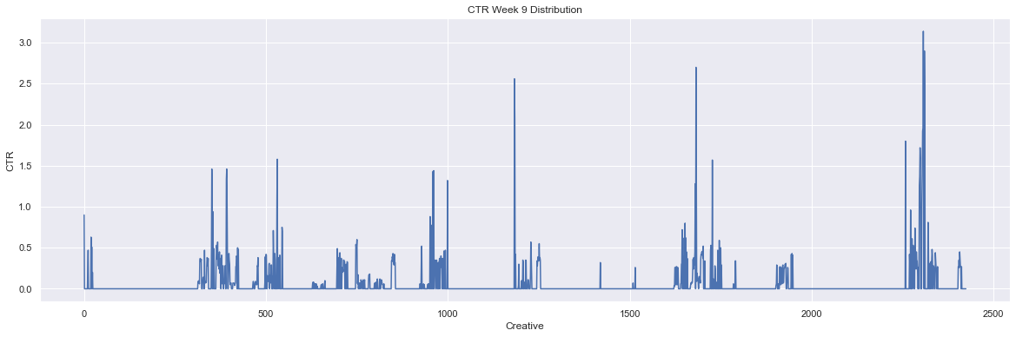

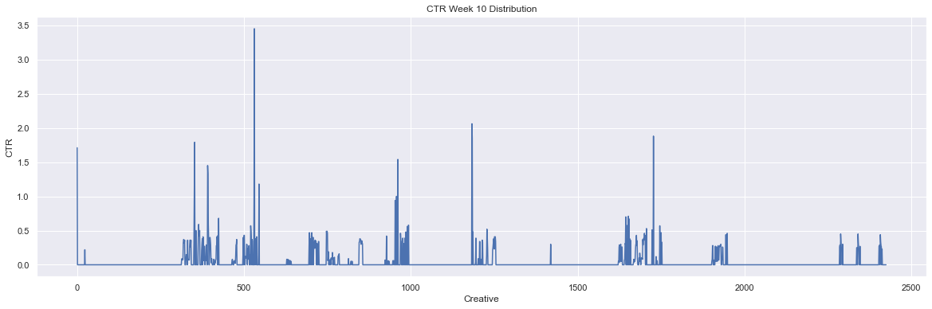

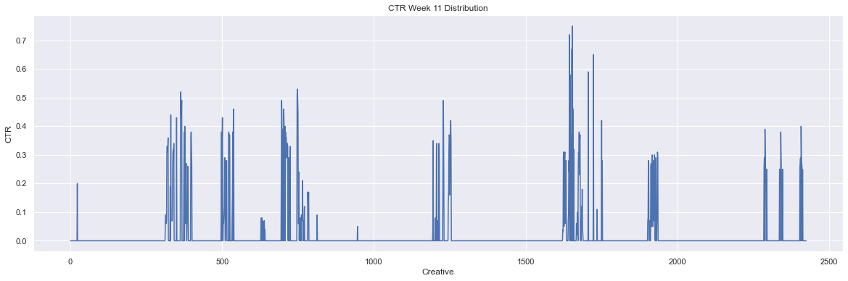

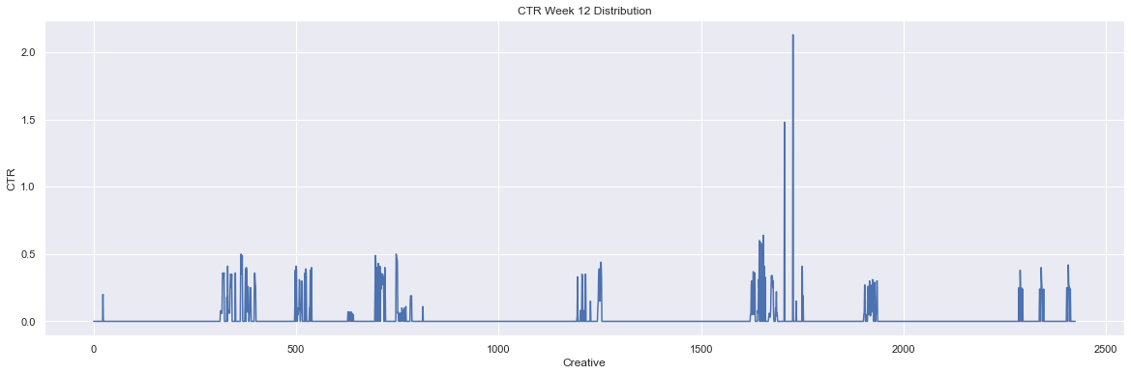

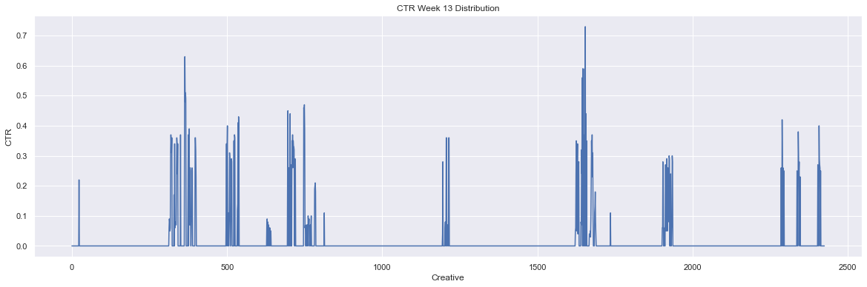

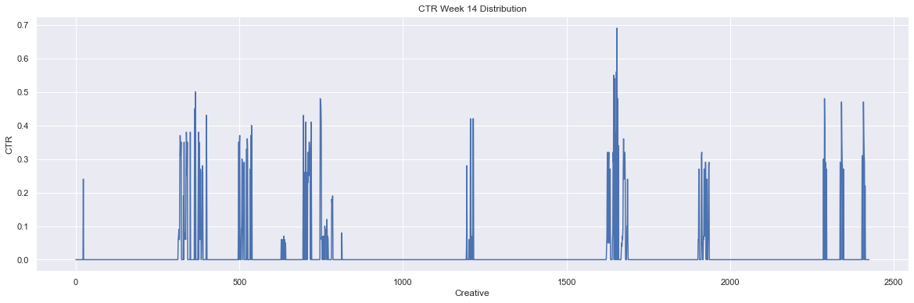

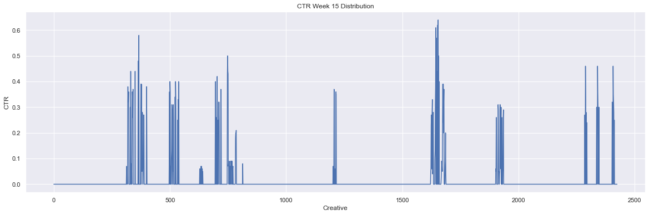

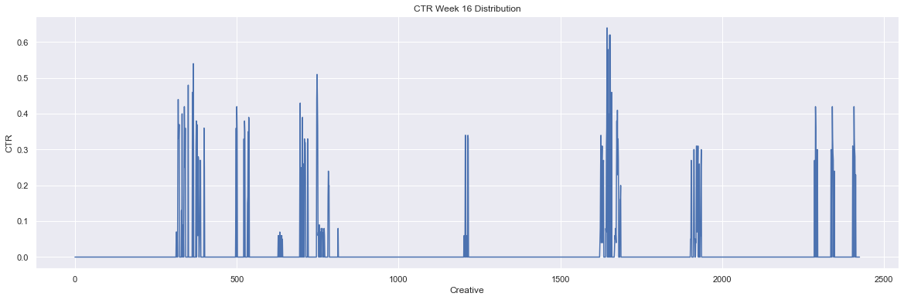

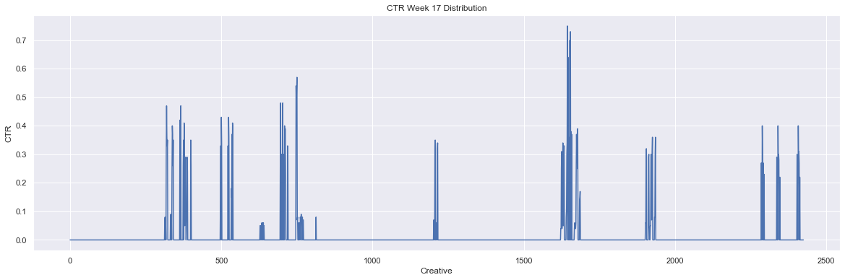

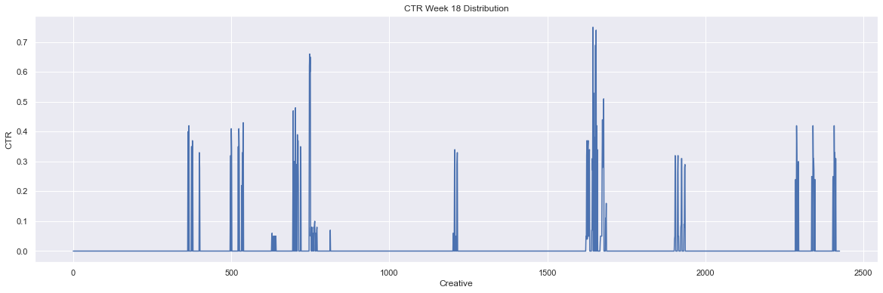

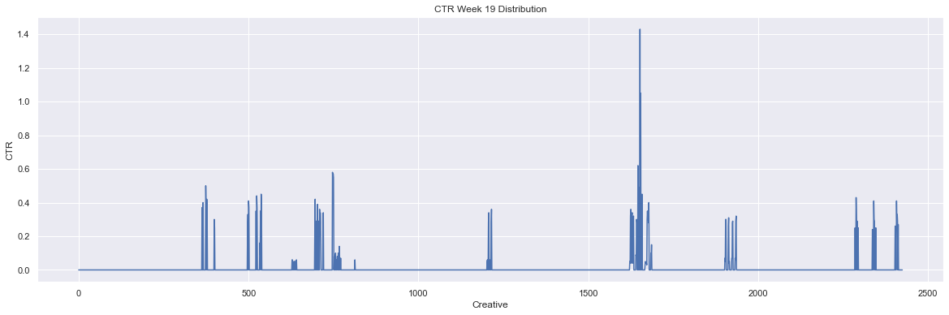

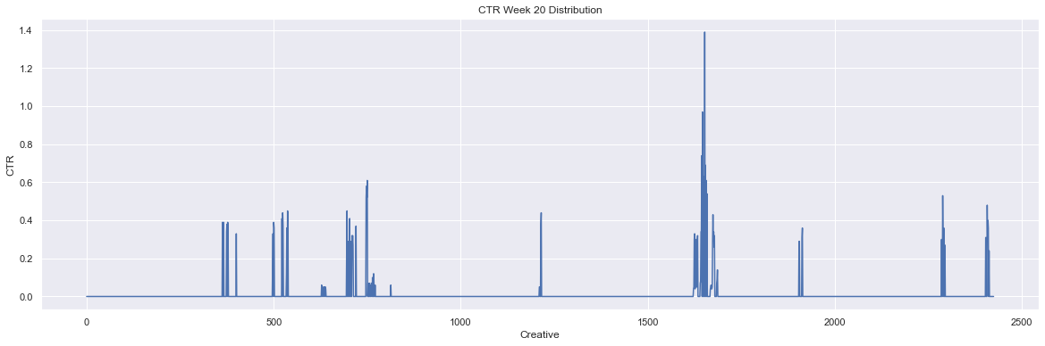

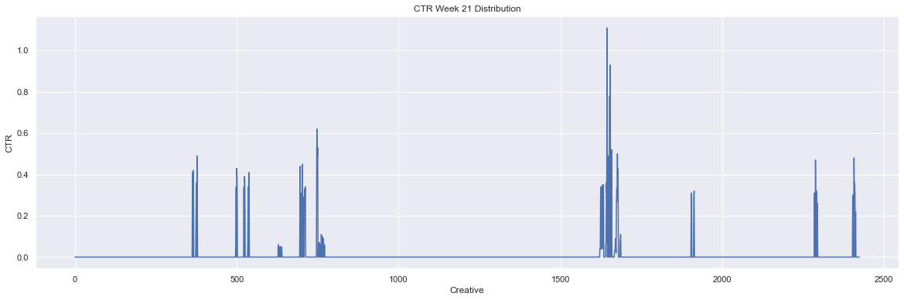

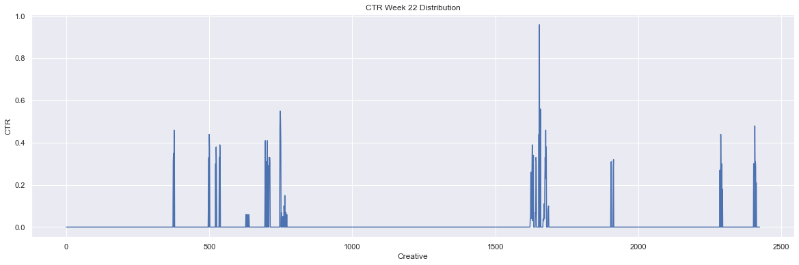

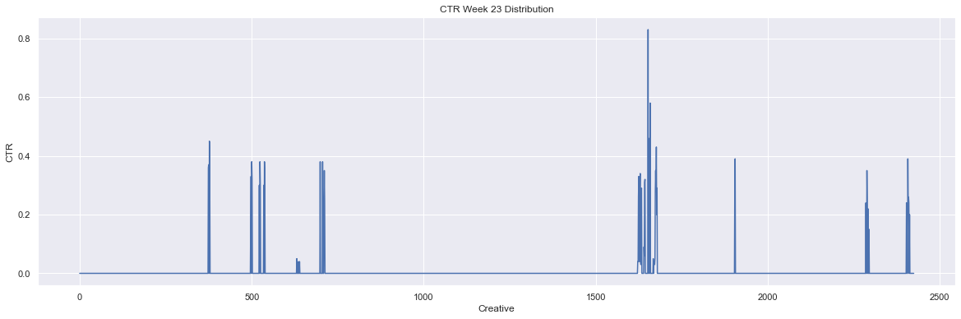

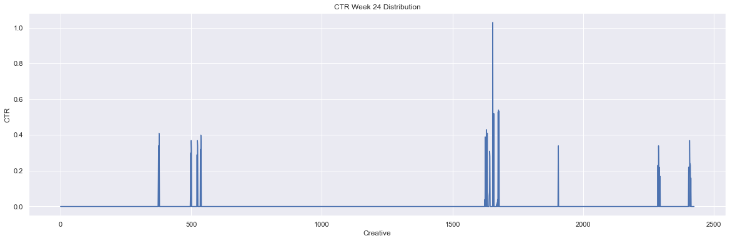

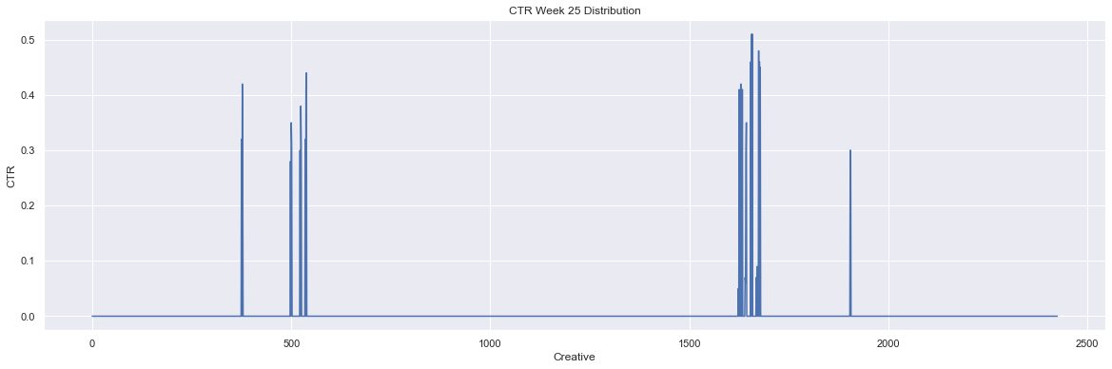

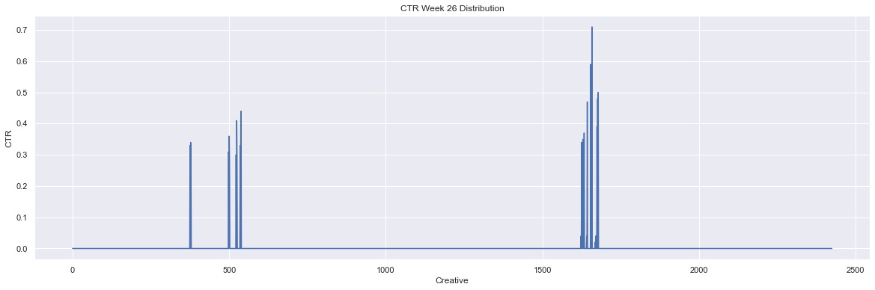

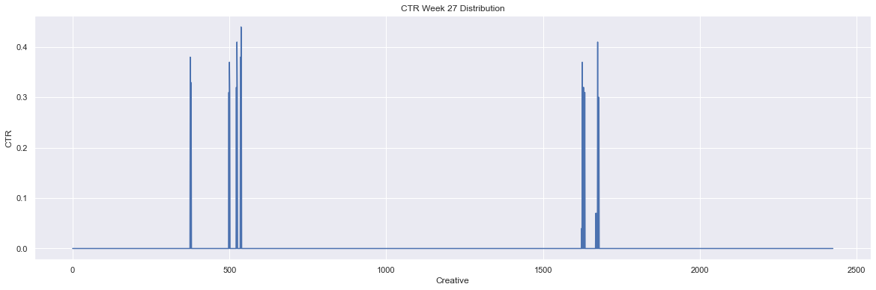

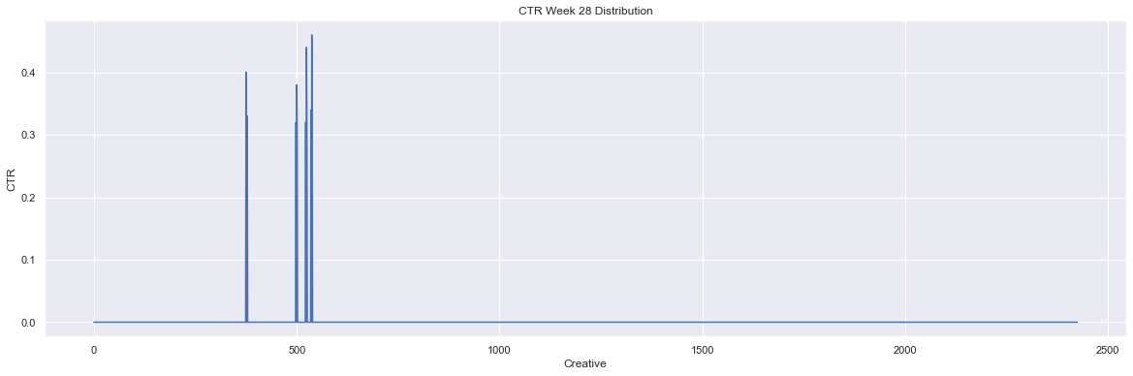

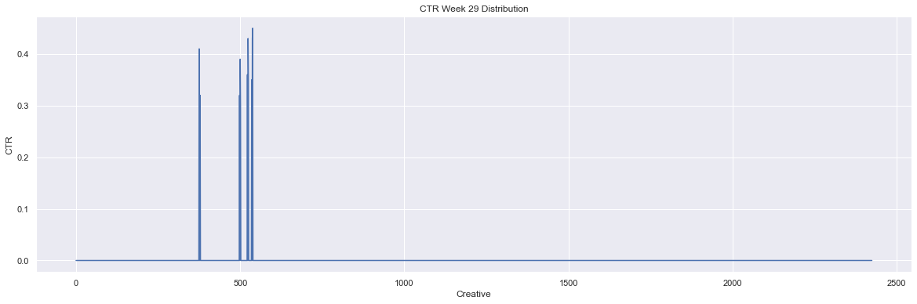

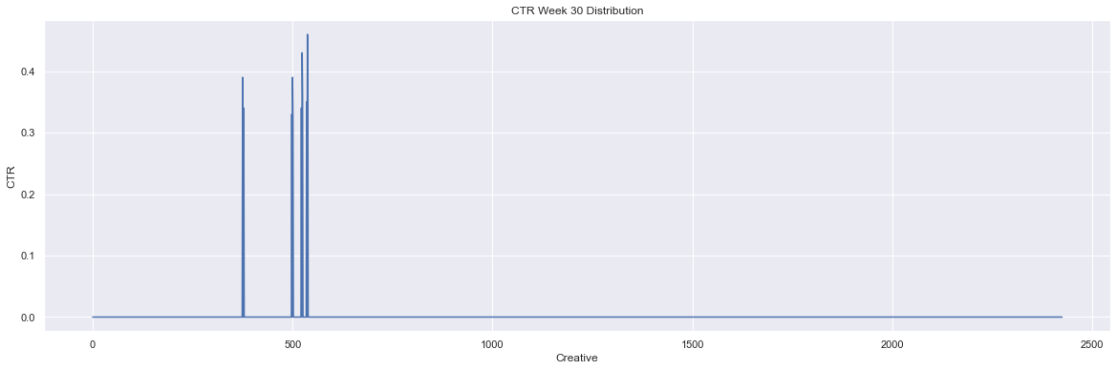

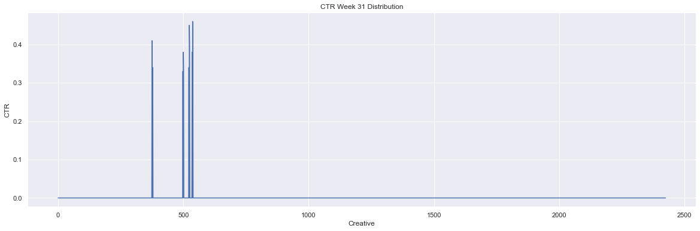

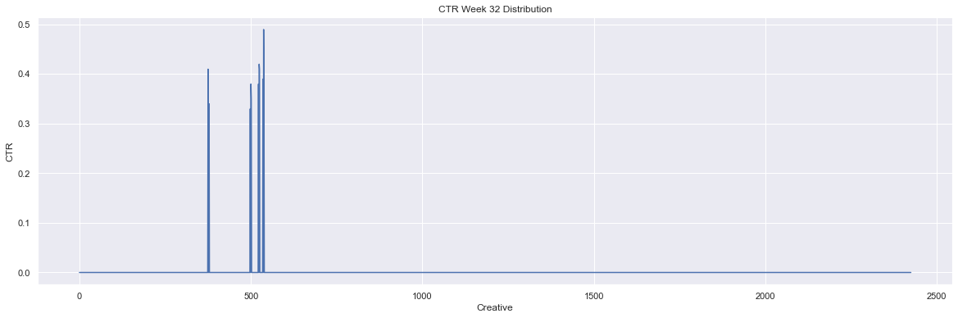

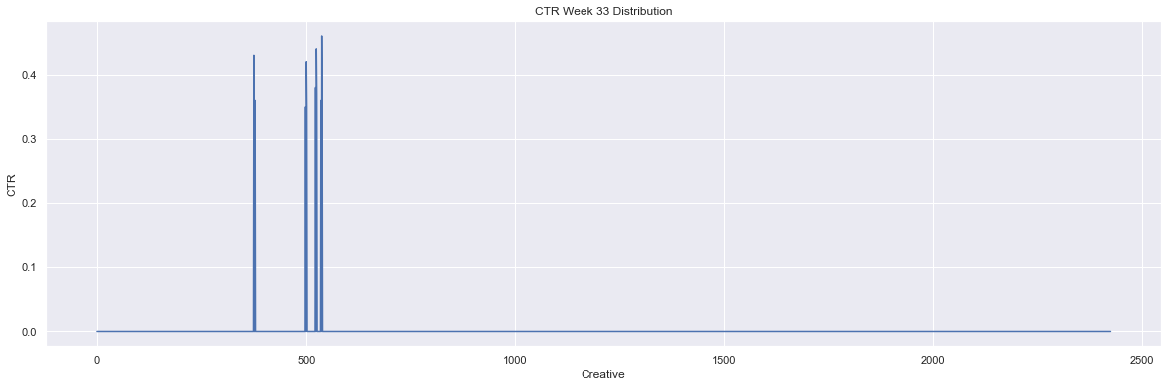

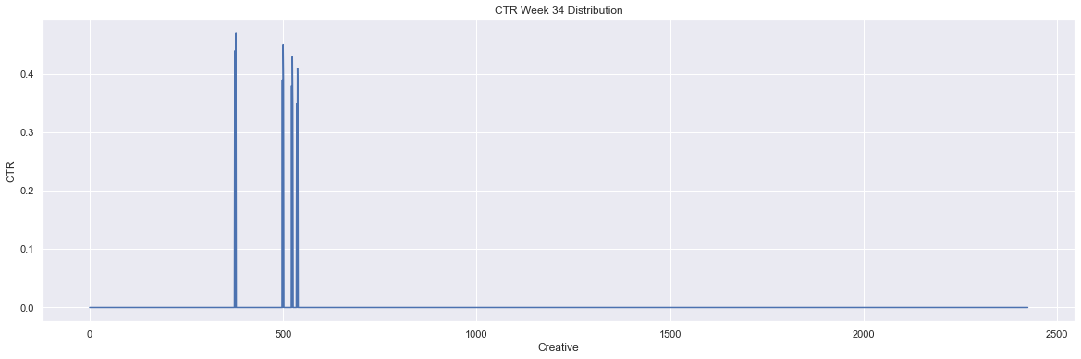

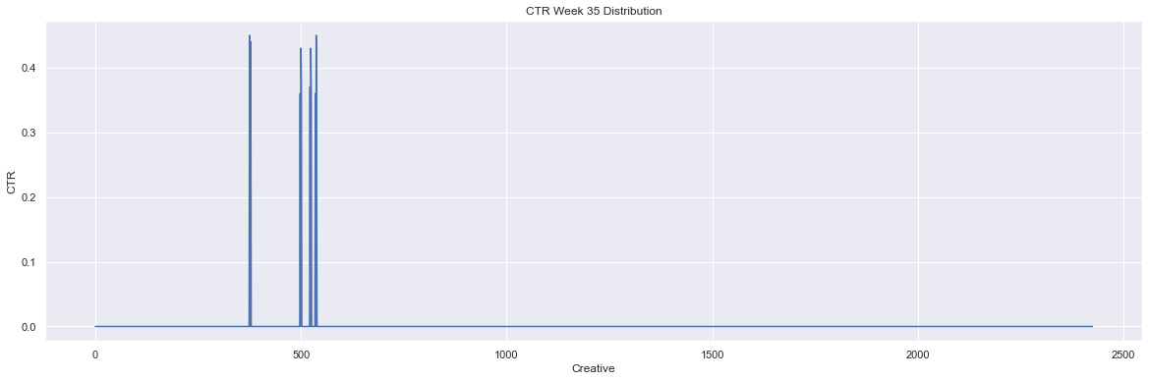

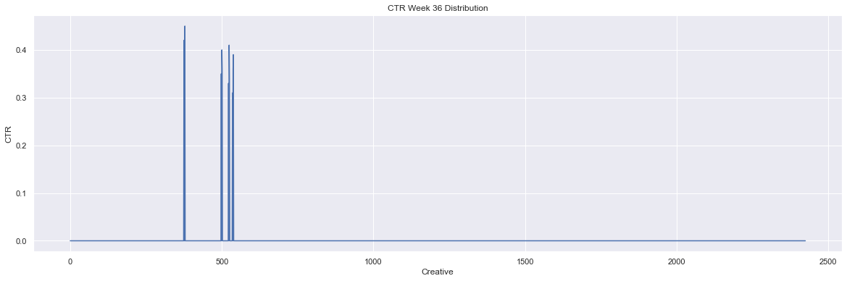

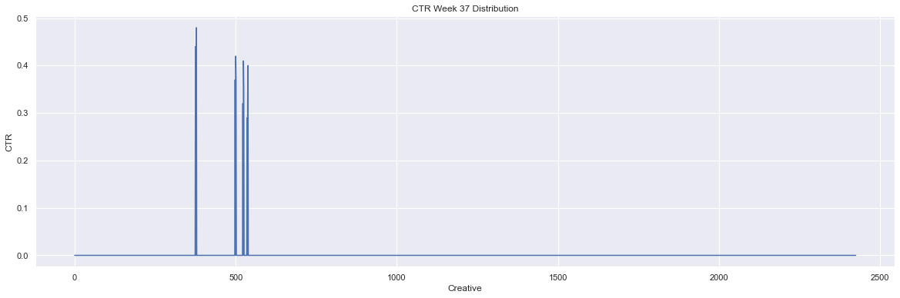

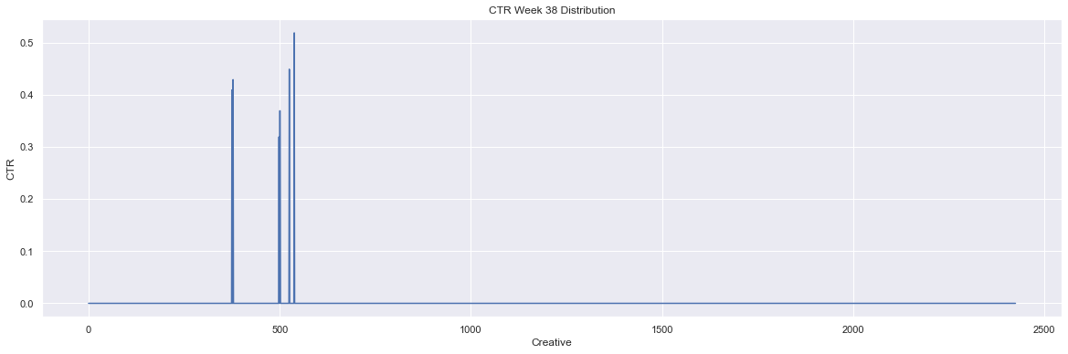

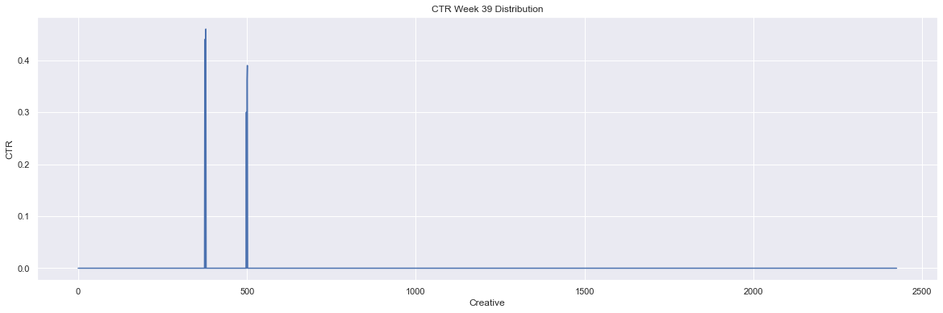

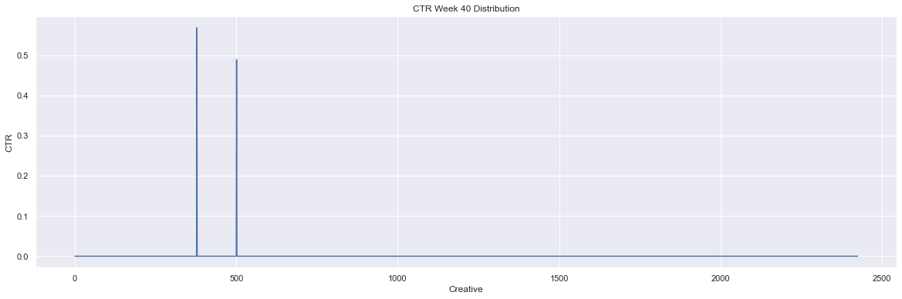

In [ ]:

*# Plot distributions of buy flow conversion rate*  
**for** idx, bf **in** enumerate(cvrbf_w):  
 plt**.**figure(figsize**=**(20, 6))  
 week_data[bf]**.**plot()  
 plt**.**title(f'Buy Flow CVR Week {idx} Distribution')  
 plt**.**xlabel('Creative')  
 plt**.**ylabel('CVR(BF)')  
 plt**.**show()

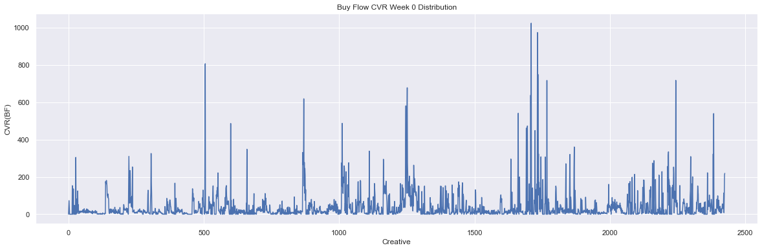

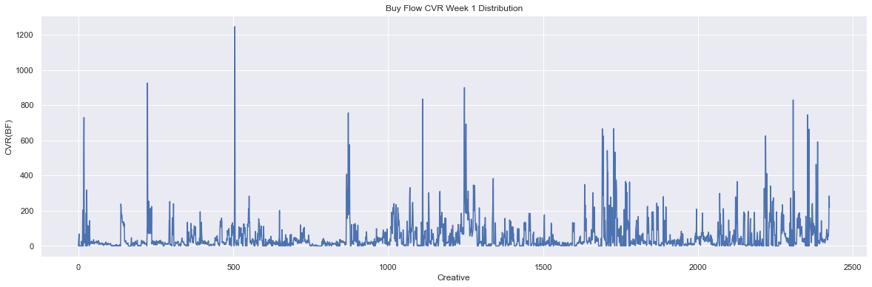

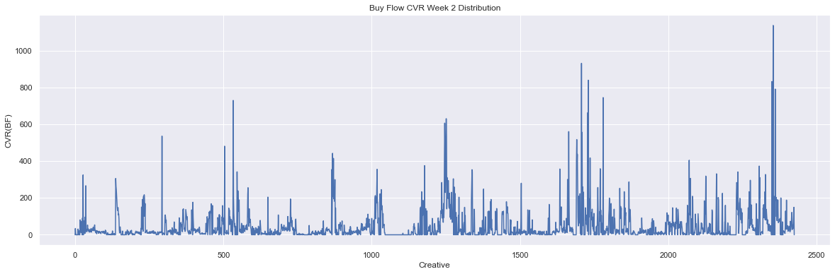

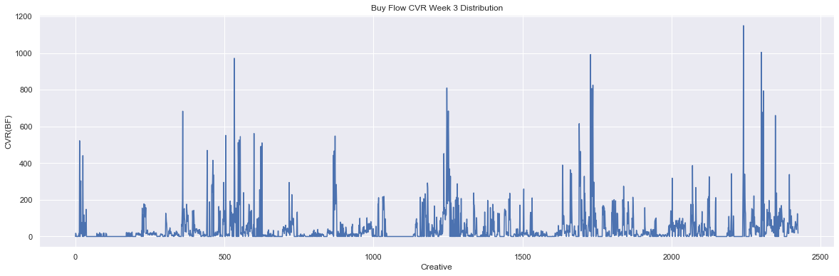

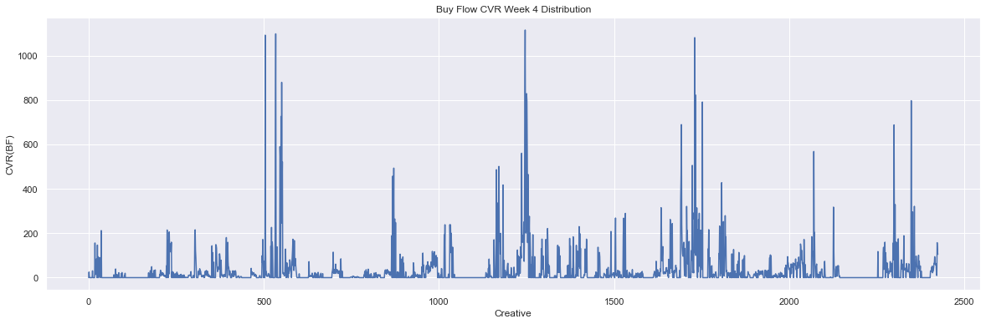

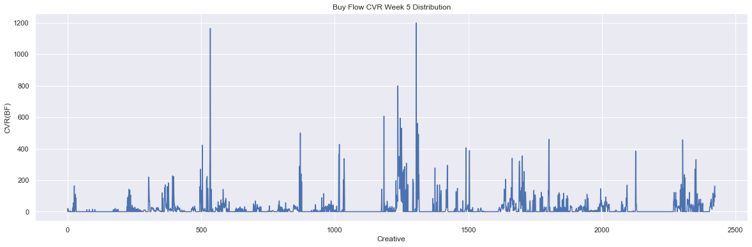

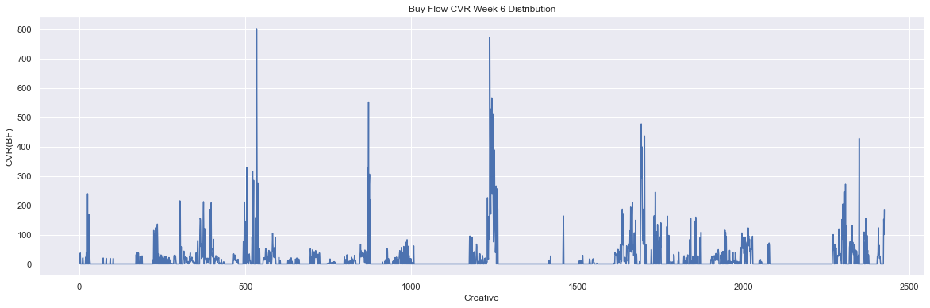

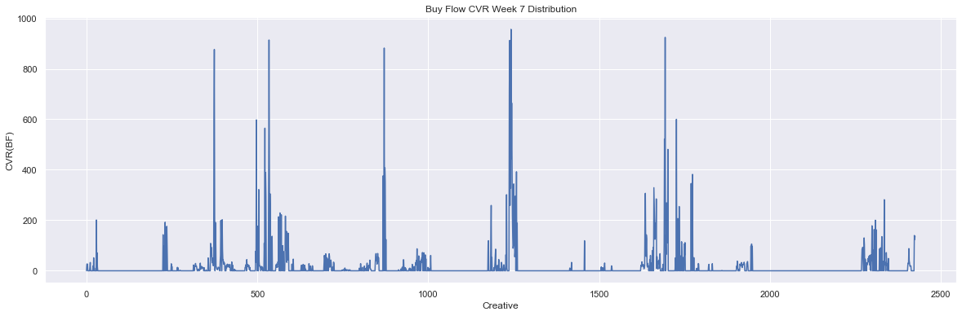

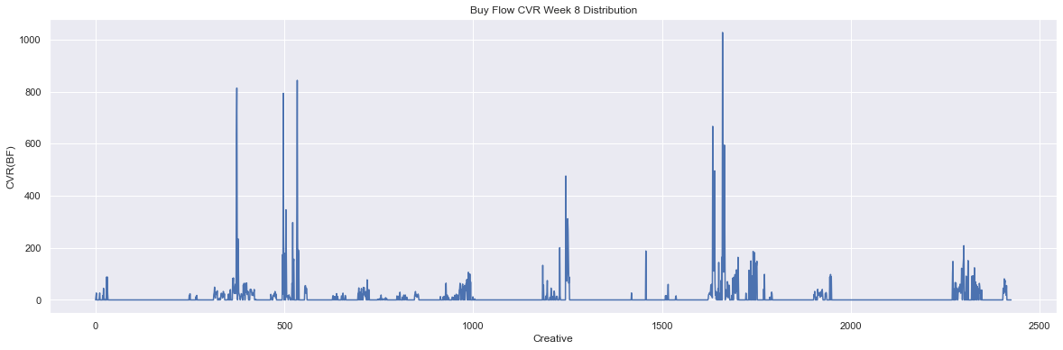

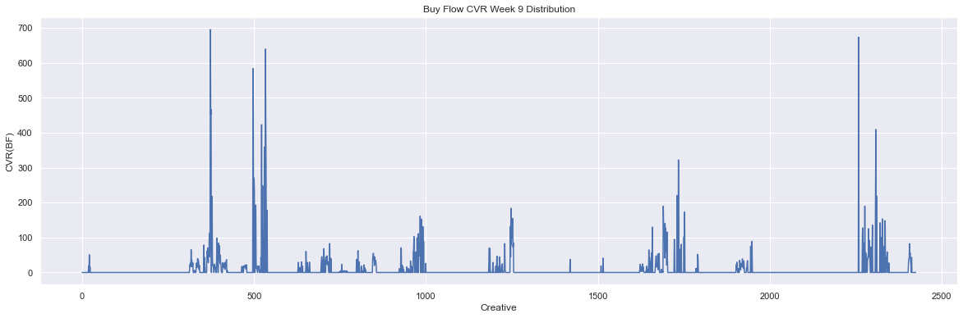

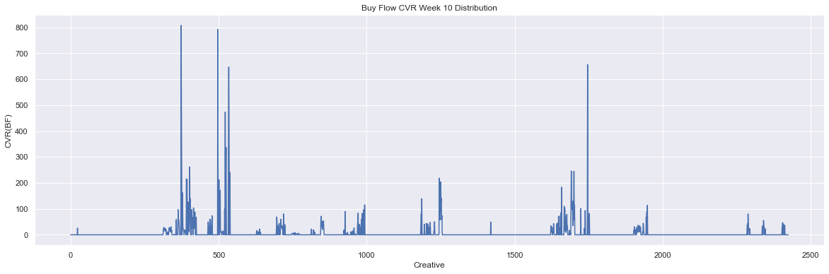

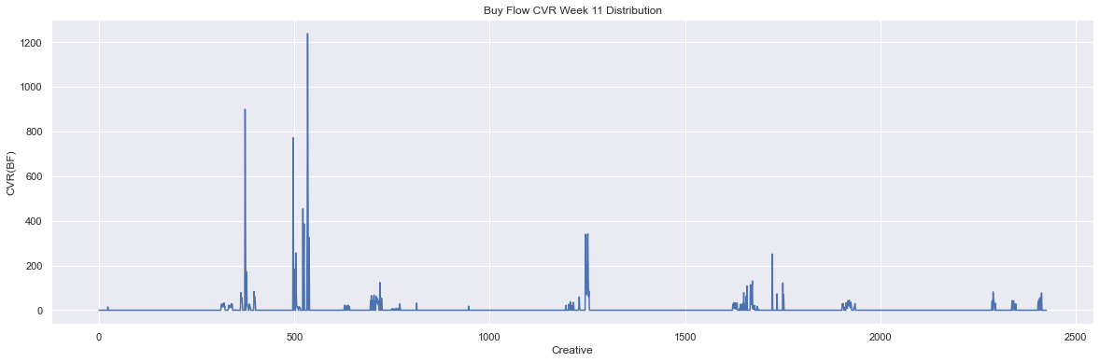

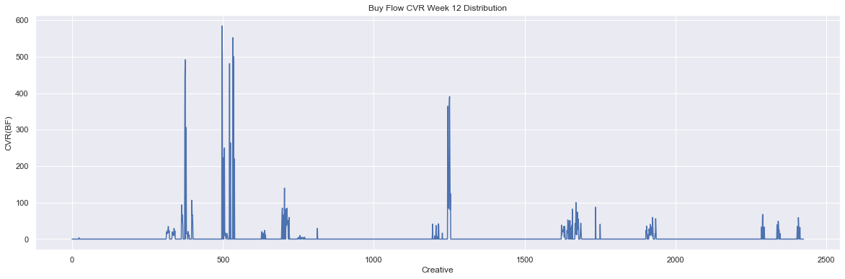

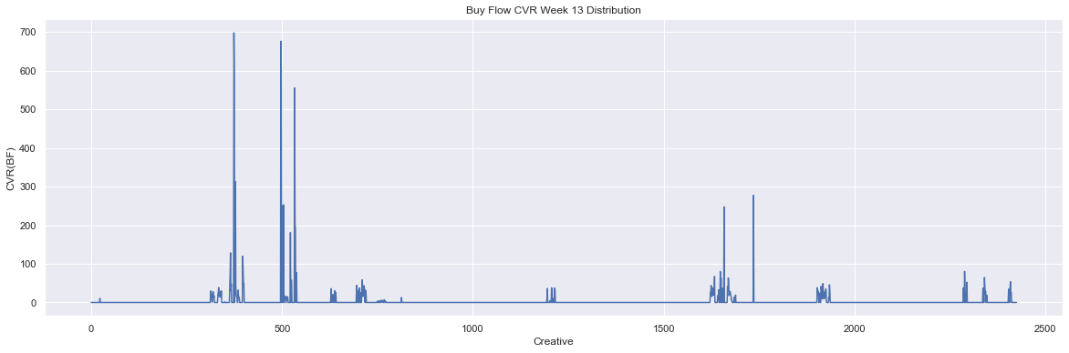

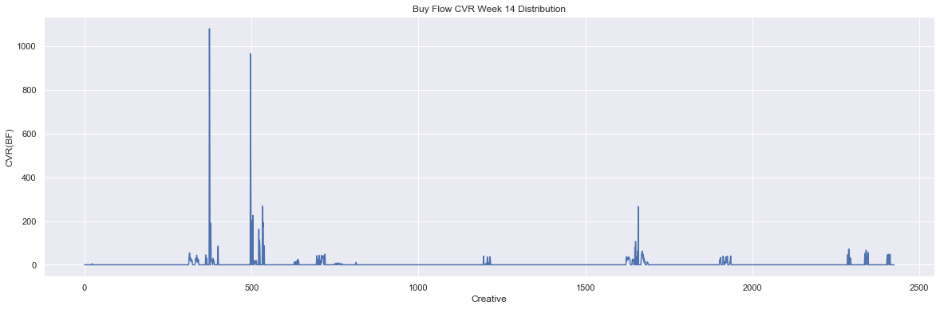

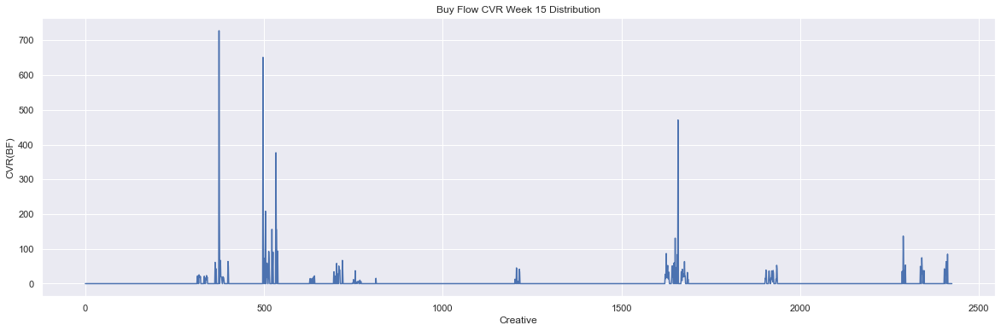

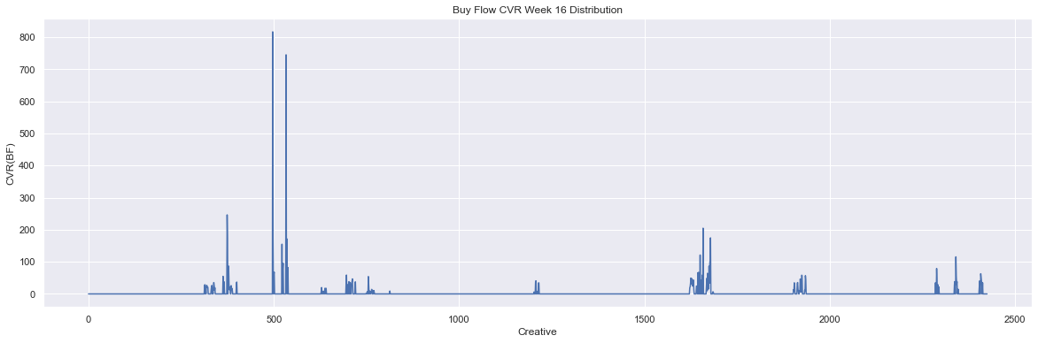

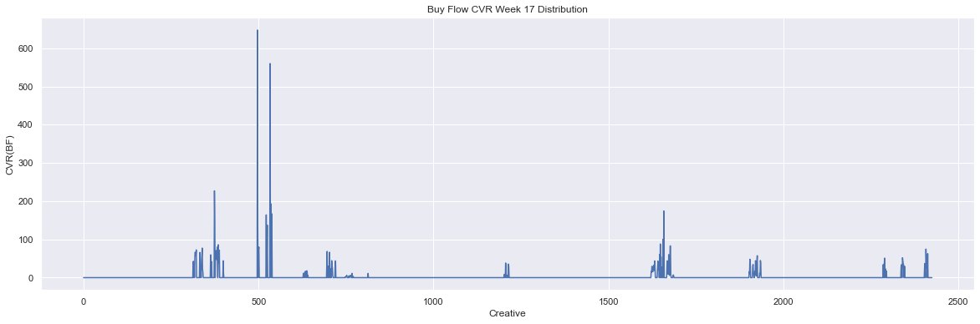

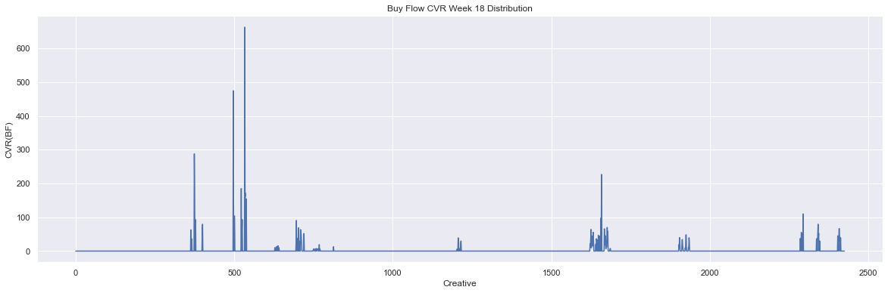

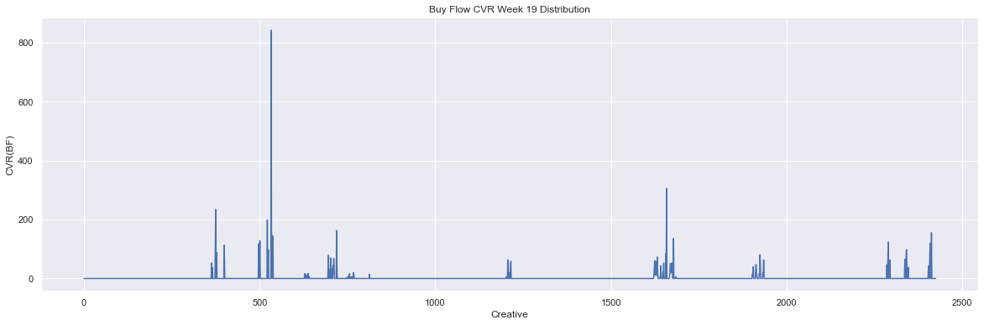

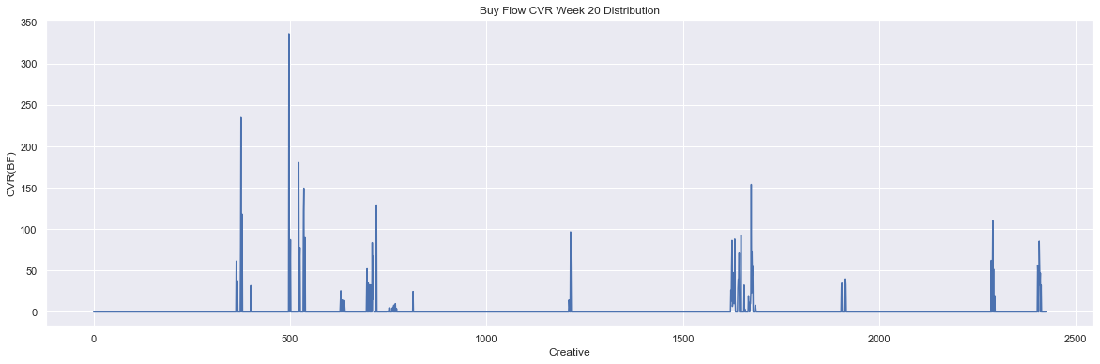

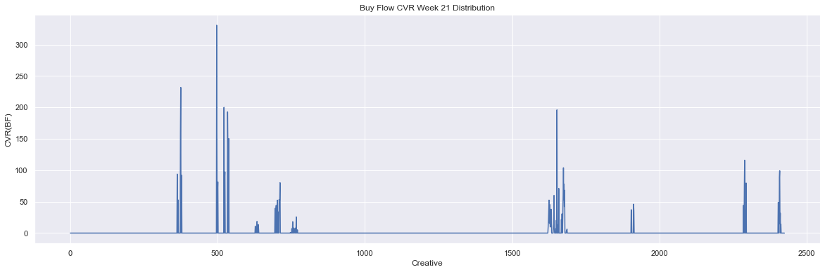

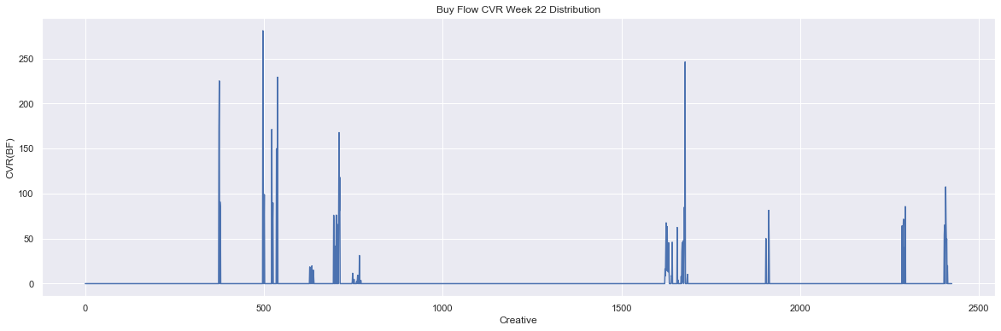

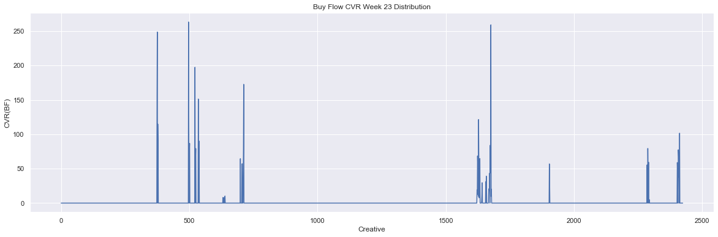

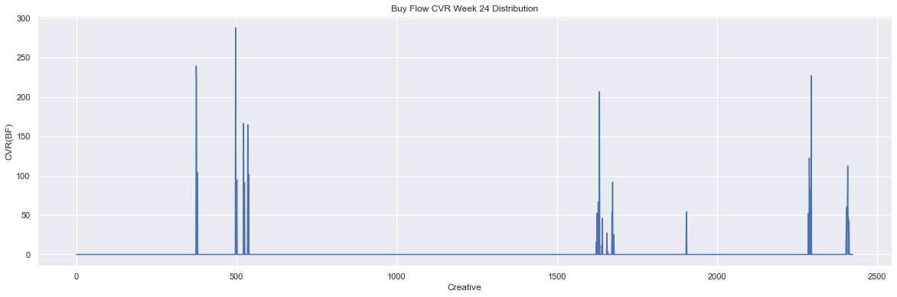

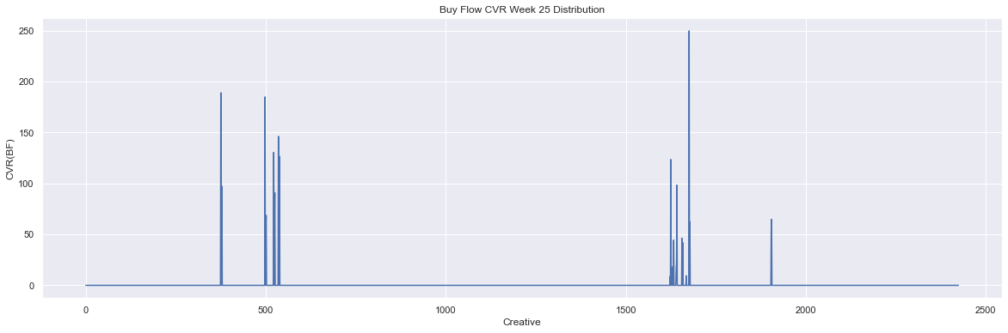

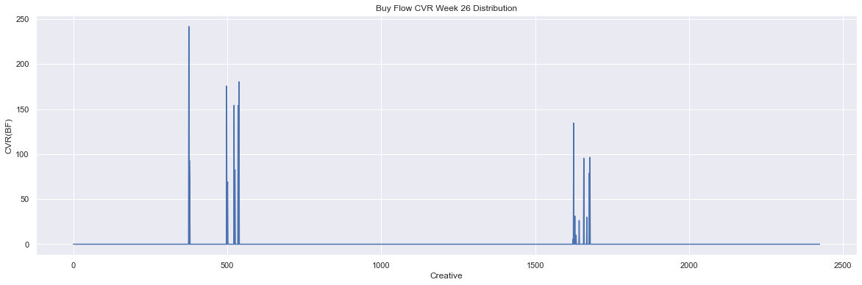

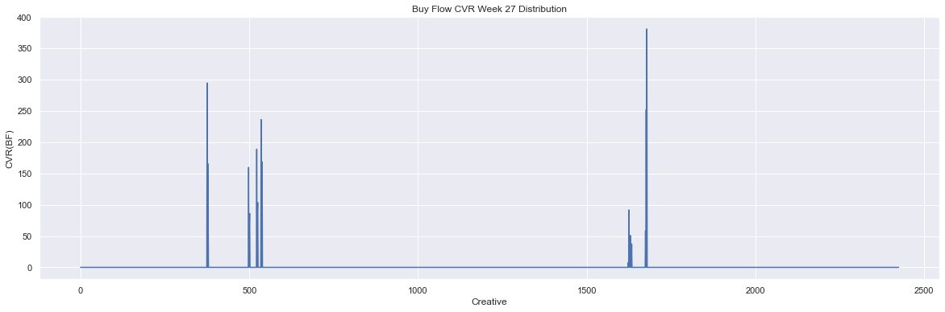

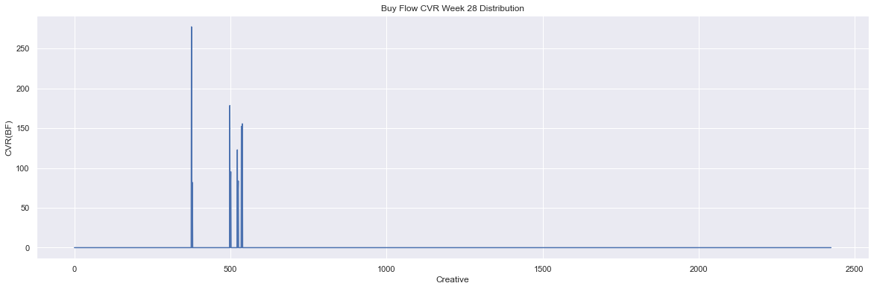

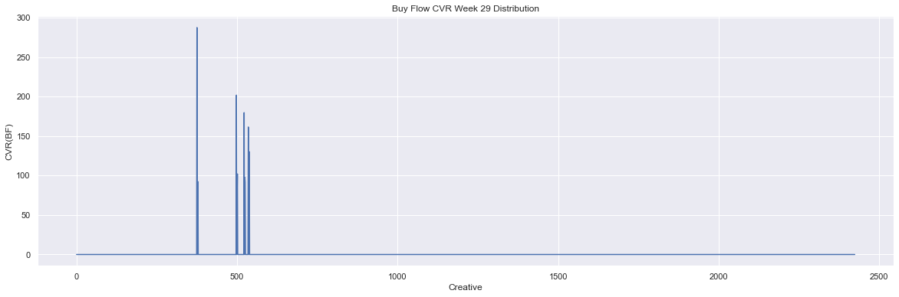

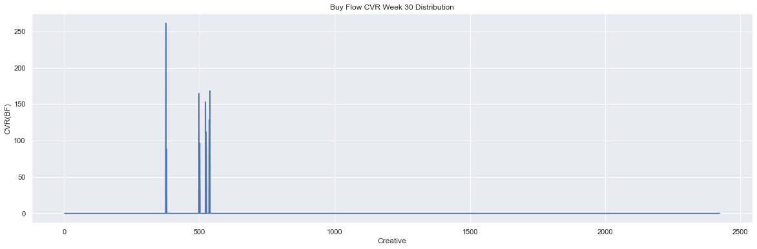

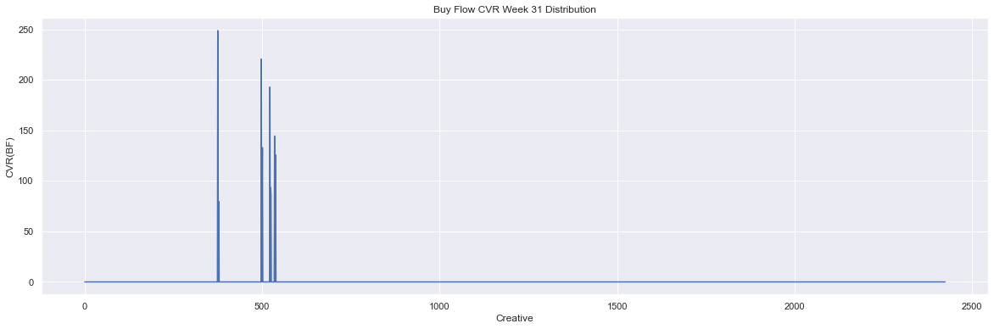

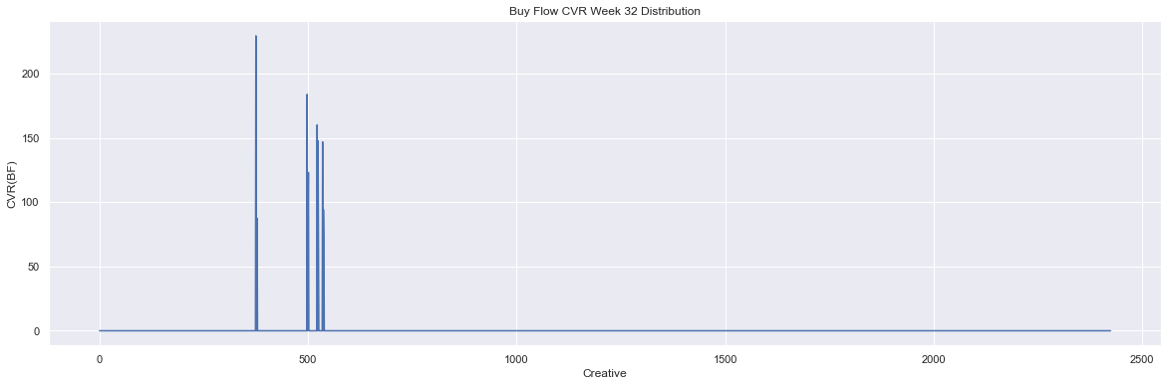

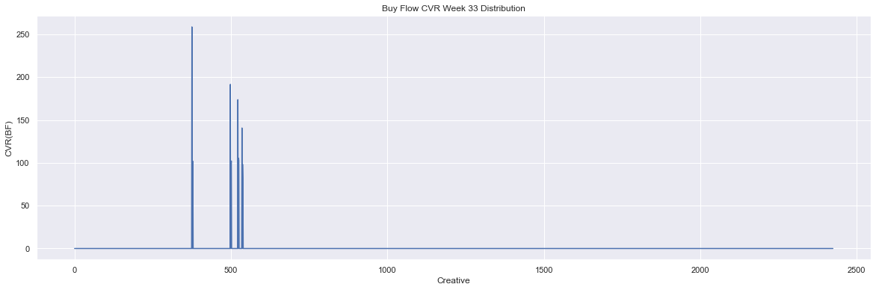

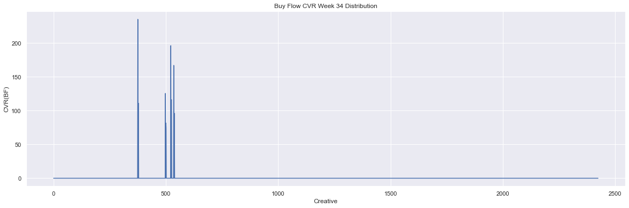

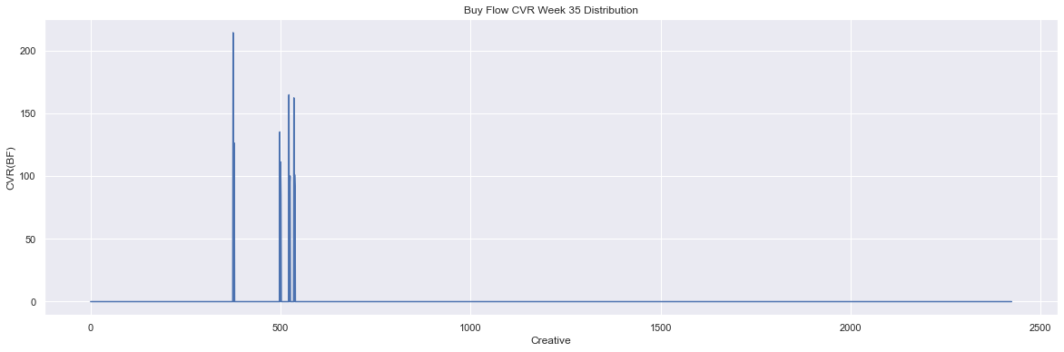

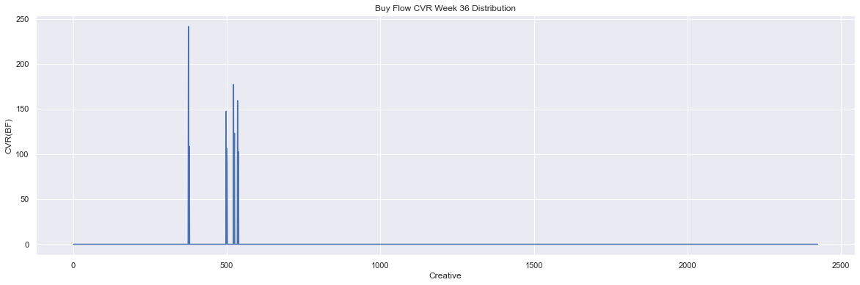

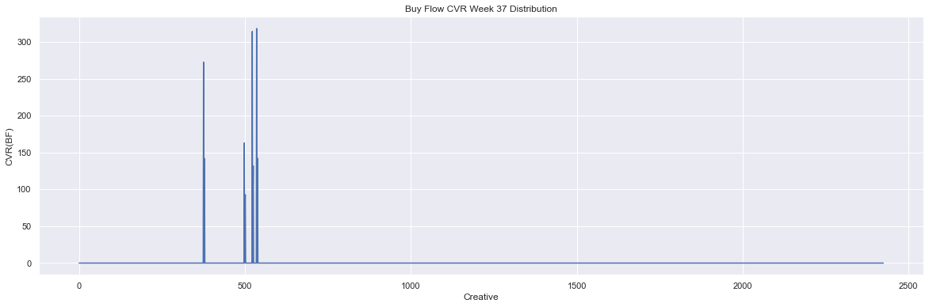

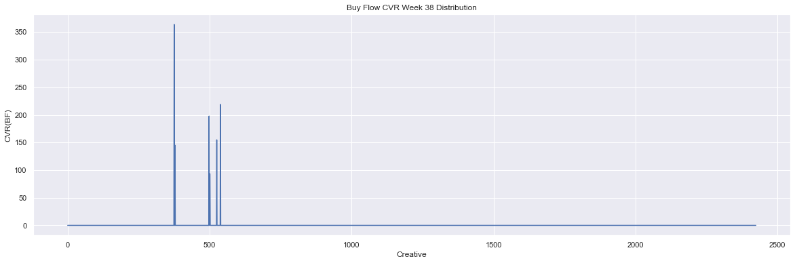

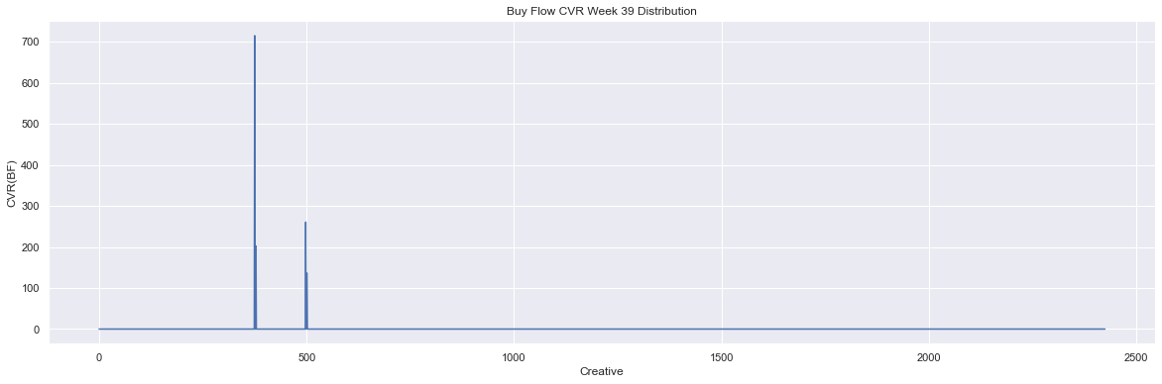

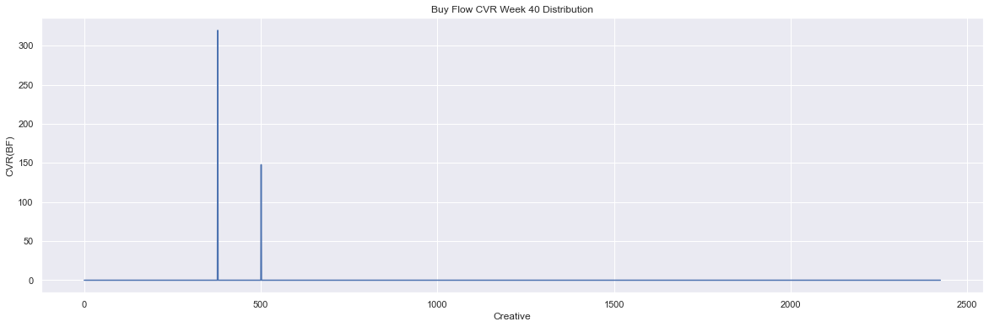

In [ ]:

*# Plot distributions of site visit conversion rate*  
**for** idx, sv **in** enumerate(cvrsv_w):  
 plt**.**figure(figsize**=**(20, 6))  
 week_data[sv]**.**plot()  
 plt**.**title(f'Site Visit Week {idx} Distribution')  
 plt**.**xlabel('Creative ID')  
 plt**.**ylabel('CVR(SV)')  
 plt**.**show()

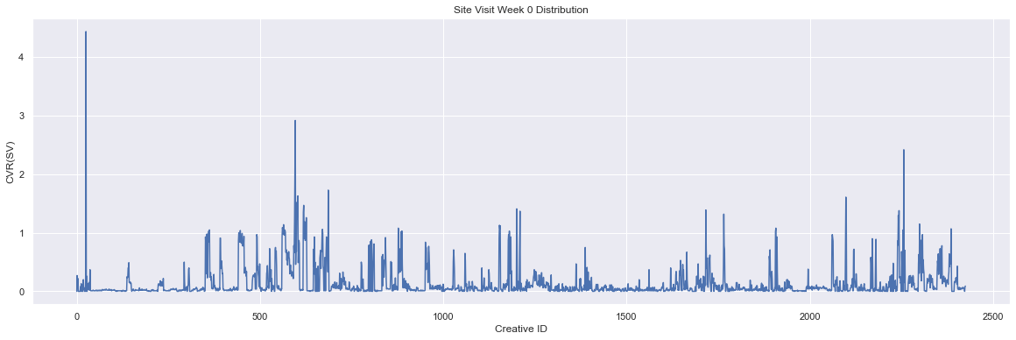

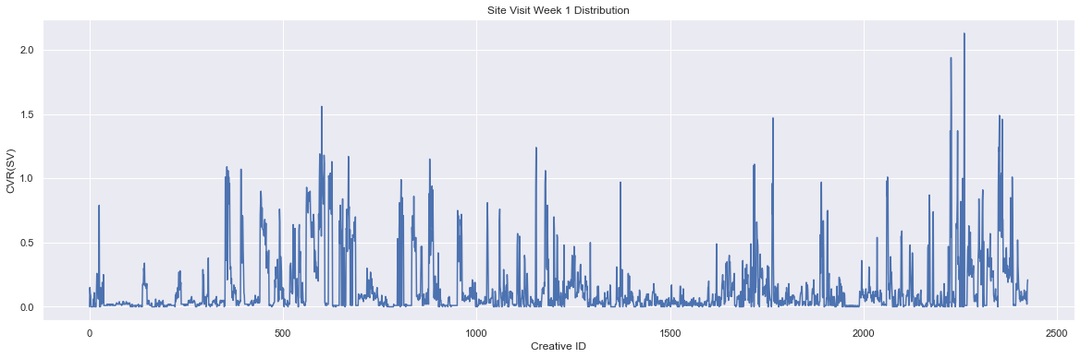

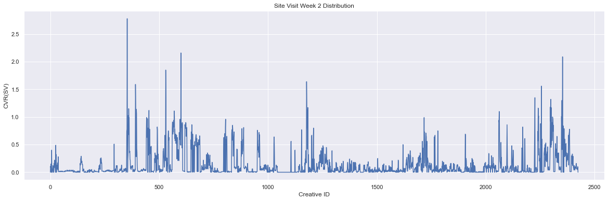

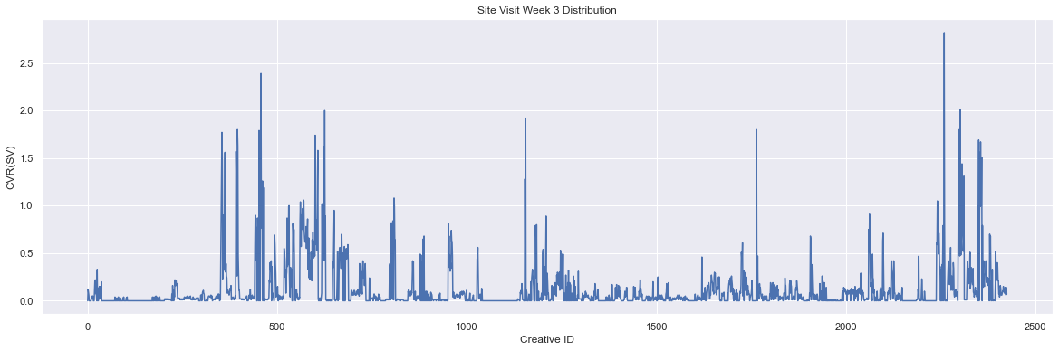

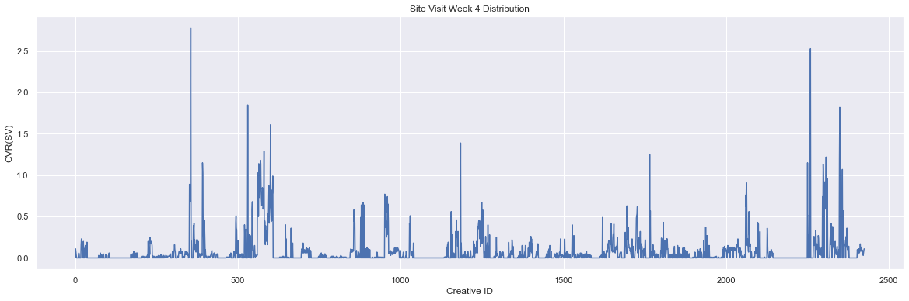

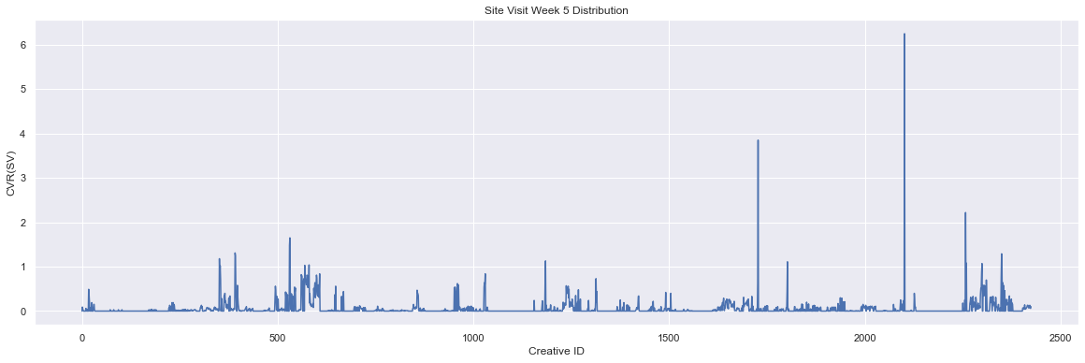

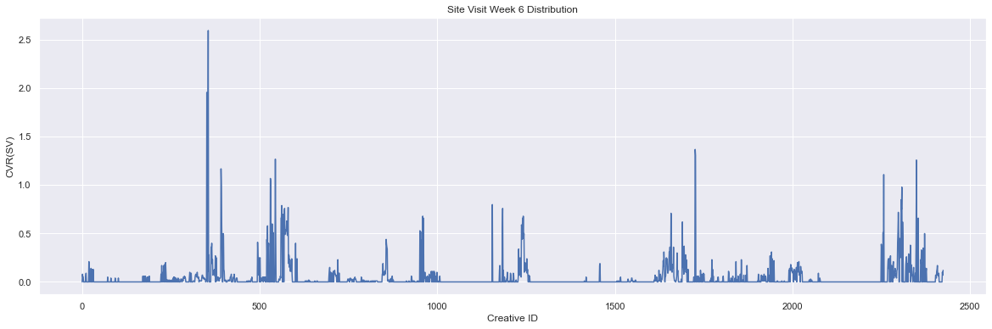

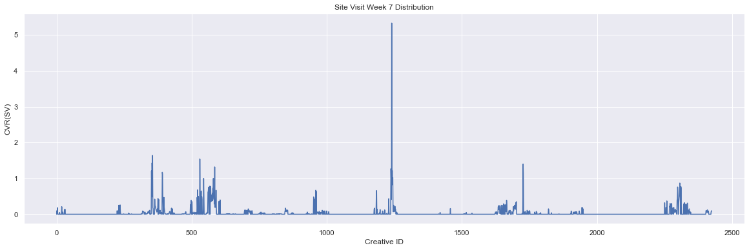

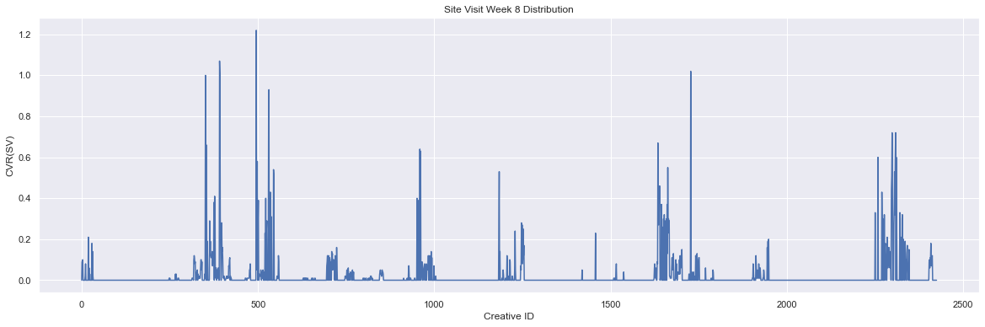

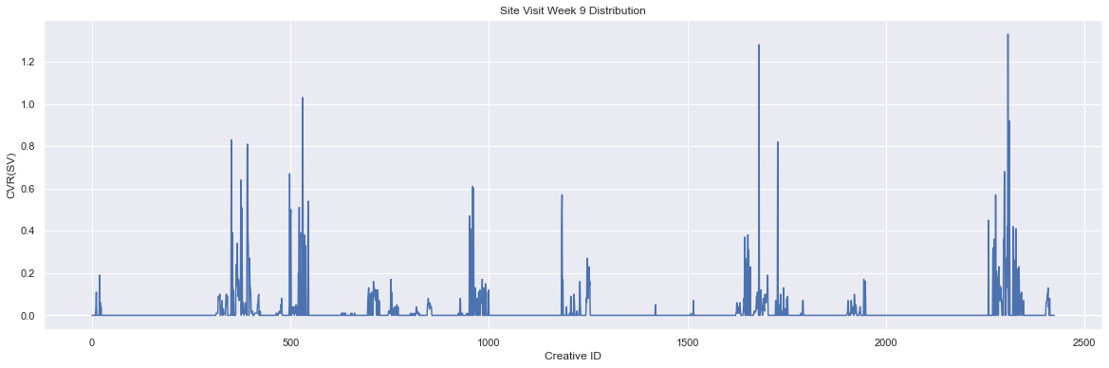

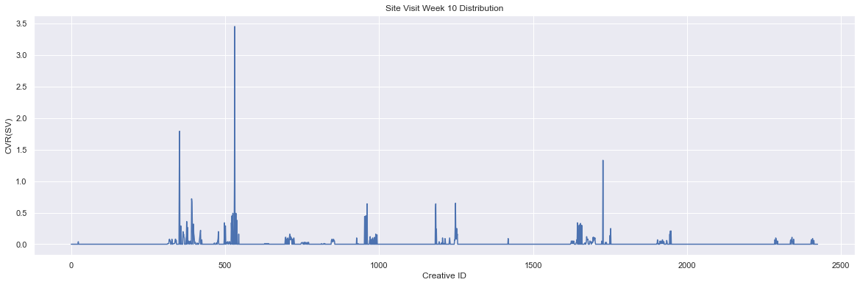

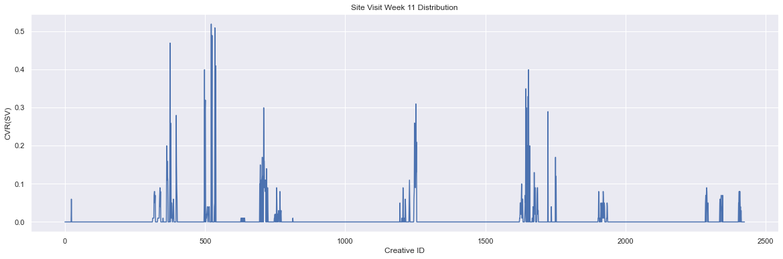

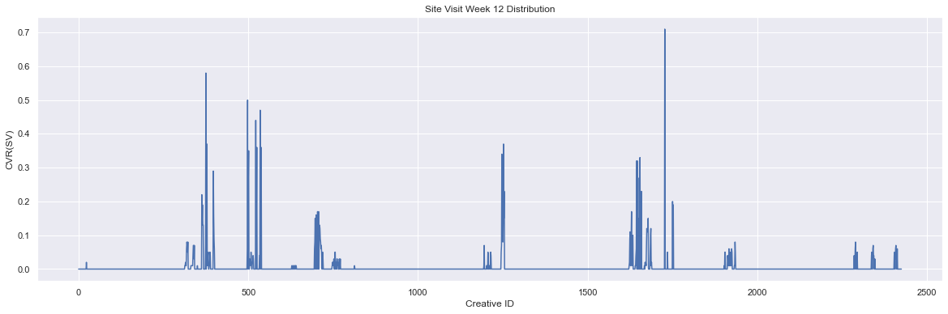

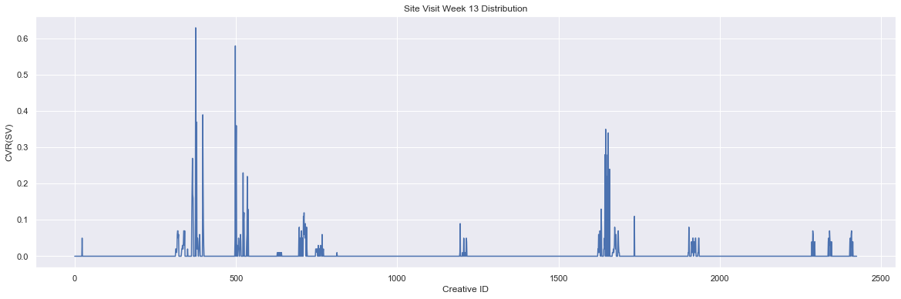

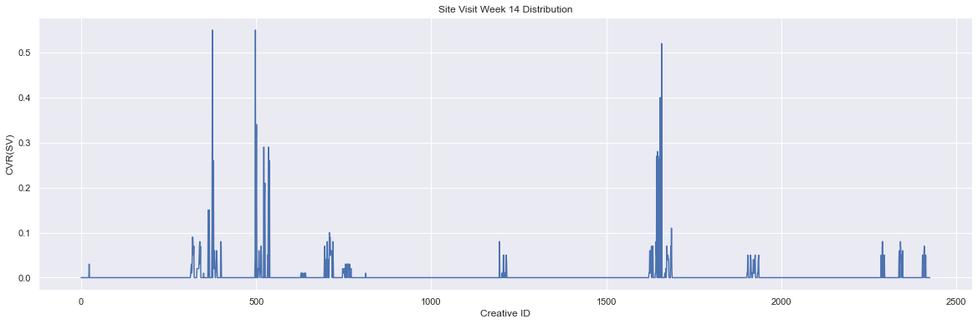

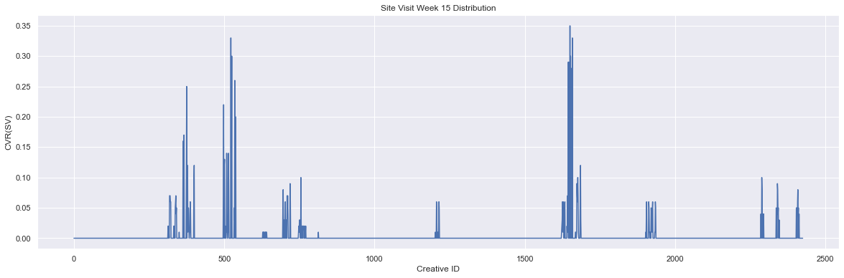

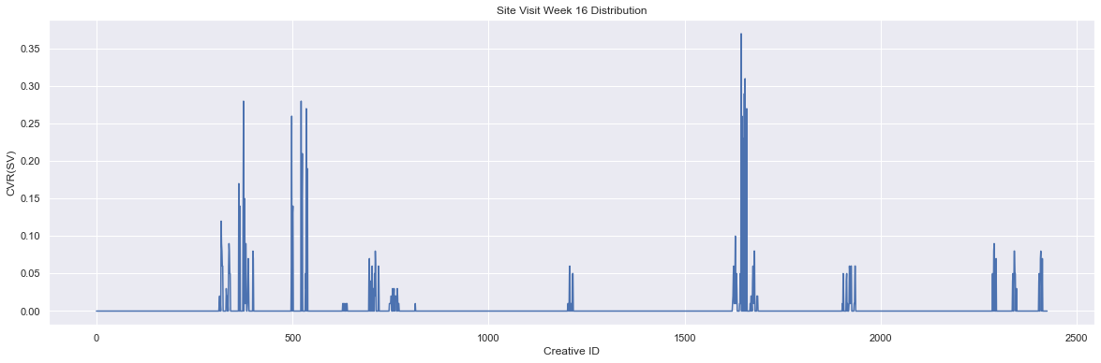

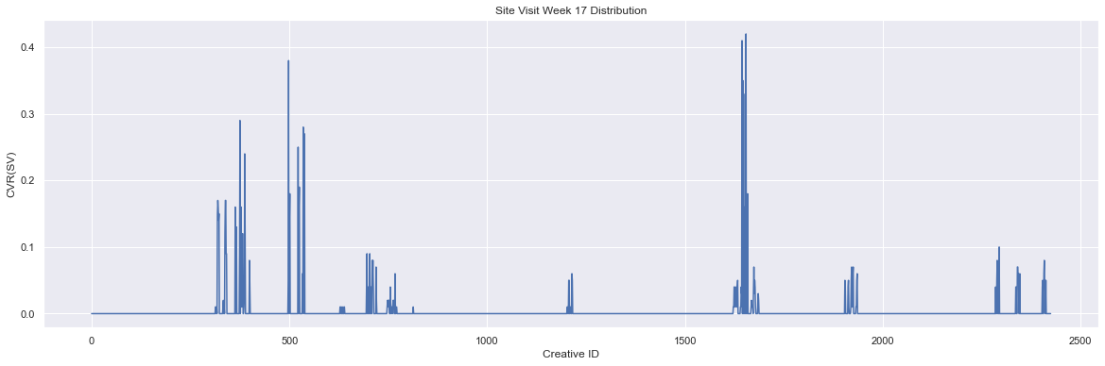

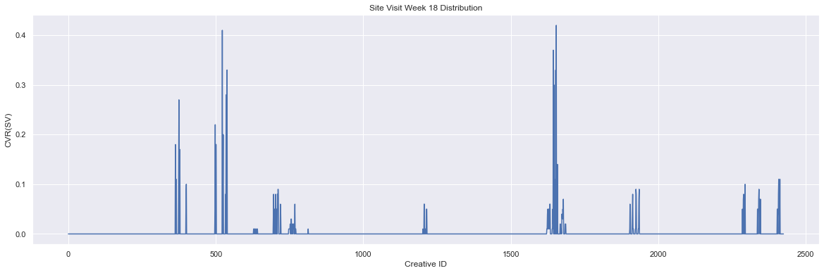

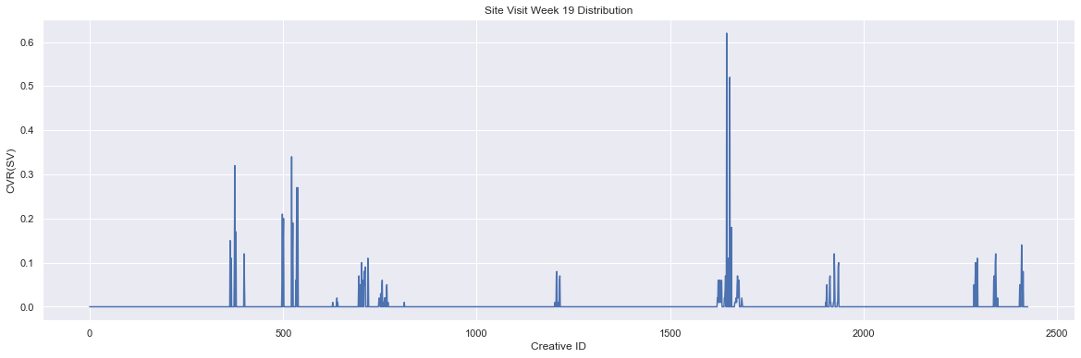

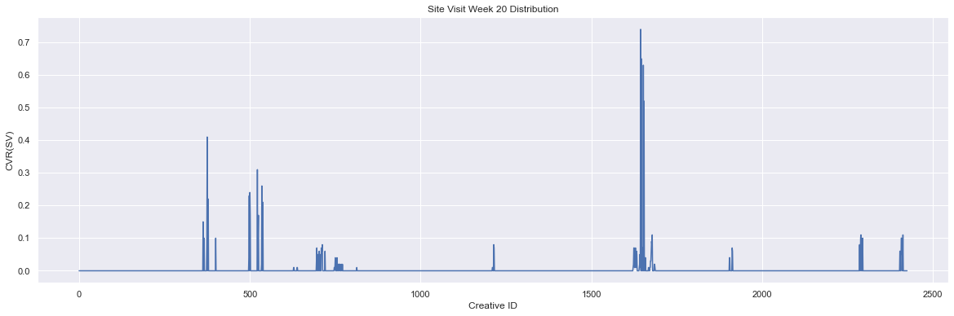

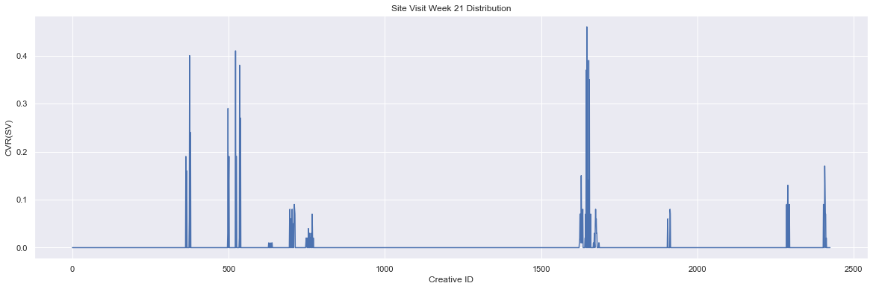

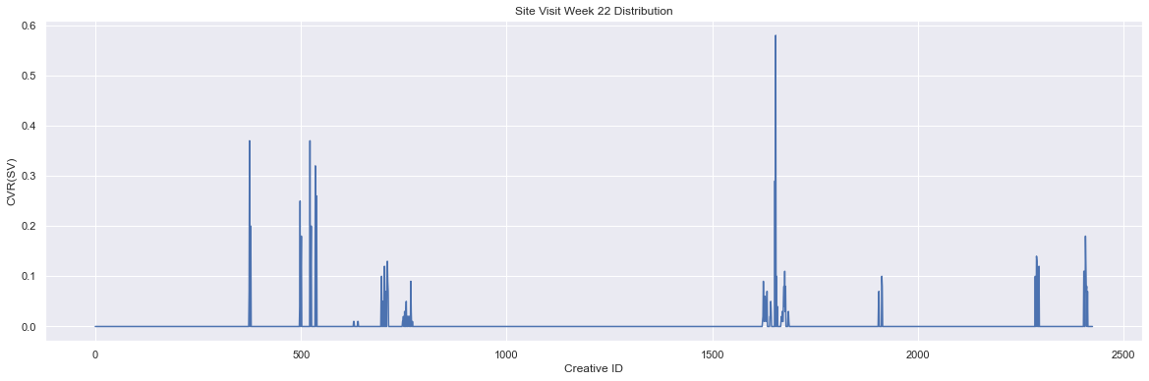

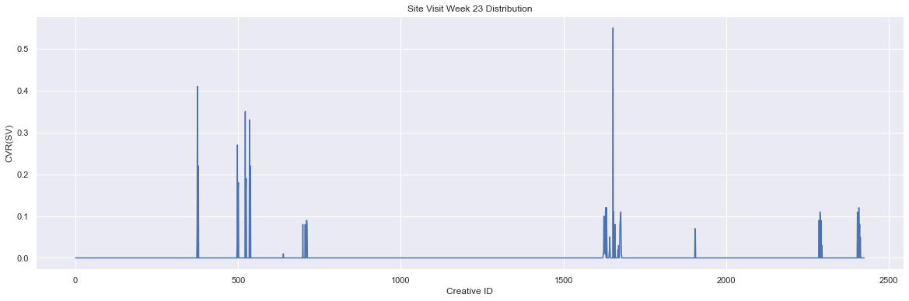

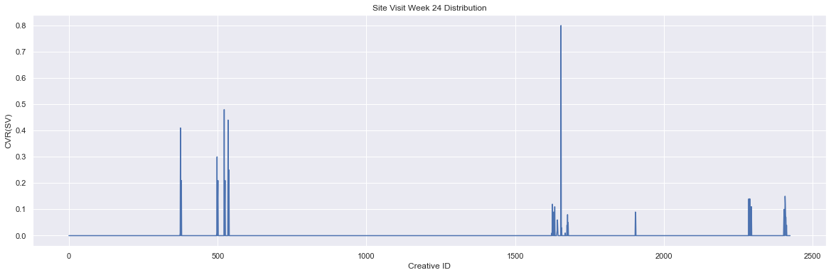

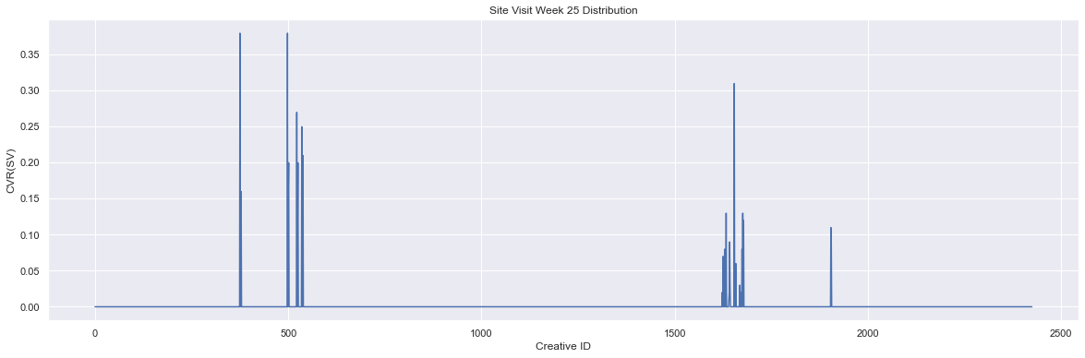

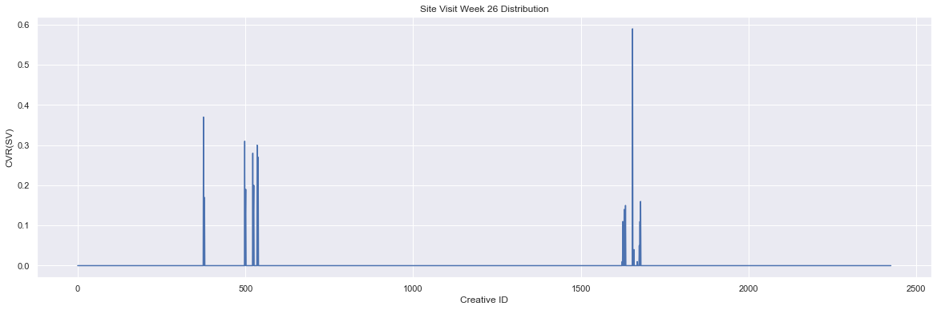

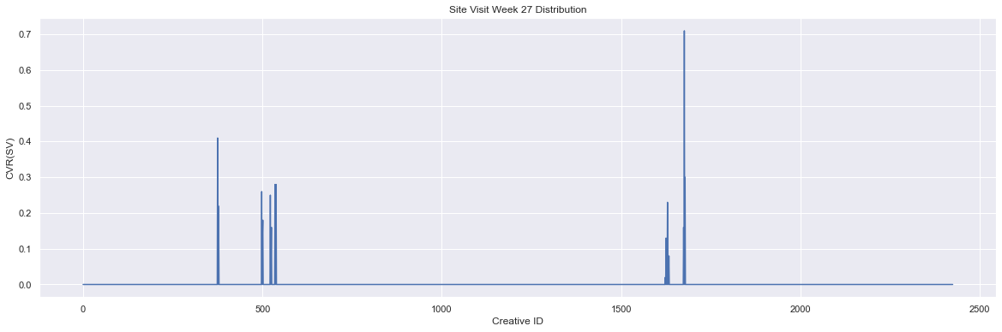

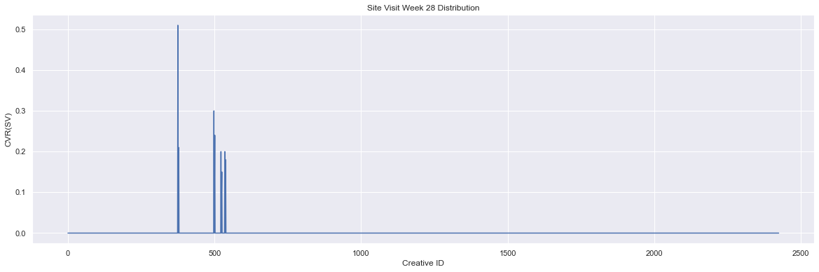

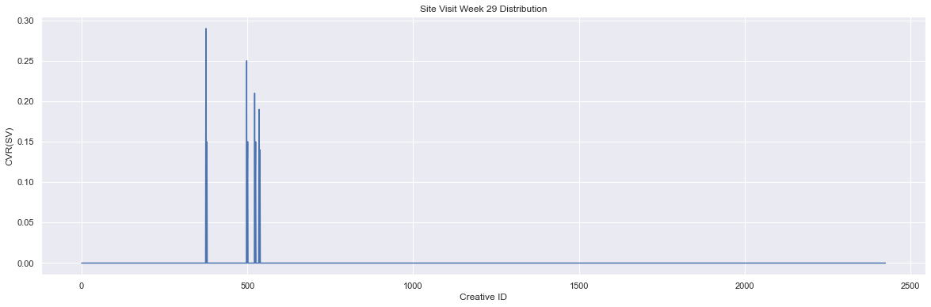

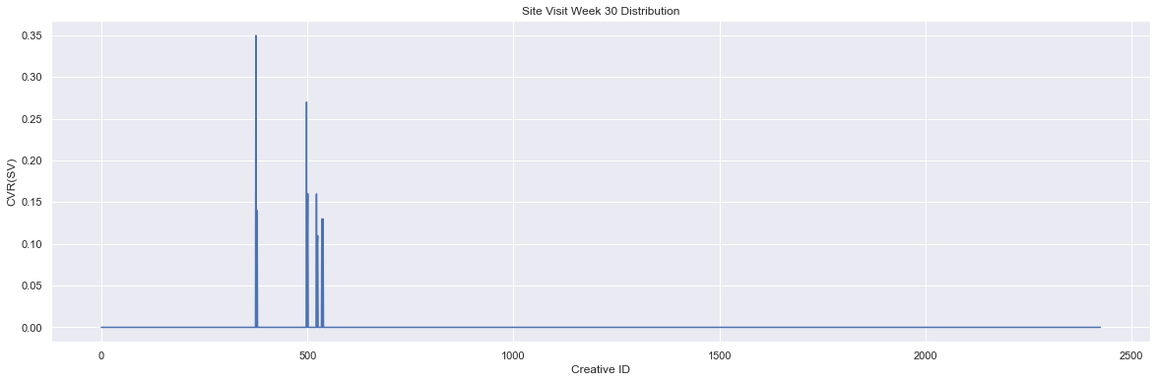

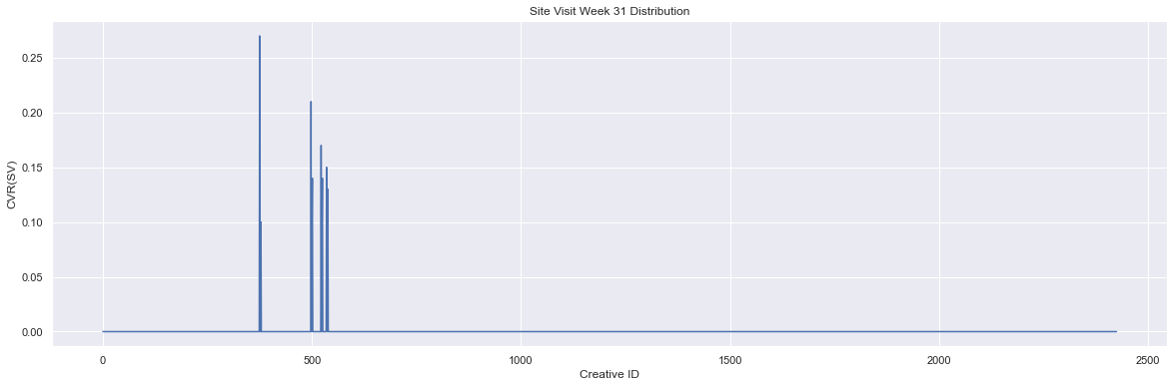

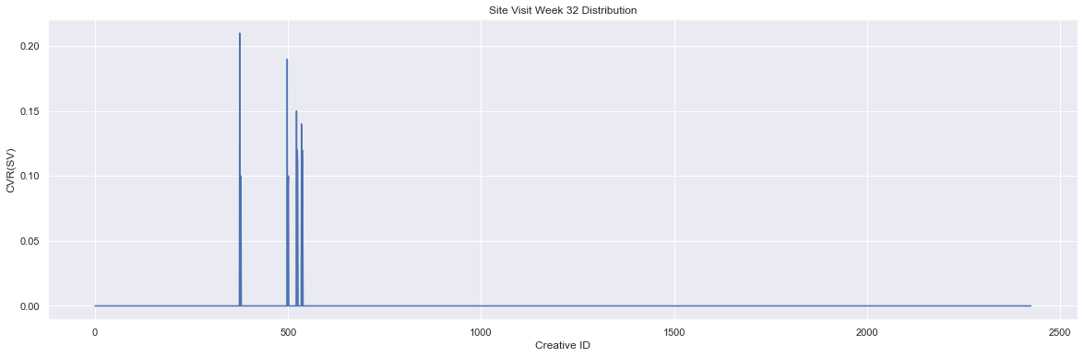

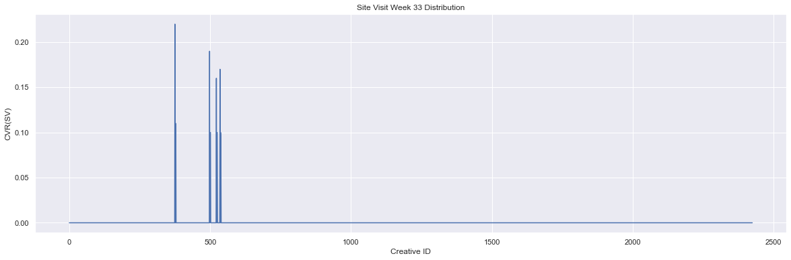

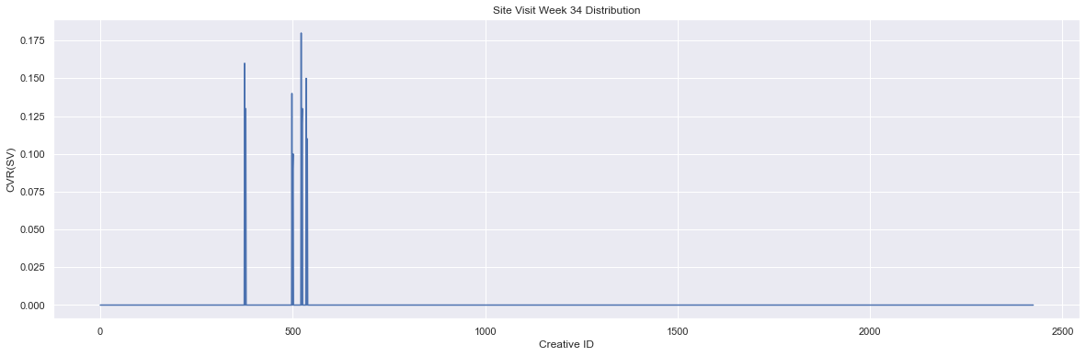

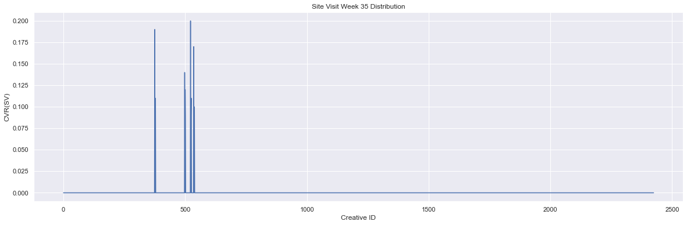

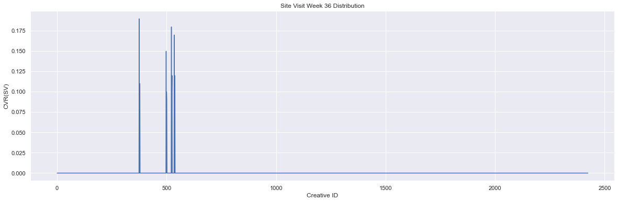

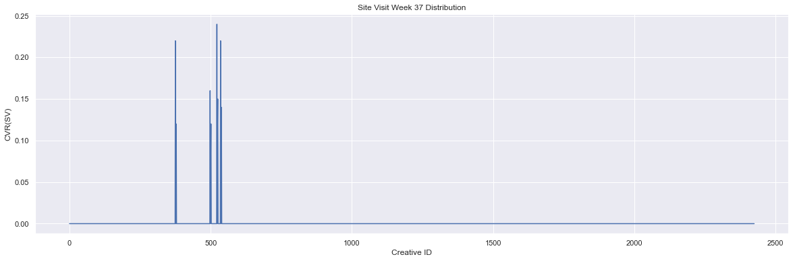

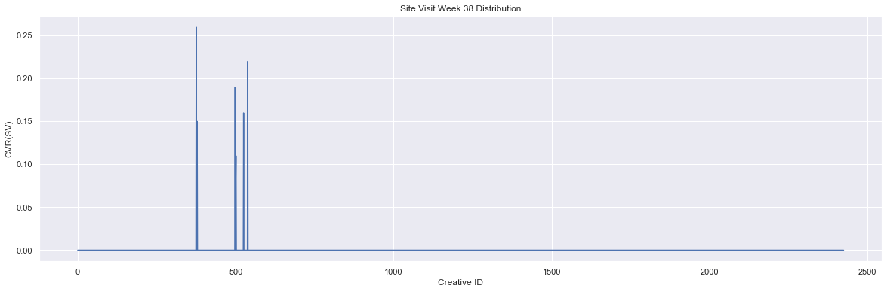

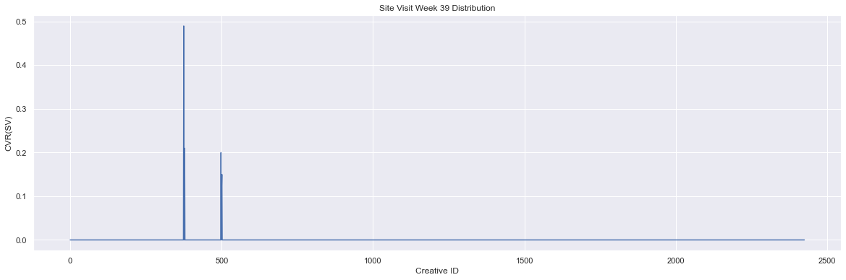

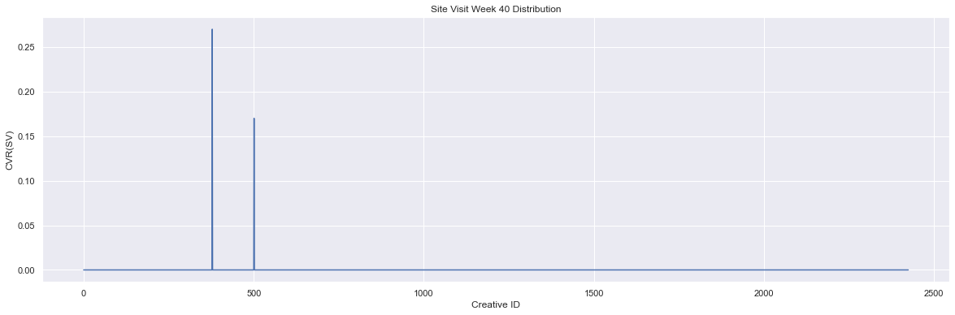

In [ ]:

*# Plot distributions of sales conversion rate*  
**for** idx, sales **in** enumerate(cvrint_w):  
 plt**.**figure(figsize**=**(20, 6))  
 week_data[sales]**.**plot()  
 plt**.**title(f'Sales CVR W{idx} Distribution')  
 plt**.**xlabel('Creative ID')  
 plt**.**ylabel('Sales CVR')  
 plt**.**show()

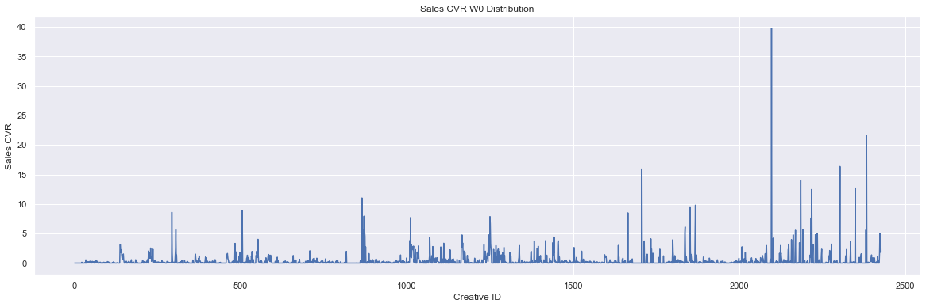

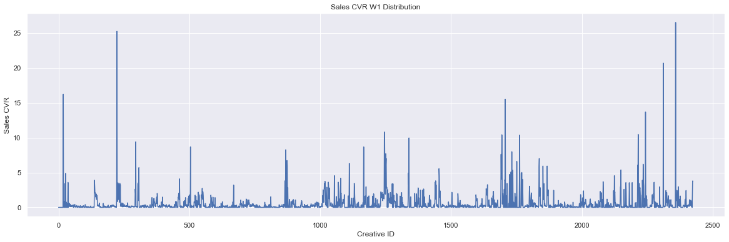

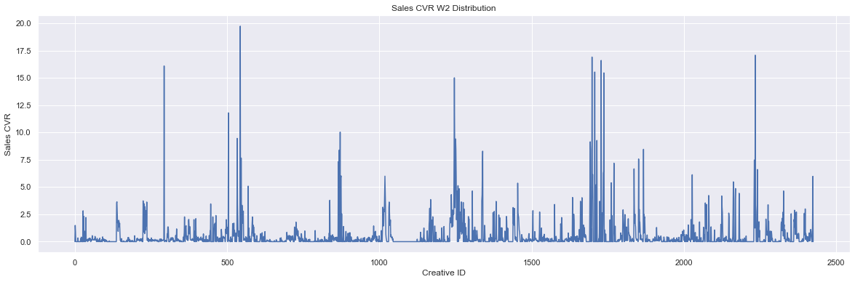

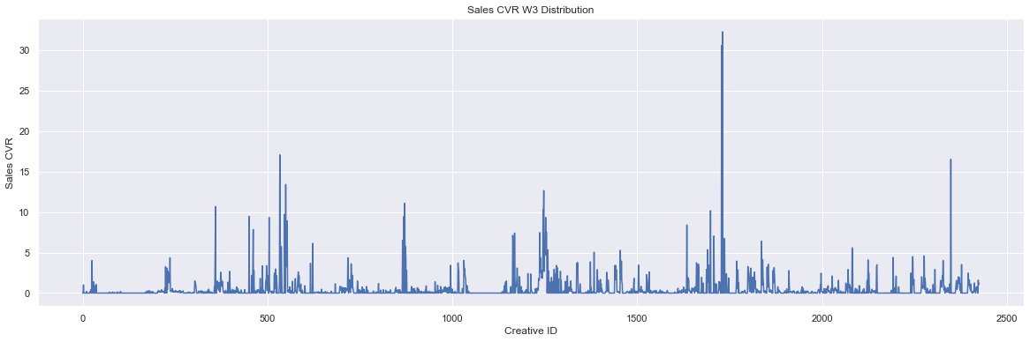

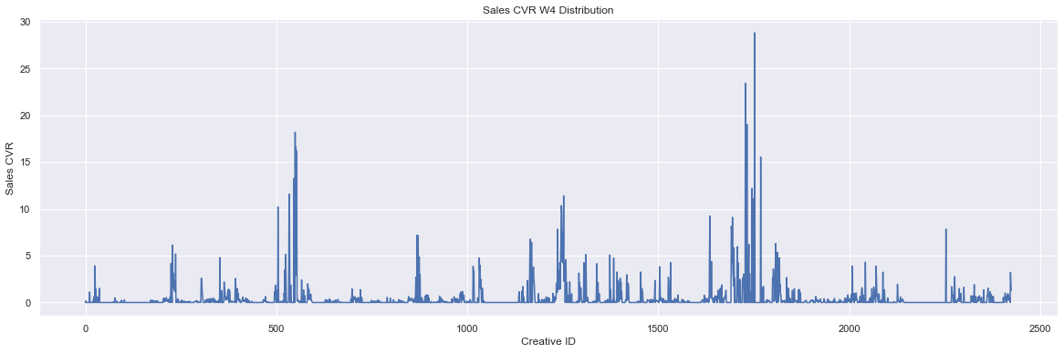

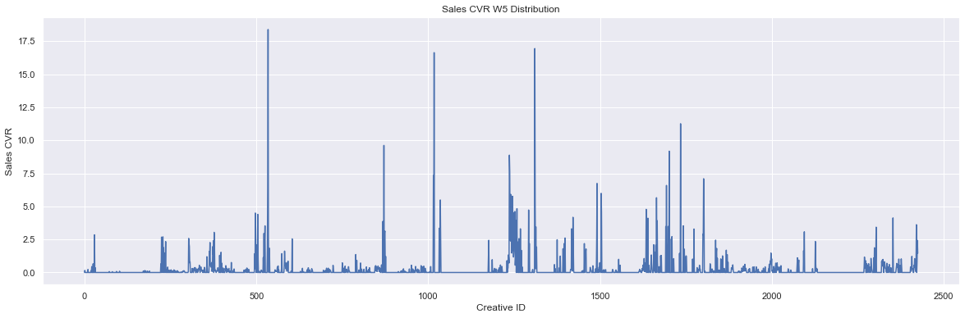

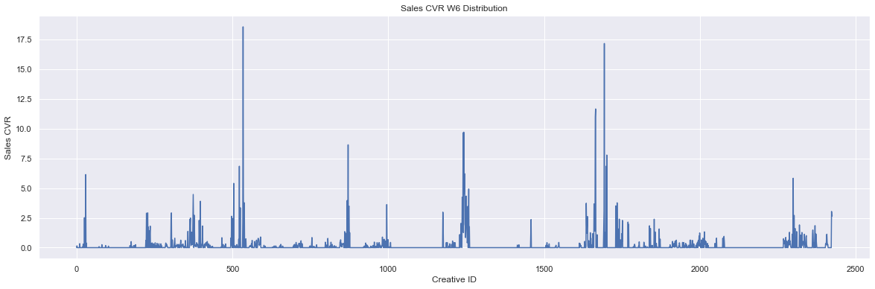

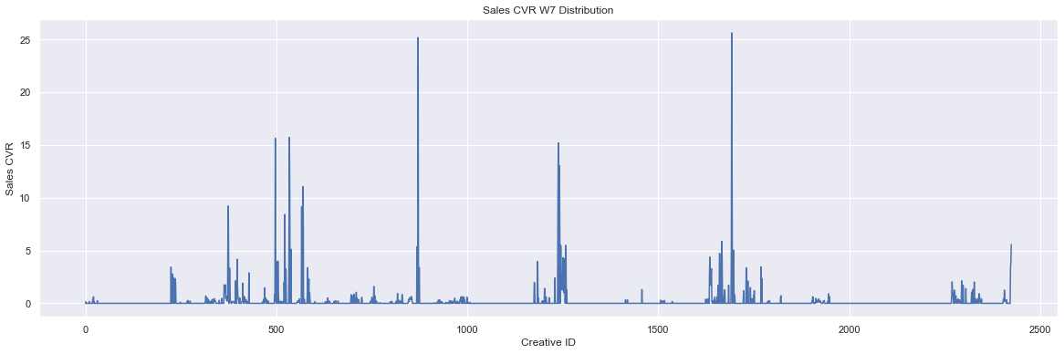

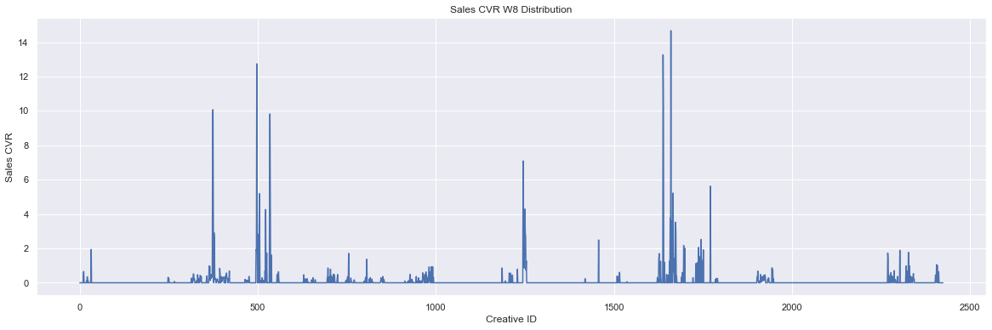

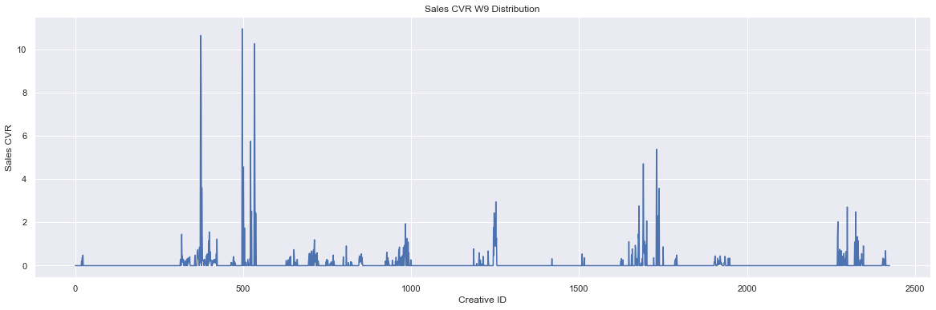

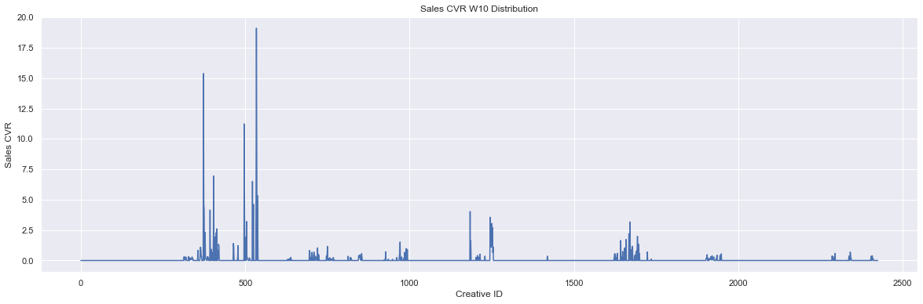

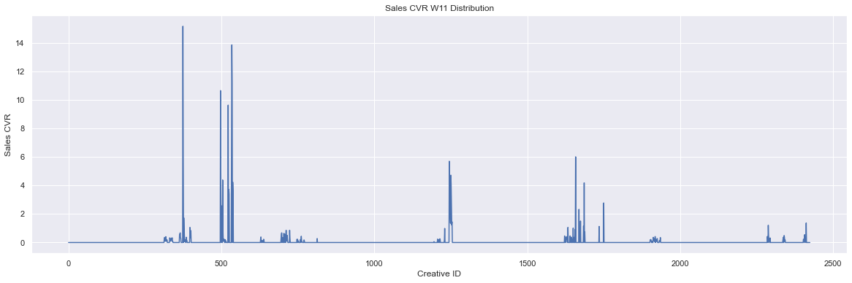

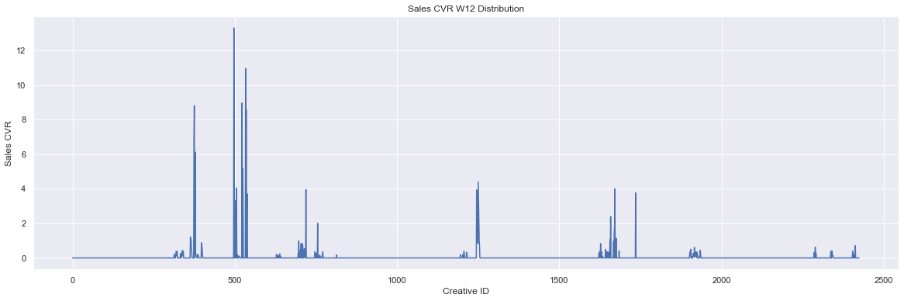

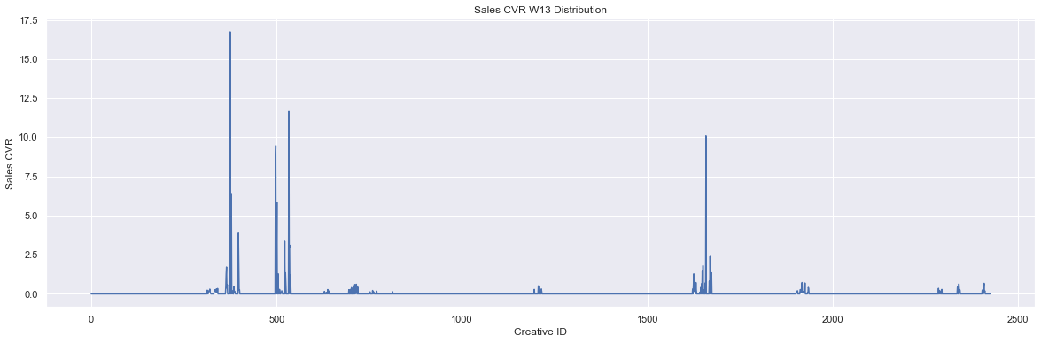

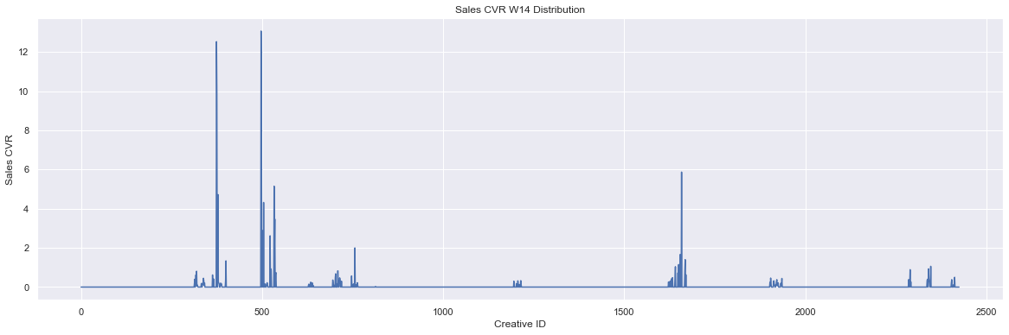

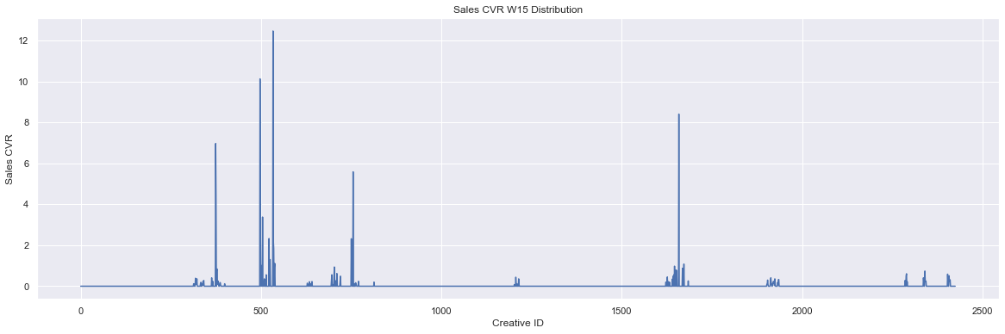

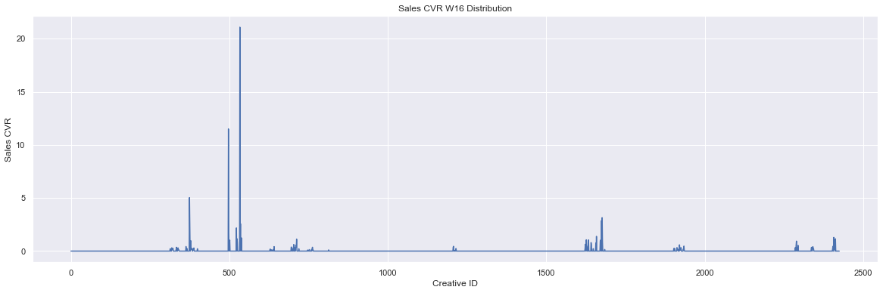

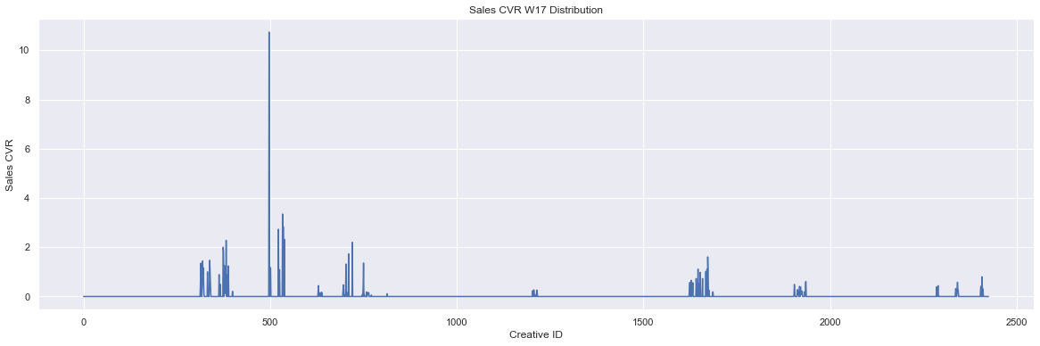

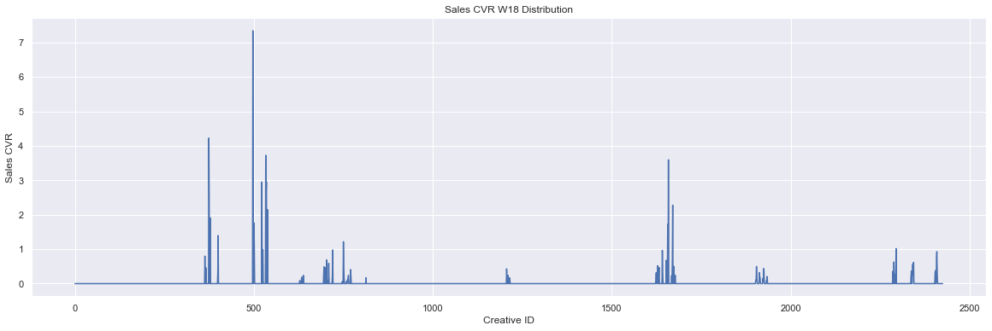

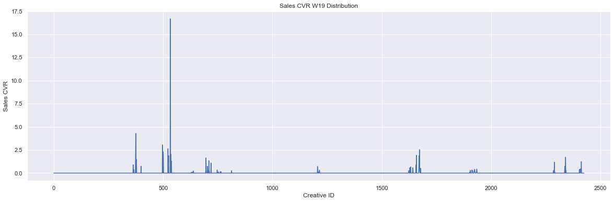

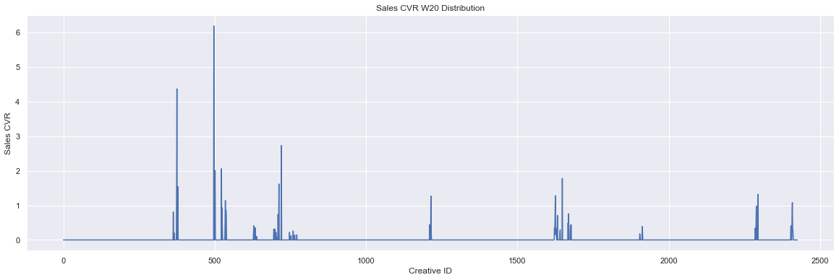

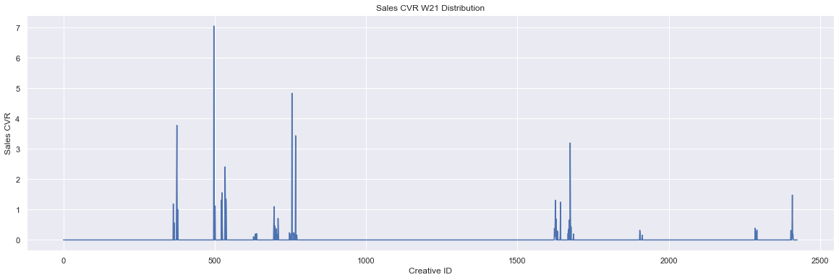

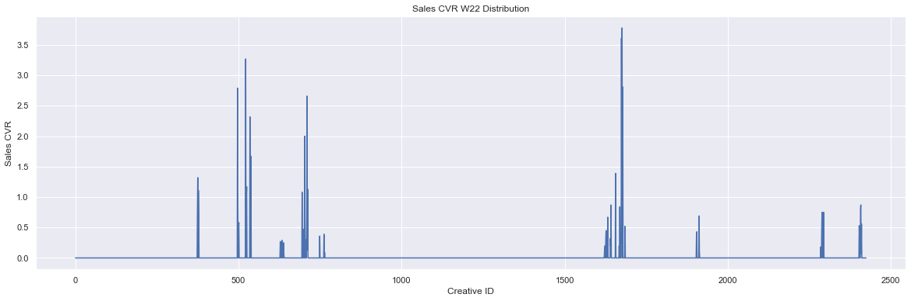

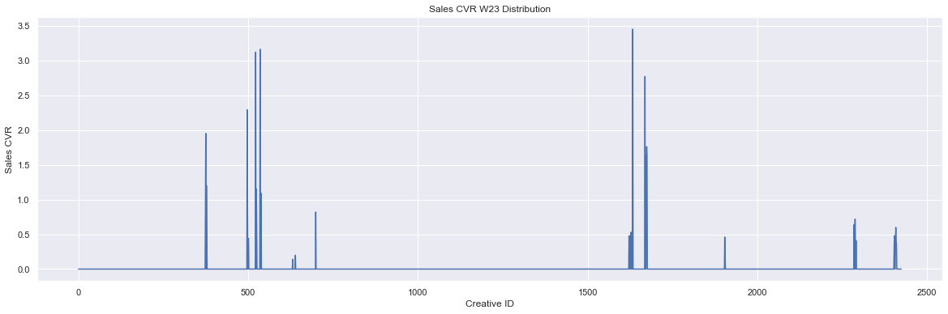

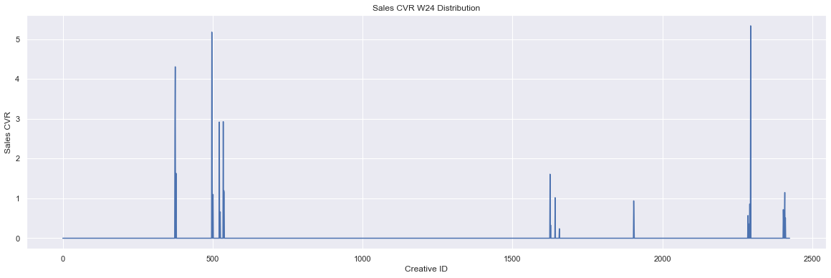

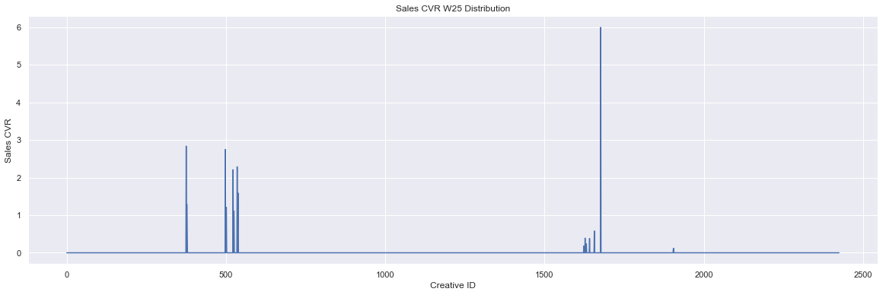

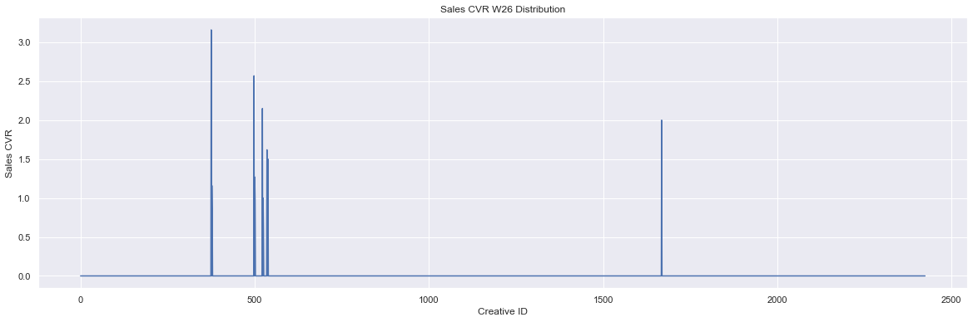

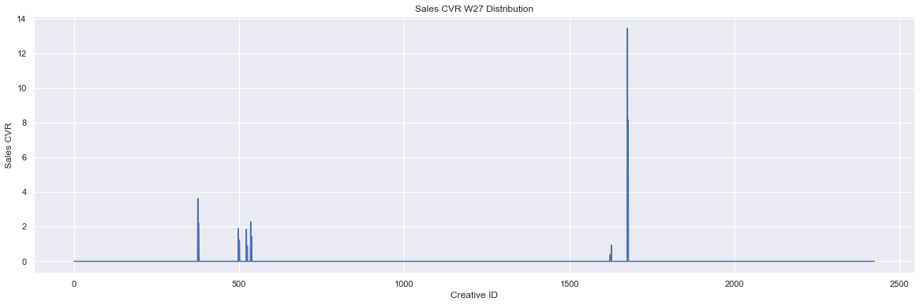

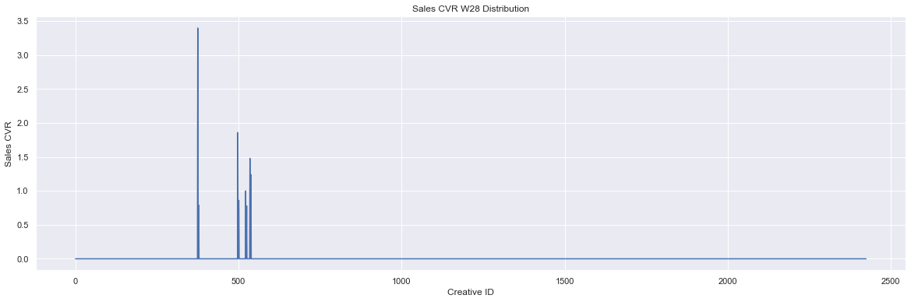

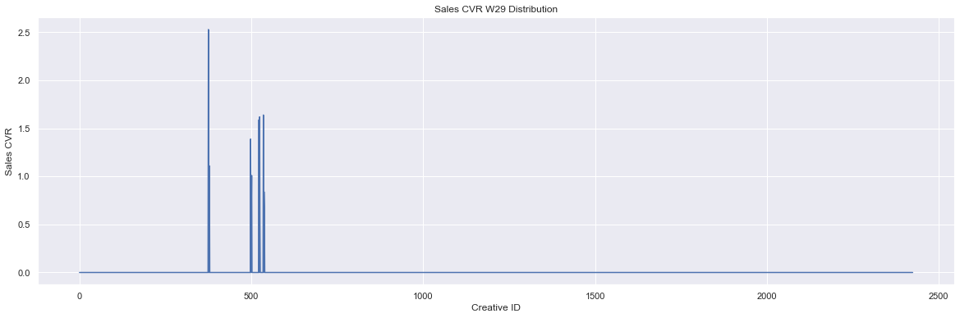

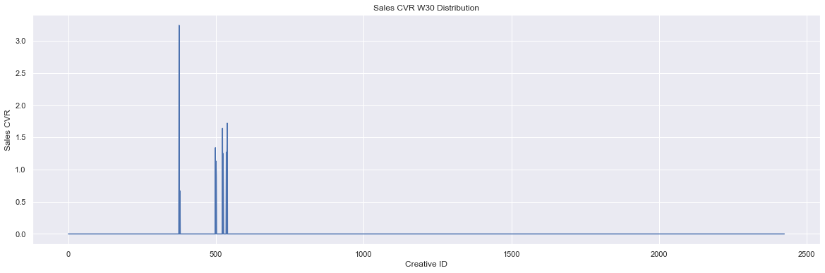

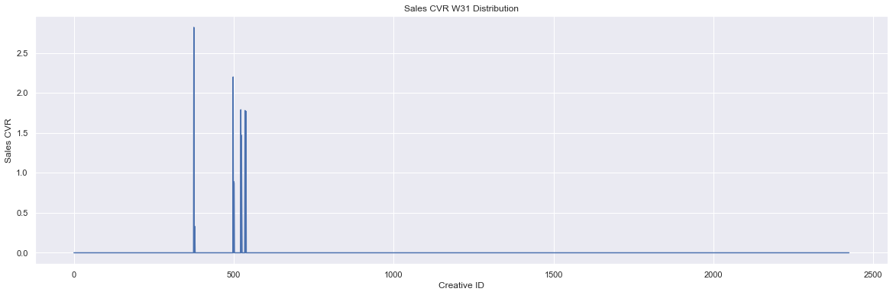

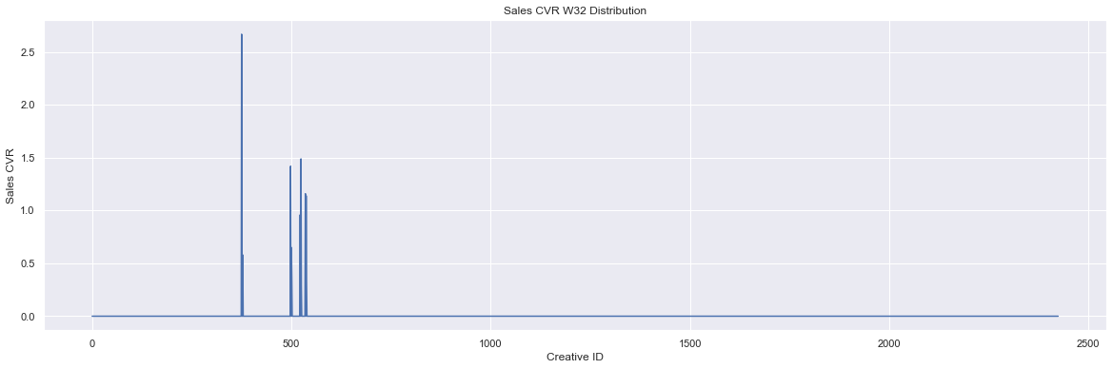

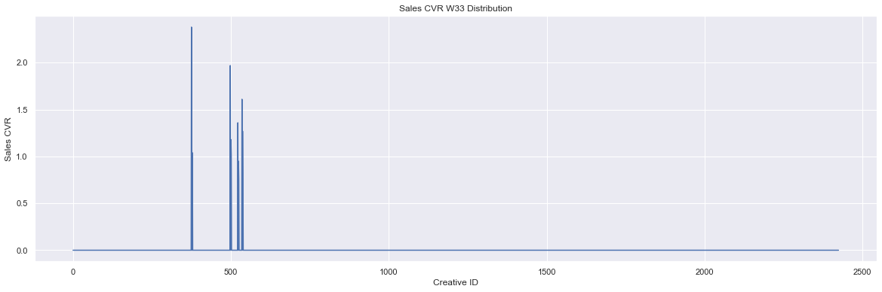

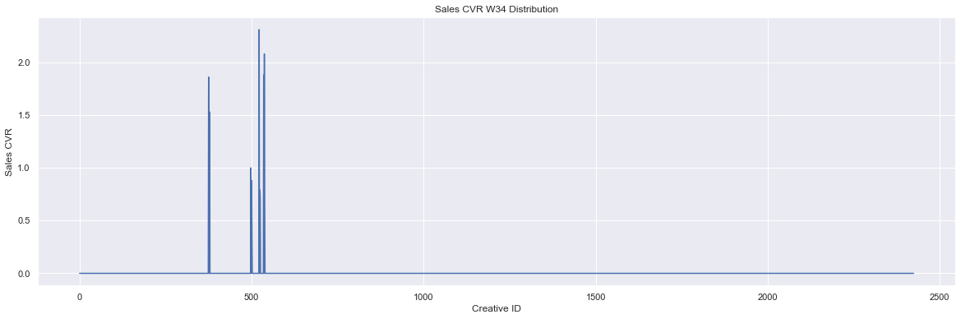

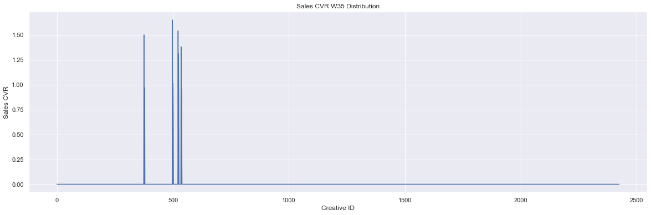

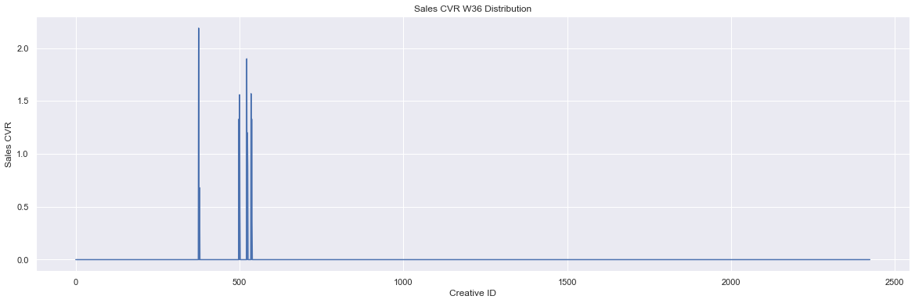

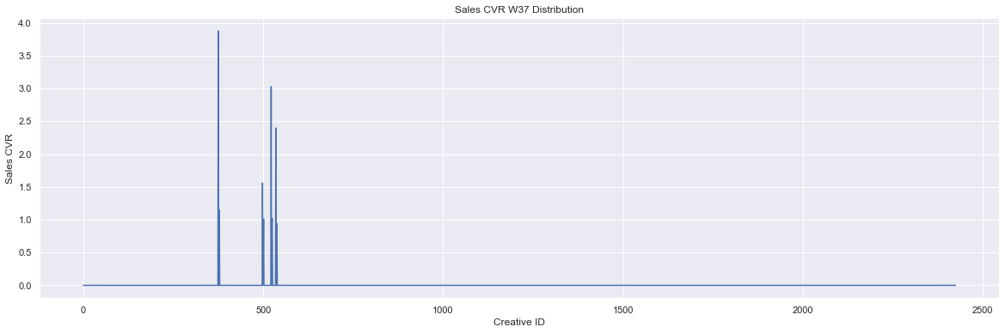

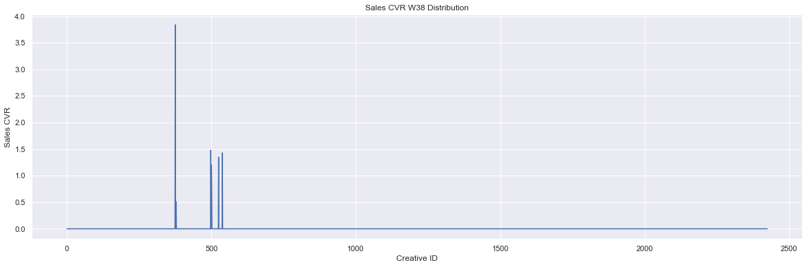

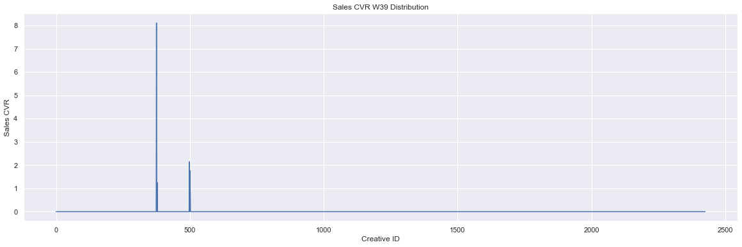

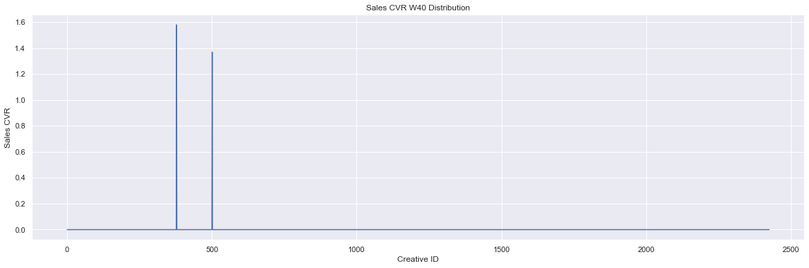

In [ ]:

*# Plot distributions of impressions*  
imps_w **=** [week **for** week **in** week_data**.**columns **if** week**.**startswith('Impressions')]  
**for** idx, imp **in** enumerate(imps_w):  
 plt**.**figure(figsize**=**(20, 6))  
 week_data[imp]**.**plot()  
 plt**.**title(f'Impressions Week {idx} Distribution')  
 plt**.**xlabel('Creative ID')  
 plt**.**ylabel('Impressions')  
 plt**.**show()

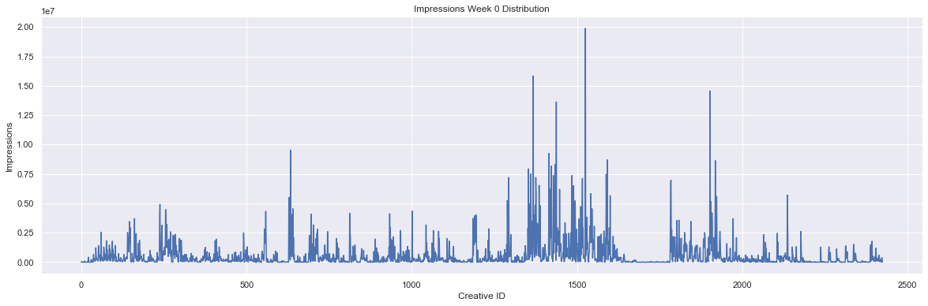

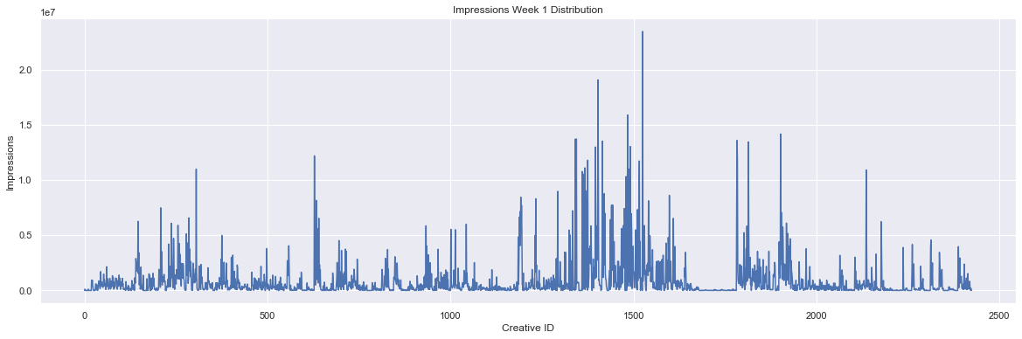

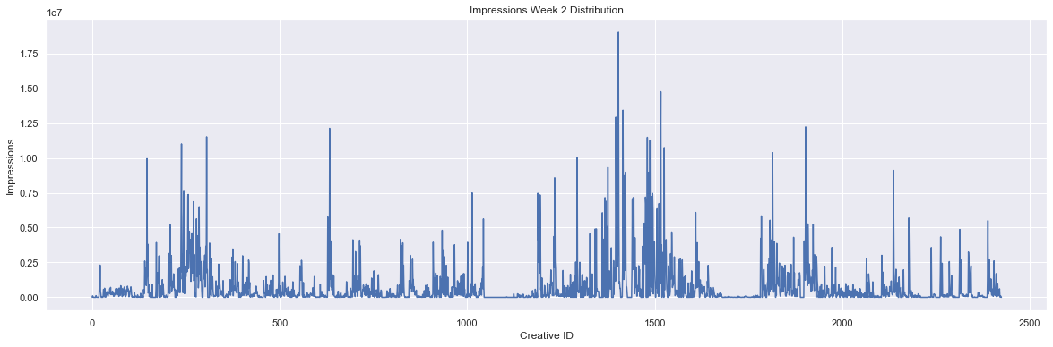

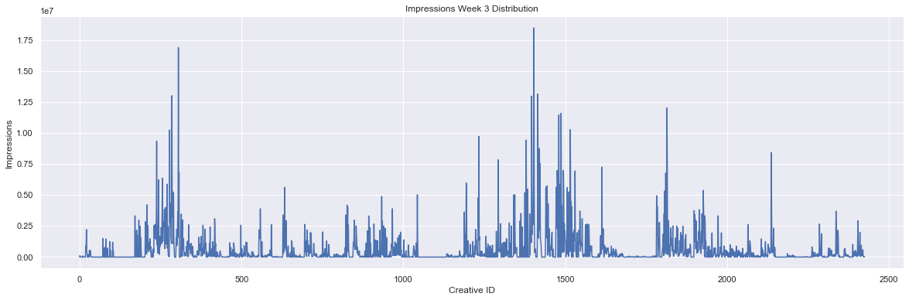

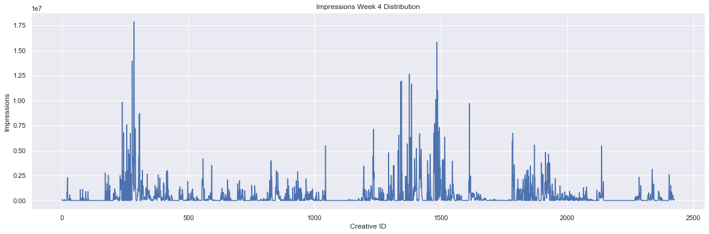

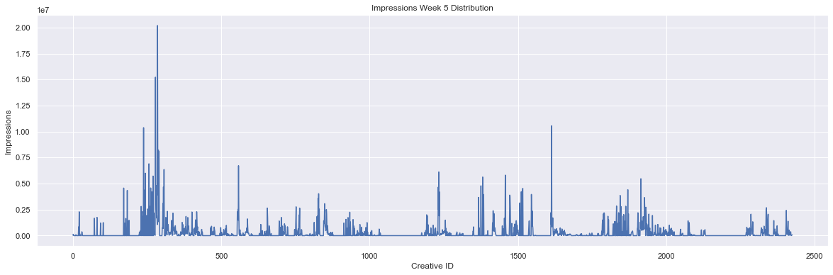

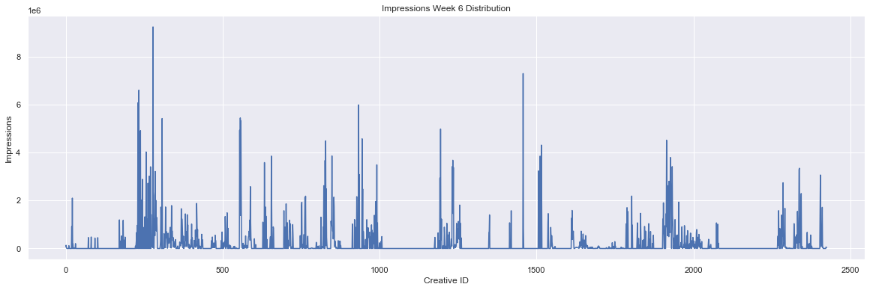

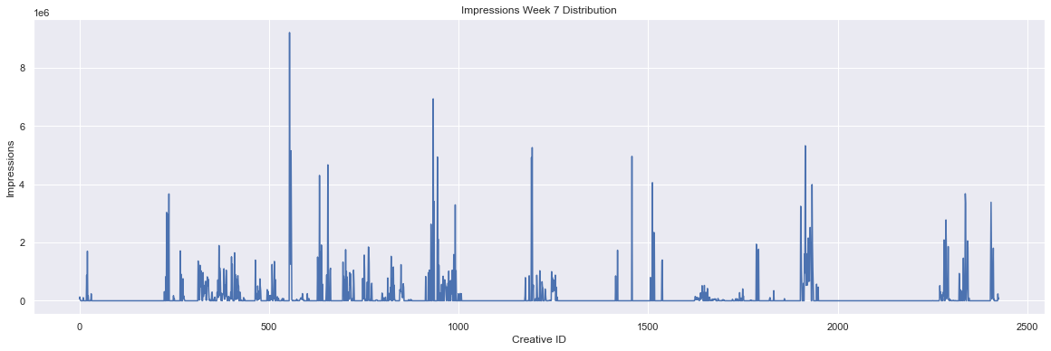

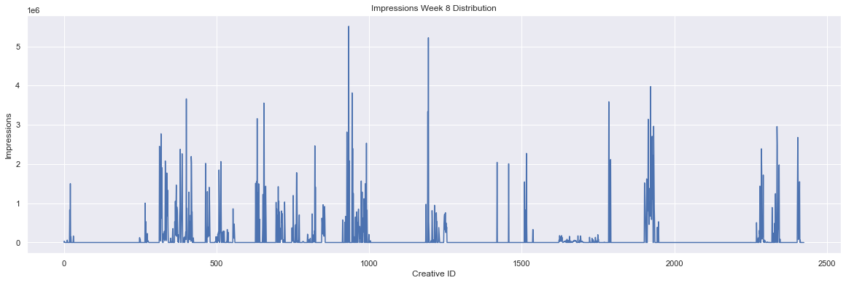

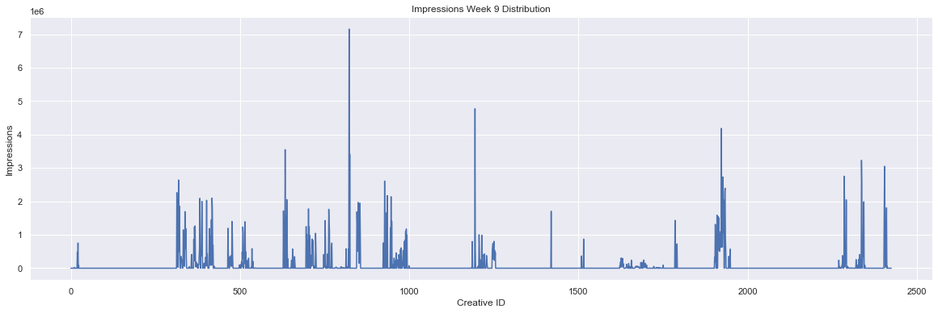

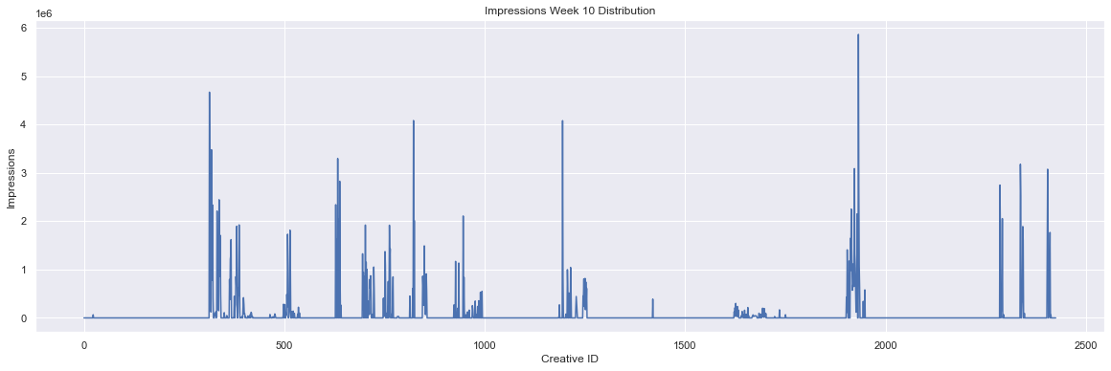

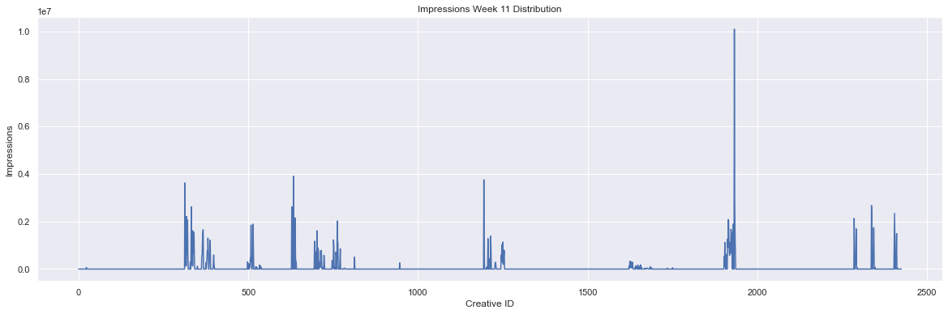

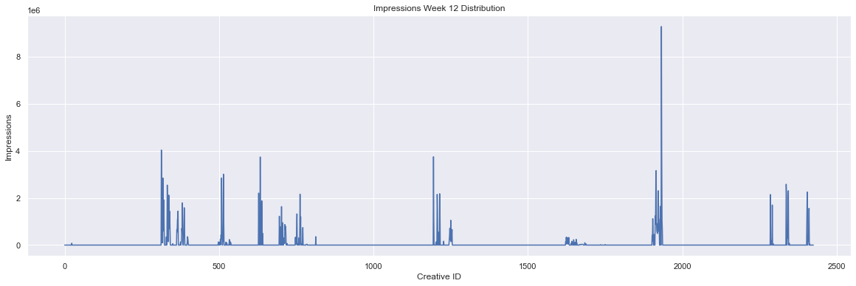

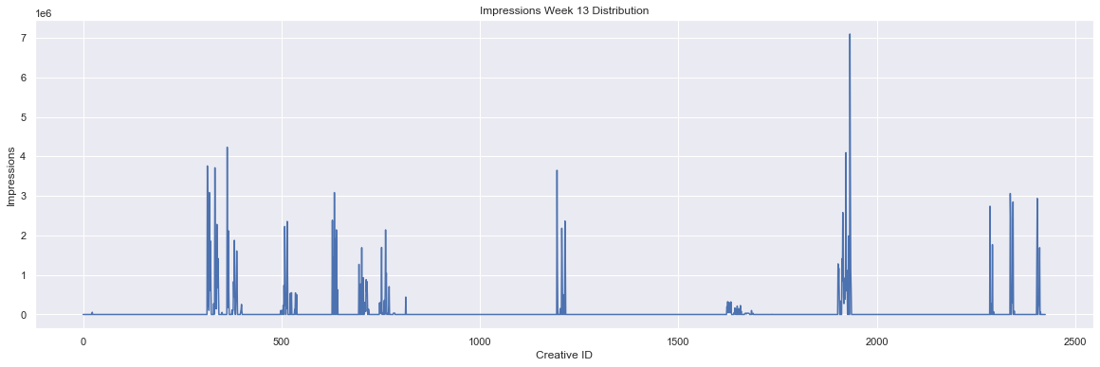

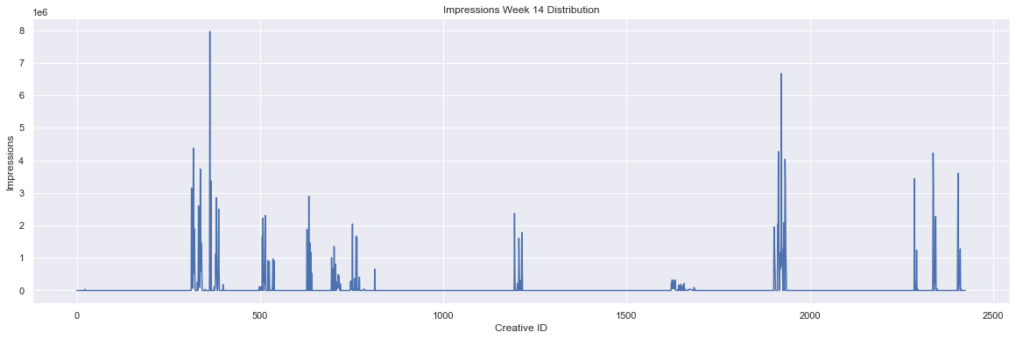

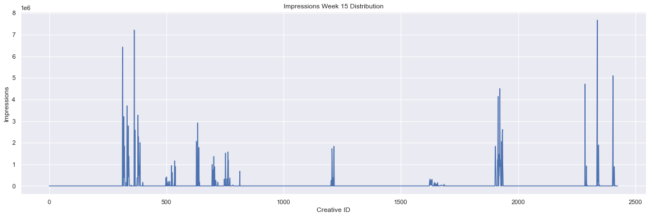

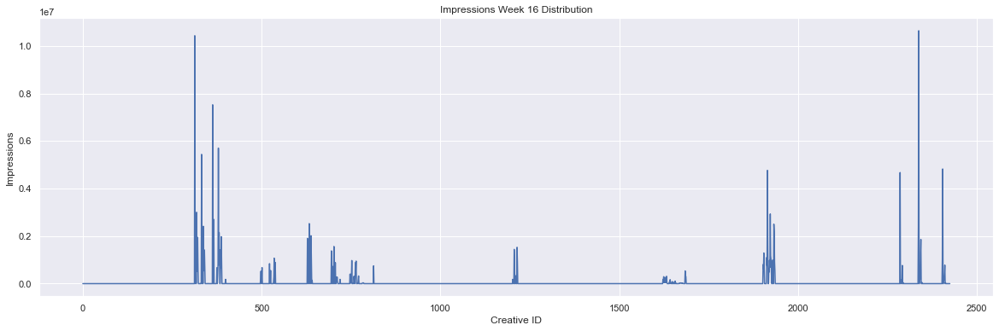

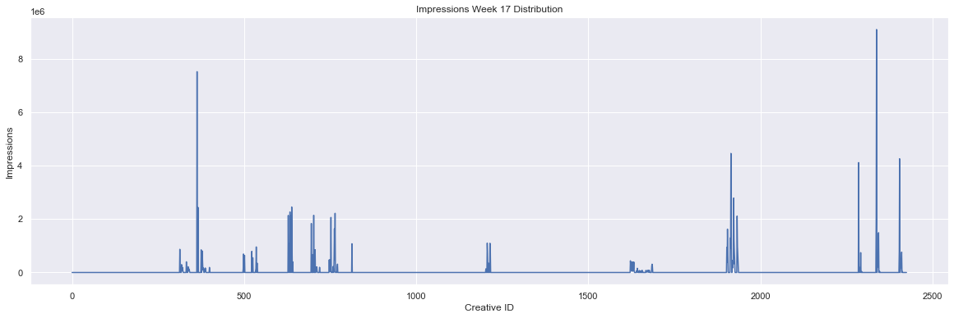

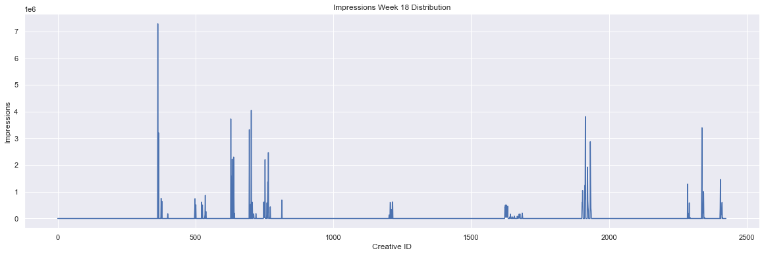

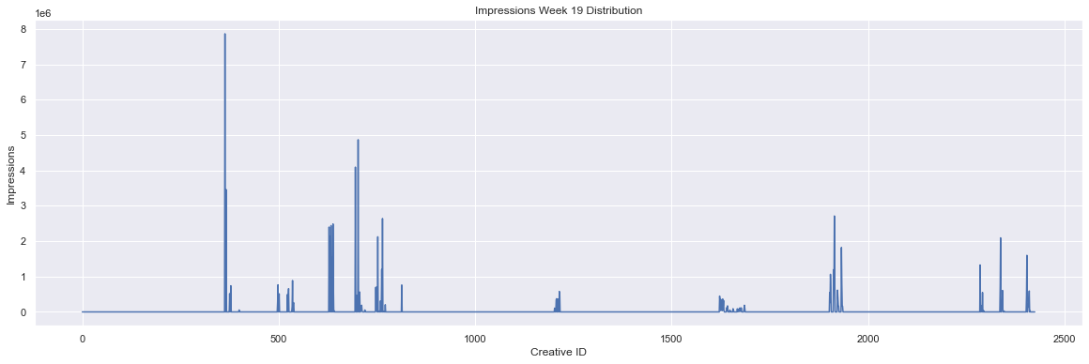

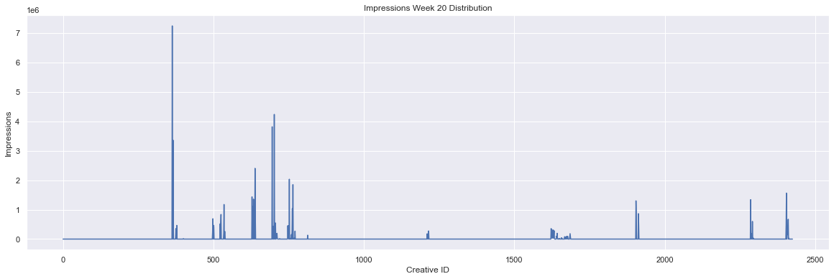

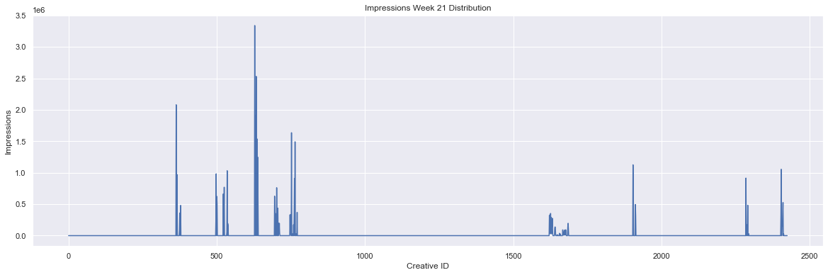

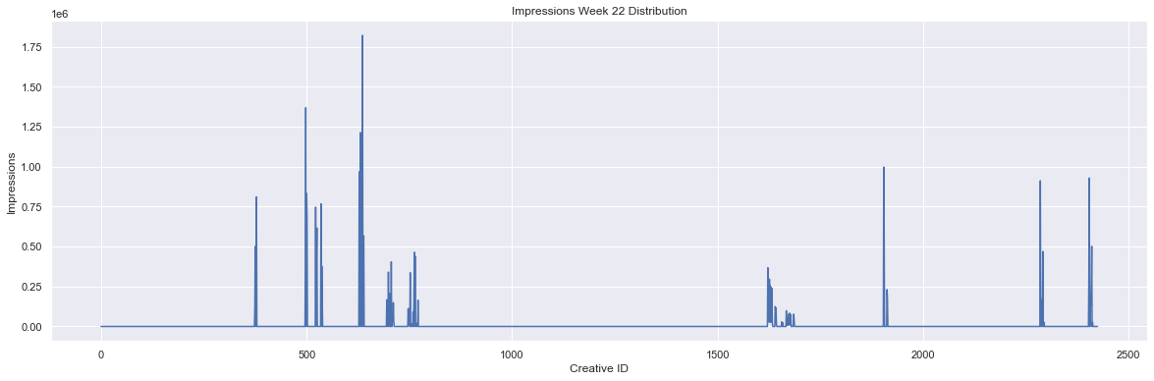

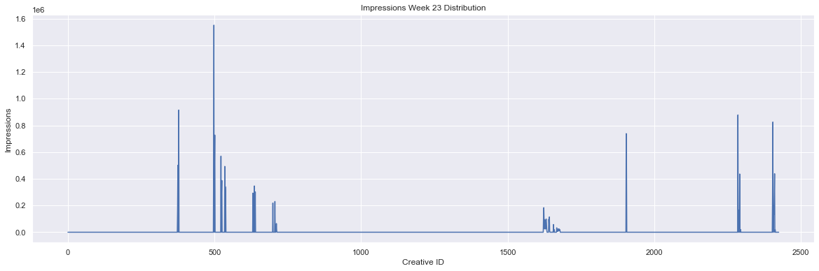

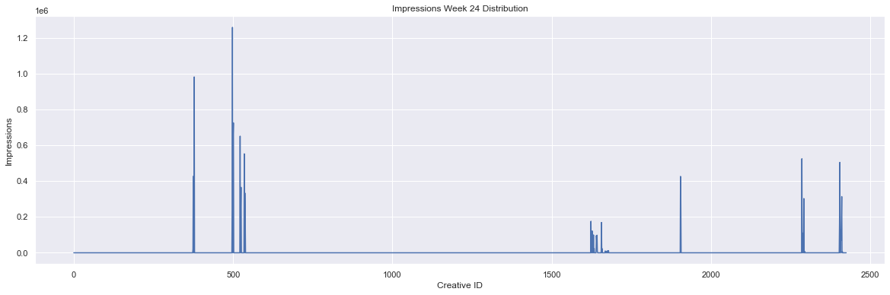

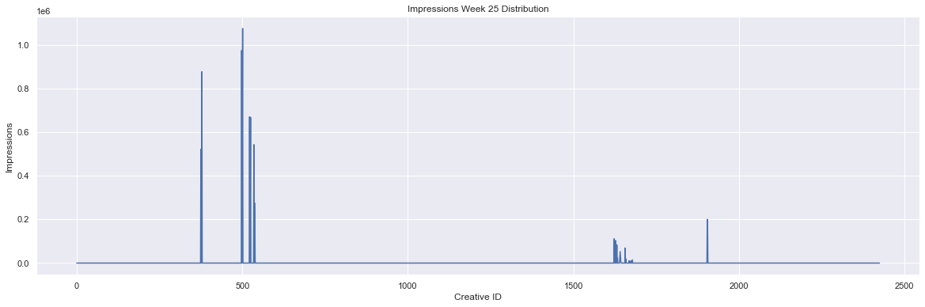

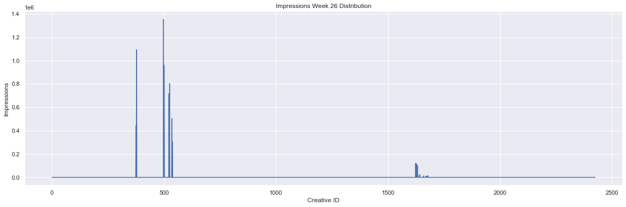

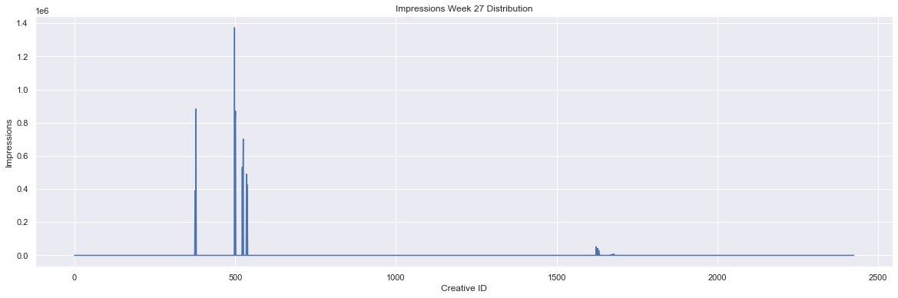

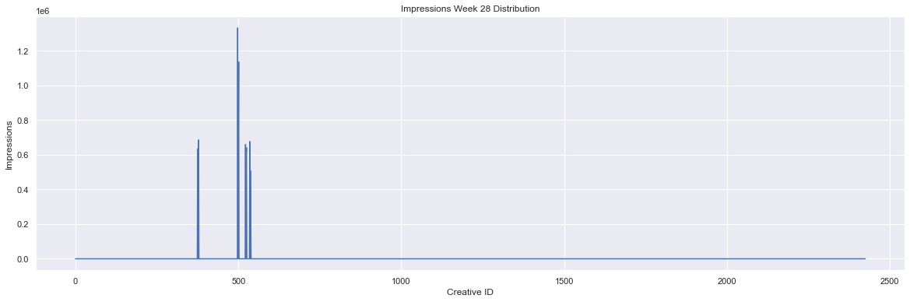

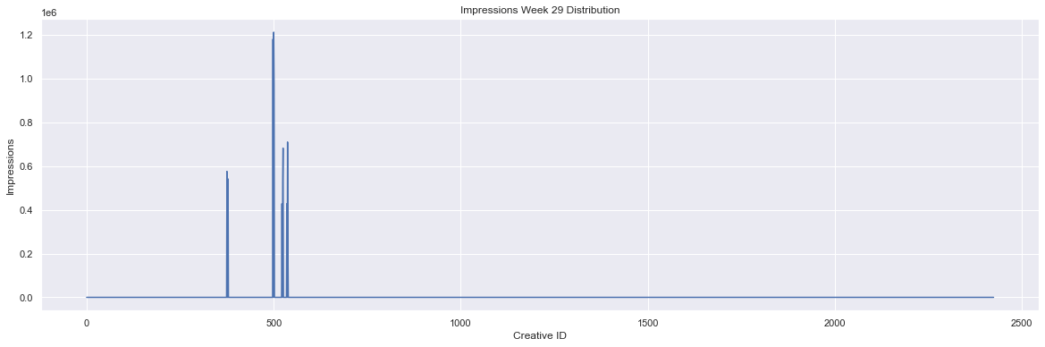

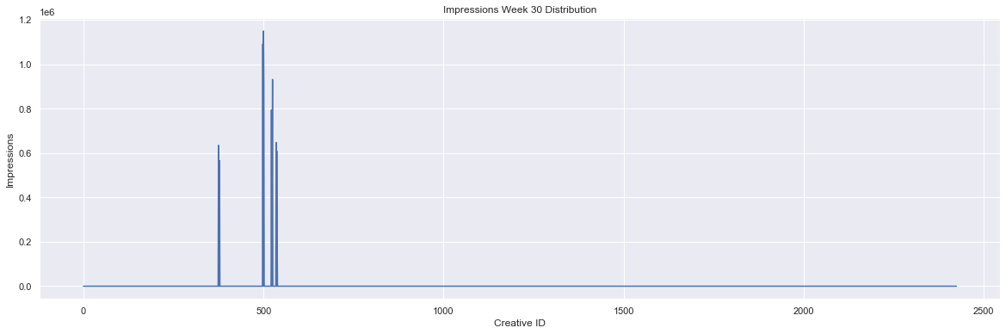

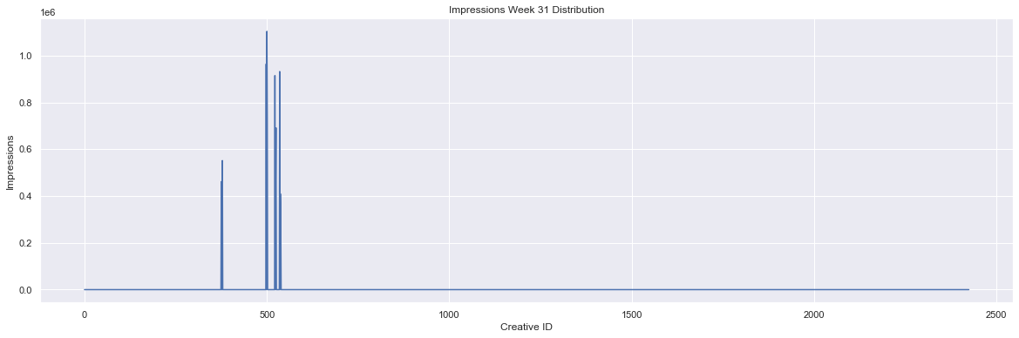

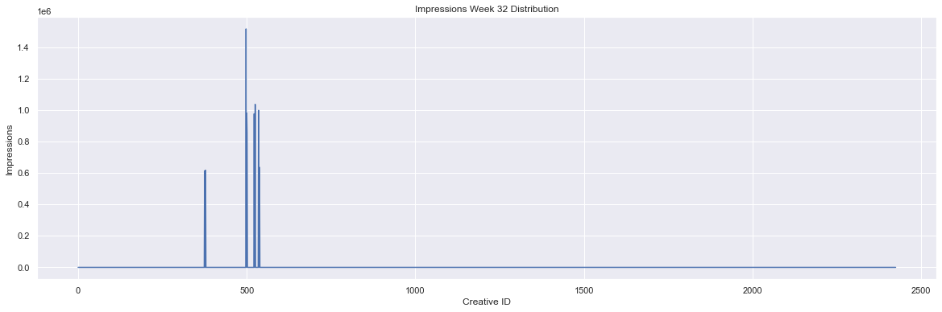

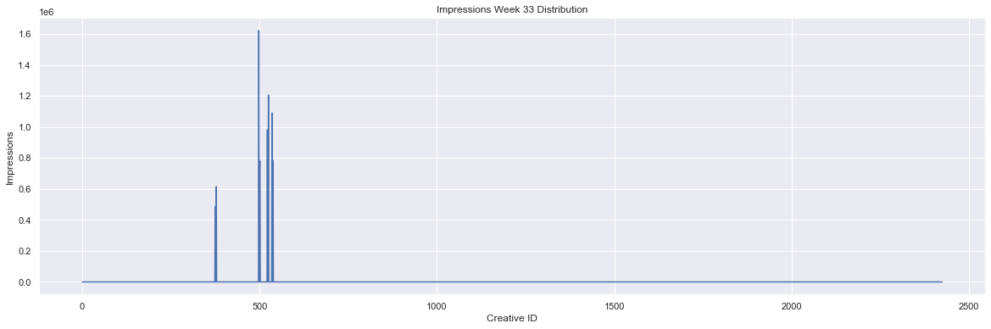

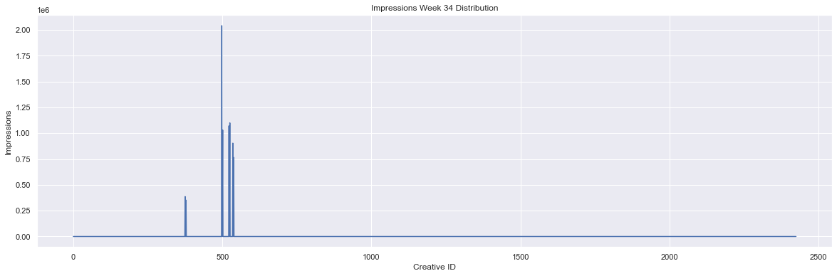

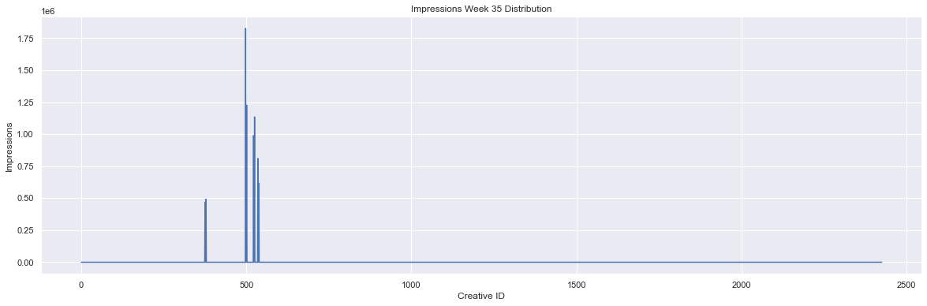

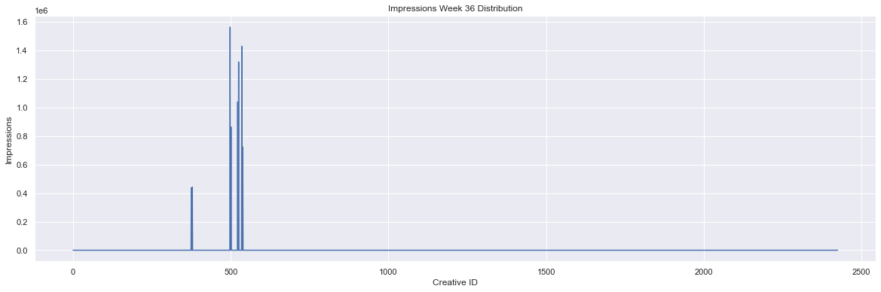

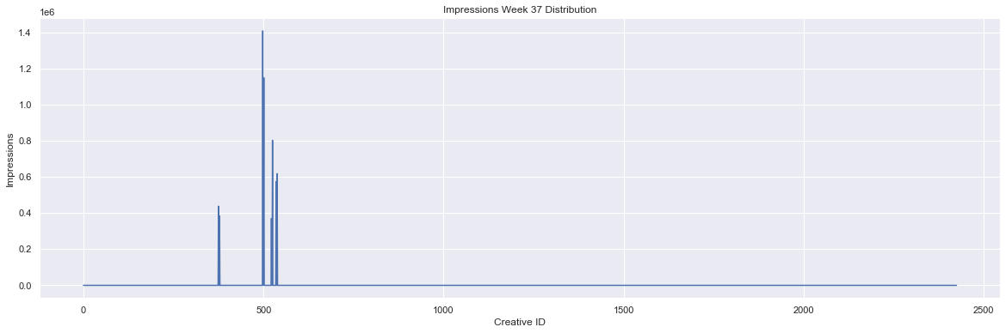

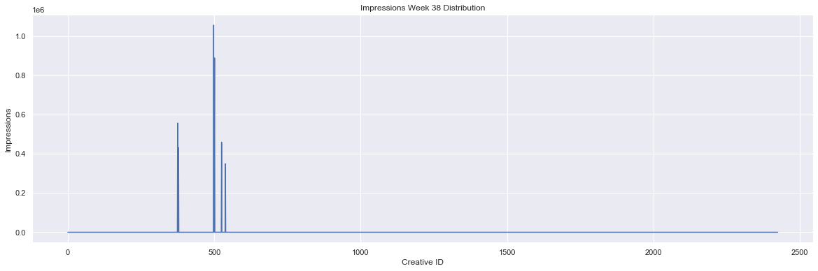

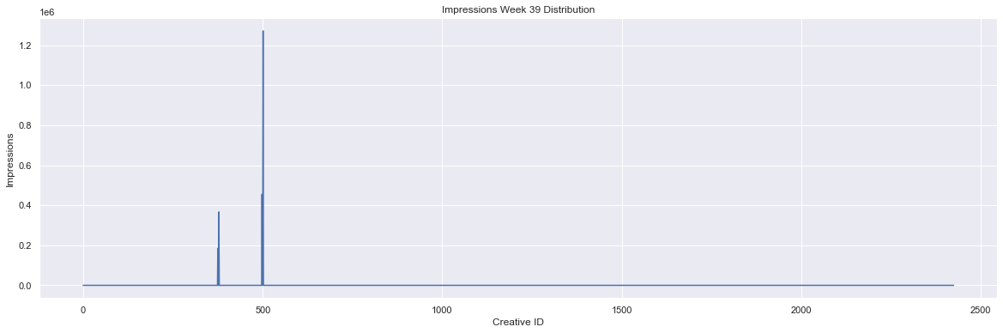

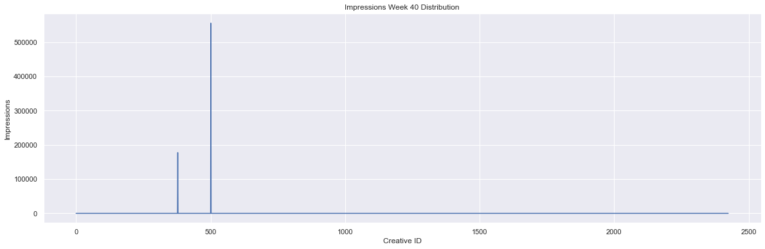

In [ ]:

*# Plot distributions of spending*  
spend_w **=** [week **for** week **in** week_data**.**columns **if** week**.**startswith('Spend')]  
**for** idx, spend **in** enumerate(spend_w):  
 plt**.**figure(figsize**=**(20, 6))  
 week_data[spend]**.**plot()  
 plt**.**title(f'Spend Week {idx} Distribution')  
 plt**.**xlabel('Creative ID')  
 plt**.**ylabel('Spending')  
 plt**.**show()

